Supplementary Material

Optimization of two-step asymmetric PCR protocol to prepare single-strand DNA for aptamer screening
Huajie Gu^{1*}, Jiaming Shen¹, Zihan Chen¹, Liling Hao²
¹ School of Chemistry and Life Sciences, Suzhou University of Science and Technology, Suzhou 215009, Jiangsu, China
² School of Health Science and Engineering, Shanghai Engineering Research Center for Food Rapid Detection, University of Shanghai for Science and Technology, Shanghai 200093, China

*Corresponding author:
Huajie Gu
School of Chemistry and Life Sciences, Suzhou University of Science and Technology, Suzhou 215009, Jiangsu, China
E-mail address: liongu@usts.edu.cn

Table S1 The relative quantity values of 80 nt ssDNA bands in the two-factor cross grouping experiment
cycles  ratios | 20 | 24 | 28 | 32 | 36 | 40 | 44
50:1 | 0.204±0.018 | 0.236±0.026 | 0.257±0.022 | 0.246±0.010 | 0.393±0.055 | 0.364±0.083 | 0.339±0.016
75:1 | 0.233±0.006 | 0.215±0.026 | 0.234±0.019 | 0.250±0.014 | 0.284±0.030 | 0.273±0.009 | 0.254±0.016
100:1 | 0.170±0.017 | 0.198±0.008 | 0.176±0.018 | 0.201±0.019 | 0.211±0.029 | 0.261±0.035 | 0.239±0.031
125:1 | 0.150±0.017 | 0.162±0.012 | 0.160±0.017 | 0.182±0.020 | 0.263±0.015 | 0.283±0.029 | 0.199±0.016
150:1 | 0.223±0.024 | 0.323±0.023 | 0.290±0.018 | 0.286±0.017 | 0.415±0.026 | 0.438±0.031 | 0.360±0.017
175:1 | 0.205±0.005 | 0.336±0.028 | 0.215±0.006 | 0.282±0.017 | 0.281±0.025 | 0.311±0.012 | 0.263±0.018
200:1 | 0.210±0.011 | 0.245±0.038 | 0.245±0.038 | 0.272±0.015 | 0.229±0.013 | 0.073±0.011 | 0.051±0.005

Table S2 The productive rates in the two-factor cross grouping experiment
cycles  ratios | 20 | 24 | 28 | 32 | 36 | 40 | 44
50:1 | 2.358±0.040 | 3.828±0.291 | 3.703±0.092 | 6.343±0.488 | 3.761±0.204 | 5.085±0.776 | 5.147±0.606
75:1 | 2.331±0.149 | 3.034±0.147 | 4.163±0.493 | 6.466±0.748 | 4.127±0.466 | 5.323±0.247 | 3.851±0.292
100:1 | 2.509±0.197 | 3.225±0.178 | 4.229±0.311 | 4.205±0.522 | 5.379±0.545 | 7.380±0.589 | 4.742±0.392
125:1 | 2.678±0.230 | 2.798±0.235 | 4.078±0.221 | 5.316±0.590 | 6.516±0.443 | 6.726±0.594 | 3.050±0.638
150:1 | 3.320±0.079 | 4.832±0.187 | 6.412±0.408 | 8.481±0.821 | 12.923±0.642 | 7.744±0.678 | 10.185±1.221
175:1 | 2.249±0.136 | 2.907±0.180 | 5.003±0.391 | 5.088±0.154 | 7.222±0.463 | 7.652±0.764 | 5.409±0.544
200:1 | 3.326±0.400 | 3.208±0.105 | 4.591±0.332 | 4.728±0.129 | 5.963±0.579 | 2.880±0.373 | 3.848±0.635

Table S3 Variance analysis of the relative quantity values in the two-factor cross grouping experiment
Source | Type III Sum of Squares (SS) | df | Mean Square (MS) | F value | Significance  (P value)
Corrected Model | 0.821ª | 48 | 0.017 | 27.711 | 0.000
Intercept | 9.092 | 1 | 9.092 | 14727.988 | 0.000
cycles | 0.141 | 6 | 0.024 | 38.171 | 0.000
ratios | 0.358 | 6 | 0.060 | 96.762 | 0.000
cycles * ratios | 0.321 | 36 | 0.009 | 14.460 | 0.000
Error | 0.060 | 98 | 0.001
Total | 9.974 | 147
Corrected Total | 0.882 | 146
ª R² = 0.931 (adjusted R² = 0.898)

Table S4 Variance analysis of the productive rates in the two-factor cross grouping experiment
Source | Type III Sum of Squares (SS) | df | Mean Square (MS) | F value | Significance  (P value)
Corrected Model | 650.881ª | 48 | 13.560 | 60.458 | 0.000
Intercept | 3535.936 | 1 | 3535.936 | 15765.034 | 0.000
cycles | 259.458 | 6 | 43.243 | 192.800 | 0.000
ratios | 204.471 | 6 | 34.078 | 151.939 | 0.000
cycles * ratios | 186.953 | 36 | 5.193 | 23.154 | 0.000
Error | 21.980 | 98 | 0.224
Total | 4208.798 | 147
Corrected Total | 672.862 | 146
ª R² = 0.967 (adjusted R² = 0.951)

Table S5 Post hoc multiple comparisons of the relative quantity values among different amplification cycles (Duncan method)
cycles | N | Subset
cycles | N | 1 | 2 | 3 | 4
20 | 21 | 0.19929
28 | 21 |  | 0.22517
44 | 21 |  |  | 0.24348
24 | 21 |  |  | 0.24488
32 | 21 |  |  | 0.24546
40 | 21 |  |  |  | 0.28610
36 | 21 |  |  |  | 0.29652
Significance |  | 1.000 | 1.000 | 0.810 | 0.177

Table S6 Post hoc multiple comparisons of the relative quantity values among different primer ratios (Duncan method)
ratios | N | Subset
ratios | N | 1 | 2 | 3 | 4 | 5 | 6
200:1 | 21 | 0.18928
125:1 | 21 | 0.19984 | 0.19984
100:1 | 21 |  | 0.20784
75:1 | 21 |  |  | 0.24892
175:1 | 21 |  |  |  | 0.27029
50:1 | 21 |  |  |  |  | 0.29108
150:1 | 21 |  |  |  |  |  | 0.33366
Significance |  | 0.171 | 0.299 | 1.000 | 1.000 | 1.000 | 1.000

Table S7 Post hoc multiple comparisons of the productive rates among different amplification cycles (Duncan method)
cycles | N | Subset
cycles | N | 1 | 2 | 3 | 4 | 5 | 6 | 7
20 | 21 | 2.68161
24 | 21 |  | 3.40447
28 | 21 |  |  | 4.59693
44 | 21 |  |  |  | 5.17593
32 | 21 |  |  |  |  | 5.80382
40 | 21 |  |  |  |  |  | 6.11299
36 | 21 |  |  |  |  |  |  | 6.55566
Significance |  | 1.000 | 1.000 | 1.000 | 1.000 | 1.000 | 1.000 | 1.000

Table S8 Post hoc multiple comparisons of the productive rates among different primer ratios (Duncan method)
ratios | N | Subset
ratios | N | 1 | 2 | 3 | 4 | 5
200:1 | 21 | 4.07777
75:1 | 21 | 4.18495 | 4.18495
50:1 | 21 | 4.31767 | 4.31767 | 4.31767
125:1 | 21 |  | 4.45160 | 4.45160
100:1 | 21 |  |  | 4.52412
175:1 | 21 |  |  |  | 5.07581
150:1 | 21 |  |  |  |  | 7.69948
Significance |  | 0.124 | 0.087 | 0.187 | 1.000 | 1.000

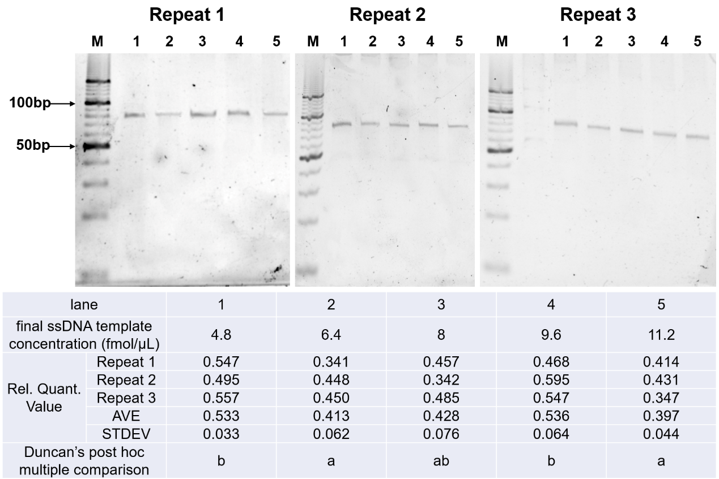
Fig.S1 The native PAGE diagrams and data of the influence of ssDNA template concentration on symmetric PCR. M: 10 bp DNA ladder. Different lowercase letters (a, b, c) in Duncan’s post hoc multiple comparison indicate significant different groups (P<0.05). The groups with the same letter indicate no significant difference.
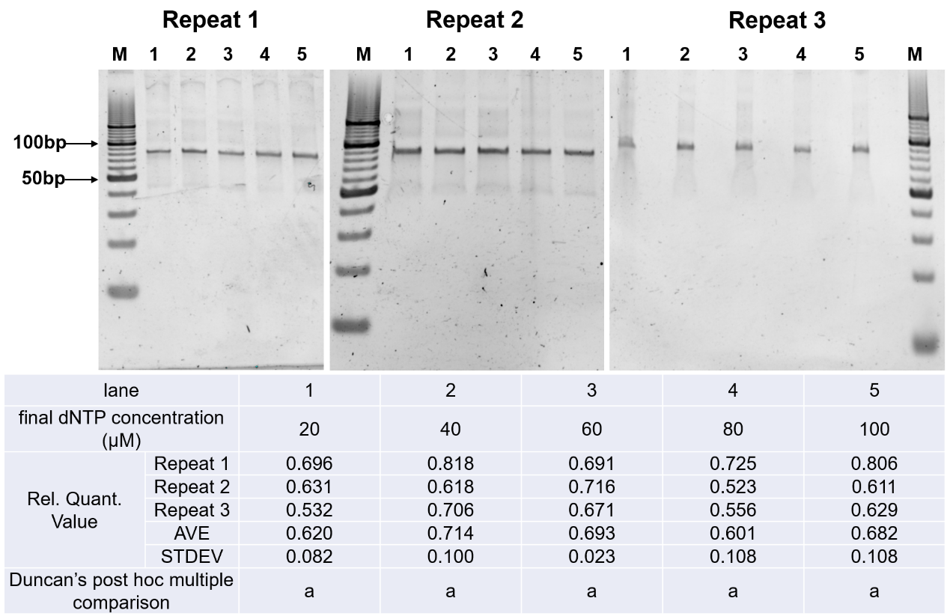
Fig.S2 The native PAGE diagrams and data of the influence of dNTP concentration on symmetric PCR. M: 10 bp DNA ladder. Different lowercase letters (a, b, c) in Duncan’s post hoc multiple comparison indicate significant different groups (P<0.05). The groups with the same letter indicate no significant difference.
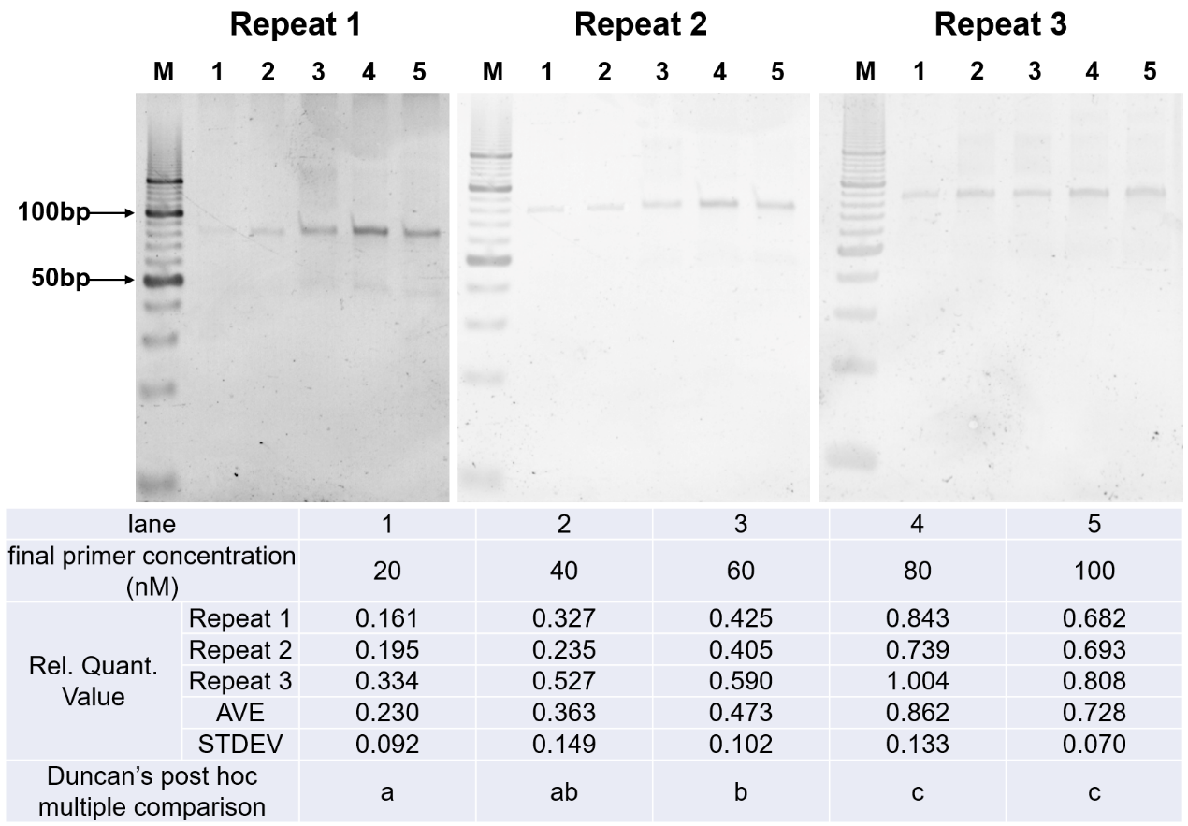
Fig.S3 The native PAGE diagrams and data of the influence of primer concentration on symmetric PCR. M: 10 bp DNA ladder. Different lowercase letters (a, b, c) in Duncan’s post hoc multiple comparison indicate significant different groups (P<0.05). The groups with the same letter indicate no significant difference.
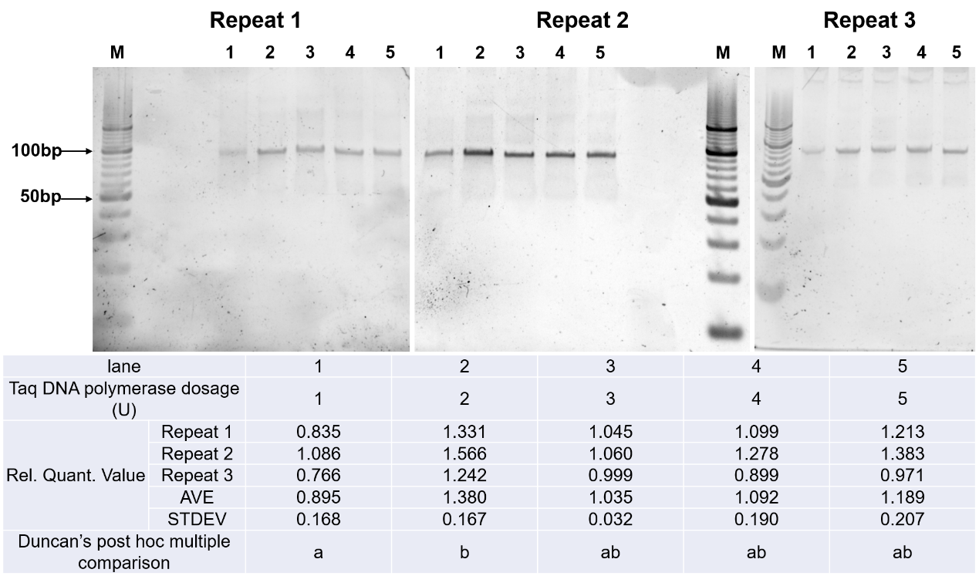
Fig.S4 The native PAGE diagrams and data of the influence of Taq DNA polymerase dosage on symmetric PCR. M: 10 bp DNA ladder. Different lowercase letters (a, b, c) in Duncan’s post hoc multiple comparison indicate significant different groups (P<0.05). The groups with the same letter indicate no significant difference.
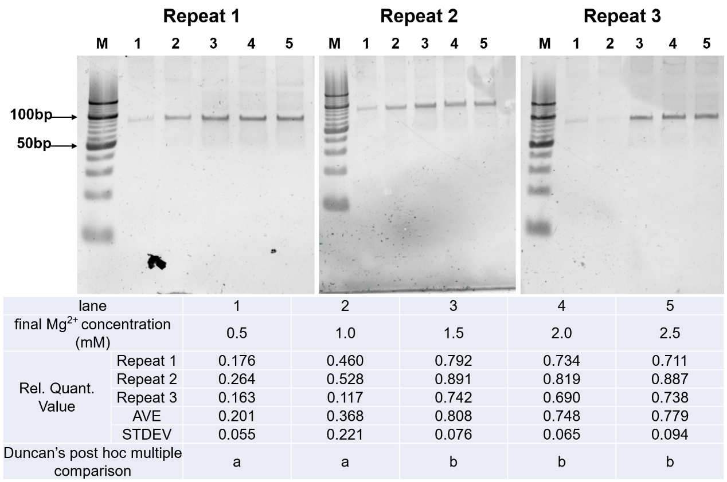
Fig.S5 The native PAGE diagrams and data of the influence of Mg²⁺ concentration on symmetric PCR. M: 10 bp DNA ladder. Different lowercase letters (a, b, c) in Duncan’s post hoc multiple comparison indicate significant different groups (P<0.05). The groups with the same letter indicate no significant difference.
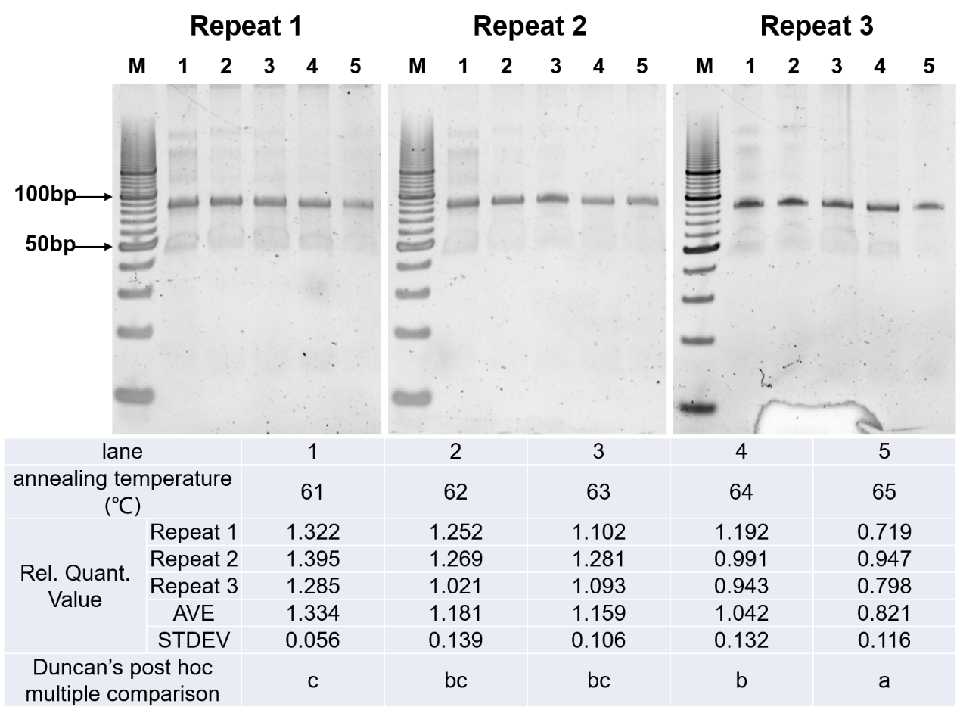
Fig.S6 The native PAGE diagrams and data of the influence of annealing temperature on symmetric PCR. M: 10 bp DNA ladder. Different lowercase letters (a, b, c) in Duncan’s post hoc multiple comparison indicate significant different groups (P<0.05). The groups with the same letter indicate no significant difference.
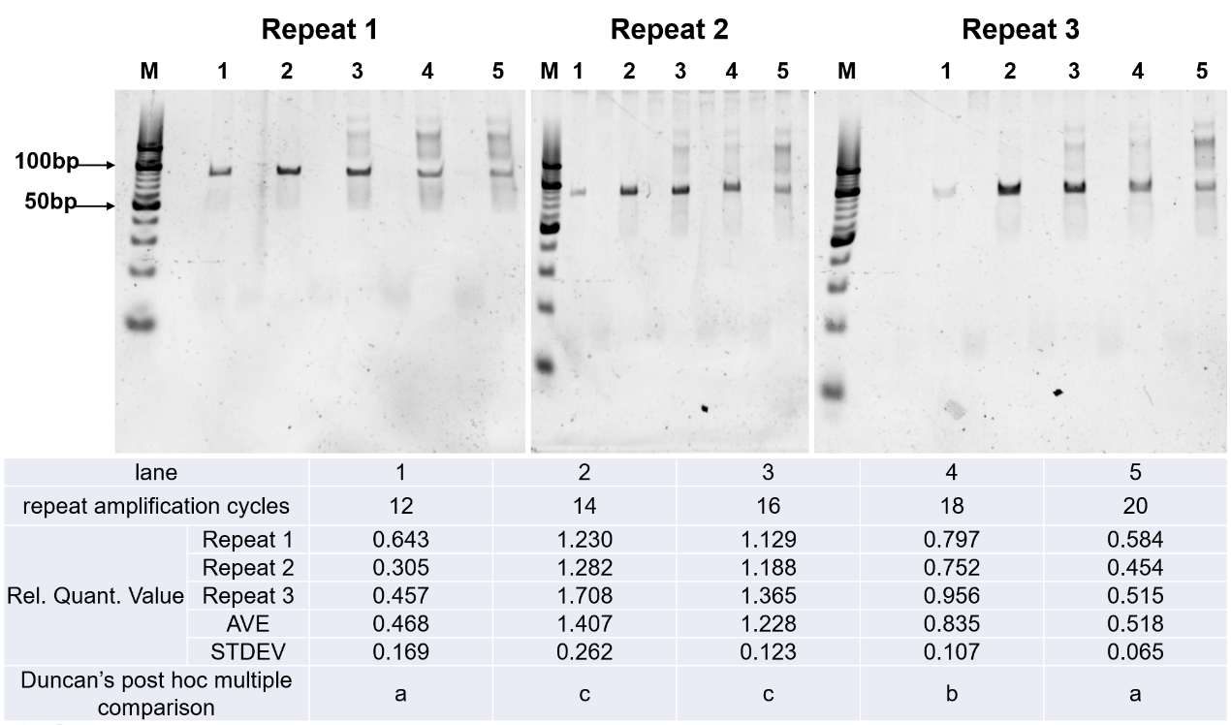
Fig.S7 The native PAGE diagrams and data of the influence of repeat amplification cycles on symmetric PCR. M: 10 bp DNA ladder. Different lowercase letters (a, b, c) in Duncan’s post hoc multiple comparison indicate significant different groups (P<0.05). The groups with the same letter indicate no significant difference.
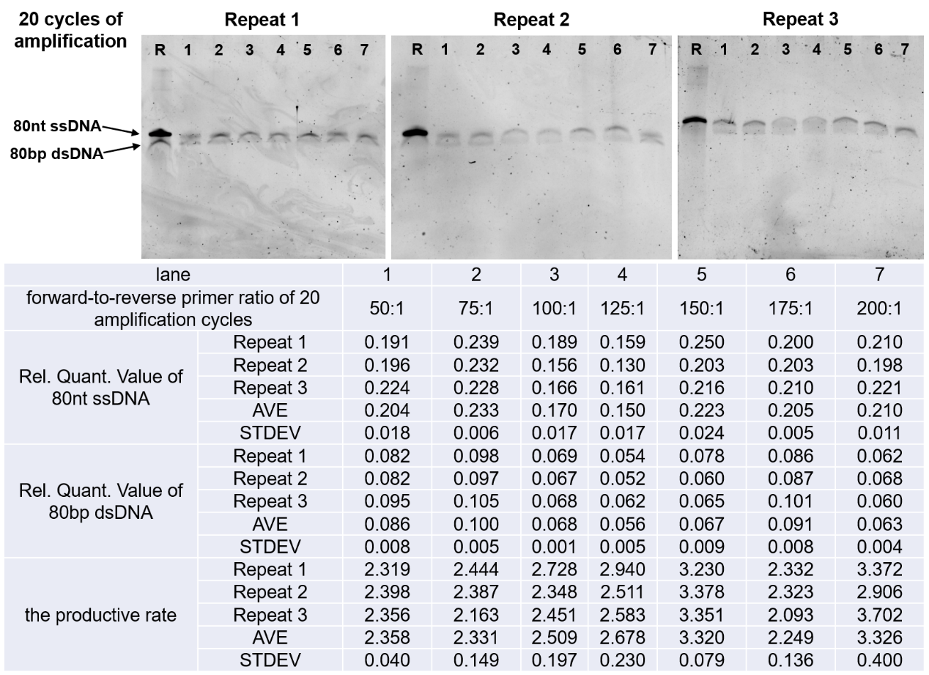
Fig.S8 The denatured PAGE diagrams and data of A-PCR with different primer ratios during 20 amplification cycles. R: 80nt ssDNA library.
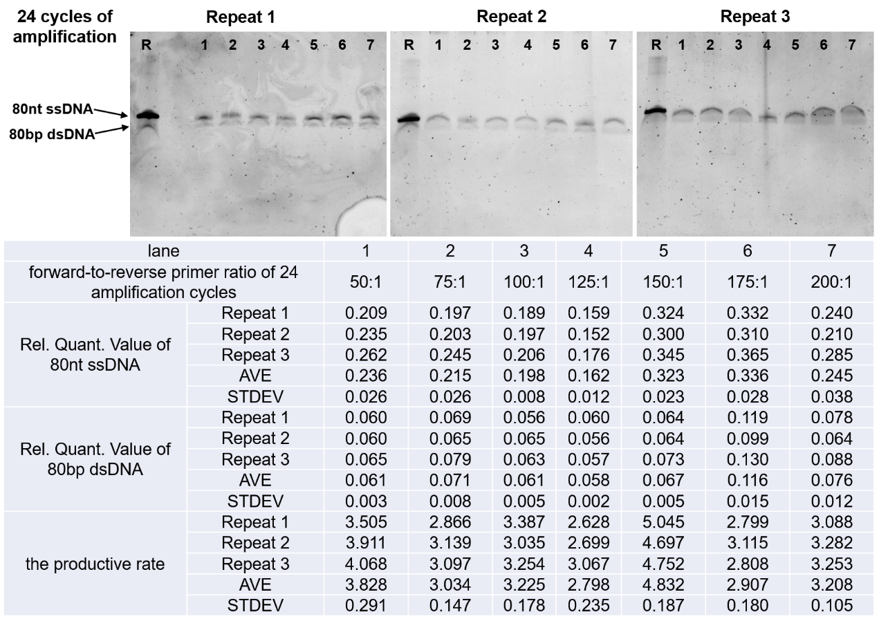
Fig.S9 The denatured PAGE diagrams and data of A-PCR with different primer ratios during 24 amplification cycles. R: 80nt ssDNA library.
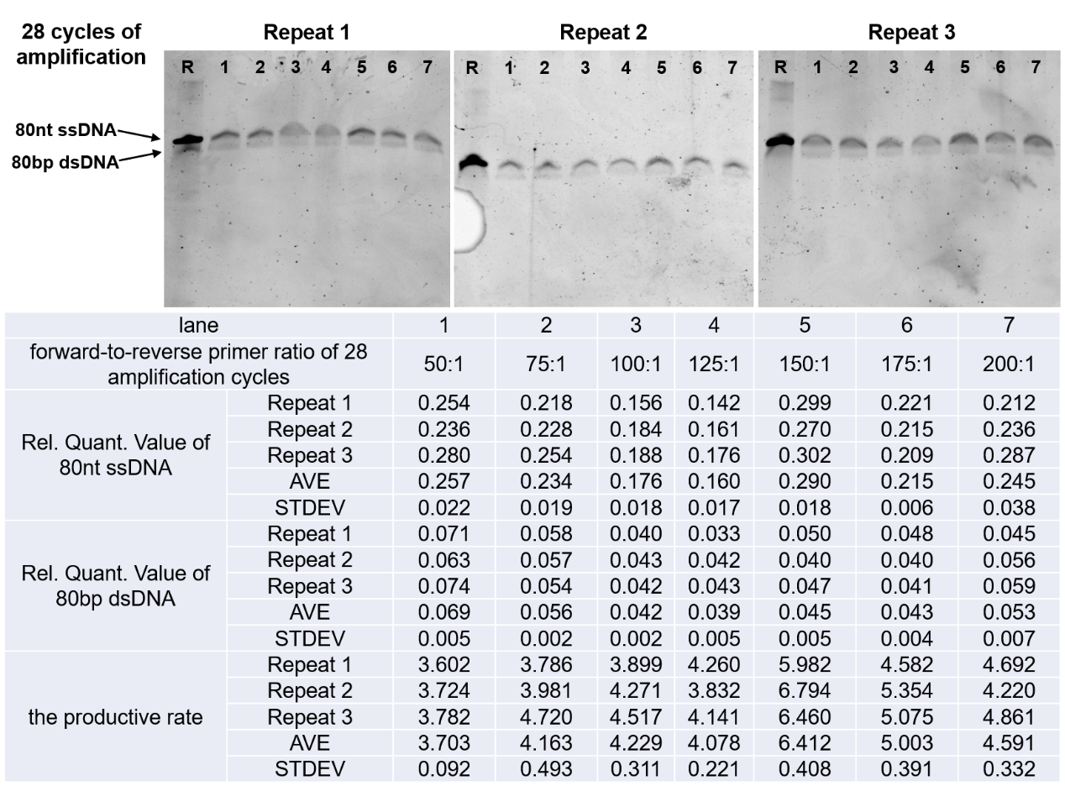
Fig.S10 The denatured PAGE diagrams and data of A-PCR with different primer ratios during 28 amplification cycles. R: 80nt ssDNA library.
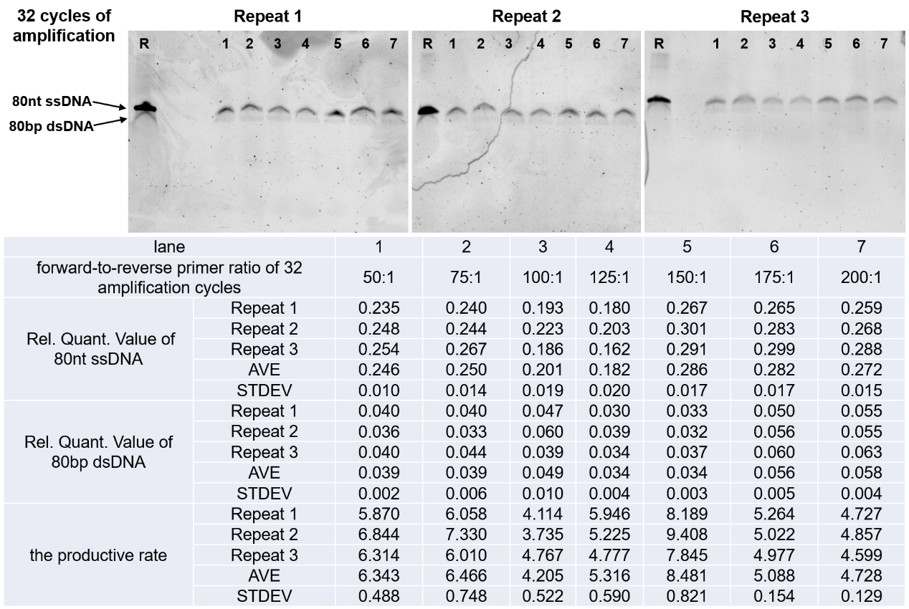
Fig.S11 The denatured PAGE diagrams and data of A-PCR with different primer ratios during 32 amplification cycles. R: 80nt ssDNA library.
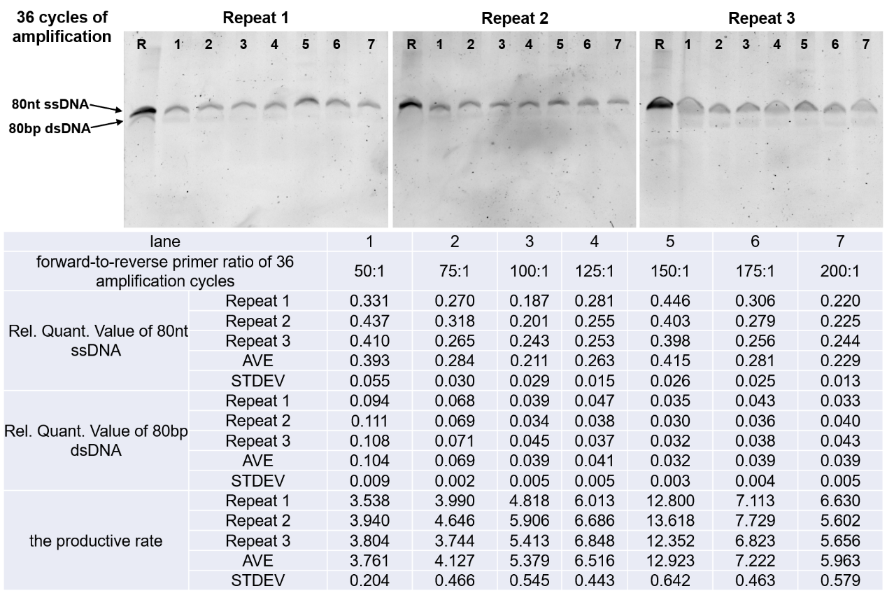
Fig.S12 The denatured PAGE diagrams and data of A-PCR with different primer ratios during 36 amplification cycles. R: 80nt ssDNA library.
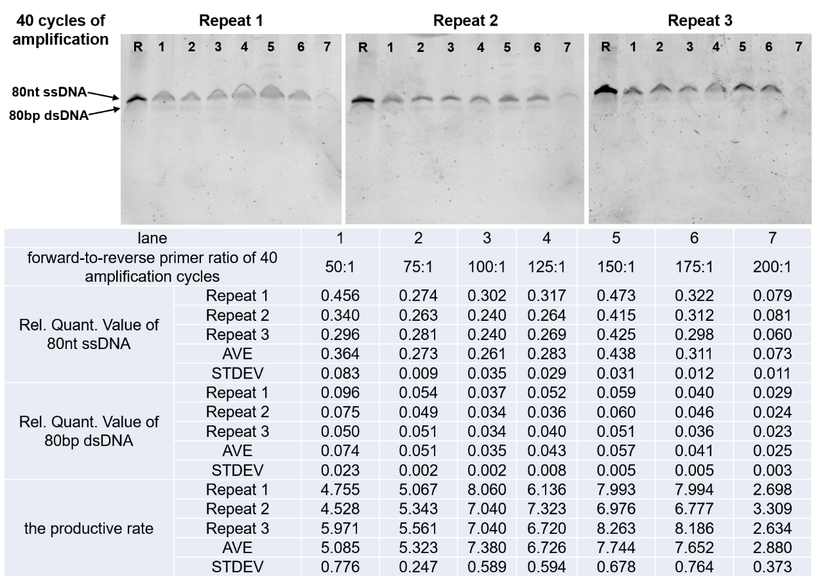
Fig.S13 The denatured PAGE diagrams and data of A-PCR with different primer ratios during 40 amplification cycles. R: 80nt ssDNA library.
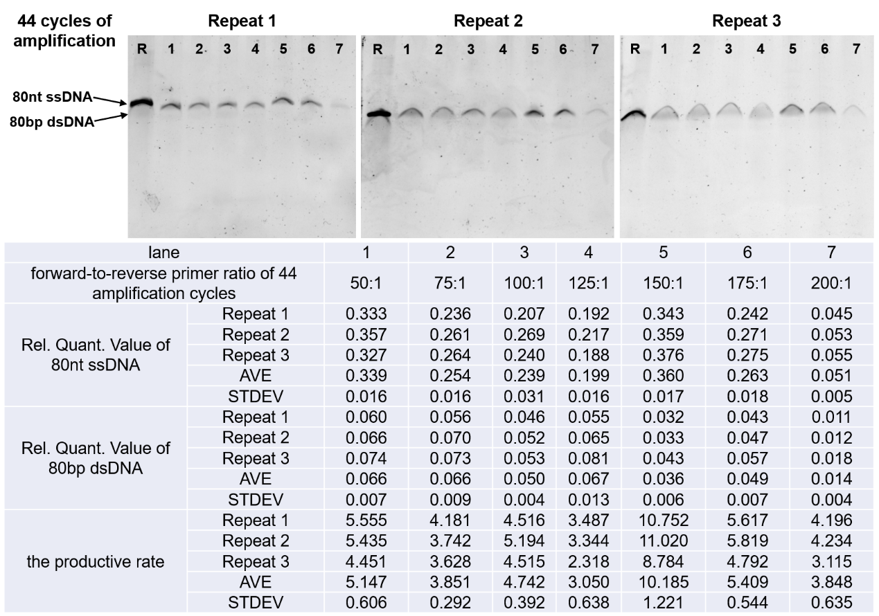
Fig.S14 The denatured PAGE diagrams and data of A-PCR with different primer ratios during 44 amplification cycles. R: 80nt ssDNA library.

