SMART - Additional File 3

Figure 1 Assessment of Ventilation Distribution by Electrical Impedance Tomography
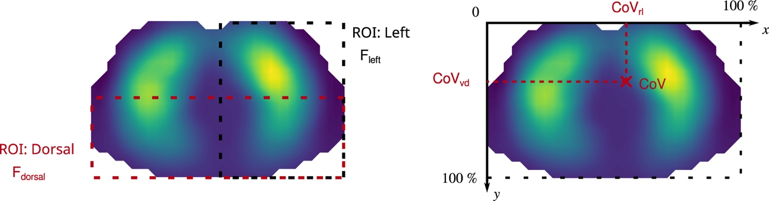
Assessment of ventilation distribution with EIT, using the fraction of ventilation in the dorsal and left region-of-interest (ROI) and by the geometrical center of ventilation (CoV). ROI fractions of the left and dorsal halves are referred to as F_{dorsal} and F_{left}, respectively. For the CoV, two components were distinguished, namely the CoV_{rl} along the right-to-left axis and the CoV_{vd} along the ventral-to-dorsal axis. Values over $50 \%$ represent a ventilation that is shifted in the left and dorsal direction. Note that classical medical image conventions are used, where the left lung is on the right side of a transverse section.

