SMART - Additional File 1
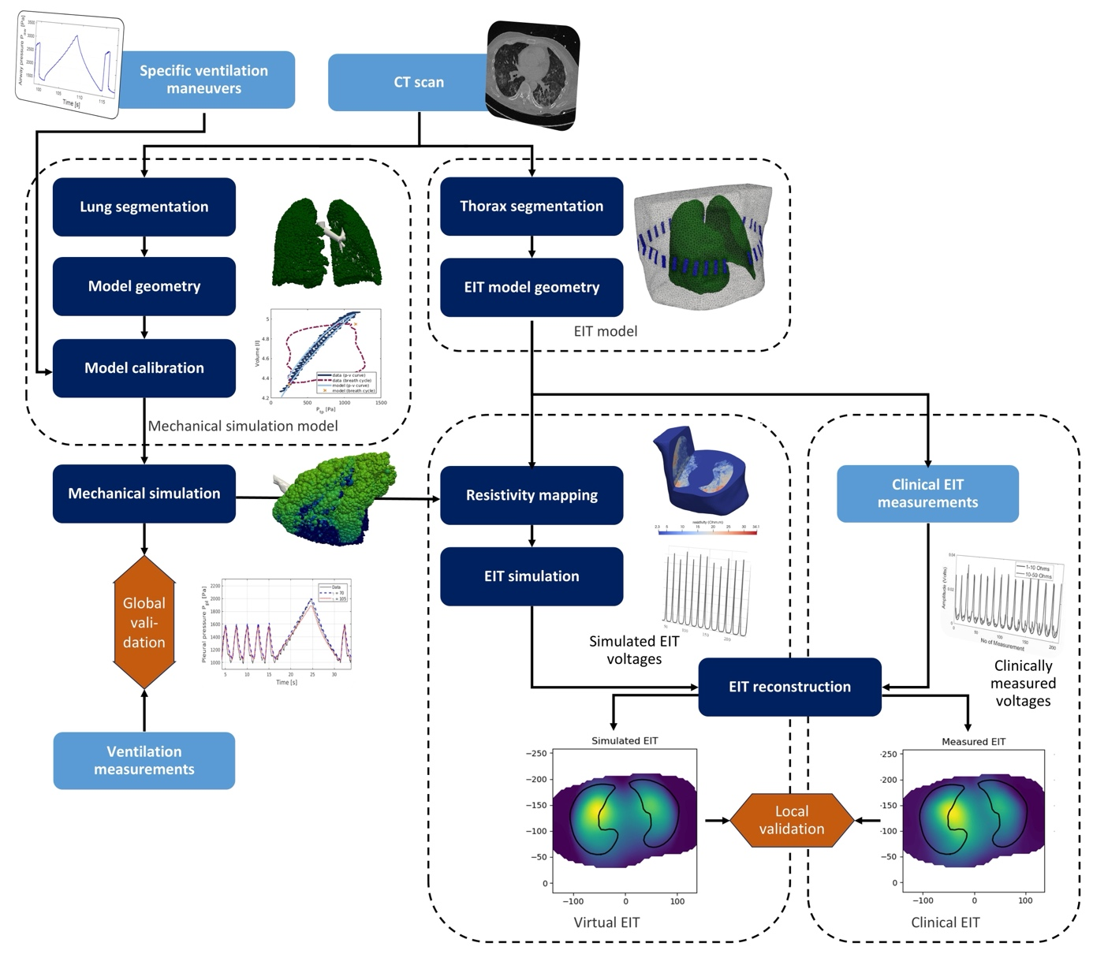
Figure 1 Workflow of the computational modeling process. highlighting the point of use of clinical data (light blue), procedural steps (dark blue), and their sequence (arrows).

