SMART - Additional File 7
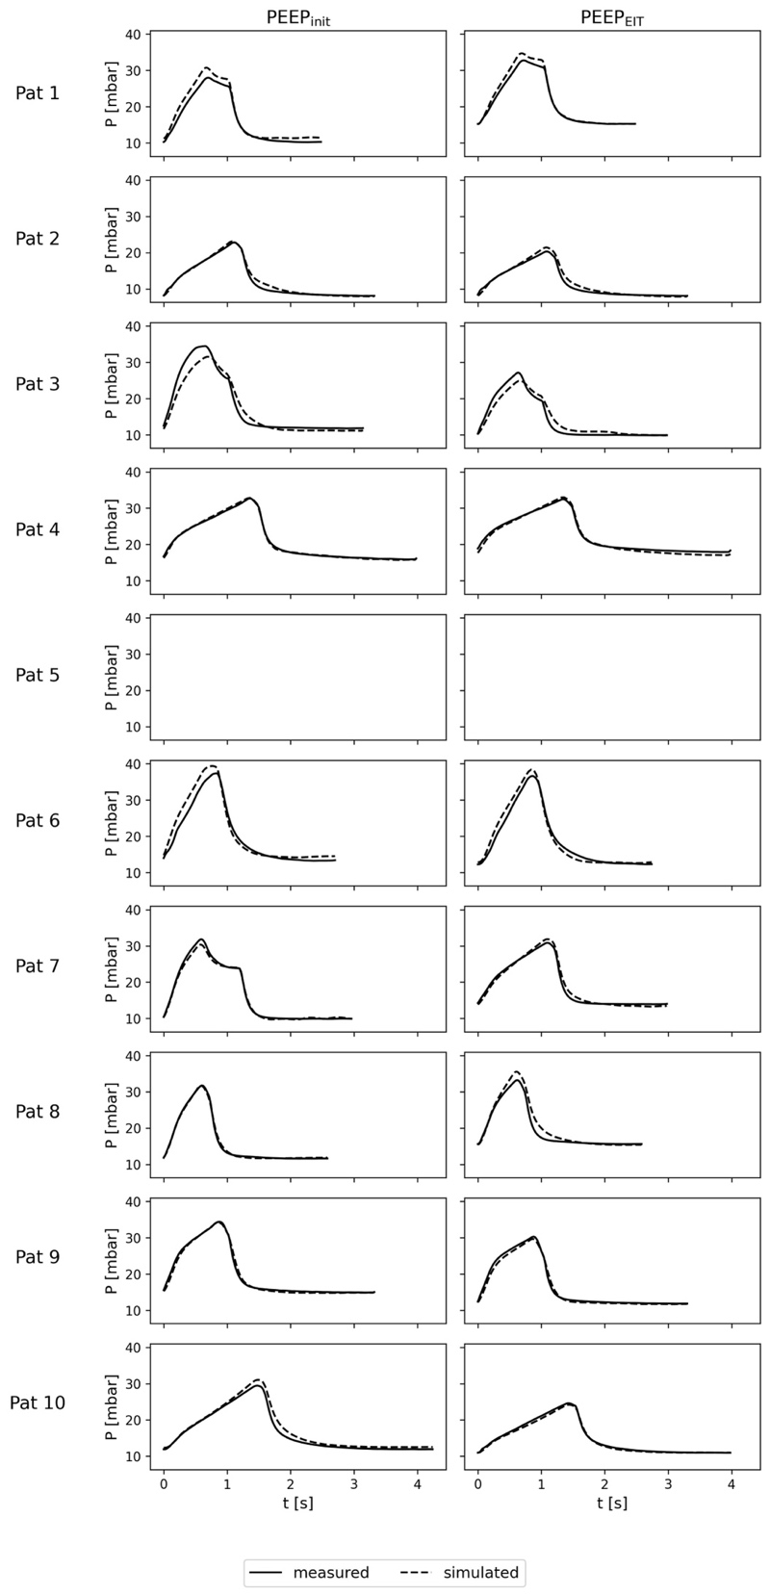
Comparison of Measured and Simulated Airway Pressure and Tidal Volume
Figure 1 Comparison of measured and simulated airway pressure curves at PEEP_{init} and PEEP_{EIT} across all patients.
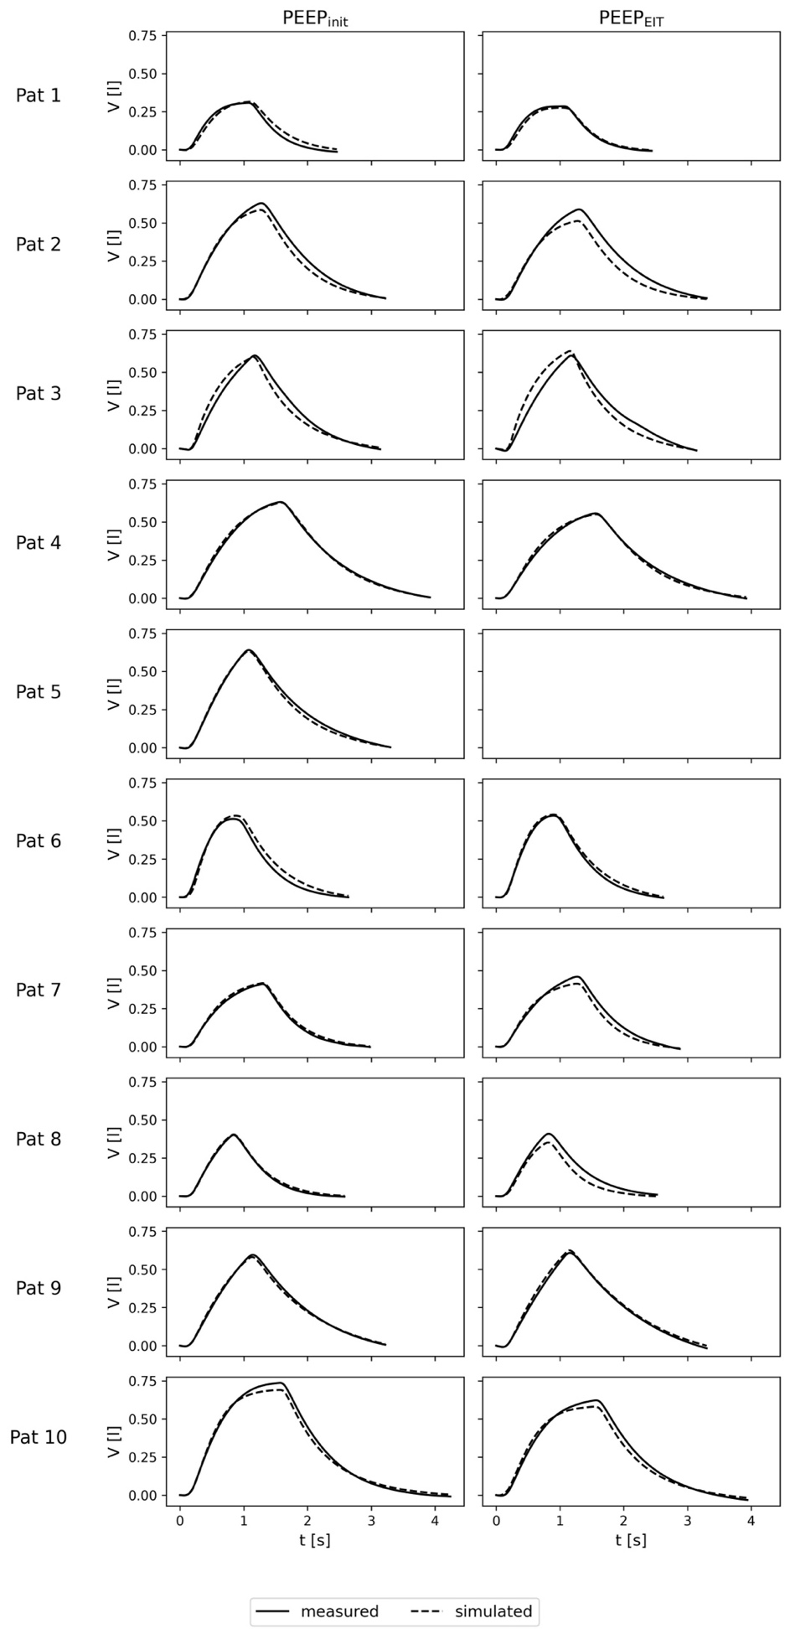
Figure 2 Comparison of measured and simulated tidal volume curves at PEEP_{init} and PEEP_{EIT} across all patients.

