SMART - Additional File 4

Additional model insights

The physics-based modeling approach employed in this validation study has an important advantage over purely data-based approaches: internal model quantities are constrained by physical principles and can therefore be assigned a physical interpretation. Such quantities may provide useful clinical insight even if independent validation is not possible because no bedside measurement technique is available to provide a clinical reference. In this supplement, we present selected model-derived quantities that we expect to be of particular interest to the clinical community.

A key parameter in the modeling approach of Geitner et al (https://doi.org/10.1002%2Fcnm.3787) is the factor of edema volume k_{edema} that defines the ratio of edema volume compared to the tissue volume. This is an input to the model that quantifies how much tissue is available for straining by occupying a part of the tissue, as it may be the case in the real lung with alveolar edema, and thus influences the pressure-volume curve of the model. It strongly affects the pressure-volume relationship of the model and can therefore be uniquely identified during model calibration. Based on k_{edema}, we derive the volume of edema V_{edema} and the volume of tissue V_{tissue} that are reported in Table 1 for the individual patients. These volumes remain constant throughout the simulation. From a clinical perspective, these V_{edema} and V_{tissue} might estimate ARDS severity because of its correlation with fractions of edema. Importantly, the model does not distinguish between alveolar and interstitial edema; V_{edema} should therefore be interpreted as an effective mechanical representation of edema-related fluid accumulation, assuming alveolar edema as a first approximation.

Table 1: Model calibrated lung tissue and edema volume
Patients | 1 | 2 | 3 | 4 | 5 | 6 | 7 | 8 | 9 | 10
V_{tissue} (l) | 0.81 | 1.16 | 1.77 | 1.06 | 1.32 | 1.69 | 1.07 | 1.26 | 1.23 | 1.47
V_{edema} (l) | 0.10 | 0.45 | 0.19 | 0.19 | 0.13 | 0.78 | 0.26 | 0.13 | 0.34 | 0.53

Another insight derived from our computational model is the percentage of open lung volume. This quantity is obtained from the alveolar recruitment–derecruitment model developed by Geitner et al (https://doi.org/10.1002%2Fcnm.3787). Figure 1 presents the open lung volume for each patient case across all evaluated PEEP levels. This analysis allows us to assess the extent of recruitment associated with changes in PEEP. It is a clear extension to the capabilities of EIT as our model also allows us to quantify the absolute amount of non-aerated lung volume in contrast to the tidal information provided by EIT (Reviewer 1, #4). A more detailed analysis could further characterize the effects of recruitment during individual ventilation maneuvers.

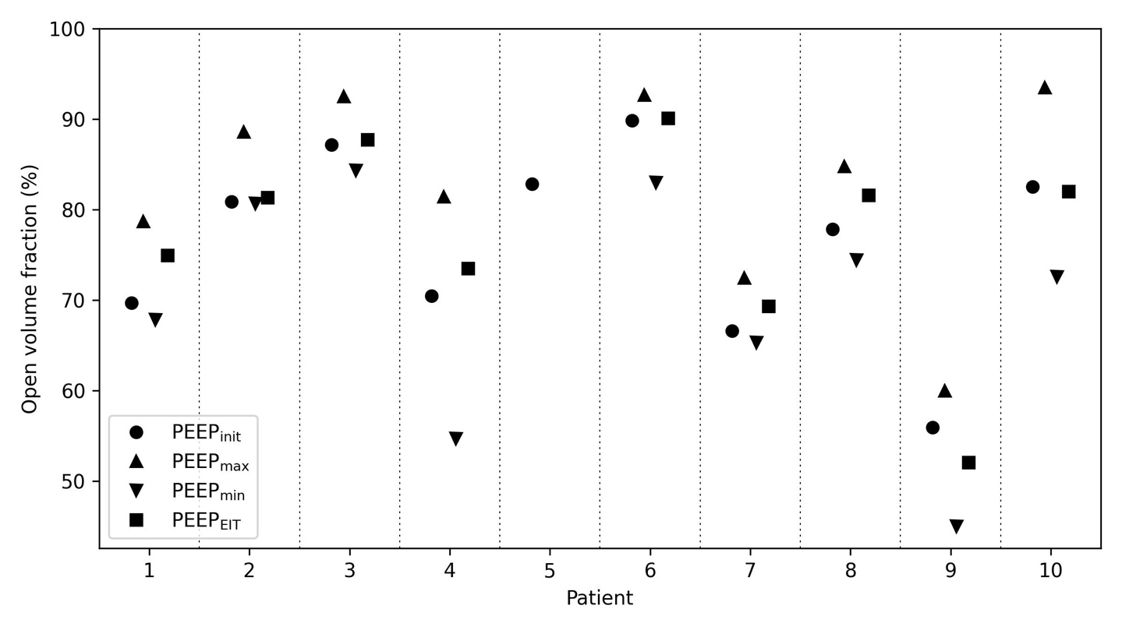
Figure 1: Mean end-expiratory open lung volume during PCV at different PEEP levels

