Extended Data figure legends
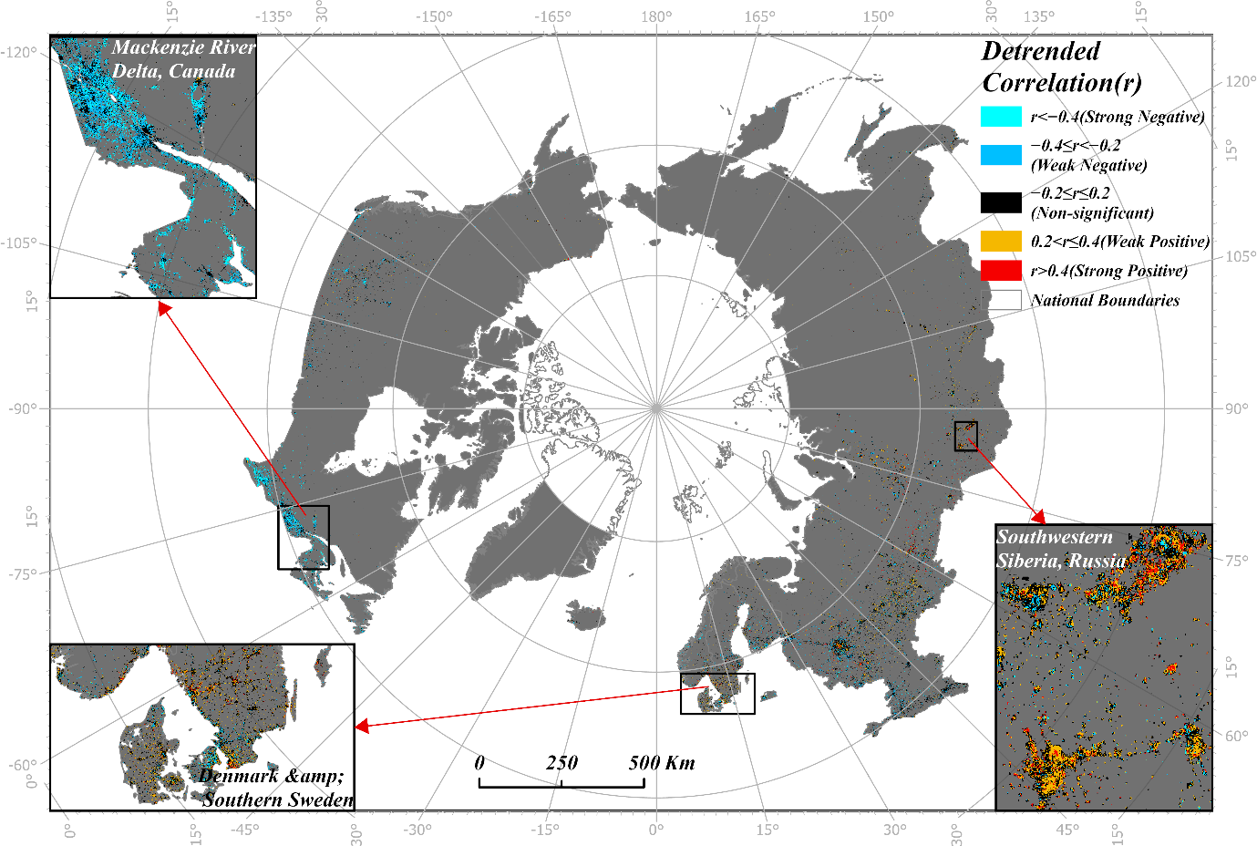
Extended Data Fig. 1 | Detrended MAT–NTL associations across the pan-Arctic. Pixel-wise Pearson correlations between detrended MAT and NTL residuals for 2000–2021. Red and blue denote positive and negative associations, respectively; black denotes weak association (|r|≤0.2). Insets show the Mackenzie Delta, southwestern Siberia and Denmark–southern Sweden. Correlation classes describe magnitude and do not denote formal statistical significance.
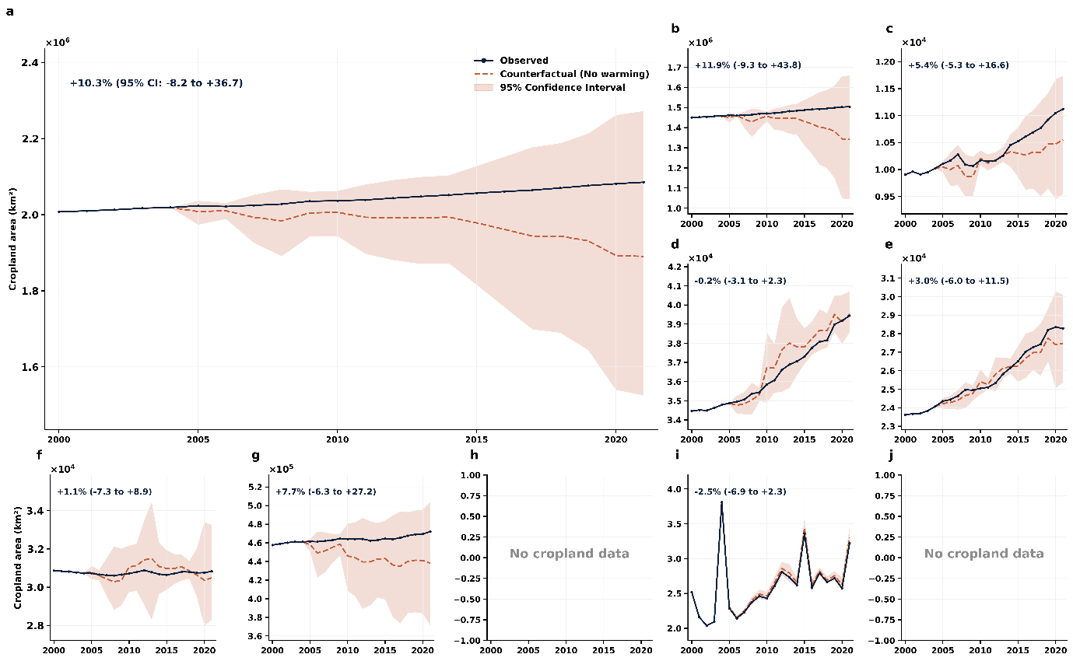
Extended Data Fig. 2 | Temperature-freeze counterfactual estimates for cropland. a, Pan-Arctic and b–j, national observed cropland trajectories compared with trajectories in which post-2004 temperature terms are held at the 2000–2004 mean. Shading shows model-based 95% bootstrap intervals. Labels report 2021 point estimates. Alaska and Greenland lack cropland observations.
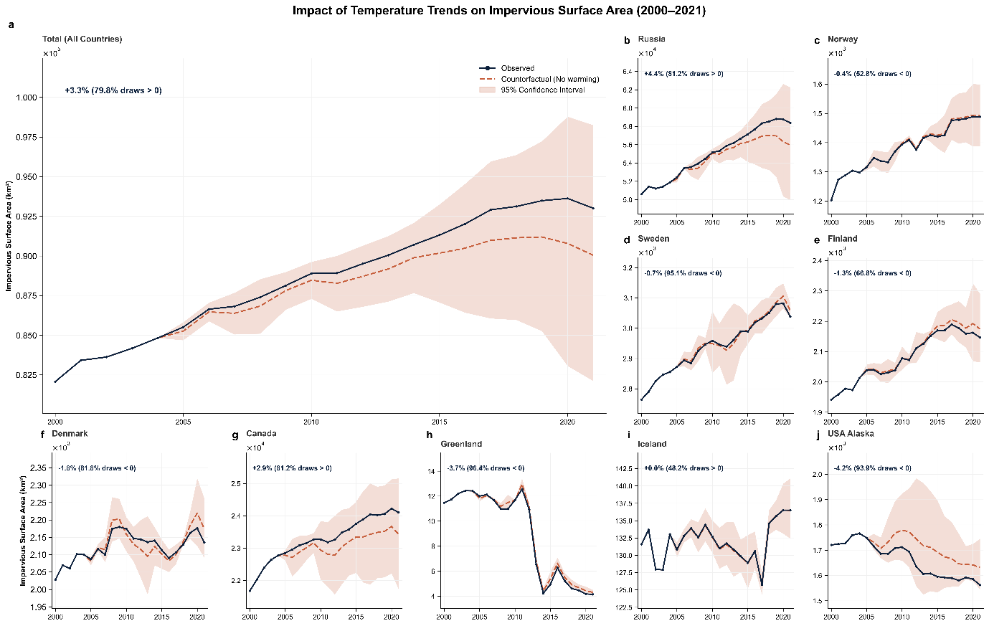
Extended Data Fig. 3 | Temperature-freeze counterfactual estimates for ISA. a, Pan-Arctic and b–j, national observed ISA trajectories compared with temperature-freeze counterfactuals. Shading shows model-based 95% bootstrap intervals. Labels report point estimates and the proportion of bootstrap draws with the estimated sign. Negative point estimates in Alaska and Greenland are interpreted cautiously because the two-sided intervals overlap zero and Greenland uses a reduced specification.

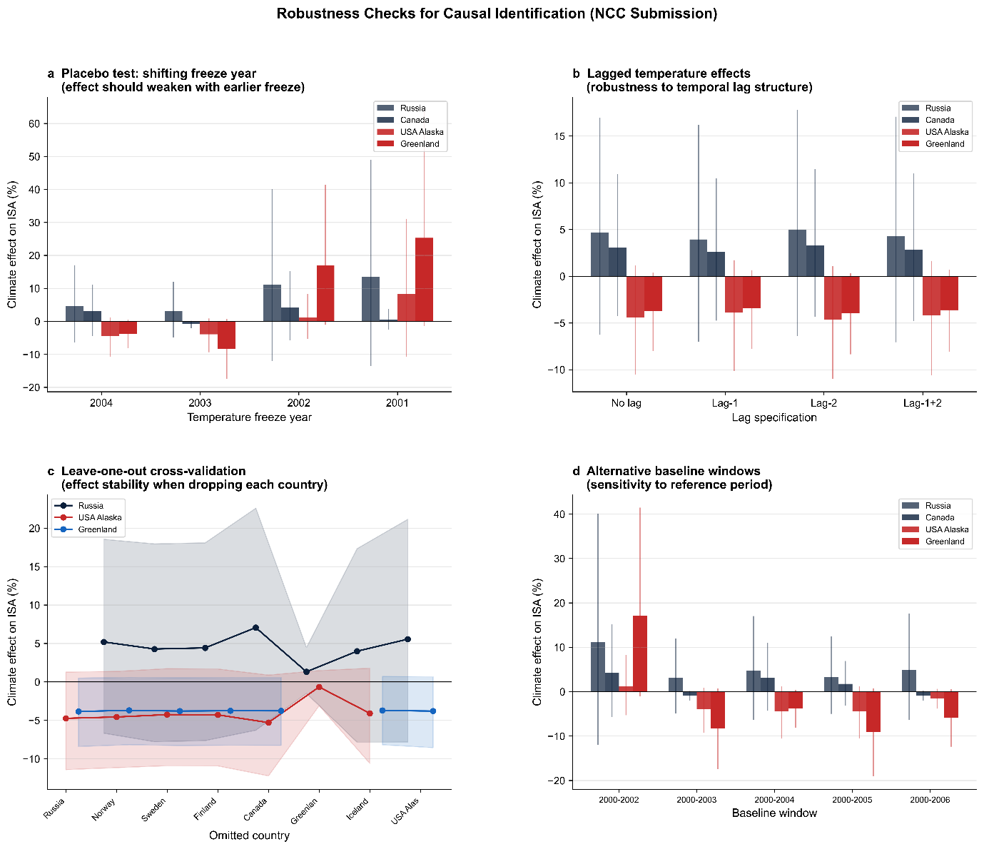
Extended Data Fig. 4 | National-level sensitivity analyses for counterfactual attribution. a, Freeze-year sensitivity from 2001 to 2004. b, Specifications with no lag, lag 1, lag 2 and both lags. c, Leave-one-country-out estimates. d, Alternative baseline windows from 2000–2002 to 2000–2006. Whiskers show model-based 95% bootstrap intervals. These analyses evaluate specification sensitivity and are not formal placebo experiments.
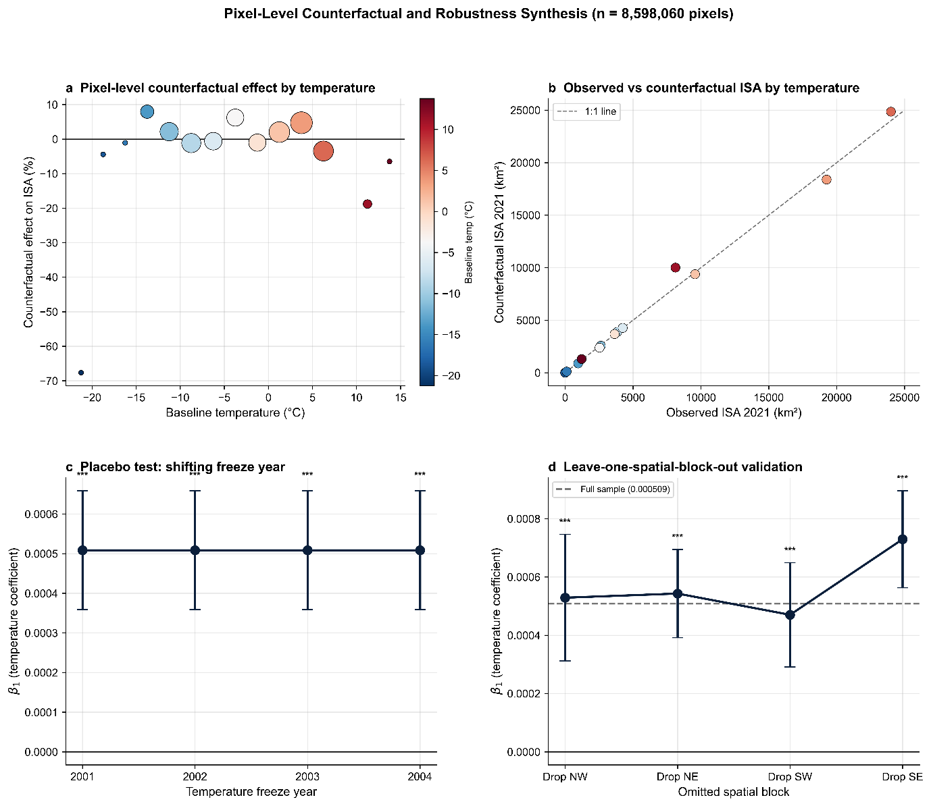
Extended Data Fig. 5 | Pixel-level counterfactual estimates and sensitivity analyses. a, ISA point estimates by baseline-temperature band; bubble area is proportional to the number of pixels and colour indicates baseline temperature. b, Observed versus counterfactual ISA in 2021 by temperature band, with the 1:1 line shown dashed. c, Temperature coefficients under alternative freeze years. d, Leave-one-spatial-block-out estimates. Error bars are model-based 95% intervals and do not fully account for fine-scale spatial dependence.

