Supporting Information

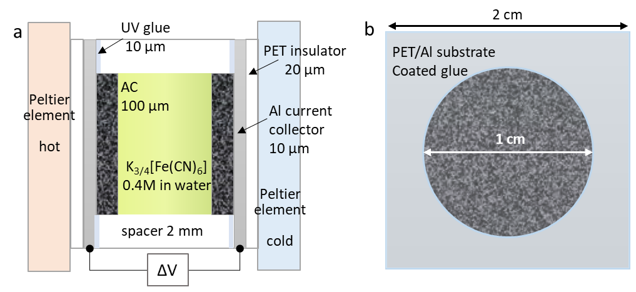
Figure S1. Illustration of the details of the TGC used in this study. a) Cross section structure of the TGC with dimensions and b) top view of the TGC.

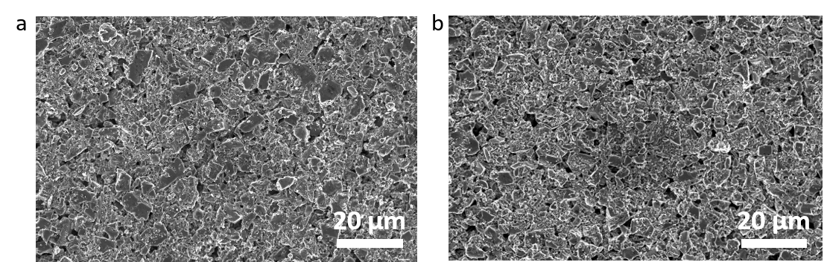
Figure S2. SEM images of activated carbon (AC) printed on substrate. a) 1-layer printed and b) 3-layer printed.

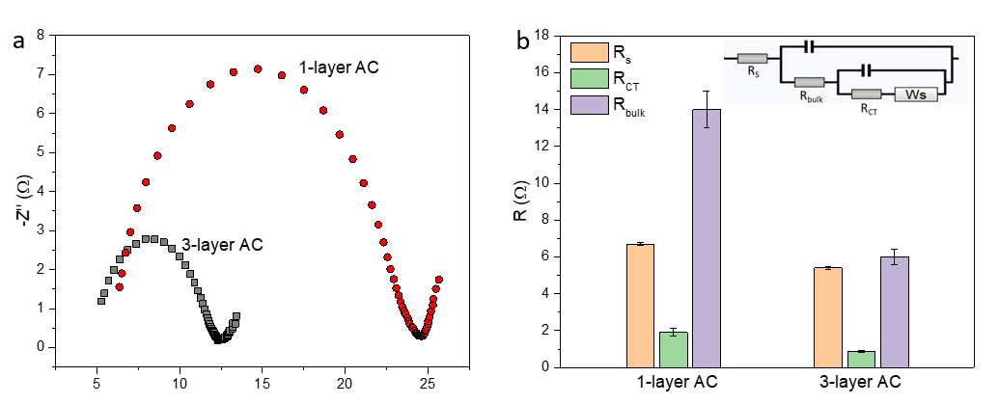
Figure S3. The electrical characterization of the TGCs with different electrode thickness. a) The impedance spectroscopy of 1-layer and 3-layer printed AC electrode. b) Separate resistance obtained from the impedance results. R_{s} is the series resistance includes the electronic resistance in the electrode, ionic resistance in the electrolyte and contact resistance at electrode/electrolyte interface; R_{ct} is the charge transfer resistance; R_{bulk} is related to the ionic transport in the bulk of the electrode material; and Warburg component (W) represents the mass transport limitation phenomena at the low frequency in the impedance measurement. The separate resistances values were simulated from the equivalent circuit as shown in the inset utilizing the software RelaxIS.

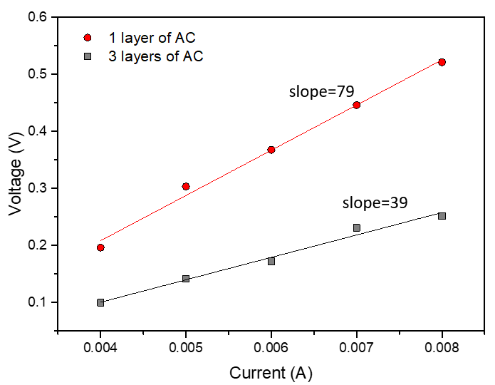
Figure S4. The internal resistance characterization of the TGCs with different electrode thickness. Stabilized voltage across the device was recorded when applying current between 4 mA to 8 mA, and the slope of the linear fitting was used as the internal resistance.

Table S1. Representative performance ranges of different cooling technologies and the present printable thermogalvanic cooling device. The reported values are approximate and depend strongly on device configuration and operating conditions. Therefore, the table is intended only to provide a qualitative comparison of typical operating regimes.
Technology | Driving mechanism | Typical voltage | Typical current | Temperature span (ΔT) | Cooling power | COP
Vapor-compression refrigeration | Refrigerant phase transition | 110–240 V AC | A | 20–80 K | W–kW | 2–6 [1-2]
Thermoelectric cooling | Peltier effect | 3–15 V | 1–10 A | 10–70 K | 1–100 W | 0.3-1.5[3,4]
Electrocaloric cooling | Electric-field-induced entropy change | 10²–10⁴ V | μA–mA | 5–20 K | mW–W | 5–10[5,6]
Elastocaloric cooling | Stress-induced phase transition | Mechanical actuation | – | 5–20 K | W | 3–10[7]
Thermogalvanic cooling (Zeng et al.) | Redox entropy | <1 V | mA | ~1 K | mW[8] | —
This work | Redox entropy | <1 V | mA | 0.1 K | 1–2 mW | 2.5

Reference:
[1] D.R. Brown, J.A. Dirks, N. Fernandez, T.E. Stout, The Prospects of Alternatives to Vapor Compression Technology for Space Cooling and Food Refrigeration Applications, Pacific Northwest National Laboratory (PNNL-19259), Richland, WA, USA, 2010. https://doi.org/10.2172/979500.
[2] S. Qian, D. Nasuta, A. Rhoads, Y. Wang, Y. Geng, Y. Hwang, R. Radermacher, I. Takeuchi, Not-in-kind cooling technologies: A quantitative comparison of refrigerants and system performance, Int. J. Refrig. 62 (2016) 177–192. https://doi.org/10.1016/j.ijrefrig.2015.09.010.
[3] F.J. DiSalvo, Thermoelectric cooling and power generation, Science 321 (2008) 1457–1461. https://doi.org/10.1126/science.1158899.
[4] R.A. Taylor, G.L. Solbrekken, Optimization of thermoelectric refrigeration systems for electronics cooling, IEEE Trans. Compon. Packag. Technol. 31 (2008) 828–839. https://doi.org/10.1109/TCAPT.2008.2000902.
[5] J. Shi, D. Han, Z. Li, L. Yang, S.-G. Lu, Z. Zhong, J. Chen, Q.M. Zhang, X. Qian, Electrocaloric cooling materials and devices for zero-global-warming-potential, high-efficiency refrigeration, Joule 3 (2019) 1200–1225. https://doi.org/10.1016/j.joule.2019.03.021.
[6] Y. Wang, Z. Zhang, D. Shen, M. Behrens, J. Wang, S. Qian, I. Takeuchi, A high-performance solid-state electrocaloric cooling system, Science 370 (2020) 129–133. https://doi.org/10.1126/science.aba2648.
[7] S. Qian, Y. Geng, Y. Wang, J. Ling, I. Takeuchi, A review of elastocaloric cooling: Materials, cycles and system integrations, Int. J. Refrig. 56 (2015) 244–252.
[8] Y. Zeng, X. Zhang, J. Wang, et al., Solvation entropy engineering of thermogalvanic electrolytes for efficient electrochemical refrigeration, Joule 9 (2025) 101822. https://doi.org/10.1016/j.joule.2025.101822.

