A retrospective analysis of the effects of TIME on Compliance and Driving pressures in acute respiratory distress syndrome: The TIMED study

Supplemental Materials

Supplemental Figure S1. Study flow diagram 2
Outcomes in COVID-19 positive patients stratified by culture positive/negative status 3
Supplemental Figure S2. Time-to-death and time-to-discharge in COVID-19 positive patients stratified by culture positive/negative status 4
Supplemental Figure S3. Change in static lung compliance and driving pressure in COVID-19 positive patients stratified by culture positive/negative status 5
Supplemental Figure S4. Unadjusted in-hospital mortality rate 6
Supplemental Figure S5. Probability of death and hospital discharge 7

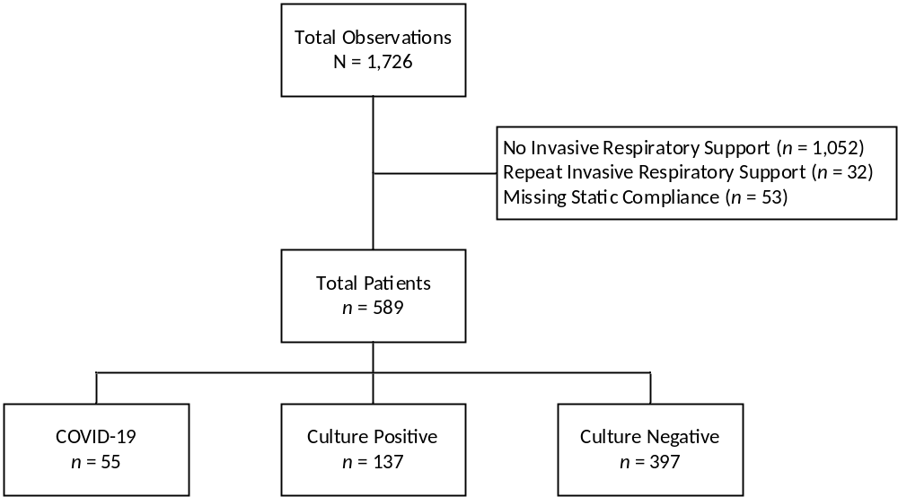

Supplemental Figure S1. Study flow diagram showing inclusion/exclusion criteria

Outcomes in COVID-19 positive patients stratified by culture positive/negative status
Of the 55 COVID-19 positive patients, 24 (44%) were culture positive. COVID-19 positive culture positive patients had longer time on ventilator compared to COVID-19 positive culture negative patients (median days: 17 days vs. 7 days, p < .001) and, therefore, more ventilator observations (medians: 39 vs. 13, p < .001). The overall mortality rates were statistically similar between COVID-19 positive culture positive patients and COVID-19 positive culture negative patients (42% vs. 54%, p = .368) as was time-to-death (log-rank p = .392; Supplemental Figure S2) and risk-of-death (HR: 0.71, 95% CI: 0.33-1.57, p = .402). Further, time-to-discharge from the hospital was shorter in culture negative COVID patients (median LOS: 18 vs. 30 days, p = .001; Supplemental Figure S2).
COVID-19 patients who were culture positive or culture negative showed a statistically similar decrease in static compliance across ventilator checks (–0.01 per check vs. –0.16 per check; interaction p = .251); as with the combined COVID group, these changes were not statistically significant (simple main effect p = .860 and .166, respectively; Supplemental Figure S3). Likewise, COVID-19 patients who were culture positive or culture negative showed a statistically similar increase in driving pressure across ventilator checks (0.01 per check vs. 0.07 per check; interaction p = .260); as with the combined COVID group, these changes were not statistically significant (simple main effect p = .572 and .125, respectively; Supplemental Figure S3).
Overall use of pre-intubation noninvasive respiratory support (NIV) was similar between COVID-19 patients who were culture negative or culture positive (39% vs. 42%, p = .824). Likewise, days of NIV prior to invasive mechanical ventilation was not different in COVID-19 patients who were culture positive or culture negative who used NIV (medians: 2 days vs. 2 days, p = 0.706).

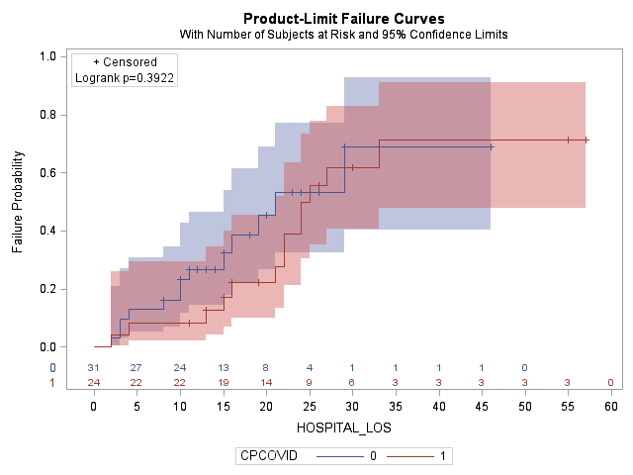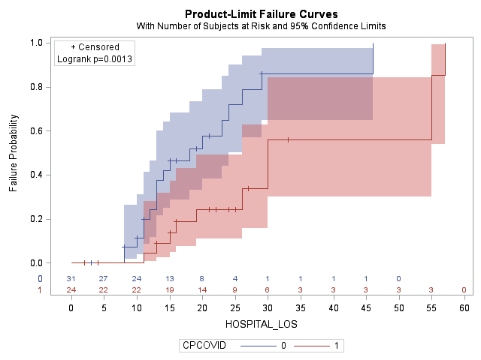
Supplemental Figure S2. Time-to-in-hospital mortality (left) and time-to-discharge censored at in-hospital mortality (right) in COVID-19 patients stratified by culture negative (CPCOVID = 0) and culture positive (CPCOVID = 1) status.

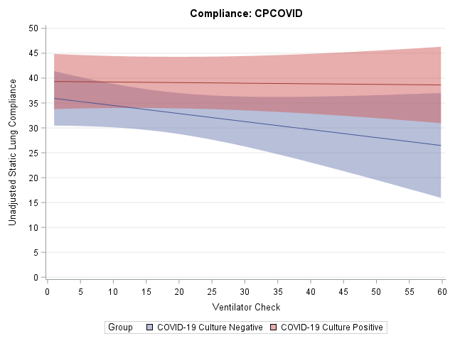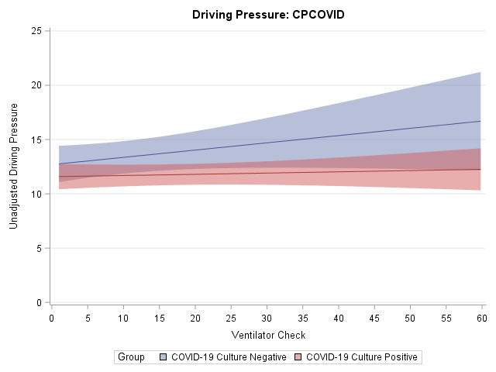
Supplemental Figure S3. Change in static lung compliance (left) and driving pressure (right) in COVID-19 positive patients stratified by culture positive/negative status.

Supplemental Figure S4. Unadjusted in-hospital mortality rate stratified by patient groups. Error bars represent 95% Agresti-Coull confidence intervals. Note that the COVID-19 group represents all COVID-19 positive patients, the Culture Positive group represents COVID-19 negative patients with positive blood, sputum, and/or other viral culture, and the Culture Negative group represents COVID-19 negative patients with negative blood, sputum, and other viral culture.

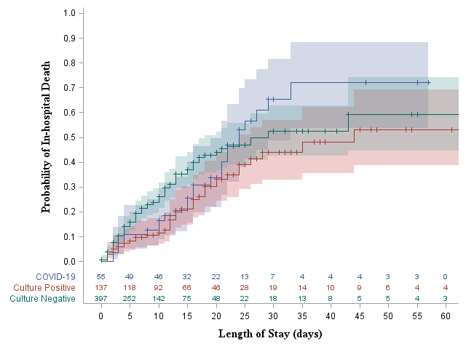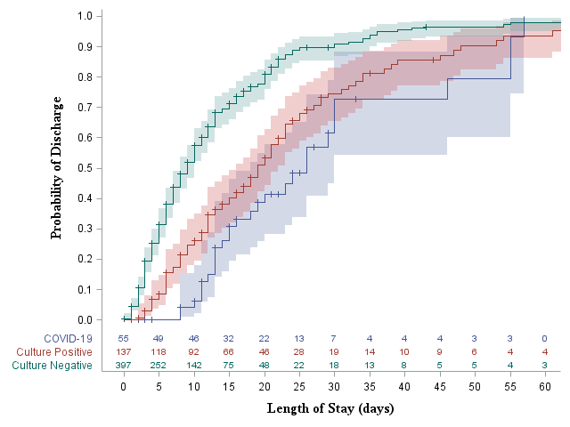
Supplemental Figure S5. Kaplan-Meier curve showing probability of in-hospital death (left; log-rank p = .029) and probability of hospital discharge using death as the censoring variable (right; log-rank p < .001). Shaded areas represent 95% confidence intervals. Note that the COVID-19 group represents all COVID-19 positive patients, the Culture Positive group represents COVID-19 negative patients with positive blood, sputum, and/or other viral culture, and the Culture Negative group represents COVID-19 negative patients with negative blood, sputum, and other viral culture.

