Supplementary Material

Pairwise tree interactions and biomass accumulation strengthen diversity-productivity effects over time
Sebastian Mader, Wentao Yu, Benjamin Rosenbaum, Werner Härdtle, Helge Bruelheide, Stefan Trogisch, Goddert von Oheimb, Ulrich Brose

Supplementary Table 1: List of species with species IDs of the 8-species subsample of scenario A1 from Yu et al. ¹ and Bruelheide et al. ². The extinction sequence, i.e. the species compositions of the respective diversity levels, can be found in Supplementary Fig. 1. Species names are in accordance with the Flora of China (http://www.efloras.org/).
Species name | Species ID - Yu et al. (2024) | Species ID - Bruelheide et al. (2014)
Castanea henryi (Skan) Rehd. et Wils. | 1 | 1
Castanopsis sclerophylla (Lindl.) Schott. | 2 | 14
Choerospondias axillaris (Roxb.) Burtt et Hill. | 3 | 4
Liquidambar formosana Hance | 4 | 6
Nyssa sinensis Oliver | 5 | 20
Quercus serrata Murray | 6 | 8
Sapindus saponaria Linn. | 7 | 19
Triadica sebifera (L.) Small | 8 | 21

Supplementary Table 2: Estimated parameter distributions of the time-dependent-interactions model (Eq. (2)): time effects for the three different groups of interactions (interspecific facilitative, interspecific competitive, intraspecific) and the standard deviation (Sigma) of the log-normal function that we used to back-transform the predicted log(biomass) when fitting it to the empirical biomass measures. For each of these parameters, we document the mean, standard error, standard deviation, quantiles for 95% credibility interval (CI; 2.5%, 97.5% cut-offs), median (50%), effective sample size (n_eff), and the measure of convergence R-hat. The latter approaches 1 with convergence of the parameter estimates. See Supplementary Fig. 3 for plotted posterior distributions.
 | mean | se_mean | sd | 2.50% | 50% | 97.50% | n_eff | R-hat
Time effect inter_pos | 0.0063 | 1.8e-05 | 0.0023 | 0.0009 | 0.0067 | 0.0095 | 15688 | 1.0001
Time effect inter_neg | -0.0262 | 2.8e-05 | 0.0038 | -0.0326 | -0.0267 | -0.0176 | 18571 | 0.9999
Time effect intra | -0.0559 | 2.4e-05 | 0.0043 | -0.0642 | -0.0559 | -0.0477 | 31494 | 1
Sigma | 0.4184 | 1.64e-05 | 0.0034 | 0.4117 | 0.4184 | 0.4253 | 44241 | 0.9999

Supplementary Table 3: Model comparison of our focal time-dependent-interactions model (Eq. (3)) with the average-time-effect model as well as with the nonlinear syntax. We used the loo-package ³ to compute differences in predictive performance (elpd_diff), their associated standard error (se_diff), and posterior probabilities, $P(elpd_diff>0)$, of the compared model performing worse (p_worse) ⁴. Furthermore, we tested a pairwise-time-effect model where every species interaction has a specific time effect. However, many pair-specific estimates were only or mostly informed by the provided prior, rendering this model not meaningful given our dataset. Hence, we did not include it in the model comparison. In the code, these models are referred to as m.1 (average time effect), m.4 (time-dependent interactions), and m.9 (pairwise time effect), respectively, with the addition additive and linear or nonlinear. The focal model is, hence, defined as m.4.additive.linear.
Model | elpd_diff | se_diff | p_worse | pareto_k_good
time-dependent-interactions model – linear | 0 | 0 | – | 99.91 %
average-time-effect model – linear | -36.9 | 40.1 | 0.821 | 99.91 %
average-time-effect model – nonlinear | -44.6 | 35.4 | 0.896 | 99.94 %
time-dependent-interactions model – nonlinear | -214.2 | 73.8 | 0.998 | 99.79 %

Supplementary Table 4: Differences of mean individual biomass increments between the average most diverse polyculture (eight species) and the average monoculture per year, ${ΔP}_{t}$ (gram biomass per tree individual). We calculated this per virtual BEF experiment and report means +/- standard errors.
Scenario | Year 1 | Year 2 | Year 3 | Year 4 | Year 5 | Year 6
Unshuffled | 4.28 +/- 0.26 | 12.84 +/- 0.52 | 29.82 +/- 0.99 | 59.68 +/- 1.79 | 107.82 +/- 3.12 | 180.47 +/- 5.22
Time-shuffled | 5.95 +/- 0.26 | 15.72 +/- 0.51 | 34.18 +/- 0.97 | 65.60 +/- 1.75 | 115.28 +/- 3.04 | 189.07 +/- 5.08
Interaction-shuffled | -0.60 +/- 0.33 | -1.51 +/- 0.73 | -2.63 +/- 1.44 | -4.02 +/- 2.63 | -5.70 +/- 4.53 | -7.75 +/- 7.41
Biomass-shuffled | 4.35 +/- 0.29 | 5.89 +/- 0.55 | 8.96 +/- 0.97 | 13.21 +/- 1.84 | 16.50 +/- 3.01 | 27.98 +/- 4.88

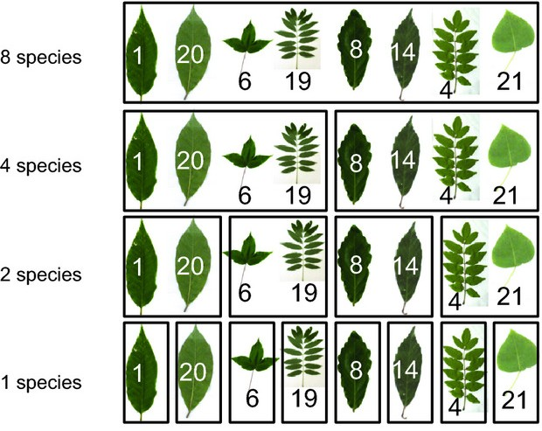
Supplementary Figure 1: The random extinction sequence, i.e. species compositions, of our subsample of the random extinction scenario A1 from BEF-China (cropped from Bruelheide et al. ²). Find the respective species nomenclature in Supplementary Tab. 1.

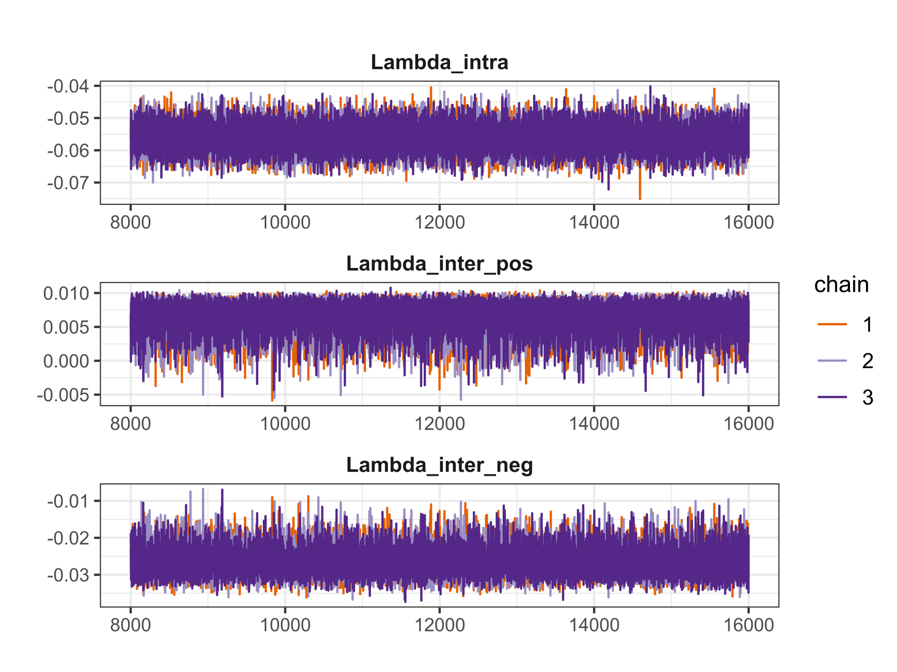
Supplementary Figure 2: Trace plots of the NUTS sampler for the different time effect parameters of our focal model: intraspecific, interspecific facilitative, and interspecific competitive. Here, the 8000 iterations post-warm-up are shown. If the chains (different colours) overlap, they covered the same parameter space, leading to convergence of the model.
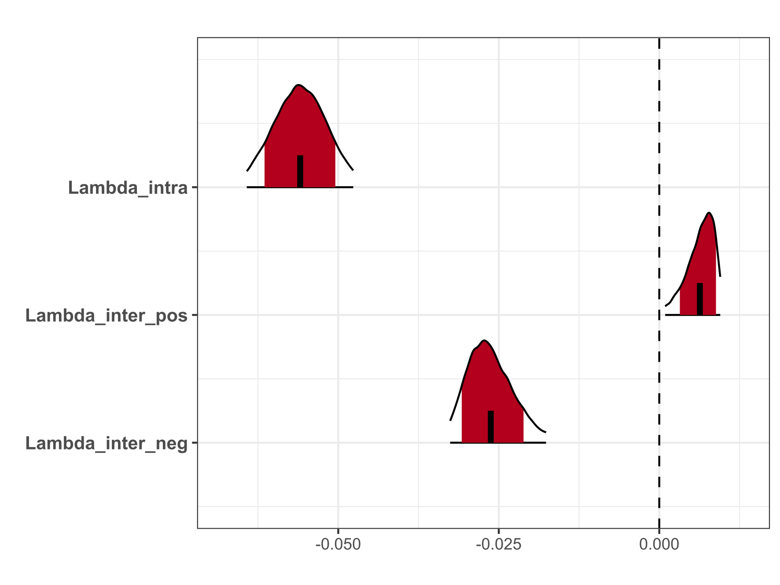
Supplementary Figure 3: Density plots of the estimates for the different time effect parameters of our focal model: intraspecific, interspecific facilitative, and interspecific competitive. The short vertical black line displays the respective mean point estimate, the colour-filled space the 80%, and the lines the 95% credibility intervals of the posterior distribution.

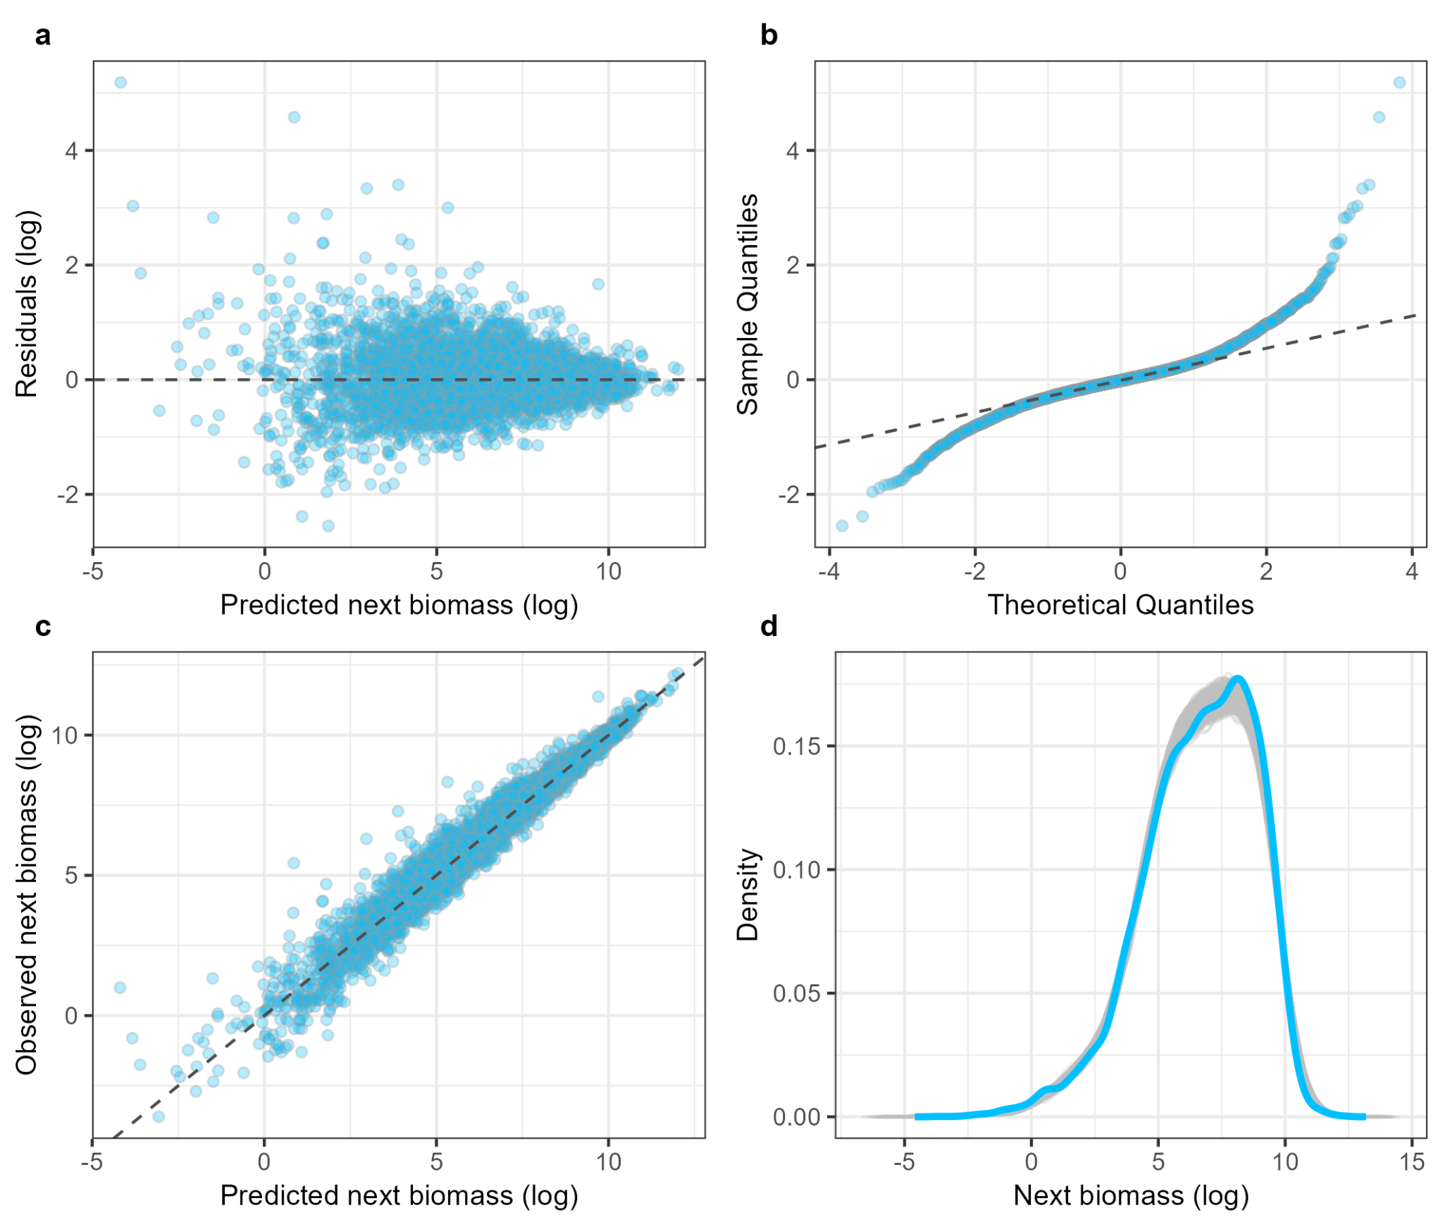
Supplementary Figure 4: Model assumption checks and posterior predictive check based on iteration medians. (a) Residuals along next year’s biomass predictions (both on log-scale). (b) Quantile-quantile plot to check normality. (c) Observed next year’s biomass follows the predicted next year’s biomass (both on log-scale) well, indicating a good model fit. (d) The observed distribution of next year’s biomass falls within the predicted distributions of next year’s biomass from 1000 random iteration draws, which indicates a good model fit.

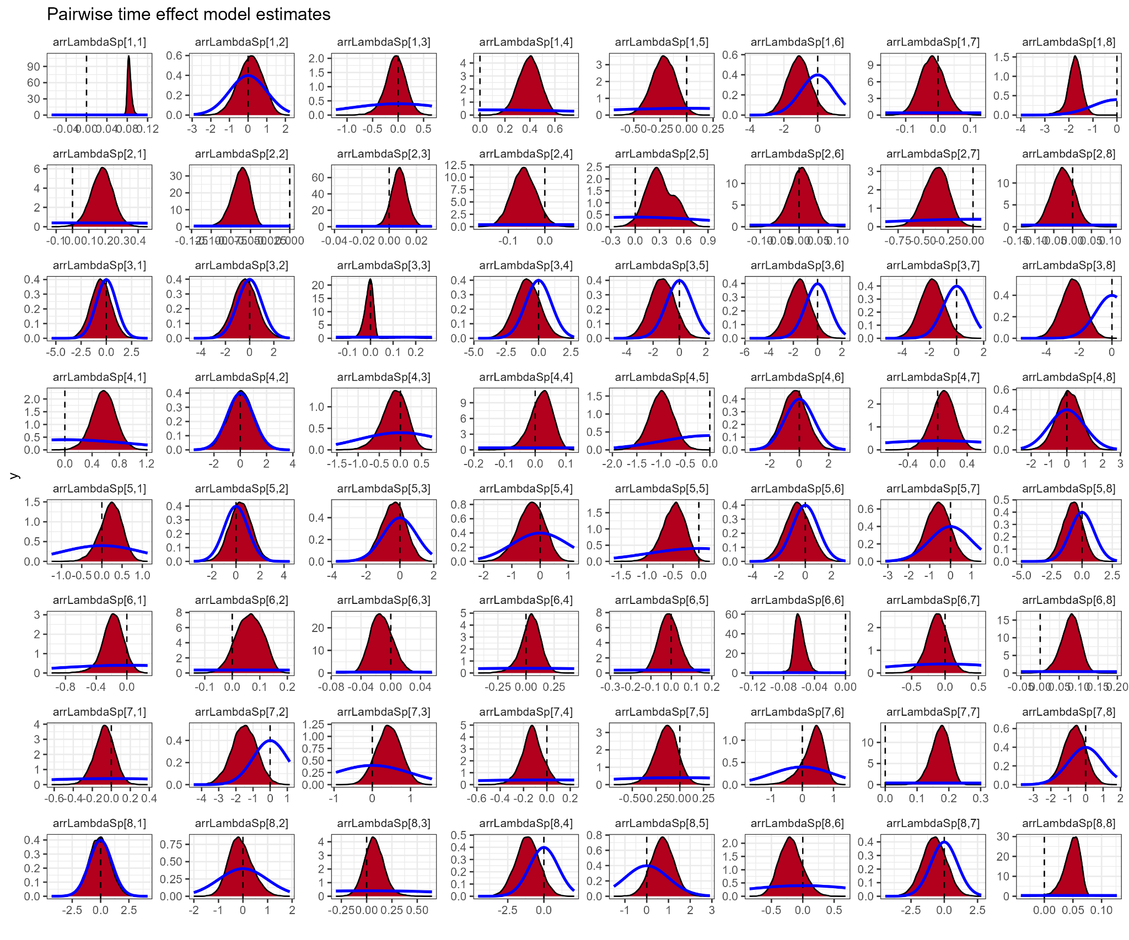
Supplementary Figure 5: Parameter estimates of pairwise-time-effect model in comparison to prior distribution. The red densities depict the posterior distributions of the estimations for the time effect of each species pair. The blue line overlaying the panels is the provided prior distribution of the model fitting: $normal(mean = 0, sd = 1)$. Note cases like $arrLambda[4,2]$ or $arrLambda[8,7]$, where the density closely follows the prior distribution. This indicates that there were not enough observations for these species pairs across the years to properly inform a time effect specific to this interaction. Note, that this will not affect predictive performance, as there are not many - if any - observations of these interactions to predict with the uninformed time effect estimates. This renders a model comparison with the other time effect structures not informative.
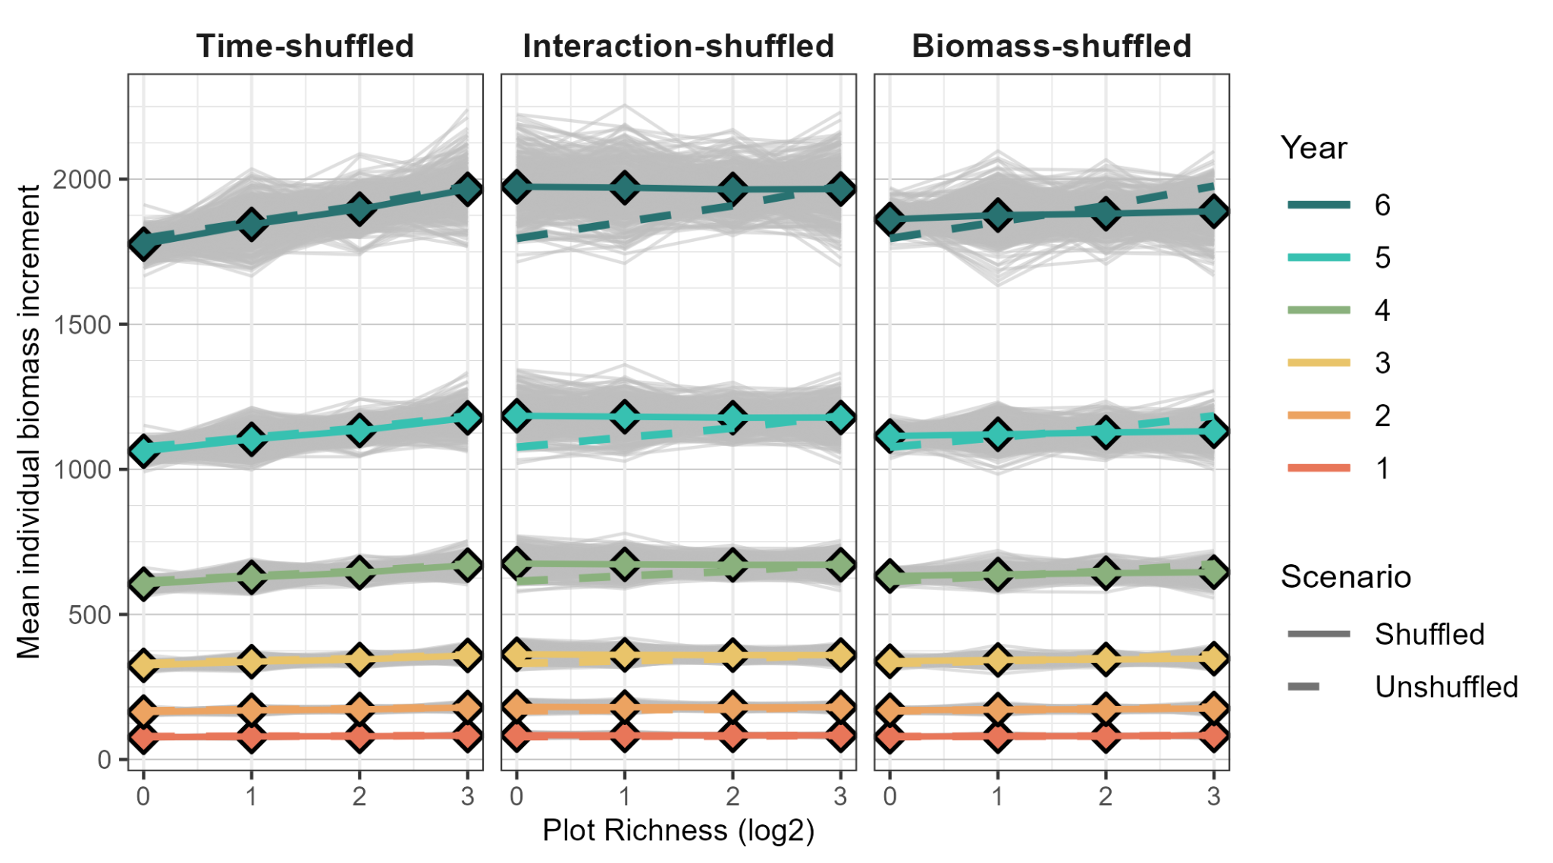
Supplementary Figure 6: Individual tree biomass increments of different simulation scenarios. Thin grey lines depict single virtual BEF experiments and connect mean tree biomass increments at respective degrees of diversity at different years. Solid coloured lines connect the mean biomass increment of respective degree of diversity across virtual BEF experiments at different years. In all three panels, the dashed lines connect the respective mean values of the Unshuffled scenario simulations, based on the originally estimated effects of time on pairwise interactions. See Tables S3 and S4 for the absolute and relative differences between 8-species mixtures and monocultures.

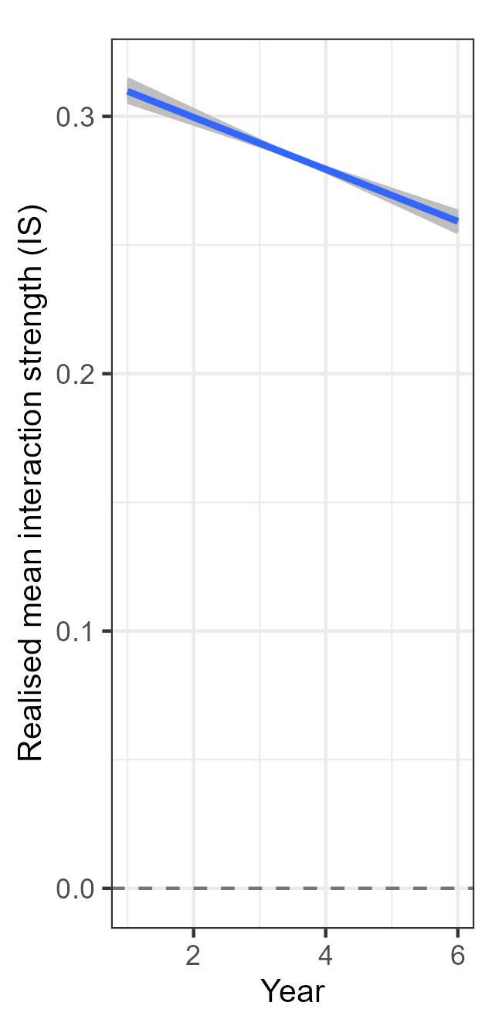
Supplementary Figure 7: Net per-biomass interaction strength across time. This constitutes the average across all interaction types. The coloured line represents the mean net interaction strength over time. The thin grey lines surrounding the mean depict the mean net interaction strength calculated from the same 100 posterior draws as in Fig. 3.

Supplementary References
1. Yu, W. et al. Systematic distributions of interaction strengths across tree interaction networks yield positive diversity–productivity relationships. Ecol. Lett. 27, e14338 (2024).
2. Bruelheide, H. et al. Designing forest biodiversity experiments: general considerations illustrated by a new large experiment in subtropical China. Methods Ecol. Evol. 5, 74–89 (2014).
3. Vehtari, A. et al. loo: Efficient leave-one-out cross-validation and WAIC for Bayesian models. (2024).
4. Sivula, T., Magnusson, M., Matamoros, A. A. & Vehtari, A. Uncertainty in Bayesian Leave-One-Out Cross-Validation Based Model Comparison. Bayesian Anal. 1, 1–31 (2025).

