Table 3 The Patient Persona of Health Information Literacy in Patients with Cardiometabolic Multimorbidity
Name | Information-Dependent Passive Care Recipients | Cognition-Compromised Biased Self-Regulators | Planning-Oriented Autonomous Precision Managers | Experience-Deficient Anxious Health Seekers
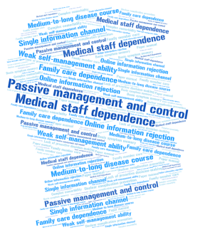  Personas |  |   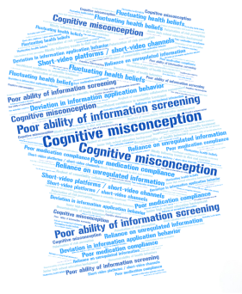 | 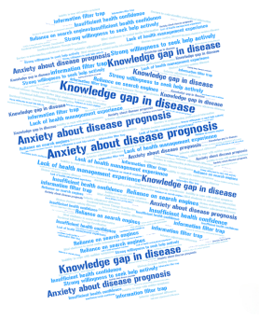
Individuals | A3,A7,A11,A14,A19,A21 | A2,A4,A10,A15,A18,A20 | A5,A9,A13,A16,A22 | A1,A6,A8,A12,A17,A23
Age | 68-75 | 48-69 | 48-59 | 45-54
Gender | Two men and four women | Three men and three women | Three men and two women | Four men and two women
Educational level | Three with primary education and three with secondary education | Six with secondary education | Five with higher education | Four with secondary education and two with higher education
Description of core features | ●Reliant on professional guidance  ●Single information source  ●Weak self-management capacity | ●Unregulated information sources  ●Cognitive misconceptions  ●Blind self-management | ●Proactive self-management  ●Authoritative information utilization  ●Precise health behaviour planning | ●Newly diagnosed anxiety  ●Insufficient management experience  ●Information overload
Disease knowledge mastery | ●Basic symptom & drug knowledge only  ●Poor comorbidity mechanism understanding  ●Insufficient complication prevention knowledge | ●Fragmented health knowledge  ●Supplement-for-drug cognitive misconceptions  ●Knowledge-to-action translation difficulty | ●Solid comorbidity mechanism understanding  ●Proactive latest guideline learning  ●Core/adjunctive prevention measure differentiation | ●Zero foundational health knowledge  ●Poor disease association understanding  ●Need for step-by-step introductory learning
Health belief perception | ●Absolute reliance on healthcare authority  ●Extremely low health self-efficacy  ●Negation of autonomous behaviour role | ●Fluctuating health beliefs  ●Folk remedy treatment misconceptions  ●Misguided health management direction | ●High health self-efficacy  ●Health management as life core  ●Rational attitude to healthcare advice | ●Severe initial diagnosis anxiety  ●Excessive prognostic worry  ●Emotion-dependent treatment compliance
Health behavior management | ●Passive medication & follow-up completion  ●Caregiver behaviour-dependent  ●Poor self-management implementation | ●Unsustainable health behaviours  ●Poor medication adherence  ●Neglected comorbidity management | ●Personalized health management plan  ●Professional tool for record & adjustment  ●Standardized sustainable health behaviours | ●No foundational health management experience  ●Prone to quit over no short-term effects  ●Deficient health behaviour planning ability
Health risk management | ●Difficulty recognizing complication warning signs  ●No emergency management capacity  ●Passive complication screening acceptance | ●Bipolar health risk perception  ●Inadequate risk anticipation capacity  ●Poor medication & dietary risk understanding | ●Monitoring data-based risk anticipation  ●Active complication screening  ●Basic emergency management mastery | ●Vague health risk perception  ●No acute symptom response capacity  ●Anxiety-amplified risk perception
Health information literacy | ●Limited health information channels  ●No information screening & evaluation capacity  ●Weak health information application ability | ●Chaotic health information channels  ●Prone to false health information belief  ●Biased one-sided information application | ●Authoritative diversified health information channels  ●Strong information screening & evaluation capacity  ●Efficient information-to-plan translation | ●Unmanageable health information overload  ●No health information evaluation capacity  ●Inability to translate information into action

