Additional file 1. Supplementary Figures
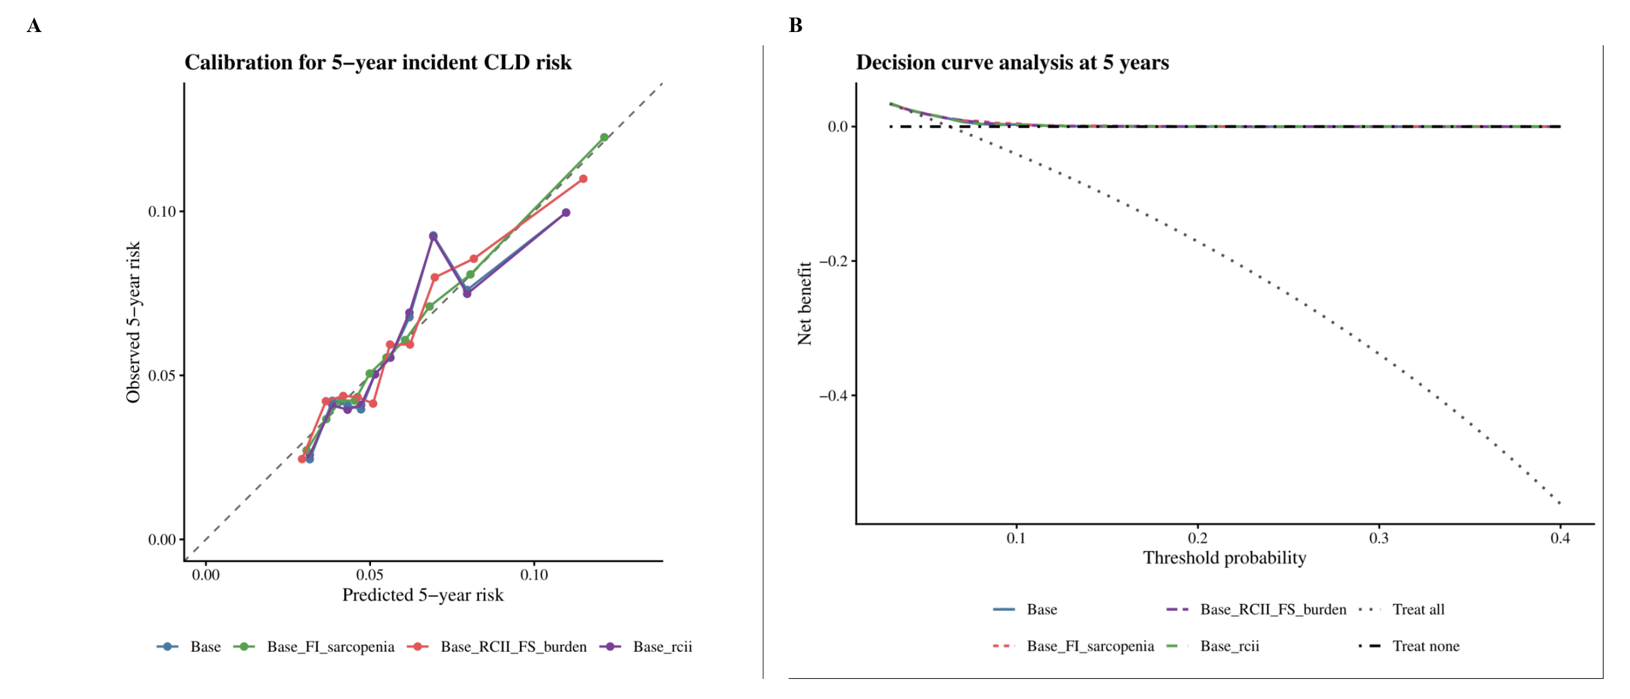
Supplementary Figure S1. Five-year calibration curves and Five-year decision curve analysis.

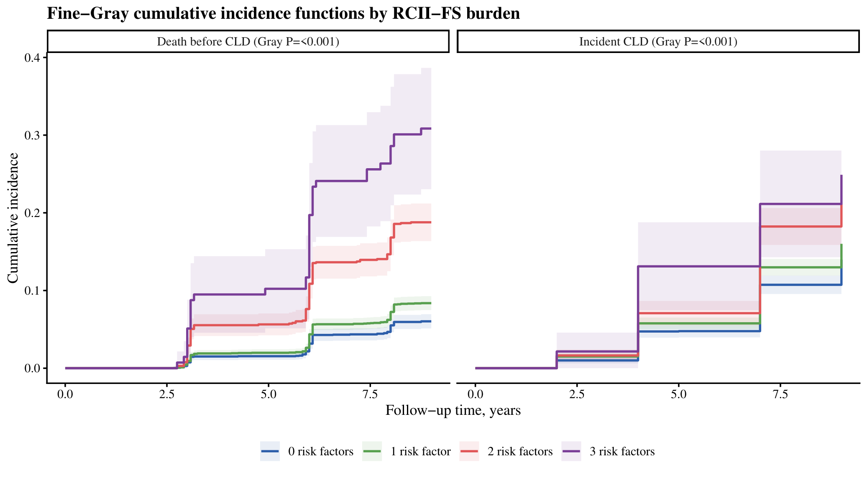
Supplementary Figure S2. Fine-Gray cumulative incidence functions for incident CLD and death before CLD by RCII-FS burden.

