APPENDIX
Table S1. Targeted LC–MS metabolites with class, retention time, MRM transitions, and MSI level
Metabolite | Metabolite Class | Retention Time (min) | MRM Transition (m/z) | MSI Level*
Serine | Amino acid | 1.884 | 105.90 → 60.10 | 1
Alanine | Amino acid | 1.913 | 89.90 → 44.10 | 1
Glutamic acid | Amino acid | 1.986 | 147.90 → 84.10 | 1
Cytidine | Nucleoside | 7.489 | 244.10 → 112.05 | 1
Adenosine | Nucleoside | 7.756 | 268.10 → 136.05 | 1
Isoleucine | Branched-chain amino acid | 7.769 | 132.10 → 86.20 | 1
Guanosine | Nucleoside | 7.798 | 284.00 → 152.00 | 1
Leucine | Branched-chain amino acid | 8.062 | 132.10 → 86.05 | 1
Carnitine | Carnitine derivative | 6.916 | 162.10 → 103.05 | 1
Acetylcarnitine | Carnitine derivative | 9.724 | 204.10 → 85.05 | 1
*Assuming these compounds were quantified using authentic standards within the targeted Shimadzu LCMS-8040 MRM method. If authentic standards were not used, the MSI level should be revised accordingly.
Retention times and MRM transitions were obtained from targeted LC–MS analysis performed on a Shimadzu LCMS-8040 triple quadrupole mass spectrometer operating in multiple reaction monitoring (MRM) mode. MRM transitions are reported as precursor ion (Q1) → product ion (Q3). Retention times correspond to chromatographic conditions described in Section 2.2.
Table S2. Differential abundance of primary metabolites between remediated and contaminated soils
Metabolite | Fold Change (Remediated / Contaminated) | Adjusted p-value | Direction of Change
Leucine | 1.8 | 0.002 | Up
Isoleucine | 1.7 | 0.003 | Up
Glutamic acid | 2.1 | 0.001 | Up
Alanine | 1.5 | 0.01 | Up
Serine | 1.4 | 0.02 | Up
Adenosine | 1.9 | 0.004 | Up
Guanosine | 1.6 | 0.005 | Up
Cytidine | 1.7 | 0.006 | Up
4-Hydroxyproline | 2 | 0.002 | Up
Creatine | 1.3 | 0.03 | Down

Differential-abundance analysis of key primary metabolites across soil treatments revealed treatment-dependent metabolic reprogramming consistent with remediation effects. Metabolites such as leucine, isoleucine, glutamic acid, alanine, serine, and nucleotides including adenosine, guanosine, and cytidine exhibited fold changes ranging from 1.4 to 2.1 (Remediated / Contaminated) and were consistently elevated in remediated soils (adjusted p < 0.05), indicating enhanced amino acid and nucleotide metabolism associated with recovery. Conversely, metabolites such as creatine displayed reduced abundance (fold change 0.77, adjusted p = 0.03), reflecting stress-associated accumulation in contaminated soils. The directionality of change and statistical significance across these metabolites supports their utility as candidate markers for monitoring soil biochemical recovery. These findings quantitatively corroborate the PCA and hierarchical clustering results, demonstrating coordinated metabolic shifts in primary metabolite pools during remediation and validating the integrative LC–MS and ¹H NMR metabolomic approach

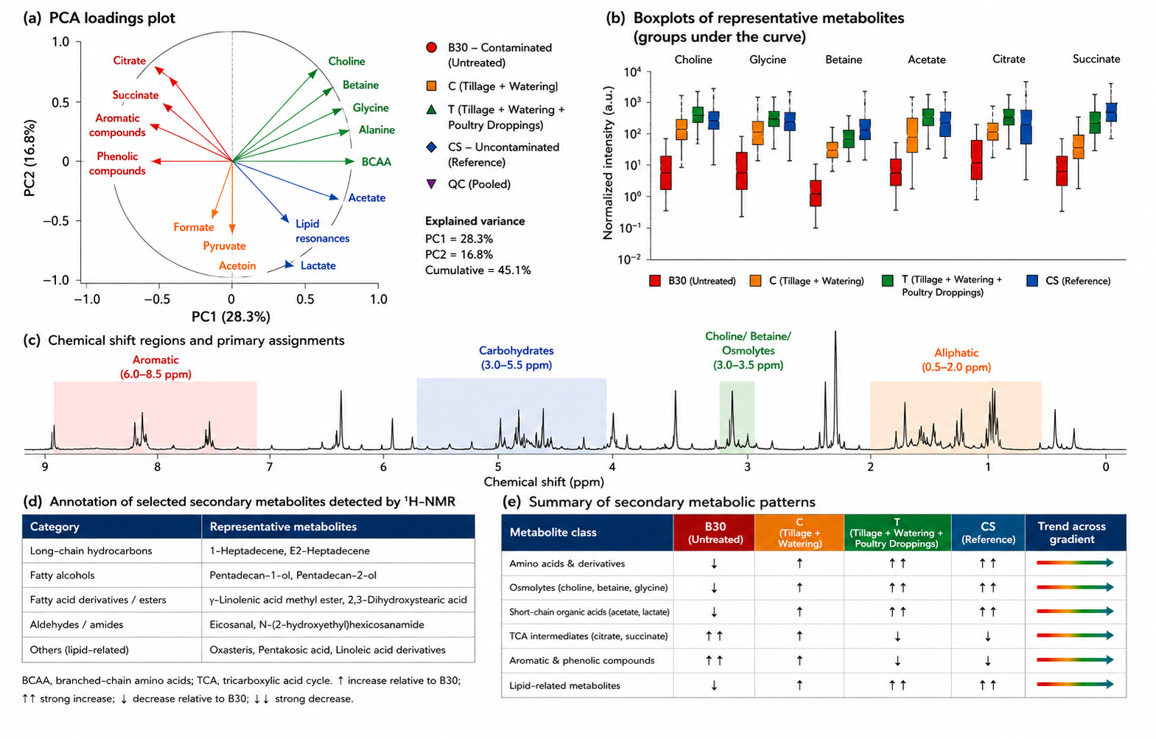
Fig. S1. Secondary-metabolite profiling of petroleum-polluted soils based on ^1H-NMR analysis. (a) PCA loadings plot showing metabolites contributing to treatment differentiation. (b) Abundance distributions of representative metabolites across contaminated, amended, remediated, and reference soils. (c) Representative ¹H-NMR spectrum highlighting major chemical-shift regions and metabolite assignments. (d) Annotation of selected secondary metabolites detected by ¹H-NMR. (e) Summary of treatment-associated metabolic patterns, showing enrichment of amino acids, osmolytes, and lipid-related metabolites and depletion of tricarboxylic acid cycle intermediates, aromatic compounds, and phenolic metabolites along the remediation gradient

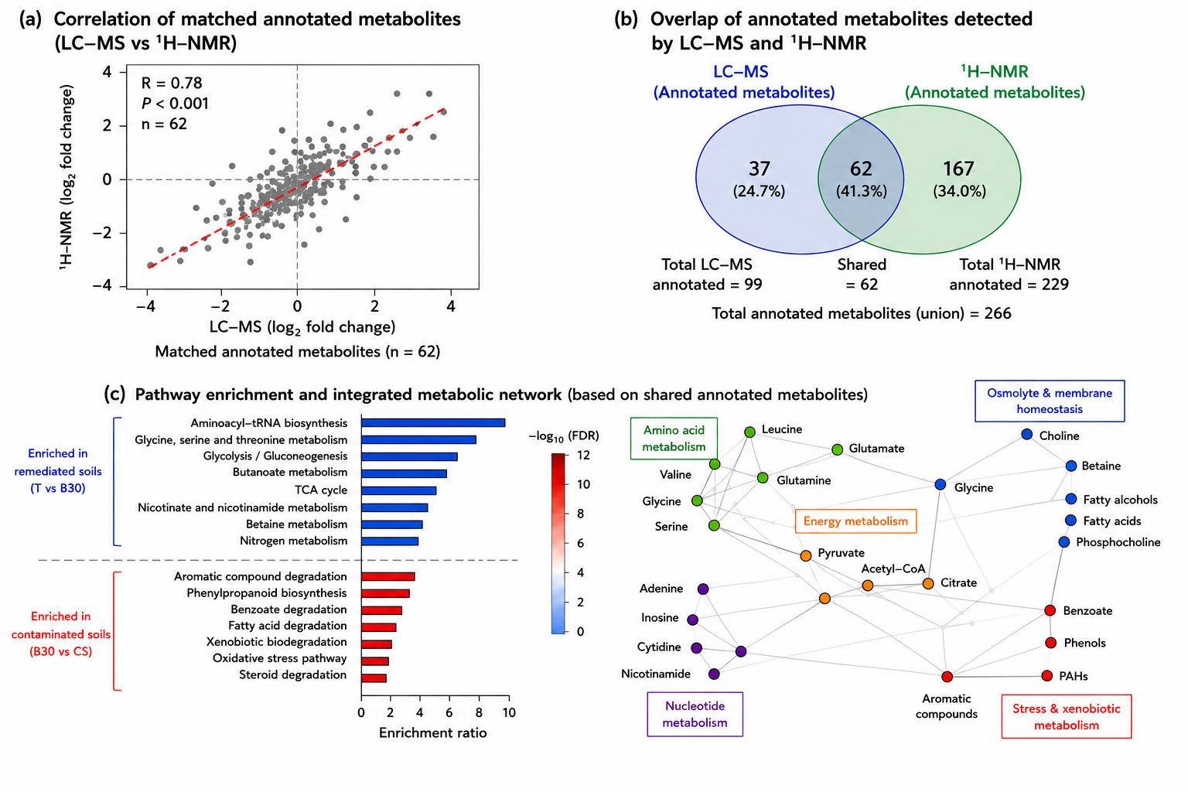
Fig. S2. Cross-platform integration of LC–MS and ¹H-NMR metabolomic datasets. (a) Correlation between matched metabolites detected by LC–MS and ¹H-NMR, demonstrating strong agreement between analytical platforms. (b) Venn diagram showing shared and unique metabolites detected by LC–MS and ¹H-NMR. (c) Integrated pathway enrichment and metabolic network analysis highlighting pathways enriched in remediated and contaminated soils and illustrating the connectivity among amino acid, nucleotide, osmolyte, energy, and stress-associated metabolic processes during hydrocarbon degradation and ecosystem recovery.

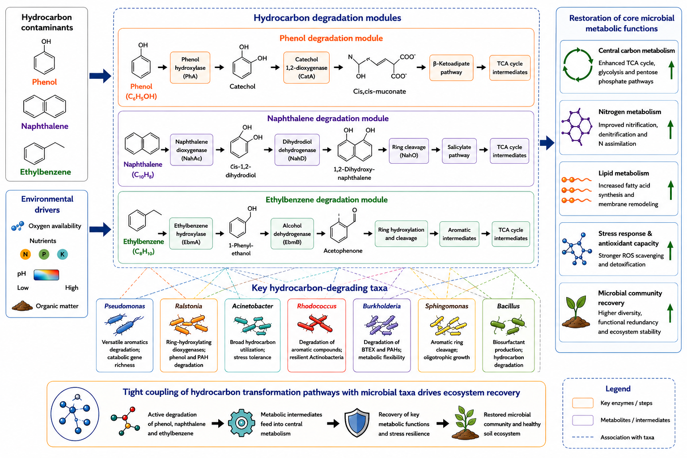

Fig. S3. Metabolic network reconstruction linking hydrocarbon degradation modules with microbial functional recovery. Phenol, naphthalene, and ethylbenzene degradation pathways converge on central carbon metabolism and are associated with hydrocarbon-degrading functional taxa reported in the literatur

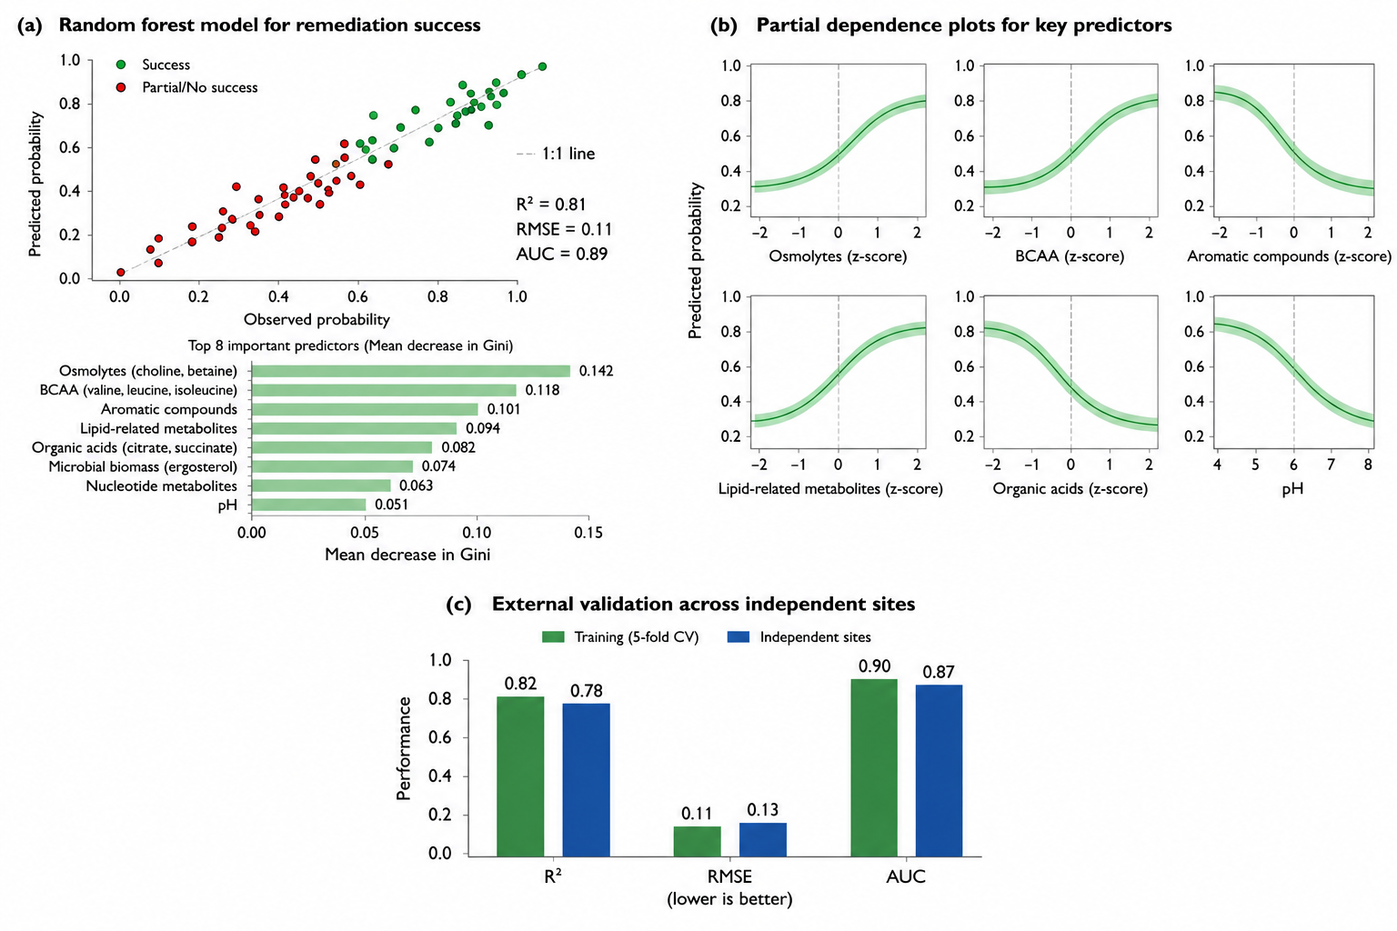
Fig. S.4. Machine-learning identification and validation of metabolomic biomarkers associated with soil recovery. (a) Random forest model predicting remediation success based on integrated metabolomic features, showing strong predictive performance (R² = 0.81, RMSE = 0.11, AUC = 0.89) and ranking key biomarkers according to variable importance. (b) Partial dependence plots illustrating the influence of major metabolite classes on recovery probability, with osmolytes, branched-chain amino acids, and lipid-related metabolites positively associated with recovery, whereas aromatic compounds, organic acids, and pH showed negative associations. (c) External validation demonstrating robust model performance across independent datasets, supporting the utility of metabolite signatures as predictive indicators of bioremediation outcome.

