SUPPLEMENTARY METHODS FILE

INDEX
M1: Plasma lipid extraction
M2: Targeted lipidomics analysis
M3: R-analysis pipeline for lipidomics
M4: Metaboanalyst Modules for lipidomics analysis
M5: Proteomics sample preparation and run conditions
M6: PMN sample preparation
M7: Data Processing and Bioinformatics Analysis of Proteomics data

M1: Plasma lipid extraction
Venous Blood was collected from study participants, in EDTA vials. The blood vials were processed within 1 hour of sample collection. For plasma separation, the vials were centrifuged at 700 x g for 10 minutes. The resulting plasma was separated aseptically and aliquot in 1.5 ml sterile micro-centrifuge tubes. The plasma was stored at -80℃ until further use. The remaining blood cell pellet was used for other experiments. A modified Bligh and Dyer method (1, 2) consisting of a triphasic solution of dichloromethane/methanol/water (2:2:1v/v) was used. In brief, plasma (10μL) from the subject was mixed with 490μL of water (in a glass tube) and incubated on ice for 10 minutes. It was followed by the addition of methanol (2 mL) and dichloromethane (1 mL); the mixture was vortexed and allowed to incubate for 30 minutes at room temperature. After incubation, 500μL water and 1 mL dichloromethane were added to the solution and vortexed for 5 seconds. The mixture was centrifuged at 300 g for 10 minutes for a phase separation. The lower organic layer was collected into a fresh glass tube. 2 mL dichloromethane was added to the remaining mixture in the extraction tube and centrifuged again to collect the lower layer. The previous step was repeated one more time. The solvent was evaporated in a vacuum dryer at 25°C and the lipids were resuspended in 100μL of ethanol; vortexed for 5 minutes, sonicated for 10 minutes, and again, vortexed for 5 minutes. The suspension was transferred to polypropylene autosampler vials and subjected to an LC-MS run

M2: Targeted Lipidomics Analysis
A single injection of 10μL of resuspended lipids was used per run. The Waters ACQUITY ™ UPLC BEH HILIC X Bridge Amide column, coupled with the Sciex QTRAP 6500+ LC/MS/MS system, was used to separate lipid species. The oven temperature was set at 35 °C, and the autosampler was set at 4 °C. Lipids were separated using buffer A (95% acetonitrile with 10 mM ammonium acetate, pH 8.2) and buffer B (50% acetonitrile with 10 mM ammonium acetate, pH 8.2) with a defined flow rate. Turbo source with Electrospray Ionization (ESI) probe was used with the following parameters; curtain gas (CUR): 35 psi, temperature (TEM): 500-degree, source gas 1(GS1): 50 and source gas 2 (GS2): 60 psi, ionization voltage (IS): 5500 for positive mode and IS: −4500 for negative mode, target scan time: 0.5 s, scan speed: 10 Da/s, settling time: 5.0000 ms and MR pause: 5.0070 ms.
For peak mapping and method development, MultiQuant 3.0.3 (MQ) software was used (https://sciex.com/products/software/multiquant-software). Peak integration and regression were done to incorporate relevant peaks, keeping the intensity in check. A set of standard compounds was run prior to each acquisition batch in the scheduled MRM method to assess potential retention time shifts, intensity variation, and instrument performance. In addition, pooled quality control (QC) samples (prepared using pooled plasma, following the same lipid extraction protocol) were injected intermittently throughout the run sequence, between study samples and blanks, to serve as internal run controls.
The scheduled MRM method utilized in this study enabled the simultaneous detection of all the major human plasma lipid species within a short span of a single MS/MS run, and carried out highly sensitive and reproducible identifications across study groups. MRM-based lipidomics is particularly well-suited for clinical studies due to its high selectivity, minimal ion suppression, and reproducibility across batches, even in complex matrices like plasma or serum (3).This method has proved to be advantageous over single-reference based method optimizations. The ease of carrying out multiple transitions within shorter cycles, and multiplexing in large sample size makes the scheduled MRM an ideal method for MS-based targeted biomarker validations (4, 5).

M3: R-analysis pipeline for lipidomics
Integrated peak data was exported in .txt format consisting of species and sample names in columns, and intensity values (features) in rows. A separate .csv file was generated with the shortlisted lipid species and corresponding intensities per sample. Group headers were created for ACLF non-survivor (NS1, NS2, NS3….NS28), ACLF survivor (S1, S2, S3….S30) and Healthy controls (H1, H2, H3….H29). The raw MS/MS peak concentrations were tabulated in the form of a data file containing 87 (samples by 1218 (compounds) data matrix.
R-Pipeline: The raw MS/MS intensity dataset (1,218 lipid species) was processed in R using a uniform, reproducible pipeline. Lipid species detected in fewer than 70% of samples were removed to reduce sparsity. Remaining missing values (including zeros treated as non-detects) were imputed using the non-parametric random-forest method implemented in the missForest R package. Imputed intensities were log₂-transformed to stabilize variance and approximate normality. To correct for systematic batch effects, empirical Bayes batch correction was applied using the ComBat function from the sva package. Quality control included per-feature and per-sample missingness summaries, visual inspection of intensity distributions and boxplots, and principal component analysis (PCA) before and after normalization/batch correction to confirm reduction of batch-associated variation. All processing steps were performed in R (Version 4.3.3) and the final processed matrix was exported for downstream statistical analyses.
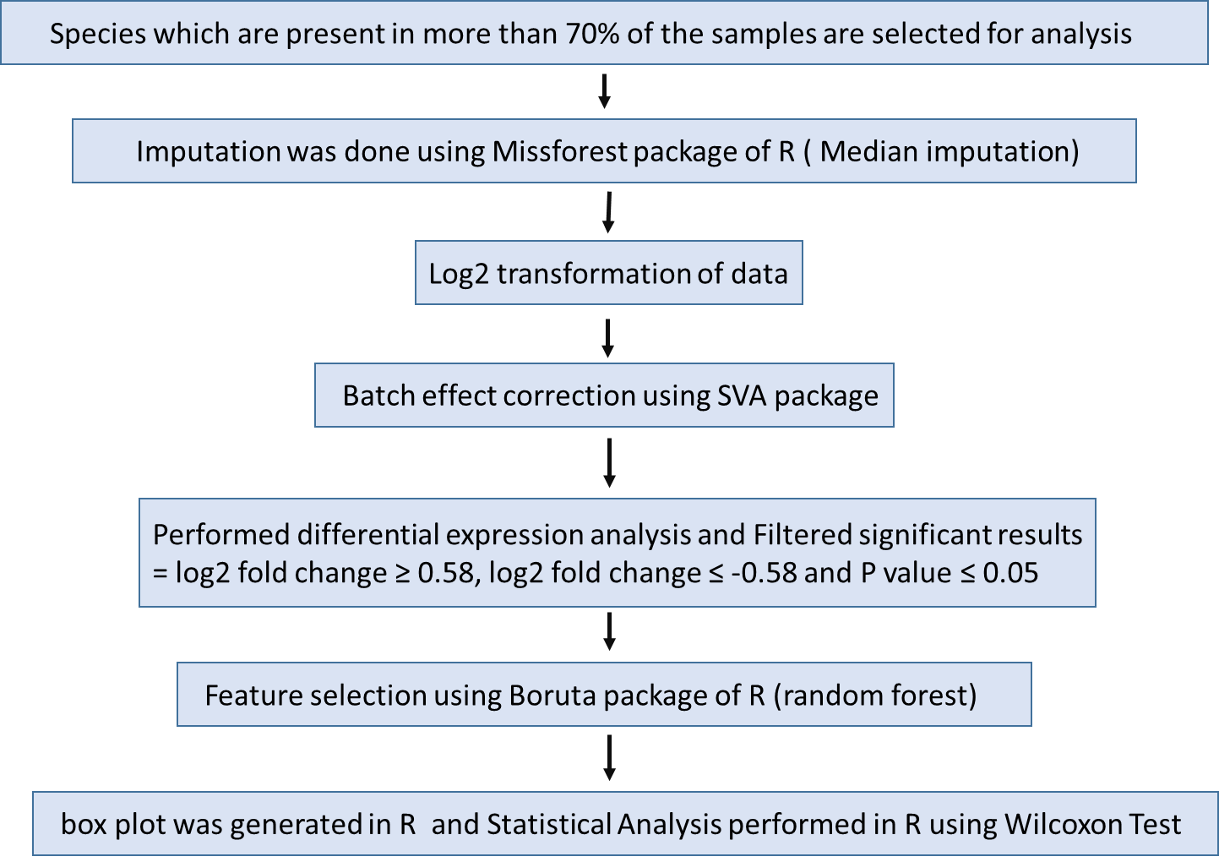

Statistical analysis pipeline of raw lipid intensity data in R

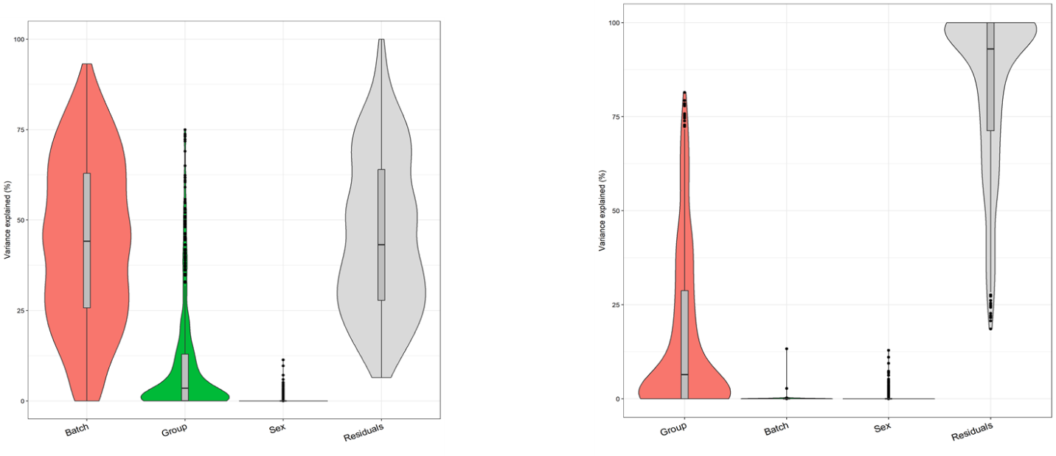

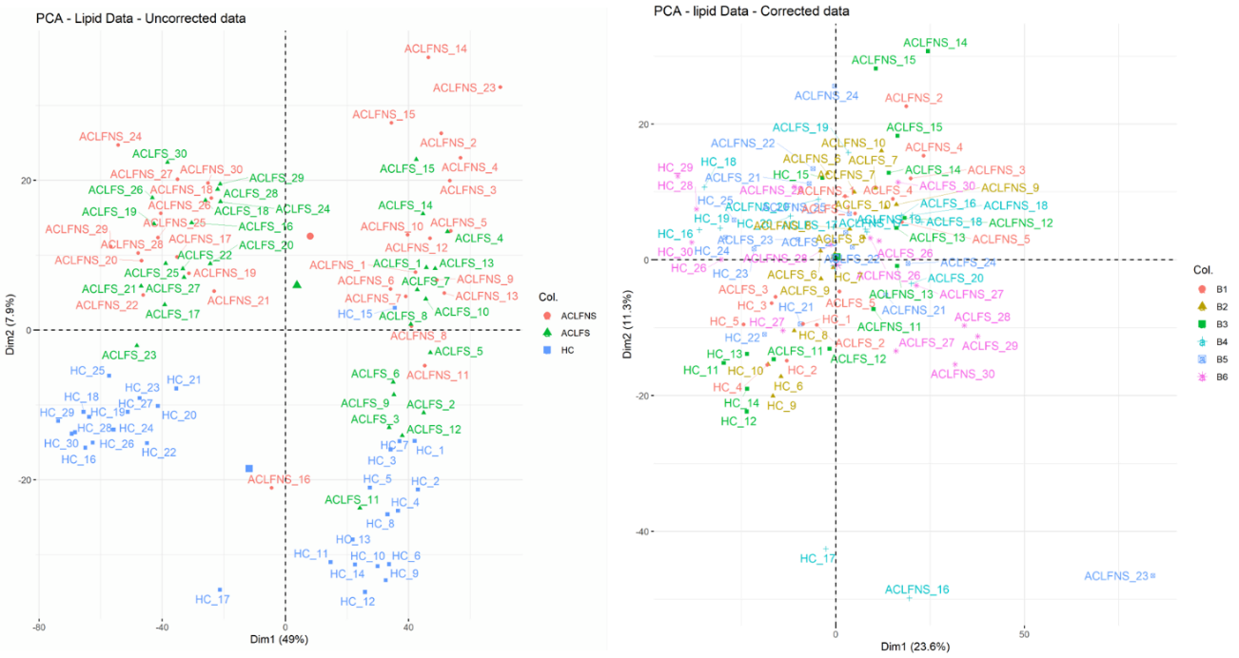

Cohort 1

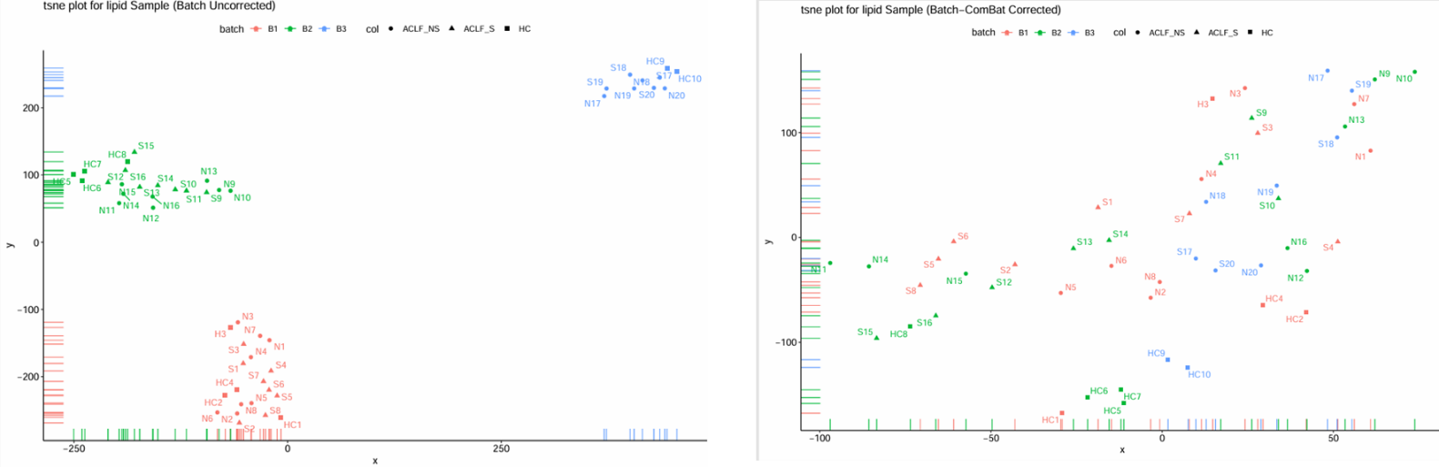
Batch correction (before and after correcting for groups, age and gender) Above: Variance plot of before and after batch correction; Below PCA plot before and after batch correction in Cohort 1 and Cohort 2
Cohort 2

M4: Metaboanalyst Module
After quality-control filtering, 620 lipid species remained for downstream analysis. The final .csv file generated after R-based data transformation, was uploaded in MetaboAnalyst 6.0 software (https://www.metaboanalyst.ca/) and a one-factor analysis was carried out.
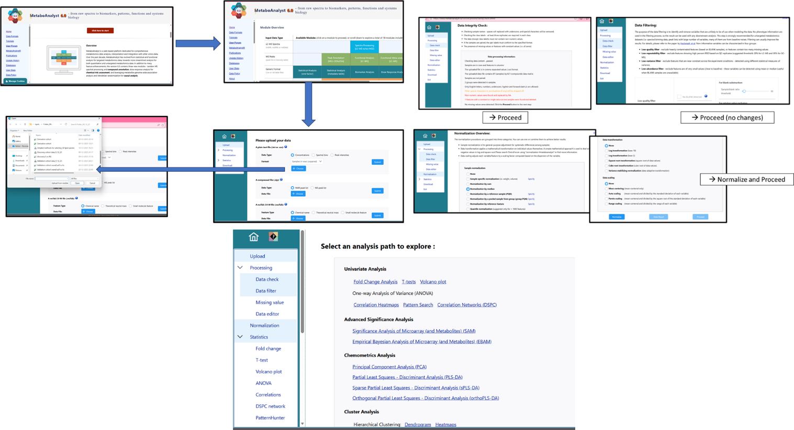

Univariate statistical analysis was performed using two-sample t-tests to identify differentially abundant lipid species between ACLF and healthy controls within each cohort independently. Multiple testing correction was applied using the Benjamini-Hochberg false discovery rate (FDR), and lipid species with adjusted p < 0.05 were considered significant. Fold-change cutoffs were not imposed, as no lipid species exceeded a 1.5-fold change across cohorts.
Multivariate analysis was conducted using partial least squares-discriminant analysis (PLS-DA). Model robustness was evaluated using 5-fold cross-validation and permutation testing to assess classification stability and minimize overfitting. Score plots, loading plots, and variable importance in projection (VIP) scores were used for visualization and interpretation.
Cross-cohort concordance analysis was carried out by comparing FDR-significant lipid species identified in Cohort 1 and Cohort 2. Lipids significant in both cohorts and showing consistent directionality based on t-statistics were defined as reproducible ACLF-associated lipid species.
For survival analysis (ACLF survivor vs non-survivor), exploratory Wilcoxon Ran Sum test t-tests using raw p values were applied within each cohort.

M5: Proteomics sample preparation and run conditions
Isolated neutrophils were lysed in freshly prepared radioimmunoprecipitation assay (RIPA) buffer containing a protease inhibitor cocktail (Sigma-Aldrich). The lysates were subjected to sonication on ice (three rounds of 10-second pulses, with 5-minute cooling intervals between rounds). After sonication, samples were centrifuged at 12,000 × g for 10 minutes at 4°C. Supernatants were collected, and protein concentrations were determined using a Bradford assay (Hi-Media ML106).
Total cell lysate protein was reduced with 5 mM TCEP and alkylated using 50 mM iodoacetamide. Proteins were then digested with trypsin at a 1:50 (trypsin:protein) ratio for 16 hours at 37°C. The resulting peptides were purified using a C18 silica cartridge and dried in a speed vacuum. Dried peptide pellets were resuspended in buffer A (2% acetonitrile, 0.1% formic acid) for LC-MS/MS analysis.
Samples were analyzed using an Easy-nLC 1000 system coupled to an Orbitrap Exploris 240 mass spectrometer (Thermo Fisher Scientific) with a nanoelectrospray ion source. Peptides were loaded on a PicoFrit column (1.8 μm resin, 15 cm length) and separated using a linear gradient of 0–38% buffer B (80% acetonitrile, 0.1% formic acid) at a flow rate of 500 nL/min over 96 minutes.
The Orbitrap Exploris 240 was operated in data-dependent acquisition mode with the following parameters: Max IT = 60 ms, AGC target = 300%, RF lens = 70%, resolution = 60K, mass range = 375–1500 m/z. MS2 spectra were acquired with resolution 15K and Max IT = 60 ms, AGC target = 100% using a top-20 method with dynamic exclusion (30 s). Internal calibration was performed using polydimethylcyclosiloxane (PCM) ions (m/z 445.120025).

M6: PMN sample preparation for
For neutrophil isolation, the Bøyum’s method of double gradient centrifugation was used with following modifications. Blood pellet containing the buffy coat was diluted with twice the volume of sterile 1X PBS, at room temperature. In a 15ml centrifuge tube, a double gradient was made of Ficoll-Hisep (Himedia, INDIA, LSM 1077), layered over Granulosep (Himedia, INDIA, LS004) in a 2:3 ratio, followed by a careful layering of diluted blood on top. Centrifugation was done at 1300 x rpm for 30 minutes, at room temperature, without brakes. The following phases in order (top to bottom) were formed after centrifugation: Diluted plasma, PBMC, Hisep, PMN, Granulosep, RBC pellet. The diluted plasma was discarded, and the resulting PBMC layer was carefully separated for collection of the lower enriched PMN layer. The PMN cells were resuspended in sterile 1X PBS and washed by centrifugation at 1800 x rpm for 10 minutes. Contaminating RBCs were removed by incubating the washed pellet in 1X RBC lysis solution for 10 minutes at 4°C followed by two 1X PBS washes. The final cell pellet was used for proteomics analysis.

M7: Data Processing and Bioinformatics Analysis of Proteomics data
Raw files were processed using Proteome Discoverer v2.5, and searched against the UniProt human reference database using both Sequest and Amanda search engines. Search parameters included precursor mass tolerance of 10 ppm, fragment mass tolerance of 0.02 Da, and enzyme specificity set to trypsin/P (cleaving at K/R unless followed by P). Carbamidomethylation of cysteine was used as a fixed modification; oxidation of methionine and N-terminal acetylation were considered variable modifications. A 0.01 false discovery rate (FDR) was set for both peptide spectrum match (PSM) and protein levels.
Protein abundance values were extracted and filtered based on valid entries across all groups. Filtered abundance data were log2-transformed and subjected to Z-score normalization. Differential protein abundance between groups was assessed using a Student’s t-test, with a p-value ≤ 0.05 considered statistically significant. Z-score normalized abundance values of significantly altered proteins were visualized using custom R scripts (vProteomics). Functional pathway enrichment analyses were conducted using Metascape.

References
1. Bligh EG, Dyer WJ. A rapid method of total lipid extraction and purification. Can. J. biochem. 1959;37(8):911-7.
2. Manirakiza P, Covaci A, Schepens P. Comparative study on total lipid determination using Soxhlet, Roese-Gottlieb, Bligh & Dyer, and modified Bligh & Dyer extraction methods. J Food compost Anal. 2001;14(1):93-100.
3. Anh, Nguyen Ky, et al. "Advancements in mass spectrometry-based targeted metabolomics and lipidomics: Implications for clinical research." Molecules 29.24 (2024): 5934.
4. Hunter C, Simons B. The scheduled MRM™ algorithm enables intelligent use of retention time during multiple reaction monitoring. Sciex Tech. Note. 2010.
5. Wei R, Li G, Seymour AB. High-throughput and multiplexed LC/MS/MRM method for targeted metabolomics. Anal. Chem. 2010;82(13):5527-33.

