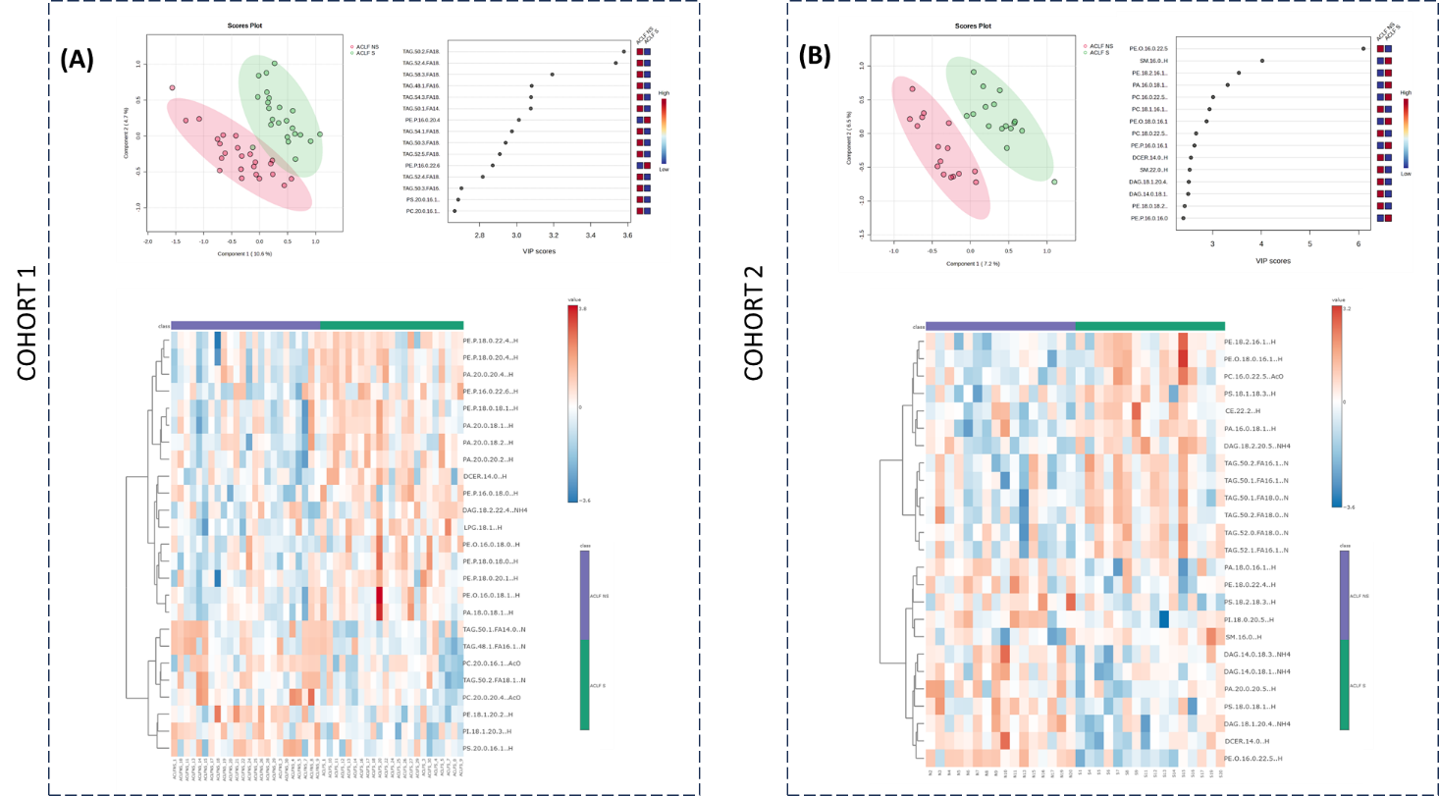

Supplementary Figure S2. Chemometric analysis of plasma lipidomic profiles distinguishing ACLF survivors and non-survivors in male patients
Analysis of plasma lipidomics data from male patients with ACLF, comparing survivors (ACLF-S) and non-survivors (ACLF-NS) in two independent cohorts. Left panels (A) (Cohort 1) and right panels (B) (Cohort 2) show partial least squares-discriminant analysis (PLS-DA) score plots demonstrating separation between ACLF-S and ACLF-NS groups. Corresponding variable importance in projection (VIP) scores identify lipid species contributing most to group discrimination. Heatmaps depict the top 25 discriminatory lipid species across individuals, with hierarchical clustering applied to lipids.

