Supplementary Figure S 1
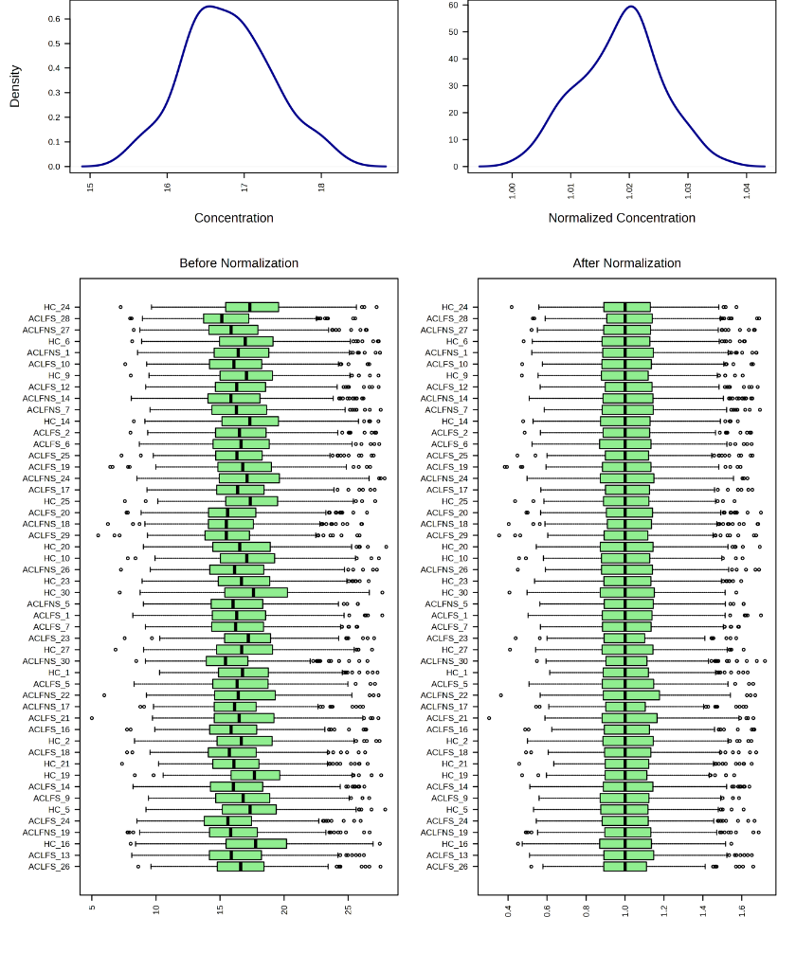
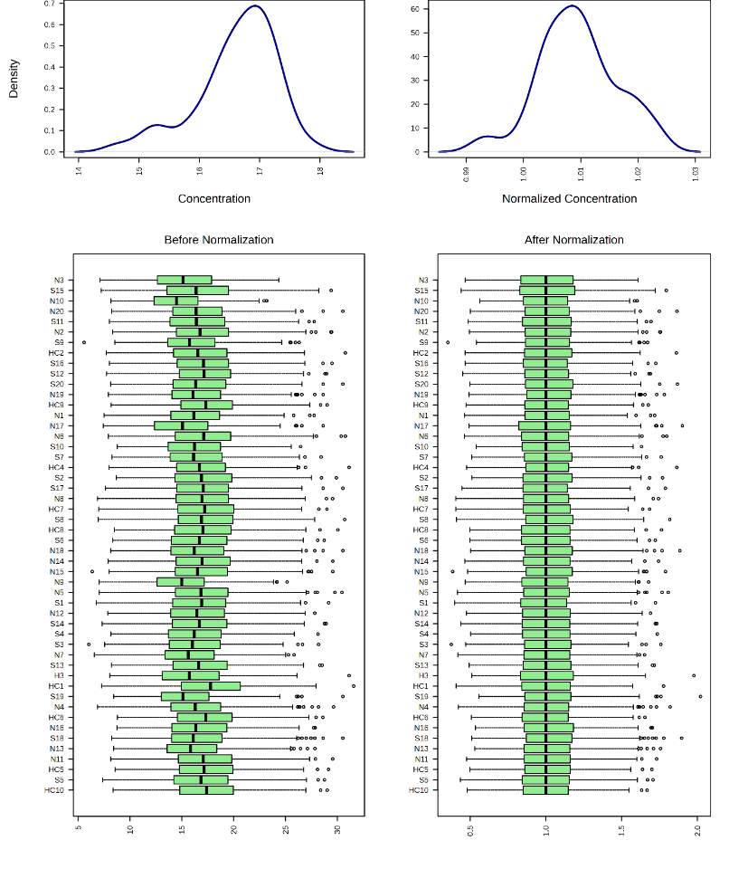

Figure. Representation of samples in Cohort 1 (left) and Cohort 2 (right) after median normalization in Metaboanalyst (ver 6.0)
Density plot (top panel) and box plots (lower panel) of a representative set of 50 samples showing the effect of data normalization.

