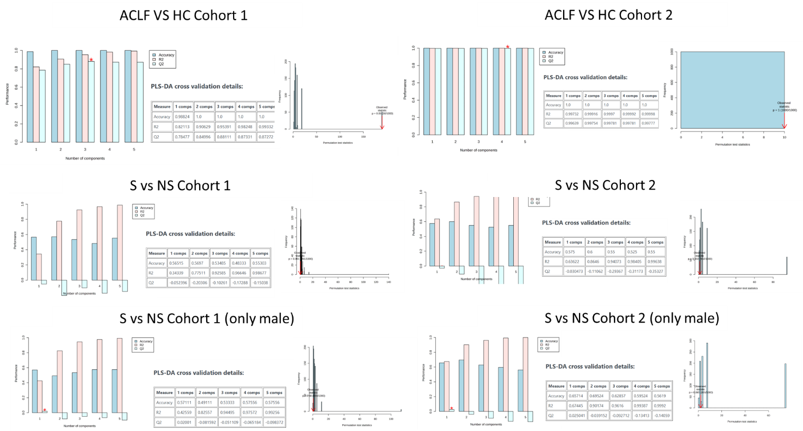

Supplementary Figure S3. PLS-DA model evaluation for lipidomics analysis
Model robustness was evaluated using 5-fold cross-validation (left panels) and permutation testing (n = 1000) (right panels) in Cohort 1 vs Cohort 2 with stratifications: ACLF vs HC (top), Survivor vs Non-survivor (middle), and Survivor vs Non-survivor males (bottom)

