Supplementary Figure 1 Flow chat of cross-sectional study selection.
Supplementary Figure 2 Single and multiple comorbidity associations with dementia: odds ratios and 95% confidence intervals for hypertension, eye disorders, osteoarthritis, diabetes, oral diseases, and ear diseases.
Supplement Table 1 Additive and multiplicative interaction effects between pairs of chronic diseases on dementia risk.
Abbreviations: hyp, hypertension; diab, diabetes mellitus; oa, osteoarthritis; ear, ear diseases; eye, eye diseases; oral, oral diseases. Additive interaction indices include the relative excess risk due to interaction (RERI), attributable proportion (AP), and synergy index (S). Multiplicative interaction is assessed by the odds ratio (OR) of the product term and corresponding P-value
Disease Pair | Additive interaction |  |  |  | Multiplicative interaction
 | RERI | AP(95%CI) |  | S |  |  | OR(95% CI) | P
Hypertension * Diabetes | -0.221 (-0.889-0.447) | -0.182 (-0.751-0.387) |  | 0.484 |  |  | 0.86 (0.52-1.41) | 0.5463
Hypertension * Osteoporosis | -0.017 (-0.654-0.62) | -0.016 (-0.615-0.582) |  | 0.852 |  |  | 0.99 (0.55-1.77) | 0.9695
Hypertension * Ear disease | 0.277 (-0.866-1.42) | 0.168 (-0.472-0.807) |  | 1.800 |  |  | 1.22 (0.57-2.63) | 0.6097
Hypertension * Eye disease | 0.474 (-0.15-1.097) | 0.405 (-0.031-0.841) |  | -0.550 |  |  | 1.64 (0.85-3.17) | 0.1433
Hypertension * Oral disease | -0.214 (-1.134-0.707) | -0.148 (-0.817-0.52) |  | 0.683 |  |  | 0.88 (0.49-1.60) | 0.6812
Diabetes * Osteoporosis | 0.119 (-0.752-0.991) | 0.080 (-0.471-0.632) |  | 1.364 |  |  | 1.07 (0.56-2.04) | 0.8332
Diabetes * Ear disease | 0.250 (-1.437-1.937) | 0.115 (-0.613-0.842) |  | 1.298 |  |  | 1.04 (0.43-2.49) | 0.9331
Diabetes * Eye disease | 0.726 (-0.523-1.976) | 0.385 (-0.076-0.846) |  | 7.300 |  |  | 1.67 (0.77-3.61) | 0.1956
Diabetes * Oral disease | 1.567 (-0.281-3.414) | 0.500 (0.17-0.829) |  | 3.807 |  |  | 1.91 (0.95-3.84) | 0.0699
Osteoporosis * Ear disease | -0.176 (-1.495-1.144) | -0.114 (-1.034-0.805) |  | 0.770 |  |  | 0.87 (0.37-2.07) | 0.7539
Osteoporosis * Eye disease | 0.214 (-0.728-1.156) | 0.166 (-0.49-0.822) |  | 8.387 |  |  | 1.20 (0.54-2.67) | 0.6454
Osteoporosis * Oral disease | -0.723 (-1.749-0.302) | -0.595 (-1.709-0.519) |  | 0.238 |  |  | 0.59 (0.27-1.26) | 0.1717
Ear disease * Eye disease | -0.995 (-2.345-0.354) | -0.882 (-2.346-0.582) |  | 0.116 |  |  | 0.53 (0.22-1.23) | 0.1375
Ear disease * Oral disease | 0.313 (-1.338-1.965) | 0.140 (-0.522-0.802) |  | 1.355 |  |  | 1.05 (0.44-2.48) | 0.9116
Eye disease * Oral disease | 0.342 (-0.896-1.579) | 0.190 (-0.409-0.789) |  | 1.792 |  |  | 1.28 (0.58-2.80) | 0.5399

iseases.
Supplementary Figure 3 Predicted probability of dementia according to the interaction between pairs of chronic diseases.
Fifteen subplots (A-O) show interaction effects between all pairs of six chronic diseases on the predicted probability of dementia (with 95% confidence intervals). Blue lines indicate participants without the corresponding disease; orange lines indicate participants with the disease. The pairwise combinations are: A: Diabetes mellitus * Eye diseases; B: Diabetes mellitus * Hypertension; C: Diabetes mellitus * Osteoporosis; D: Diabetes mellitus * Ear disorders; E: Diabetes mellitus * Oral diseases; F: Hypertension * Eye diseases; G: Hypertension * Osteoporosis; H: Hypertension * Ear disorders; I: Hypertension * Oral diseases; J: Eye diseases * Osteoporosis; K: Eye diseases * Ear disorders; L: Eye diseases * Oral diseases; M: Osteoporosis * Ear disorders; N: Osteoporosis * Oral diseases; O: Ear disorders * Oral diseases.
Supplement Table 2 Subgroup analysis of the association between chronic diseases and dementia risk, stratified by gender and age groups.
Elderly age strata follow official WHO classification: young-old elderly (60-74 years), old-old elderly (75-89 years), oldest-old elderly (≥90 years). The table displays subgroup-specific odds ratios, 95% confidence intervals and P-values for correlations between chronic diseases and dementia risk.
Pattern type | Pattern | Age group_OR(95%CI) |  |  |  |  |  | Gender group_OR(95%CI)
Pattern type | Pattern | Age 60-74y | p | Age 75-89y | p | Age >=90y | p | Gender_Male_OR_CI | p | Female | p
Single disease | Hypertension | 1.15 (0.83-1.60) | 0.40 | 1.00 (0.75-1.32) | 0.99 | 0.37 (0.15-0.94) | 0.04 | 0.94 (0.70-1.26) | 0.68 | 0.99 (0.75-1.30) | 0.93
Single disease | Diabetes | 1.79 (1.21-2.66) | 0.00 | 1.05 (0.72-1.53) | 0.81 | 1.54 (0.55-4.33) | 0.41 | 1.22 (0.83-1.81) | 0.31 | 1.46 (1.04-2.06) | 0.03
Single disease | Osteoporosis | 1.20 (0.73-1.98) | 0.48 | 1.21 (0.80-1.83) | 0.36 | 0.80 (0.25-2.55) | 0.70 | 1.43 (0.92-2.22) | 0.11 | 0.90 (0.59-1.37) | 0.61
Single disease | Ear disease | 1.82 (0.93-3.56) | 0.08 | 1.70 (1.00-2.89) | 0.05 | 0.74 (0.19-2.83) | 0.66 | 1.96 (1.10-3.48) | 0.02 | 1.34 (0.77-2.33) | 0.30
Single disease | Eye disease | 1.18 (0.68-2.03) | 0.56 | 0.96 (0.62-1.48) | 0.85 | 1.01 (0.20-4.95) | 1.00 | 1.01 (0.61-1.68) | 0.97 | 0.99 (0.65-1.52) | 0.97
Single disease | Oral disease | 0.85 (0.50-1.45) | 0.56 | 1.94 (1.28-2.93) | 0.00 | 2.93 (0.72-11.89) | 0.13 | 2.35 (1.54-3.60) | <0.001 | 1.07 (0.70-1.65) | 0.74
Two comorbidities | Hypertension + Diabetes | 1.36 (0.81-2.26) | 0.24 | 1.10 (0.73-1.63) | 0.66 | 1.55 (0.41-5.79) | 0.51 | 1.16 (0.75-1.80) | 0.51 | 1.27 (0.84-1.93) | 0.26
Two comorbidities | Hypertension + Osteoporosis | 1.12 (0.57-2.22) | 0.74 | 1.32 (0.82-2.13) | 0.25 | 0.28 (0.06-1.37) | 0.12 | 1.30 (0.75-2.23) | 0.35 | 0.88 (0.51-1.51) | 0.65
Two comorbidities | Hypertension + Ear disease | 1.62 (0.69-3.81) | 0.27 | 2.07 (1.06-4.04) | 0.03 | 0.60 (0.10-3.51) | 0.56 | 2.20 (1.09-4.45) | 0.03 | 1.48 (0.74-2.98) | 0.27
Two comorbidities | Hypertension + Eye disease | 1.69 (0.90-3.21) | 0.11 | 1.20 (0.69-2.11) | 0.52 | 0.53 (0.07-4.28) | 0.54 | 1.03 (0.55-1.92) | 0.93 | 1.49 (0.86-2.58) | 0.16
Two comorbidities | Hypertension + Oral disease | 1.29 (0.67-2.50) | 0.45 | 1.41 (0.81-2.44) | 0.22 | 1.25 (0.23-6.90) | 0.80 | 2.34 (1.33-4.11) | 0.00 | 0.90 (0.49-1.64) | 0.72
Two comorbidities | Diabetes + Osteoporosis | 2.82 (1.36-5.83) | 0.01 | 1.19 (0.63-2.24) | 0.59 | 0.93 (0.21-4.17) | 0.92 | 1.85 (0.95-3.61) | 0.07 | 1.24 (0.63-2.43) | 0.54
Two comorbidities | Diabetes + Ear disease | 3.67 (1.29-10.46) | 0.02 | 1.75 (0.74-4.15) | 0.20 | 1.70 (0.23-12.78) | 0.60 | 2.81 (1.16-6.79) | 0.02 | 1.42 (0.54-3.75) | 0.48
Two comorbidities | Diabetes + Eye disease | 4.00 (1.58-10.15) | 0.00 | 1.35 (0.65-2.81) | 0.42 | 1.76 (0.26-11.88) | 0.56 | 1.94 (0.81-4.66) | 0.14 | 1.68 (0.80-3.52) | 0.17
Two comorbidities | Diabetes + Oral disease | 2.82 (1.21-6.59) | 0.02 | 2.36 (1.16-4.79) | 0.02 | 4.83 (0.48-48.78) | 0.18 | 4.53 (2.15-9.54) | <0.001 | 1.58 (0.71-3.51) | 0.26
Two comorbidities | Osteoporosis + Ear disease | 2.12 (0.77-5.81) | 0.15 | 1.23 (0.55-2.75) | 0.62 | 1.10 (0.16-7.73) | 0.92 | 1.33 (0.58-3.06) | 0.50 | 1.56 (0.65-3.73) | 0.32
Two comorbidities | Osteoporosis + Eye disease | 1.05 (0.35-3.13) | 0.94 | 1.20 (0.56-2.58) | 0.63 | 1.21 (0.17-8.91) | 0.85 | 1.55 (0.69-3.47) | 0.29 | 0.98 (0.41-2.30) | 0.96
Two comorbidities | Osteoporosis + Oral disease | 1.95 (0.73-5.18) | 0.18 | 0.63 (0.28-1.39) | 0.25 | 2.72 (0.35-21.14) | 0.34 | 1.48 (0.74-2.97) | 0.27 | 0.69 (0.26-1.81) | 0.45
Two comorbidities | Ear disease + Eye disease | 1.06 (0.37-3.07) | 0.92 | 1.40 (0.74-2.65) | 0.30 | 0.86 (0.08-9.30) | 0.90 | 1.45 (0.73-2.87) | 0.29 | 0.88 (0.40-1.97) | 0.76
Two comorbidities | Ear disease + Oral disease | 1.24 (0.34-4.47) | 0.74 | 2.48 (1.21-5.06) | 0.01 | 2.09 (0.29-14.87) | 0.46 | 4.40 (2.00-9.71) | <0.001 | 0.99 (0.39-2.51) | 0.99
Two comorbidities | Eye disease + Oral disease | 1.32 (0.50-3.48) | 0.57 | 2.07 (0.93-4.63) | 0.08 | 0.90 (0.12-6.78) | 0.92 | 2.77 (1.24-6.19) | 0.01 | 1.07 (0.48-2.41) | 0.87
Three comorbidities | Hypertension + Diabetes + Osteoporosis | 1.94 (0.78-4.85) | 0.16 | 1.32 (0.68-2.57) | 0.42 | 0.80 (0.15-4.26) | 0.79 | 1.51 (0.71-3.18) | 0.28 | 1.25 (0.57-2.74) | 0.58
Three comorbidities | Hypertension + Diabetes + Ear disease | 3.38 (0.92-12.33) | 0.07 | 2.72 (1.08-6.89) | 0.04 | 10.41 (0.71-152.97) | 0.09 | 3.57 (1.23-10.37) | 0.02 | 2.18 (0.75-6.36) | 0.15
Three comorbidities | Hypertension + Diabetes + Eye disease | 2.39 (0.80-7.15) | 0.12 | 1.99 (0.88-4.49) | 0.10 | 7.54 (0.58-98.08) | 0.12 | 1.75 (0.65-4.73) | 0.27 | 2.24 (0.97-5.17) | 0.06
Three comorbidities | Hypertension + Diabetes + Oral disease | 3.30 (1.33-8.22) | 0.01 | 2.42 (1.08-5.41) | 0.03 | 4.83 (0.48-48.78) | 0.18 | 5.51 (2.42-12.55) | <0.001 | 1.56 (0.64-3.82) | 0.33
Three comorbidities | Hypertension + Osteoporosis + Ear disease | 1.69 (0.56-5.15) | 0.36 | 1.72 (0.71-4.19) | 0.23 | 1.05 (0.12-8.82) | 0.97 | 1.32 (0.52-3.30) | 0.56 | 1.94 (0.71-5.31) | 0.20
Three comorbidities | Hypertension + Osteoporosis + Eye disease | 0.70 (0.17-2.94) | 0.62 | 1.41 (0.59-3.35) | 0.44 | 1.05 (0.12-8.82) | 0.97 | 0.95 (0.35-2.61) | 0.92 | 1.52 (0.55-4.24) | 0.42
Three comorbidities | Hypertension + Osteoporosis + Oral disease | 1.84 (0.64-5.32) | 0.26 | 0.62 (0.24-1.62) | 0.33 | 0.87 (0.10-7.59) | 0.90 | 1.63 (0.69-3.84) | 0.26 | 0.29 (0.07-1.29) | 0.10
Three comorbidities | Hypertension + Ear disease + Eye disease | 0.93 (0.28-3.14) | 0.91 | 1.99 (0.94-4.22) | 0.07 | 0.36 (0.02-5.63) | 0.46 | 1.63 (0.75-3.53) | 0.22 | 1.19 (0.47-3.04) | 0.71
Three comorbidities | Hypertension + Ear disease + Oral disease | 2.77 (0.77-10.04) | 0.12 | 2.50 (1.02-6.15) | 0.05 | 1.45 (0.17-12.06) | 0.73 | 7.10 (2.61-19.32) | <0.001 | 0.44 (0.10-1.84) | 0.26
Three comorbidities | Hypertension + Eye disease + Oral disease | 2.51 (0.89-7.12) | 0.08 | 1.95 (0.74-5.13) | 0.18 | 0.75 (0.11-5.24) | 0.77 | 2.76 (1.05-7.22) | 0.04 | 1.26 (0.49-3.26) | 0.63
Three comorbidities | Diabetes + Osteoporosis + Ear disease | 12.26 (2.61-57.60) | 0.00 | 1.95 (0.66-5.74) | 0.22 | 0.52 (0.07-3.97) | 0.52 | 1.55 (0.52-4.64) | 0.43 | 3.22 (0.85-12.15) | 0.09
Three comorbidities | Diabetes + Osteoporosis + Eye disease | 3.22 (0.58-17.82) | 0.18 | 1.27 (0.42-3.85) | 0.67 | 0.52 (0.07-3.97) | 0.52 | 1.07 (0.33-3.52) | 0.91 | 1.28 (0.31-5.34) | 0.73
Three comorbidities | Diabetes + Osteoporosis + Oral disease | 5.68 (1.55-20.87) | 0.01 | 0.98 (0.34-2.83) | 0.98 | 0.87 (0.10-7.59) | 0.90 | 2.72 (1.04-7.12) | 0.04 | 0.32 (0.03-2.98) | 0.32
Three comorbidities | Diabetes + Ear disease + Eye disease | 3.30 (0.72-15.03) | 0.12 | 1.57 (0.57-4.33) | 0.38 | 0.52 (0.07-3.97) | 0.52 | 2.17 (0.73-6.44) | 0.16 | 0.56 (0.13-2.44) | 0.44
Three comorbidities | Diabetes + Ear disease + Oral disease | 1.96 (0.37-10.50) | 0.43 | 3.85 (1.23-12.08) | 0.02 | 8.88 (0.61-129.82) | 0.11 | 6.88 (2.16-21.94) | 0.00 | 0.07 (0.00-2.74) | 0.16
Three comorbidities | Diabetes + Eye disease + Oral disease | 4.05 (0.90-18.24) | 0.07 | 3.49 (1.04-11.73) | 0.04 | 5.56 (0.46-67.96) | 0.18 | 3.71 (1.21-11.37) | 0.02 | 5.95 (1.39-25.53) | 0.02
Three comorbidities | Osteoporosis + Ear disease + Eye disease | 0.73 (0.16-3.40) | 0.69 | 1.29 (0.53-3.15) | 0.58 | 1.08 (0.14-8.08) | 0.94 | 1.08 (0.42-2.76) | 0.88 | 1.13 (0.37-3.41) | 0.83
Three comorbidities | Osteoporosis + Ear disease + Oral disease | 6.22 (1.28-30.35) | 0.02 | 0.81 (0.27-2.40) | 0.70 | 0.99 (0.07-13.36) | 0.99 | 1.98 (0.68-5.79) | 0.21 | 0.73 (0.18-2.93) | 0.66
Three comorbidities | Osteoporosis + Eye disease + Oral disease | 0.69 (0.10-4.79) | 0.71 | 1.22 (0.37-4.06) | 0.74 | 1.22 (0.08-18.26) | 0.88 | 1.63 (0.54-4.91) | 0.38 | 1.16 (0.28-4.79) | 0.84
Three comorbidities | Ear disease + Eye disease + Oral disease | 1.94 (0.44-8.50) | 0.38 | 3.64 (1.42-9.35) | 0.01 | 0.56 (0.05-6.51) | 0.63 | 4.34 (1.66-11.31) | 0.00 | 1.16 (0.34-3.93) | 0.81

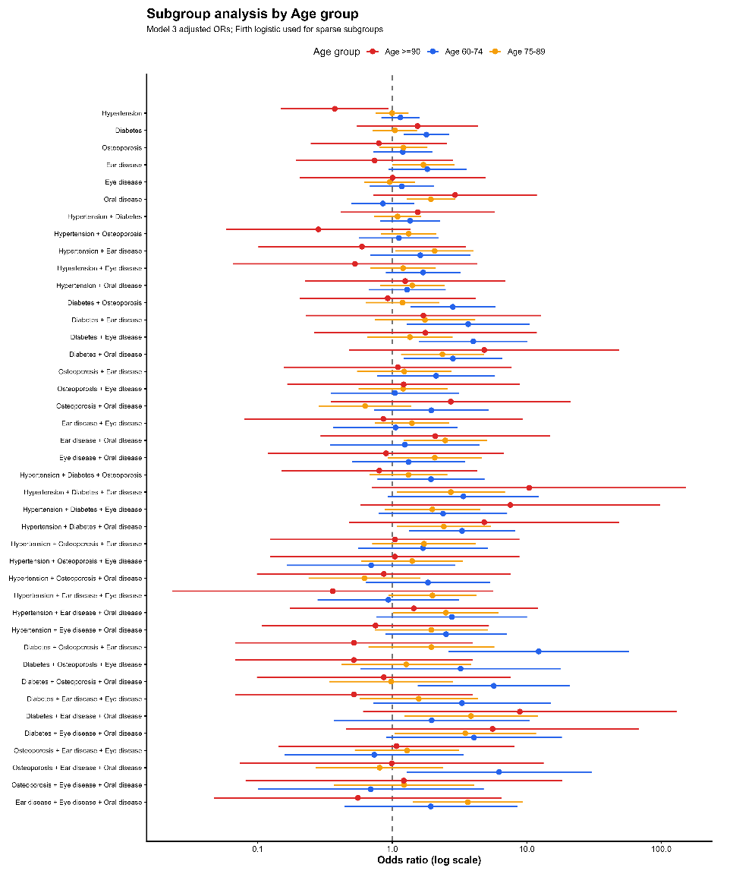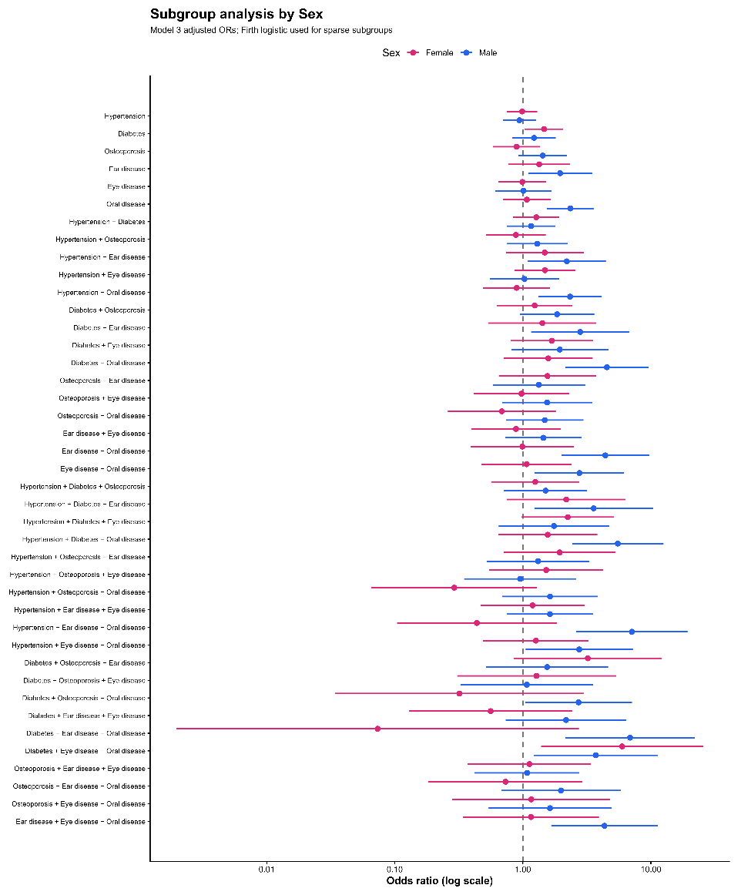
Supplementary Figure 4 Forest plot of subgroup analysis of chronic diseases and dementia risk, stratified by gender and age groups.
Supplement Table 3 Fit statistics for latent class analysis of neuropsychiatric comorbidity patterns in patients with dementia.
Fit statistics for latent class analysis (LCA) models with 2-6 classes, used to identify neuropsychiatric comorbidity patterns in patients with dementia. AIC, BIC, and adjusted BIC (aBIC) are information criteria (lower values = better fit). Entropy (0-1) measures classification accuracy (higher = better). Min_Class_P is the minimum proportion of participants in any latent class (decimal). Class_Proportions show the percentage distribution of participants across each class.
Models | AIC | BIC | aBIC | Entropy | Min_Class_P | Class_Proportions
Class-2 | 4386.05 | 4485.55 | 4412.54 | 0.723 | 0.472 | 52.8 / 47.2
Class-3 | 4348.96 | 4500.37 | 4389.27 | 0.734 | 0.086 | 8.6 / 38 / 53.4
Class-4 | 4343.49 | 4546.82 | 4397.62 | 0.819 | 0.075 | 16.4 / 36.3 / 7.5 / 39.8
Class-5 | 4340.43 | 4595.67 | 4408.38 | 0.840 | 0.036 | 7.1 / 36.5 / 40 / 3.6 / 12.8
Class-6 | 4344.65 | 4651.8 | 4426.42 | 0.795 | 0.029 | 8.1 / 7.9 / 39.6 / 15.7 / 2.9 / 25.8

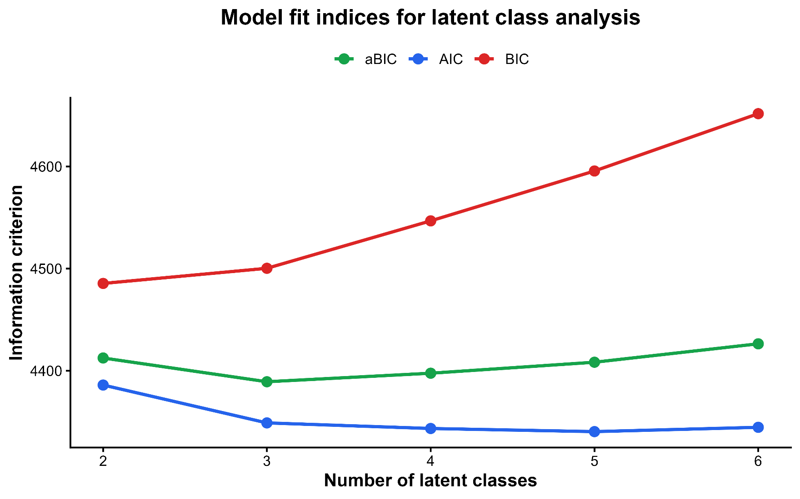
Supplementary Figure 5 Model fit indices for latent class analysis.
AIC, BIC, and adjusted BIC values were compared across models with 2-6 latent classes. Lower values indicate better model fit.
Supplementary Figure 6 Conditional probability heatmap of neuropsychiatric symptom profiles.
The heatmap shows conditional probabilities of mapped NPI-Q symptom domains across the three latent classes: C1 minimal-symptom class, C2 sleep-appetite disturbance class, and C3 agitated-irritable class.
Supplement Table 4 Prevalence of six chronic diseases across neuropsychiatric symptom subtypes of dementia patients.
 |  | C1: Minimal-symptom class | C2: Sleep-appetite disturbance class | C3: Agitated-irritable class | p
N |  | 232 | 285 | 42
Diabetes (%) |  | 201 (86.6) | 204 (71.6) | 27 (64.3) | <0.001
 |  | 31 (13.4) | 81 (28.4) | 15 (35.7)
Oral (%) |  | 218 (94.0) | 230 (80.7) | 31 (73.8) | <0.001
 |  | 14 (6.0) | 55 (19.3) | 11 (26.2)
Hypertension (%) |  | 117 (50.4) | 142 (49.8) | 15 (35.7) | 0.164
 |  | 110 (47.4) | 141 (49.5) | 27 (64.3)
Eye (%) |  | 216 (93.1) | 251 (88.1) | 29 (69.0) | <0.001
 |  | 16 (6.9) | 34 (11.9) | 13 (31.0)
Ear (%) |  | 224 (96.6) | 252 (88.4) | 33 (78.6) | <0.001
 |  | 8 (3.4) | 33 (11.6) | 9 (21.4)
Osteoporosis(%) |  | 209 (90.1) | 233 (81.8) | 29 (69.0) | <0.001
 |  | 18 (7.8) | 50 (17.5) | 13 (31.0)
Age (mean (SD)) |  | 79.42 (9.45) | 78.64 (8.82) | 81.12 (8.24) | 0.214
Gender (%) |  | 111 (47.8) | 131 (46.0) | 16 (38.1) | 0.504
 |  | 121 (52.2) | 154 (54.0) | 26 (61.9)

Supplement Table 5 Additive and multiplicative interaction effects between each pair of six chronic diseases on dementia risk, stratified by neuropsychiatric symptom subtypes.
 | C1: Minimal-symptom class |  |  |  |  |  |  |  |  |  |  | C2: Sleep-appetite disturbance class |  |  |  |  |  |  | C3: Agitated-irritable class
 | Additive interaction |  |  |  | Multiplicative  interaction |  |  |  |  |  |  | Additive interaction |  |  | Multiplicative  interaction |  |  |  | Additive interaction |  |  | Multiplicative  interaction
Disease_Pair | RERI | AP | S |  | OR |  |  | 95%CI |  | P |  | RERI | AP | S | OR | 95%CI | P |  | RERI | AP | S | OR | 95%CI | P
Hypertension * Diabetes | -0.203 | -0.338 | 2.047 | 0.740 |  | 0.323-1.695 |  |  | 0.476 |  |  | -0.235 | -0.147 | 0.719 | 0.922 | 0.499-1.704 |  | 0.796 | 0.263 | 0.114 | 1.262 | 1.054 | 0.256-4.340 | 0.942
Hypertension * Osteoporosis | 0.234 | 0.367 | 0.615 | 1.380 |  | 0.459-4.149 |  |  | 0.566 |  |  | -0.321 | -0.254 | 0.452 | 0.805 | 0.396-1.635 |  | 0.548 | 0.117 | 0.042 | 1.079 | 0.902 | 0.222-3.667 | 0.885
Hypertension * Ear disease | 0.120 | 0.183 | 0.743 | 1.134 |  | 0.270-4.765 |  |  | 0.864 |  |  | 0.387 | 0.188 | 1.577 | 1.270 | 0.513-3.144 |  | 0.605 | 1.668 | 0.398 | 2.101 | 1.485 | 0.275-8.017 | 0.646
Hypertension * Eye disease | 0.809 | 0.858 | 0.065 | 3.576 |  | 1.115-11.469 |  |  | 0.032 |  |  | 0.180 | 0.162 | -1.761 | 1.194 | 0.520-2.738 |  | 0.676 | -1.286 | -0.380 | 0.650 | 0.533 | 0.134-2.125 | 0.372
Hypertension * Oral disease | -0.049 | -0.079 | 1.150 | 0.894 |  | 0.283-2.824 |  |  | 0.848 |  |  | -0.737 | -0.375 | 0.568 | 0.729 | 0.360-1.475 |  | 0.379 | -0.269 | -0.084 | 0.898 | 0.769 | 0.173-3.410 | 0.730
Diabetes * Osteoporosis | 0.235 | 0.416 | 0.650 | 1.283 |  | 0.392-4.203 |  |  | 0.680 |  |  | 0.260 | 0.108 | 1.226 | 0.988 | 0.464-2.101 |  | 0.975 | -1.614 | -0.563 | 0.540 | 0.384 | 0.092-1.605 | 0.189
Diabetes * Ear disease | 0.739 | 0.727 | -0.022 | 2.509 |  | 0.495-12.720 |  |  | 0.266 |  |  | 0.800 | 0.227 | 1.464 | 1.018 | 0.380-2.725 |  | 0.972 | -3.511 | -1.353 | 0.316 | 0.225 | 0.035-1.426 | 0.113
Diabetes * Eye disease | 0.780 | 0.769 | -0.019 | 2.675 |  | 0.778-9.193 |  |  | 0.118 |  |  | 0.216 | 0.102 | 1.244 | 1.073 | 0.420-2.739 |  | 0.883 | 4.380 | 0.596 | 3.237 | 1.915 | 0.458-8.011 | 0.373
Diabetes * Oral disease | -0.091 | -0.209 | 1.191 | 0.748 |  | 0.128-4.390 |  |  | 0.748 |  |  | 3.152 | 0.539 | 2.858 | 1.728 | 0.776-3.843 |  | 0.180 | 4.834 | 0.656 | 4.177 | 2.390 | 0.531-10.753 | 0.256
Osteoporosis * Ear disease | -0.046 | -0.108 | 1.086 | 0.787 |  | 0.119-5.194 |  |  | 0.803 |  |  | -0.587 | -0.295 | 0.627 | 0.648 | 0.240-1.754 |  | 0.393 | -0.393 | -0.099 | 0.884 | 0.574 | 0.114-2.892 | 0.501
Osteoporosis * Eye disease | 0.153 | 0.292 | 0.758 | 1.115 |  | 0.248-5.008 |  |  | 0.887 |  |  | -0.630 | -0.570 | 0.145 | 0.600 | 0.221-1.630 |  | 0.316 | 4.223 | 0.650 | 4.318 | 2.470 | 0.567-10.755 | 0.228
Osteoporosis * Oral disease | 0.217 | 0.334 | 0.618 | 1.274 |  |  | 0.325-4.992 |  |  |  | 0.728 | -1.827 | -1.111 | 0.261 | 0.354 | 0.148-0.850 | 0.020 |  | -3.890 | -1.659 | 0.257 | 0.185 | 0.038-0.899 | 0.036
Ear disease * Eye disease | -0.354 | -0.778 | 2.853 | 0.565 |  |  | 0.120-2.667 |  |  |  | 0.471 | -1.136 | -0.772 | 0.293 | 0.561 | 0.205-1.535 | 0.260 |  | -5.082 | -1.916 | 0.246 | 0.143 | 0.027-0.754 | 0.022
Ear disease * Oral disease | -0.554 | -3.228 | 3.021 | 0.231 |  |  | 0.013-4.228 |  |  |  | 0.323 | 1.315 | 0.341 | 1.851 | 1.262 | 0.479-3.325 | 0.638 |  | -2.598 | -0.775 | 0.477 | 0.280 | 0.049-1.592 | 0.151
Eye disease * Oral disease | 0.444 | 0.543 | 0.292 | 1.738 |  |  | 0.423-7.141 |  |  |  | 0.443 | -0.421 | -0.208 | 0.710 | 0.802 | 0.304-2.112 | 0.655 |  | 3.735 | 0.573 | 3.102 | 1.833 | 0.372-9.045 | 0.456

