Supplementary materials
Tables
Table S1
Correlation Matrix of Edge Marginal Weights in the GGM Network Model.
 | A1 | A2 | A3 | A4 | A5 | A6 | D1 | D2 | D3 | I1 | I2
A1 | 0.00 | 0.42 | 0.10 | 0.01 | 0.24 | 0.20 | -0.02 | 0.00 | 0.00 | 0.00 | 0.00
A2 | 0.42 | 0.00 | 0.18 | 0.11 | 0.20 | 0.02 | 0.00 | 0.02 | 0.00 | 0.00 | -0.03
A3 | 0.10 | 0.18 | 0.00 | 0.33 | 0.15 | 0.36 | 0.00 | -0.02 | 0.00 | 0.00 | 0.00
A4 | 0.01 | 0.11 | 0.33 | 0.00 | 0.10 | 0.01 | 0.00 | 0.00 | 0.00 | 0.00 | 0.00
A5 | 0.24 | 0.20 | 0.15 | 0.10 | 0.00 | 0.24 | 0.00 | -0.03 | 0.00 | -0.02 | 0.00
A6 | 0.20 | 0.02 | 0.36 | 0.01 | 0.24 | 0.00 | -0.01 | -0.03 | 0.00 | 0.00 | 0.04
D1 | -0.02 | 0.00 | 0.00 | 0.00 | 0.00 | -0.01 | 0.00 | 0.64 | 0.25 | 0.00 | -0.02
D2 | 0.00 | 0.02 | -0.02 | 0.00 | -0.03 | -0.03 | 0.64 | 0.00 | 0.34 | -0.02 | 0.00
D3 | 0.00 | 0.00 | 0.00 | 0.00 | 0.00 | 0.00 | 0.25 | 0.34 | 0.00 | -0.01 | 0.00
I1 | 0.00 | 0.00 | 0.00 | 0.00 | -0.02 | 0.00 | 0.00 | -0.02 | -0.01 | 0.00 | 0.07
I2 | 0.00 | -0.03 | 0.00 | 0.00 | 0.00 | 0.04 | -0.02 | 0.00 | 0.00 | 0.07 | 0.00
Figures
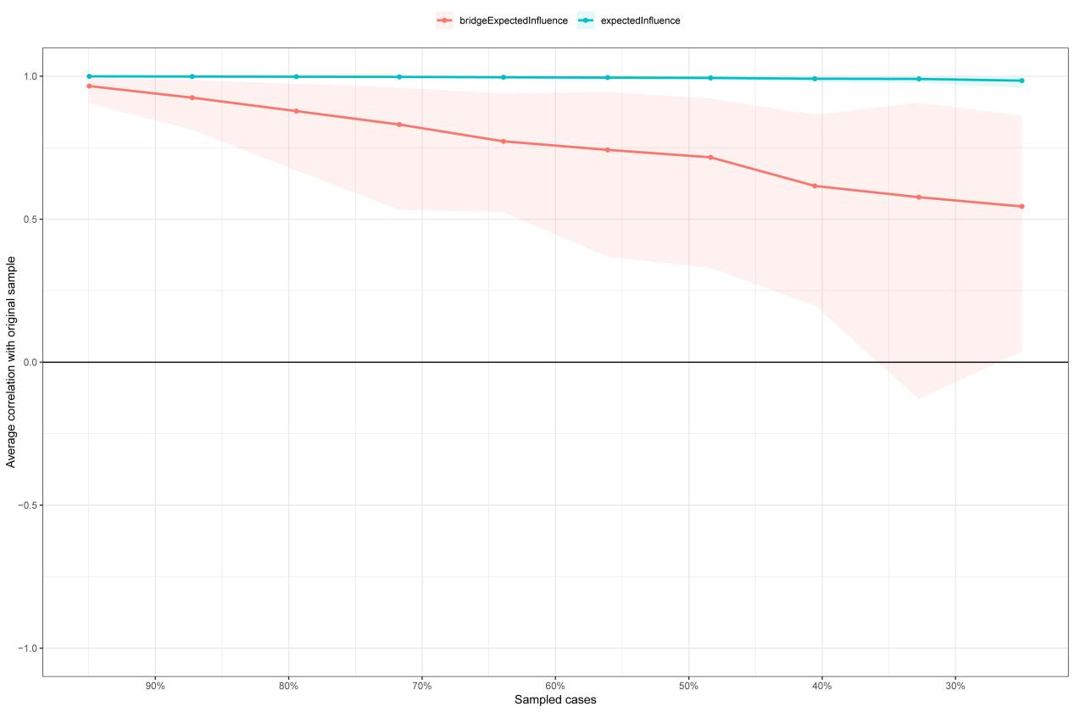
Fig. S1. Stability test of the GGM network model. Note. The blue line represents the result of the stability test for the EI indicator; the red line represents the result of the stability test for the BEI indicator.
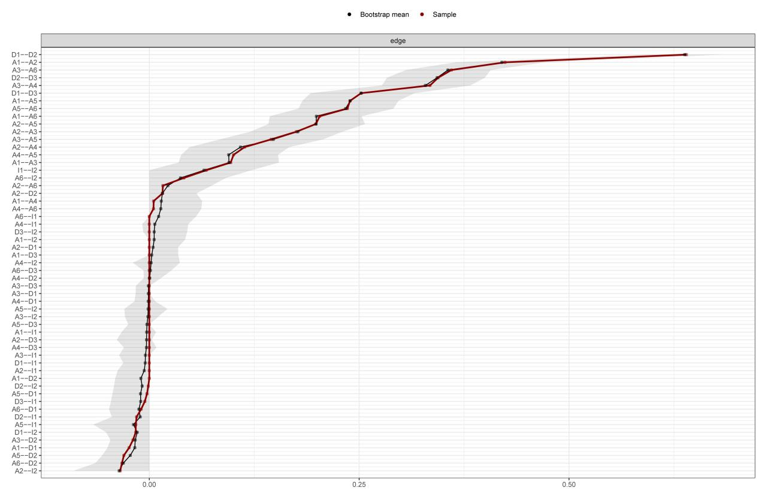
Fig. S2. Accuracy test of the GGM network model. Note. Red lines represent the edge weight values in the network model, black lines represent the average edge weight values of the sampling samples, and the gray area represents the 95% confidence interval of the edge weight values of the sampling samples.
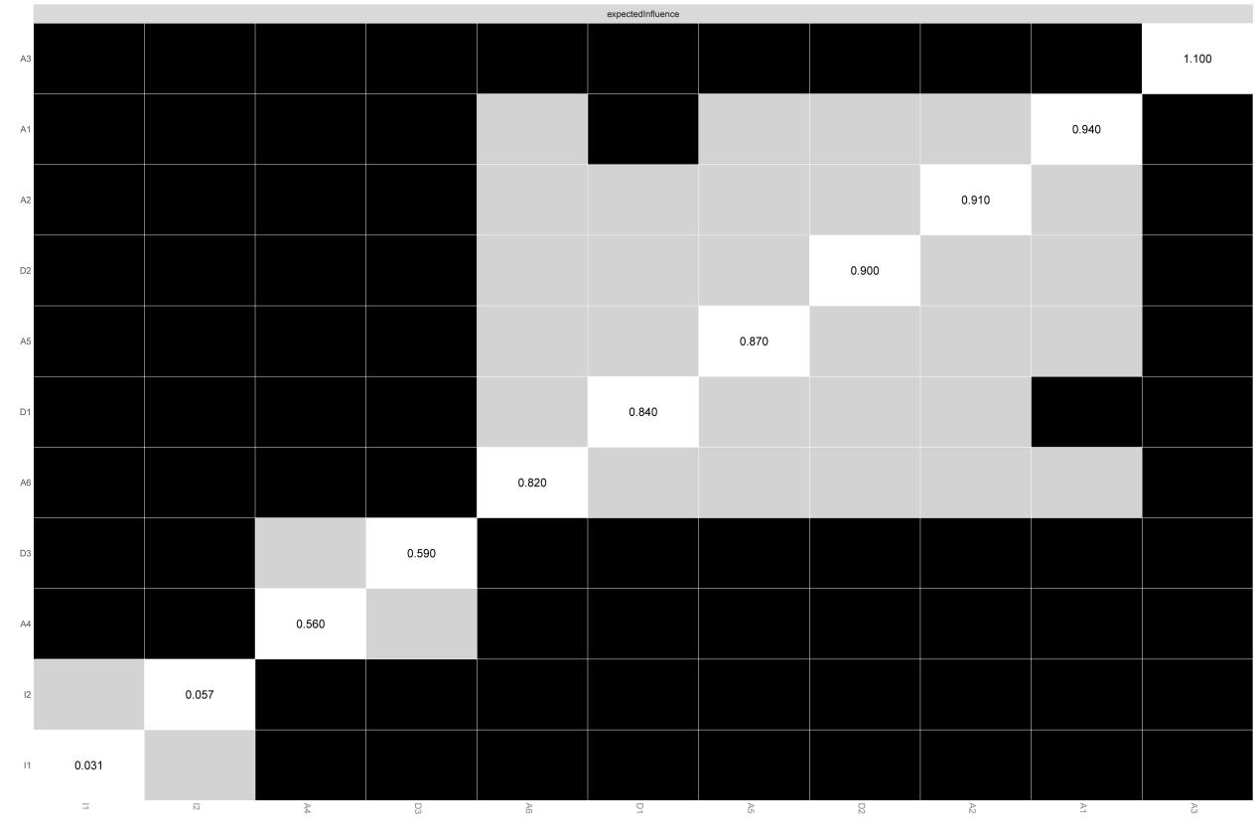
Fig. S3. The EI difference test of the GGM network model.
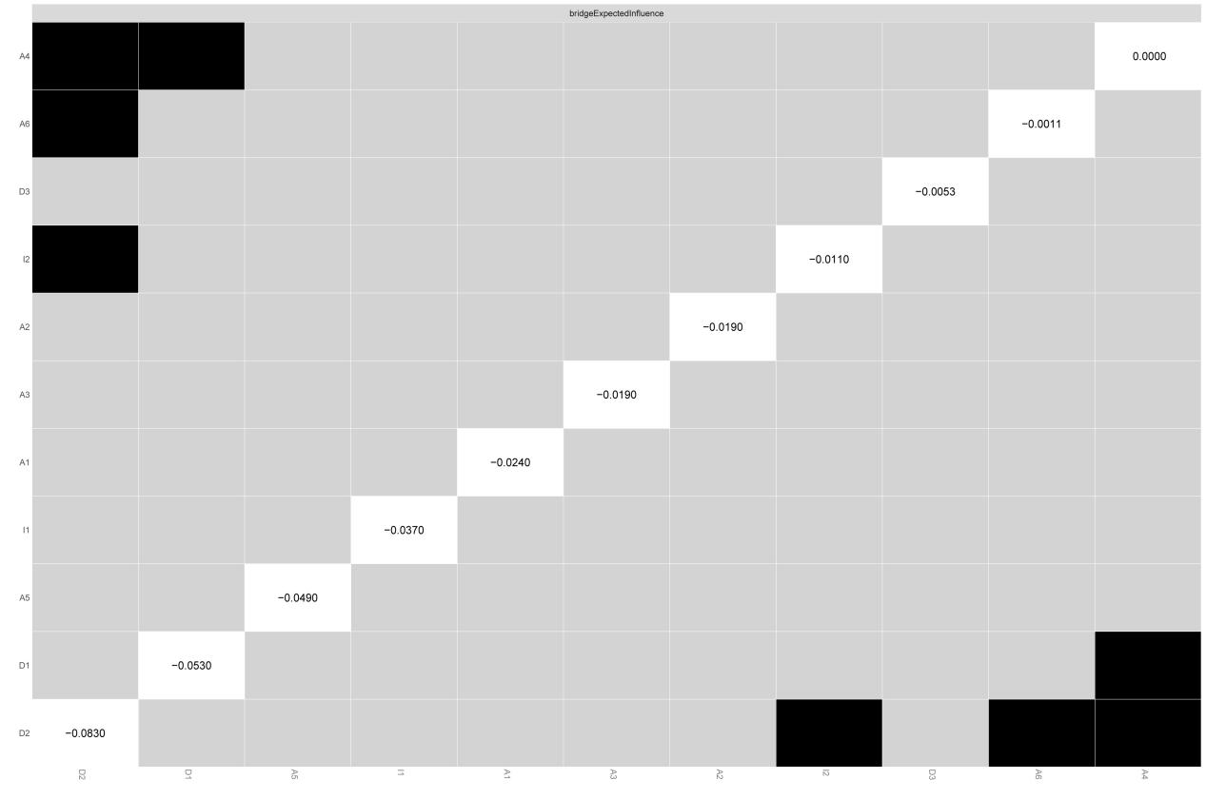
Fig. S4. The BEI difference test of the GGM network model.
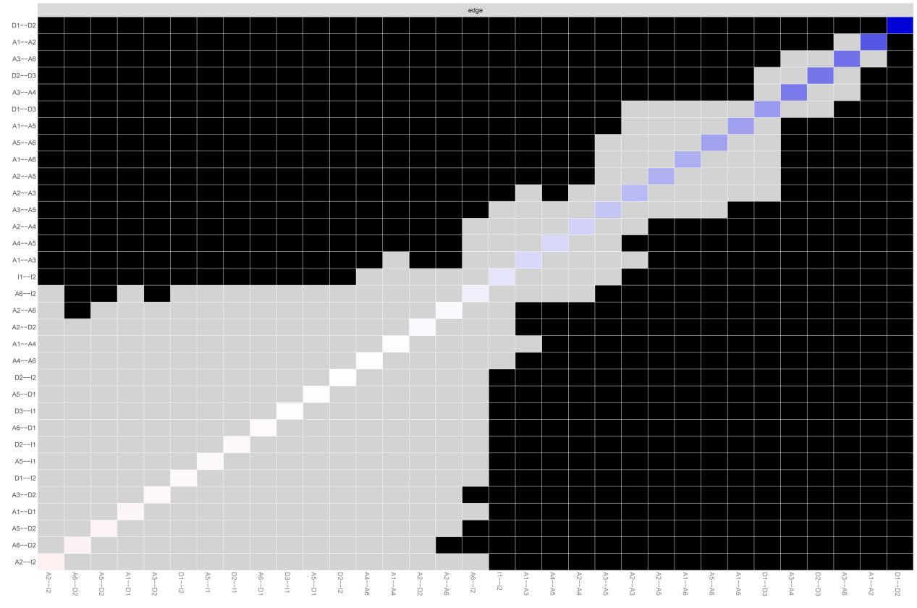
Fig. S5. The test for edge weight differences in the GGM network model. Note. The black boxes indicate that the edge weight values of the corresponding two edges are significantly different (p < 0.05), while the gray boxes indicate that the edge weight values of the corresponding two edges are not significantly different.

