Additional file 1
In utero exposure to simulated complex urban air pollution disturbs intestinal suckling-to-weaning transition in mice
Eva Guilloteau¹, Patrice Coll², Zhuyi Lu³, Madjid Djouina¹, Mathieu Cazaunau², Christophe Waxin¹, Antonin Bergé², Ségolène Caboche⁴, Aline Gratien², David Hot⁴, Laurent Dubuquoy¹, David Launay¹, Cécile Vignal¹, Sophie Lanone³, Mathilde Body-Malapel¹
- Univ. Lille, INSERM, CHU Lille, U1286 - INFINITE - Institute for Translational Research in Inflammation, F-59000 Lille, France
- Univ. Paris Est Créteil and Université de Paris, CNRS, LISA, F-94010 Créteil, France
- Univ. Paris Est Créteil, INSERM, IMRB, F-94010 Créteil, France
- Univ. Lille, CNRS, INSERM, CHU Lille, Institut Pasteur de Lille, UMR2014-US41-PLBS-Plateformes Lilloises de Biologie & Santé, F-59000, Lille, France

Fig S1 Overview of mice exposure in a dedicated exposure device. A realistic atmosphere, representative of a 2013 pollution event in Beijing, was generated in the CESAM atmospheric simulation chamber, at the extreme left of the figure. Mice were exposed to simulated Beijing-like air pollution (both gaseous and particulate phases) directly transferred from CESAM into the top part of the exposure device, while control mice (at the bottom part of the exposure device) were exposed to filtered Beijing-like air pollution during the same period.

Fig S2 Enteroendocrine cell populations markers in female ileum. Transcript levels of Tac1, Gcg, Pyy, Gip, Nts, and Sct in mice exposed to control air or Beijing-like air (n=10/group).
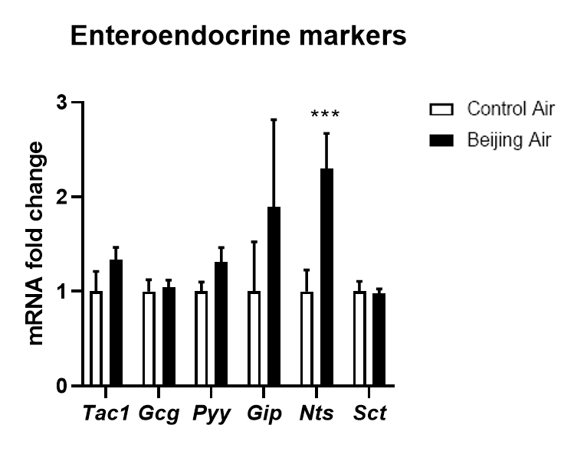

Fig S3 Evenness and Simpson α-diversity index of luminal content microbiota in male and female mice exposed in utero to control air or Beijing-like air (n=10/group).

