Online Appendix

Table A1: The 81-fund physically backed gold ETF universe from which the analytical samples are drawn
No. | Ticker | Fund name | Market | N obs.
1 | U:GLDM | Standard and Poor's Depositary Receipt Gold Minishares Trust | US | 1974
2 | U:SGOL | Abrdn Physical Gold Shares ETF | US | 4230
3 | U:OUNZ | Vaneck Merk Gold ETF | US | 3034
4 | U:BAR | Graniteshares Gold Trust | US | 2184
5 | U:GLD | Standard and Poor's Depositary Receipt Gold Shares | US | 5478
6 | U:IAU | iShares Gold Trust | US | 5427
7 | U:FGDL | Franklin Responsibly Sourced Gold ETF | US | 938
8 | C:CGL | iShares Gold Bullion ETF Hedged Common Units | Canada | 4304
9 | C:KILO | Purpose Gold Bullion Fund ETF | Canada | 1883
10 | C:ZGLD | BMO Gold Bullion Series Units ETF | Canada | 502
11 | GCGB | UBS (CMCI Gold) Sterling ETF | UK | 2369
12 | C:CGL.C | iShares Gold Bullion ETF Non-Hedged Common Units | Canada | 3820
13 | IGLN | iShares Physical (London) Gold ETC | UK | 3820
14 | RMAU | TRM Responsibly (London) Sourced Physicians Gold ETC | UK | 1548
15 | S:ZGLDUS | Swisscanto (CH) Gold ETF EA US Dollar ETF | Switzerland | 4398
16 | C:VALT | CI Gold Bullion ETF Canadian Dollar Hedged Series | Canada | 1317
17 | S:CSGOLD | iShares Gold ETF (CH) | Switzerland | 4211
18 | C:KILO.B | Purpose Gold Bullion ETF NCH | Canada | 1883
19 | PHAU | Wist PYG Individual Securities (London) ETC | UK | 4848
20 | D:4GLD | Deutsche Boerse Commodities (Frankfurt) Xetra-Gold ETC | Germany | 4679
21 | C:VALT.B | CI Gold Bullion ETF Canadian Dollar Unhedged Series | Canada | 1262
22 | SGLN | iShares Physical Gold ETC | UK | 3820
23 | S:ZGLDEU | Swisscanto (CH) Gold ETF EA European ETF | Switzerland | 4398
24 | S:AUUSI | UBS Gold ETF US Dollar DIS | Switzerland | 2995
25 | 68651M | UBS Gold ETF US Dollar (Swiss Stock Exchange) DIS | Switzerland | 4143
26 | C:ZGLH | BMO Gold Bullion ETF | Canada | 501
27 | S:RGRTU | Raiffeisen ETF-SLD Gold Resp Source and TRCB A | Switzerland | 1105
28 | CN:SFK | E Fund Gold ETF | China | 3140
29 | K:VGLD | Value Gold ETF US Dollar | Hong Kong | 2167
30 | CN:DSA | Hua An Yifu Gold ETF | China | 3240
31 | CN:GGD | Guotai Gold ETF | China | 3240
32 | IN:DGE | HDFC Gold ETF | India | 3986
33 | IN:GBE | Nippon India ETF Gold Bees | India | 4234
34 | CN:BOG | Bosera Gold ETF | China | 2958
35 | IN:FNE | SBI Gold ETF | India | 4304
36 | Q:GLD | Ktam Gold ETF Tracker | Thailand | 3734
37 | R:ETFGLDJ | 1NVEST Gold ETF | South Africa | 3062
38 | S:RGLDS | Raiffeisen Solid Gold A ETF US Dollar | Switzerland | 3641
39 | CN:CG3 | Chinaamc Gold ETF | China | 1472
40 | TW:ERF | Yuanta Standard and Poor's GSCI Gold ER Futures ETF | Taiwan | 2799
41 | CN:IGE | Icbcubs Gold ETF | China | 1477
42 | CN:QGE | First Seafront Gold ETF | China | 1477
43 | CN:FS3 | Fullgoal Shanghai Gold ETF | China | 1435
44 | CN:TSG | Tianhong Shanghai Gold ETF | China | 1184
45 | CN:GSG | Guinness Flight Shanghai Gold ETF | China | 1429
46 | IN:IPT | Icici Prudential Gold ETF | India | 3976
47 | K:VGET | Value Gold ETF | Hong Kong | 3932
48 | CN:CS0 | China Southern Shanghai Gold ETF | China | 1013
49 | CN:HSG | Harvest Shanghai Gold ETF | China | 997
50 | IN:UGF | UTI Gold Exchange Traded Fund | India | 4852
51 | SA:AGE | Albilad Gold ETF | Saudi Arabia | 1475
52 | R:GLDJ | Newgold ETF | South Africa | 5490
53 | IN:QGF | Quantum Gold Fund | India | 4626
54 | IN:AGO | Axis Gold ETF | India | 3923
55 | J:JPGE | Japan Physical Gold ETF | Japan | 4020
56 | CN:CPS | CCB Principal Shanghai Gold ETF | China | 1406
57 | KO:MA5 | Mirae Asset Tiger Gold Futures ETF (H) | South Korea | 1771
58 | IN:MI5 | Mirae Asset Gold ETF | India | 769
59 | A:QAUX | BTSH Gold Bullion CRHG ETF | Australia | 3802
60 | A:NUGGX | Vaneck Gold Bullion ETF | Australia | 824
61 | IN:IDO | LIC MF Gold Exchange Traded Fund | India | 3661
62 | IN:BUI | Aditya Birla Sun Life Gold ETF | India | 3789
63 | A:GLDNX | iShares Physical Gold ETF | Australia | 591
64 | KO:KP9 | Kim Ace KRX Physical Gold ETF | South Korea | 1077
65 | J:GPLE | Nomura NF Gold Price ETF | Japan | 4669
66 | IN:RFD | Invesco India Gold Exchange Traded Fund | India | 4094
67 | IN:ZG2 | Zerodha Gold ETF | India | 507
68 | IN:KKG | Kotak Gold ETF | India | 4771
69 | IN:DG1 | DSP Gold ETF | India | 720
70 | A:GXLDX | Global X Gold Bullion ETF | Australia | 464
71 | IN:GG1 | Groww Gold ETF | India | 339
72 | D:PPFB | iShares Physical (XETRA) Gold ETC | Germany | 3526
73 | IN:BBP | Baroda Banque Nationale de Paris Paribas Gold ETF | India | 558
74 | IN:TG1 | Tata Gold Exchange Traded Fund | India | 539
75 | Z:SMGE | Smart Gold ETF | New Zealand | 339
76 | IN:EDEI | Edelweiss Gold ETF | India | 585
77 | J:BIGE | BRJ iShares Gold ETF | Japan | 281
78 | TK:ZPG | Ziraat Portfolio Gold Participation ETF | Turkey | 1478
79 | IN:UGE | Union Gold ETF | India | 255
80 | TK:IST | QNB Portfolio Gold Participation ETF | Turkey | 4993
81 | S:ZGLD | Swisscanto (CH) Gold ETF EA Swiss Franc ETF | Switzerland | 5134

Table A2: 71 ETFs in 10 country groups for TVP-VAR connectedness, panel estimation, and Bai-Perron structural breaks
Every fund in the ten structurally coherent national markets, aggregated to equal-weighted country groups. N obs. counts non-missing daily prices through 18 February 2026.
No. | Ticker | Fund name | Market | N obs.
1 | U:GLD | SPDR Gold Shares | United States | 5545
2 | U:IAU | iShares Gold Trust | United States | 5494
3 | U:GLDM | SPDR Gold MiniShares Trust | United States | 1997
4 | U:SGOL | Abrdn Physical Gold Shares ETF | United States | 4291
5 | U:BAR | GraniteShares Gold Trust | United States | 2210
6 | U:OUNZ | VanEck Merk Gold ETF | United States | 3069
7 | U:FGDL | Franklin Responsibly Sourced Gold ETF | United States | 950
8 | C:CGL | iShares Gold Bullion ETF Hedged | Canada | 4365
9 | C:CGL.C | iShares Gold Bullion ETF Non-Hedged | Canada | 3879
10 | C:ZGLH | BMO Gold Bullion ETF | Canada | 508
11 | C:ZGLD | BMO Gold Bullion Series Units ETF | Canada | 509
12 | C:KILO | Purpose Gold Bullion Fund ETF | Canada | 1906
13 | C:KILO.B | Purpose Gold Bullion ETF NCH | Canada | 1906
14 | C:VALT | CI Gold Bullion ETF CAD Hedged | Canada | 1332
15 | C:VALT.B | CI Gold Bullion ETF CAD Unhedged | Canada | 1277
16 | SGLN | iShares Physical Gold ETC | United Kingdom | 3879
17 | IGLN | iShares Physical Gold ETC (London) | United Kingdom | 3879
18 | PHAU | WisdomTree Physical Gold ETC (London) | United Kingdom | 4913
19 | RMAU | TRM Responsibly Sourced Physical Gold ETC | United Kingdom | 1566
20 | GCGB | UBS (CMCI Gold) Sterling ETF | United Kingdom | 2398
21 | D:4GLD | Deutsche Boerse Commodities Xetra-Gold ETC | Germany | 4744
22 | D:PPFB | iShares Physical Gold ETC (Xetra) | Germany | 3582
23 | S:ZGLD | Swisscanto (CH) Gold ETF EA CHF | Switzerland | 5201
24 | S:ZGLDUS | Swisscanto (CH) Gold ETF EA US Dollar | Switzerland | 4459
25 | S:ZGLDEU | Swisscanto (CH) Gold ETF EA EUR | Switzerland | 4459
26 | S:CSGOLD | iShares Gold ETF (CH) | Switzerland | 4272
27 | 68651M | UBS Gold ETF US Dollar DIS (SIX) | Switzerland | 4202
28 | S:AUUSI | UBS Gold ETF US Dollar DIS | Switzerland | 3030
29 | S:RGLDS | Raiffeisen Solid Gold A ETF USD | Switzerland | 3700
30 | S:RGRTU | Raiffeisen ETF-SLD Gold Resp Source A | Switzerland | 1119
31 | A:GLDNX | iShares Physical Gold ETF | Australia | 600
32 | A:NUGGX | Vaneck Gold Bullion ETF | Australia | 836
33 | A:GXLDX | Global X Gold Bullion ETF | Australia | 470
34 | A:QAUX | BTSH Gold Bullion CRHG ETF | Australia | 3861
35 | CN:BOG | Bosera Gold ETF | China | 2993
36 | CN:CPS | CCB Principal Shanghai Gold ETF | China | 1423
37 | CN:CG3 | ChinaAMC Gold ETF | China | 1489
38 | CN:SFK | E Fund Gold ETF | China | 3178
39 | CN:QGE | First Seafront Gold ETF | China | 1494
40 | CN:FS3 | Fullgoal Shanghai Gold ETF | China | 1452
41 | CN:GSG | Guinness Flight Shanghai Gold ETF | China | 1446
42 | CN:GGD | Guotai Gold ETF | China | 3278
43 | CN:HSG | Harvest Shanghai Gold ETF | China | 1010
44 | CN:DSA | Hua An Yifu Gold ETF | China | 3278
45 | CN:IGE | ICBCubs Gold ETF | China | 1494
46 | CN:TSG | Tianhong Shanghai Gold ETF | China | 1198
47 | CN:CS0 | China Southern Shanghai Gold ETF | China | 1026
48 | IN:GBE | Nippon India ETF Gold BeES | India | 4295
49 | IN:DGE | HDFC Gold ETF | India | 4045
50 | IN:IPT | ICICI Prudential Gold ETF | India | 4035
51 | IN:KKG | Kotak Gold ETF | India | 4836
52 | IN:FNE | SBI Gold ETF | India | 4365
53 | IN:AGO | Axis Gold ETF | India | 3982
54 | IN:UGF | UTI Gold Exchange Traded Fund | India | 4917
55 | IN:RFD | Invesco India Gold Exchange Traded Fund | India | 4153
56 | IN:IDO | LIC MF Gold Exchange Traded Fund | India | 3720
57 | IN:QGF | Quantum Gold Fund | India | 4689
58 | IN:TG1 | Tata Gold Exchange Traded Fund | India | 546
59 | IN:DG1 | DSP Gold ETF | India | 729
60 | IN:EDEI | Edelweiss Gold ETF | India | 594
61 | IN:BUI | Aditya Birla Sun Life Gold ETF | India | 3848
62 | IN:MI5 | Mirae Asset Gold ETF | India | 779
63 | IN:UGE | Union Gold ETF | India | 259
64 | IN:GG1 | Groww Gold ETF | India | 345
65 | IN:BBP | Baroda BNP Paribas Gold ETF | India | 567
66 | IN:ZG2 | Zerodha Gold ETF | India | 514
67 | J:BIGE | BRJ iShares Gold ETF | Japan | 285
68 | J:JPGE | Japan Physical Gold ETF | Japan | 4079
69 | J:GPLE | Nomura NF Gold Price ETF | Japan | 4732
70 | KO:KP9 | Kim Ace KRX Physical Gold ETF | South Korea | 1091
71 | KO:MA5 | Mirae Asset Tiger Gold Futures ETF (H) | South Korea | 1792

Table A3: 24 ETFs, 5 markets for Markov regime switching, daily specification
Physically backed funds whose benchmark correlation supports a two-state decomposition
No. | Ticker | Fund name | Market | N obs.
1 | C:CGL | iShares Gold Bullion ETF Hedged Common Units | Canada | 3703
2 | C:CGL.C | iShares Gold Bullion ETF Non-Hedged Common Units | Canada | 3221
3 | C:KILO | Purpose Gold Bullion Fund ETF | Canada | 1494
4 | C:KILO.B | Purpose Gold Bullion ETF NCH | Canada | 1494
5 | C:VALT | CI Gold Bullion ETF Canadian Dollar Hedged Series | Canada | 1047
6 | C:VALT.B | CI Gold Bullion ETF Canadian Dollar Unhedged Series | Canada | 1003
7 | C:ZGLD | BMO Gold Bullion Series Units ETF | Canada | 396
8 | C:ZGLH | BMO Gold Bullion ETF | Canada | 396
9 | S:CSGOLD | iShares Gold ETF (CH) | Switzerland | 3610
10 | S:ZGLDEU | Swisscanto (CH) Gold ETF EA European ETF | Switzerland | 3797
11 | S:ZGLDUS | Swisscanto (CH) Gold ETF EA US Dollar ETF | Switzerland | 3797
12 | D:4GLD | Deutsche Boerse Commodities (Frankfurt) Xetra-Gold ETC | Germany | 4074
13 | GCGB | UBS (CMCI Gold) Sterling ETF | United Kingdom | 1882
14 | IGLN | iShares Physical (London) Gold ETC | United Kingdom | 3221
15 | PHAU | Wist PYG Individual Securities (London) ETC | United Kingdom | 4243
16 | RMAU | TRM Responsibly (London) Sourced Physicians Gold ETC | United Kingdom | 1231
17 | SGLN | iShares Physical Gold ETC | United Kingdom | 3221
18 | U:BAR | Graniteshares Gold Trust | United States | 1734
19 | U:FGDL | Franklin Responsibly Sourced Gold ETF | United States | 744
20 | U:GLD | Standard and Poor's Depositary Receipt Gold Shares | United States | 4871
21 | U:GLDM | Standard and Poor's Depositary Receipt Gold Minishares Trust | United States | 1567
22 | U:IAU | iShares Gold Trust | United States | 4820
23 | U:OUNZ | Vaneck Merk Gold ETF | United States | 2444
24 | U:SGOL | Abrdn Physical Gold Shares ETF | United States | 3629
Table A4: 22 ETFs, 5 markets for TVTP-MRS, weekly specification
The original 25-fund estimation less C:ZGLD and C:ZGLH, whose weekly overlap is insufficient
No. | Ticker | Fund name | Market | N obs.
1 | C:CGL | iShares Gold Bullion ETF Hedged Common Units | Canada | 3703
2 | C:CGL.C | iShares Gold Bullion ETF Non-Hedged Common Units | Canada | 3221
3 | C:KILO | Purpose Gold Bullion Fund ETF | Canada | 1494
4 | C:KILO.B | Purpose Gold Bullion ETF NCH | Canada | 1494
5 | C:VALT | CI Gold Bullion ETF Canadian Dollar Hedged Series | Canada | 1047
6 | C:VALT.B | CI Gold Bullion ETF Canadian Dollar Unhedged Series | Canada | 1003
7 | S:CSGOLD | iShares Gold ETF (CH) | Switzerland | 3610
8 | S:ZGLDEU | Swisscanto (CH) Gold ETF EA European ETF | Switzerland | 3797
9 | S:ZGLDUS | Swisscanto (CH) Gold ETF EA US Dollar ETF | Switzerland | 3797
10 | D:4GLD | Deutsche Boerse Commodities (Frankfurt) Xetra-Gold ETC | Germany | 4074
11 | GCGB | UBS (CMCI Gold) Sterling ETF | United Kingdom | 1882
12 | IGLN | iShares Physical (London) Gold ETC | United Kingdom | 3221
13 | PHAU | Wist PYG Individual Securities (London) ETC | United Kingdom | 4243
14 | RMAU | TRM Responsibly (London) Sourced Physicians Gold ETC | United Kingdom | 1231
15 | SGLN | iShares Physical Gold ETC | United Kingdom | 3221
16 | U:BAR | Graniteshares Gold Trust | United States | 1734
17 | U:FGDL | Franklin Responsibly Sourced Gold ETF | United States | 744
18 | U:GLD | Standard and Poor's Depositary Receipt Gold Shares | United States | 4871
19 | U:GLDM | Standard and Poor's Depositary Receipt Gold Minishares Trust | United States | 1567
20 | U:IAU | iShares Gold Trust | United States | 4820
21 | U:OUNZ | Vaneck Merk Gold ETF | United States | 2444
22 | U:SGOL | Abrdn Physical Gold Shares ETF | United States | 3629

Table A5: ETF-level daily constant-transition MRS estimates for the retained sample
Ticker | Country | Benchmark | Lag | N obs | Corr | Beta | TE SD | sigma_low | sigma_high | Ratio | p_LL | p_HH | Low duration | High duration | High share
C:CGL | CA | Gold_USD | 0 | 3703 | 0.941 | 0.975 | 35.75 | 19.60 | 75.02 | 3.83 | 0.958 | 0.796 | 23.720 | 4.897 | 0.143
C:CGL.C | CA | Gold_USD | 0 | 3221 | 0.810 | 0.813 | 62.66 | 44.63 | 113.66 | 2.55 | 0.968 | 0.849 | 30.785 | 6.605 | 0.144
C:KILO | CA | Gold_USD | 0 | 1494 | 0.897 | 0.931 | 47.11 | 19.89 | 88.45 | 4.45 | 0.920 | 0.755 | 12.460 | 4.081 | 0.207
C:KILO.B | CA | Gold_USD | 0 | 1494 | 0.753 | 0.758 | 71.63 | 51.69 | 149.83 | 2.90 | 0.941 | 0.586 | 17.028 | 2.417 | 0.070
C:VALT | CA | Gold_USD | 0 | 1047 | 0.798 | 0.820 | 66.57 | 24.19 | 99.51 | 4.11 | 0.880 | 0.830 | 8.305 | 5.871 | 0.377
C:VALT.B | CA | Gold_USD | 0 | 1003 | 0.701 | 0.653 | 77.62 | 45.94 | 116.56 | 2.54 | 0.860 | 0.728 | 7.160 | 3.679 | 0.261
C:ZGLD | CA | Gold_USD | 0 | 396 | 0.894 | 0.841 | 57.14 | 31.10 | 93.20 | 3.00 | 0.845 | 0.631 | 6.465 | 2.708 | 0.200
C:ZGLH | CA | Gold_USD | 0 | 396 | 0.753 | 0.780 | 90.57 | 27.99 | 128.75 | 4.60 | 0.953 | 0.944 | 21.115 | 17.872 | 0.465
S:CSGOLD | CH | Gold_USD | 0 | 3610 | 0.760 | 0.758 | 70.17 | 42.25 | 117.73 | 2.79 | 0.940 | 0.830 | 16.688 | 5.874 | 0.221
S:ZGLDEU | CH | Gold_EUR | 0 | 3797 | 0.786 | 0.771 | 64.42 | 37.50 | 112.91 | 3.01 | 0.949 | 0.840 | 19.579 | 6.252 | 0.207
S:ZGLDUS | CH | Gold_USD | 0 | 3797 | 0.792 | 0.786 | 65.71 | 33.62 | 107.10 | 3.19 | 0.914 | 0.806 | 11.583 | 5.163 | 0.264
D:4GLD | Germany | Gold_EUR | 0 | 4074 | 0.883 | 0.891 | 50.88 | 26.95 | 88.04 | 3.27 | 0.937 | 0.825 | 15.779 | 5.704 | 0.236
GCGB | UK | Gold_USD | 0 | 1882 | 0.803 | 0.789 | 59.09 | 35.53 | 99.92 | 2.81 | 0.942 | 0.830 | 17.142 | 5.875 | 0.208
IGLN | UK | Gold_USD | 0 | 3221 | 0.801 | 0.802 | 63.88 | 35.77 | 114.77 | 3.21 | 0.932 | 0.778 | 14.646 | 4.507 | 0.186
PHAU | UK | Gold_USD | 0 | 4243 | 0.773 | 0.791 | 75.69 | 38.86 | 134.00 | 3.45 | 0.932 | 0.805 | 14.825 | 5.117 | 0.218
RMAU | UK | Gold_USD | 0 | 1231 | 0.818 | 0.798 | 63.78 | 41.58 | 123.04 | 2.96 | 0.952 | 0.770 | 20.717 | 4.352 | 0.136
SGLN | UK | Gold_GBP | 0 | 3221 | 0.827 | 0.817 | 58.90 | 33.86 | 97.42 | 2.88 | 0.939 | 0.843 | 16.485 | 6.349 | 0.247
U:BAR | US | Gold_USD | 0 | 1734 | 0.981 | 0.998 | 19.37 | 10.05 | 38.37 | 3.82 | 0.945 | 0.784 | 18.290 | 4.635 | 0.170
U:FGDL | US | Gold_USD | 0 | 744 | 0.977 | 1.010 | 24.28 | 8.78 | 37.92 | 4.32 | 0.910 | 0.850 | 11.081 | 6.676 | 0.351
U:GLD | US | Gold_USD | 0 | 4871 | 0.984 | 1.004 | 20.21 | 9.99 | 38.09 | 3.81 | 0.944 | 0.810 | 17.731 | 5.273 | 0.201
U:GLDM | US | Gold_USD | 0 | 1567 | 0.986 | 0.999 | 17.22 | 9.19 | 37.46 | 4.08 | 0.937 | 0.670 | 15.810 | 3.031 | 0.122
U:IAU | US | Gold_USD | 0 | 4820 | 0.982 | 1.002 | 21.41 | 11.52 | 45.39 | 3.94 | 0.956 | 0.782 | 22.580 | 4.593 | 0.141
U:OUNZ | US | Gold_USD | 0 | 2444 | 0.981 | 0.997 | 18.90 | 10.79 | 51.29 | 4.75 | 0.966 | 0.679 | 29.423 | 3.120 | 0.077
U:SGOL | US | Gold_USD | 0 | 3629 | 0.983 | 0.996 | 18.85 | 9.14 | 35.88 | 3.93 | 0.927 | 0.751 | 13.724 | 4.017 | 0.187

Table A6: Peak windows from the cross-sectional daily MRS tracking-stress index
date | avg_prob_5d | avg_high_prob | share_high_gt50 | n_etfs
2026-01-30 | 0.931 | 0.912 | 0.920 | 25
2011-09-29 | 0.893 | 0.869 | 0.846 | 13
2009-12-09 | 0.886 | 0.758 | 0.700 | 10
2020-03-18 | 0.870 | 0.871 | 0.900 | 20
2013-05-23 | 0.861 | 0.710 | 0.692 | 13
2026-02-10 | 0.855 | 0.662 | 0.560 | 25
2020-04-14 | 0.844 | 0.834 | 0.800 | 20
2016-02-18 | 0.827 | 0.734 | 0.714 | 14
2011-08-29 | 0.824 | 0.804 | 0.846 | 13
2020-04-03 | 0.818 | 0.807 | 0.950 | 20

Table A7: Country Group Composition for TVP-VAR Connectedness Analysis
Country Group | N | ETF Tickers Included | Earliest
United States (US) | 7 | GLD, IAU, GLDM, SGOL, BAR, OUNZ, FGDL | 2004
Canada (CA) | 8 | CGL, CGL.C, ZGLH, ZGLD, KILO, KILO.B, VALT, VALT.B | 2009
UK (UK) | 5 | SGLN, IGLN, PHAU, RMAU, GCGB | 2007
Germany (DE) | 2 | D:4GLD, D:PPFB | 2007
Switzerland (CH) | 8 | ZGLD, ZGLDUS, ZGLDEU, CSGOLD, 68651M, AUUSI, RGLDS, RGRTU | 2006
Australia (AU) | 4 | GLDNX, NUGGX, GXLDX, QAUX | 2011
China (CN) | 13 | BOG, CPS, CG3, SFK, QGE, FS3, GSG, GGD, HSG, DSA, IGE, TSG, CS0 | 2013
India (IN) | 19 | GBE, DGE, IPT, KKG, FNE, AGO, UGF, RFD, IDO, QGF + 9 others | 2007
Japan (JP) | 3 | BIGE, JPGE, GPLE | 2008
South Korea (KR) | 2 | KP9, MA5 | 2019
Total | 71

Table A8: Sub-Period Connectedness Summary
Period | N | Mean TCI | Max TCI | SD | NET US | NET CN | NET CA
COVID (2020) | 246 | 67.27 | 76.80 | 3.73 | −32.3 | +7.8 | −15.6
Post-COVID (2021-2022) | 516 | 63.11 | 69.31 | 3.02 | −15.7 | +9.9 | −12.7
Russia-Ukraine (2022) | 220 | 64.52 | 67.82 | 1.71 | −11.4 | +9.8 | −10.7
Recent (2023-2025) | 774 | 64.64 | 73.30 | 2.83 | −14.4 | +8.8 | −12.7
Notes: Russia-Ukraine sub-period begins 24 February 2022. NET US, NET CN, NET CA report mean net directional connectedness for United States, China, and Canada respectively. Full-sample TCI = 64.57%.

Table A9: Formal Hypothesis Tests for H2 (Tracking Spillovers)
Test | Statistic | p-value | Decision | Interpretation
H₀: TCI = 0 | t = 766.0 | < 0.001 | Reject | Significant cross-market spillovers
H₀: NET(US) = 0 | t = −61.2 | < 0.001 | Reject | US is net receiver (−17.1%)
H₀: NET(Asia-Pac.) = 0 | t = 53.79 | < 0.001 | Reject | Asian markets are net transmitters
H₀: TCI(COVID) = TCI(Post) | t = 15.29 | < 0.001 | Reject | COVID elevates connectedness
10-country vs 9-country TCI | ρ = 0.986 | — | Robust | Qualitatively identical results
Notes: One-sample t-tests for NET measures use the full time series of daily NET values. Asia-Pacific group comprises China, India, Australia, Japan, and South Korea (means tested against zero). COVID period = 2020; Post-COVID = 2021-2022. ρ = Pearson correlation between overlapping TCI series from the 10-country main analysis and the 9-country robustness check.

Table A10: Top 15 Pairwise Connectedness Links
From | To | GFEVD (%) | Net Flow (%)
CH | UK | 21.4 | +3.2
UK | CH | 18.2 | −3.2
CH | DE | 17.4 | +3.5
KR | CN | 16.4 | +0.2
KR | AU | 16.4 | +0.4
CN | KR | 16.2 | −0.2
AU | KR | 16.0 | −0.4
CN | AU | 15.5 | +0.1
AU | CN | 15.4 | −0.1
KR | JP | 14.5 | +1.7
KR | IN | 14.5 | +1.0
CN | JP | 14.3 | +2.0
CN | IN | 14.0 | +0.9
DE | CH | 13.9 | −3.5
AU | IN | 13.8 | +0.4
Notes: Sorted by GFEVD (%) descending. Net Flow = GFEVD(From→To) − GFEVD(To→From); positive values indicate the 'From' country is a net transmitter to the 'To' country.

Table A11: Country-specific CCE-MG coefficient estimates
Market | VIX | Gold vol. | DXY | GVZ | |Gold ret.| | EPU | GPR | δ (common factor) | R²
US | -1.295*** (0.431) | 0.643 (0.409) | 0.550 (0.376) | 4.919*** (0.589) | 0.740** (0.347) | 0.497 (0.328) | 0.078 (0.397) | 0.054*** (0.008) | 0.285
Canada | 7.530*** (0.930) | -2.404*** (0.882) | 2.272*** (0.811) | -0.192 (1.270) | 5.009*** (0.748) | -3.244*** (0.707) | -0.001 (0.857) | 0.203*** (0.017) | 0.282
UK | -0.370 (1.307) | 0.455 (1.239) | 1.932* (1.140) | 3.801** (1.785) | 0.721 (1.051) | -0.780 (0.993) | 1.080 (1.205) | 0.480*** (0.024) | 0.353
Germany | 6.930*** (1.330) | -1.502 (1.261) | 2.078* (1.160) | 0.321 (1.816) | 1.557 (1.069) | 1.289 (1.010) | -0.274 (1.226) | 0.463*** (0.024) | 0.352
Switzerland | -0.112 (1.177) | -0.385 (1.116) | 3.358*** (1.026) | 2.435 (1.607) | 6.686*** (0.946) | -0.266 (0.894) | 0.952 (1.085) | 0.515*** (0.021) | 0.491
Australia | 0.812 (1.501) | 4.579*** (1.423) | -0.884 (1.309) | -7.235*** (2.049) | -3.833*** (1.206) | 0.991 (1.140) | 0.761 (1.384) | 1.711*** (0.027) | 0.795
China | -0.530 (1.428) | 0.714 (1.354) | -4.778*** (1.245) | -7.515*** (1.949) | -2.448** (1.148) | -1.663 (1.085) | -1.378 (1.316) | 1.697*** (0.026) | 0.802
India | -5.882*** (1.711) | -2.460 (1.622) | -1.075 (1.492) | 4.790** (2.336) | 0.416 (1.375) | 2.528* (1.300) | 2.998* (1.577) | 1.426*** (0.031) | 0.699
Japan | -2.711 (1.911) | -1.837 (1.812) | -3.379** (1.666) | 1.413 (2.609) | 0.631 (1.536) | -1.154 (1.452) | -3.619** (1.761) | 1.609*** (0.035) | 0.696
South Korea | -4.372*** (1.464) | 2.196 (1.388) | -0.075 (1.276) | -2.738 (1.999) | -9.478*** (1.177) | 1.802 (1.112) | -0.597 (1.349) | 1.842*** (0.026) | 0.816
Notes: Country-specific slope estimates from the CCE-MG specification, Eq. (9), with classical standard errors in parentheses. All regressors are standardised, so coefficients are in basis points per standard deviation. δ is the loading on the cross-sectional mean of the dependent variable, the proxy for unobserved common factors; country intercepts are omitted. T = 1,721 daily observations per market, April 2019 to February 2026. The mean of the country R² values is 0.557 and the mean δ is 1.000, as reported in Table 6. *** p < 0.01, ** p < 0.05, * p < 0.10.

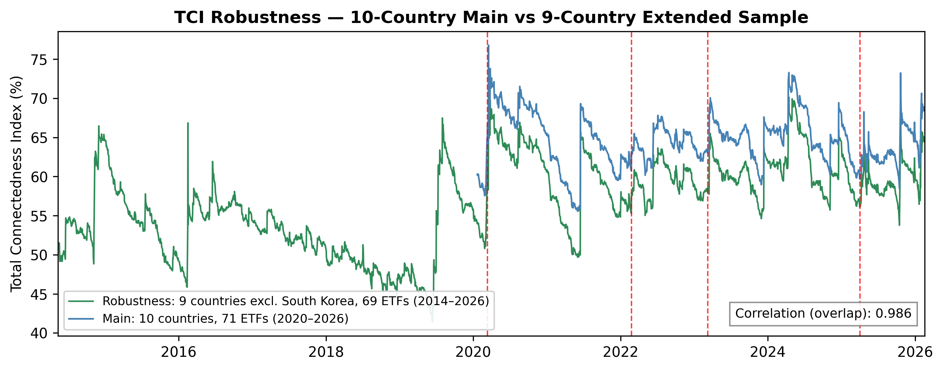
Fig.A1: TCI Robustness - 10 vs 9 Country Groups

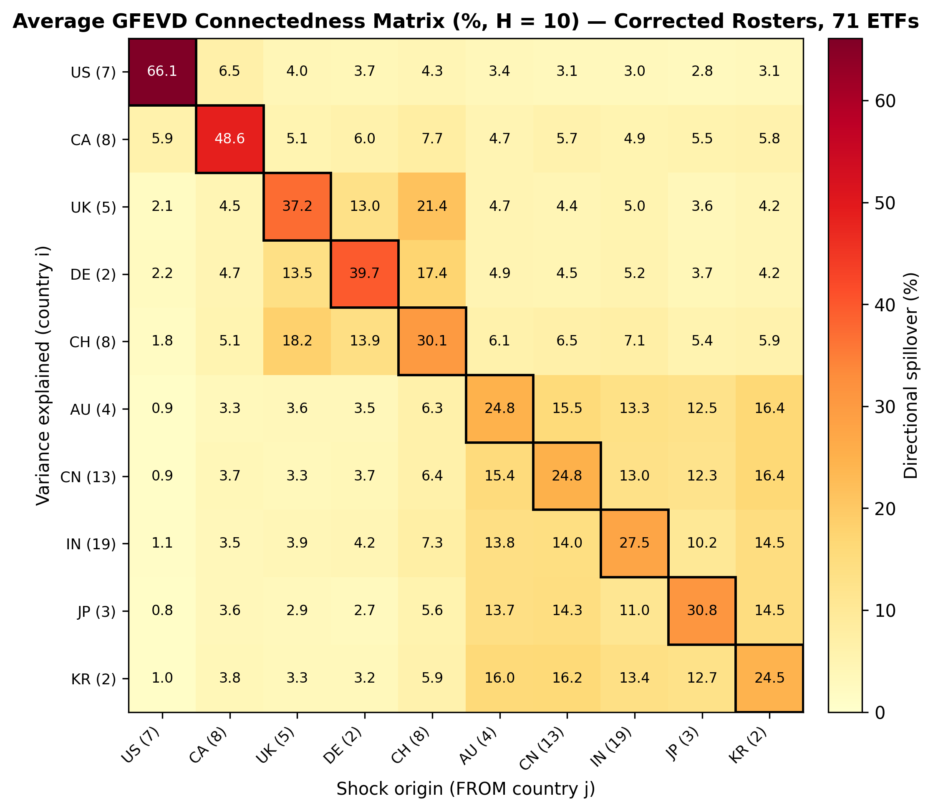
Fig. A2: Average GFEVD Connectedness Heatmap

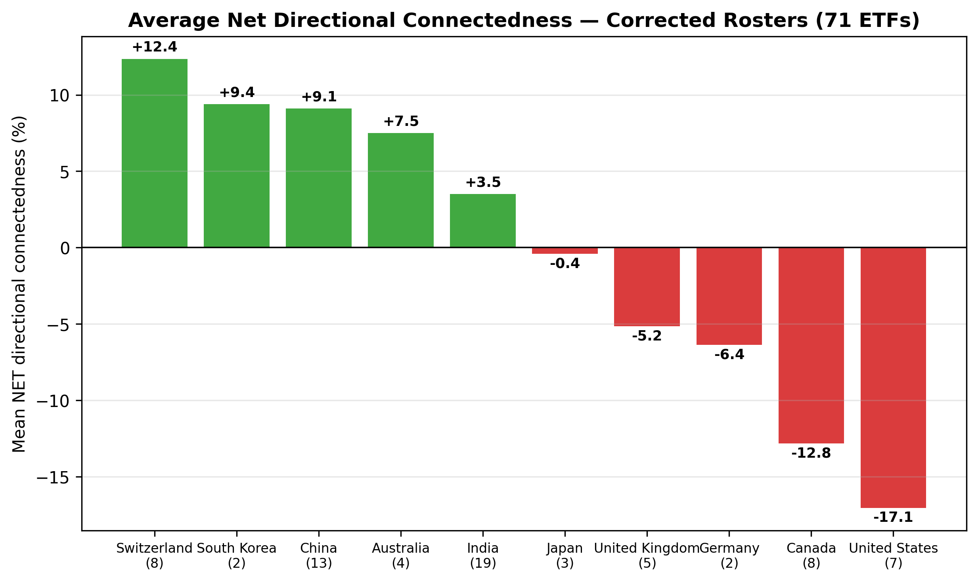
Fig. A3: Average Net Directional Connectedness

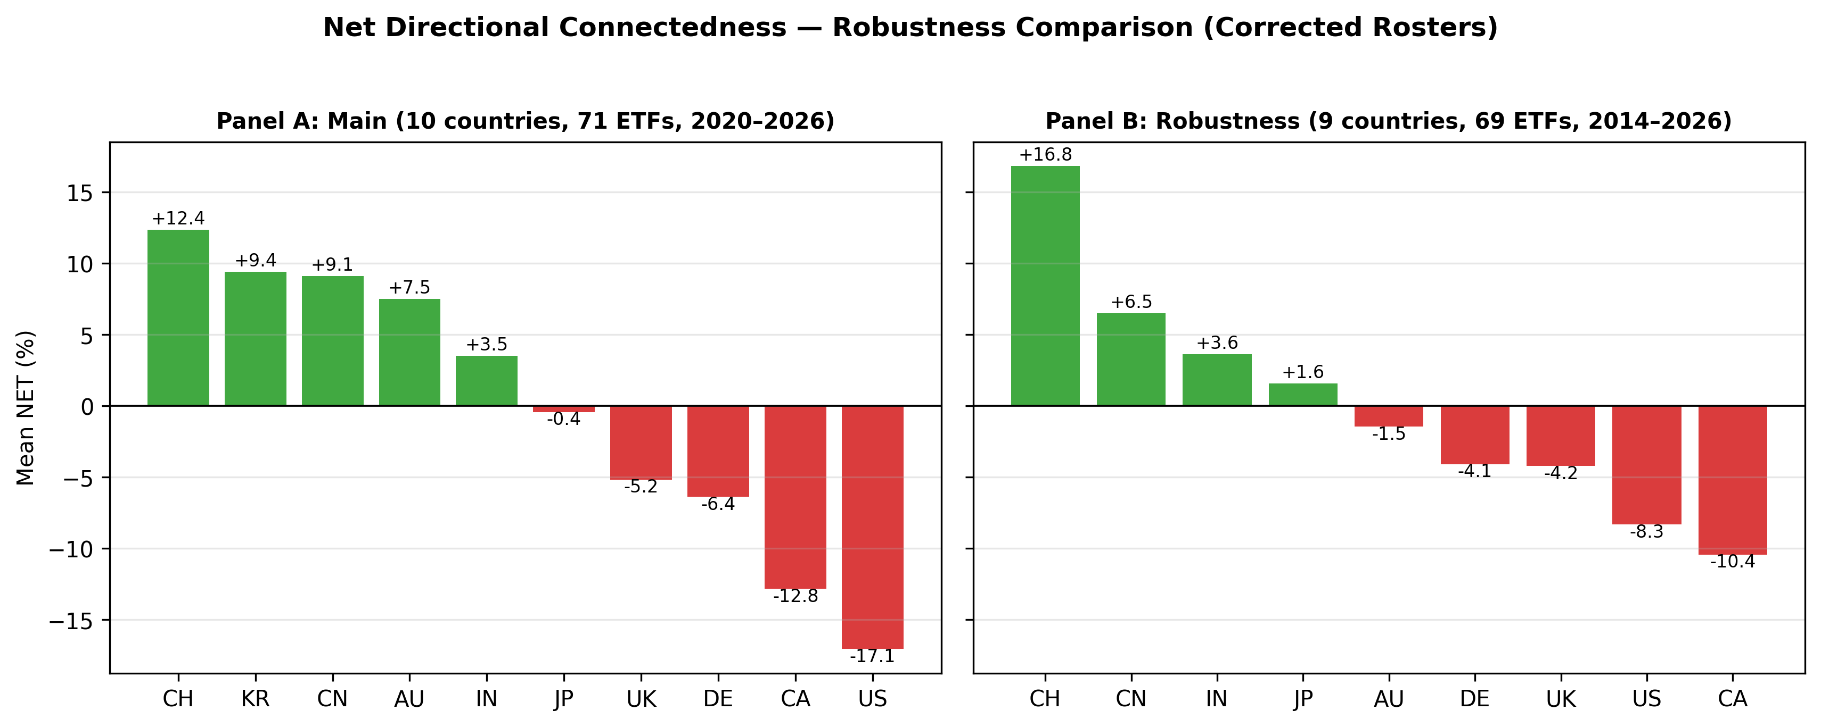
Fig. A4: Net Directional Connectedness - Robustness Comparison

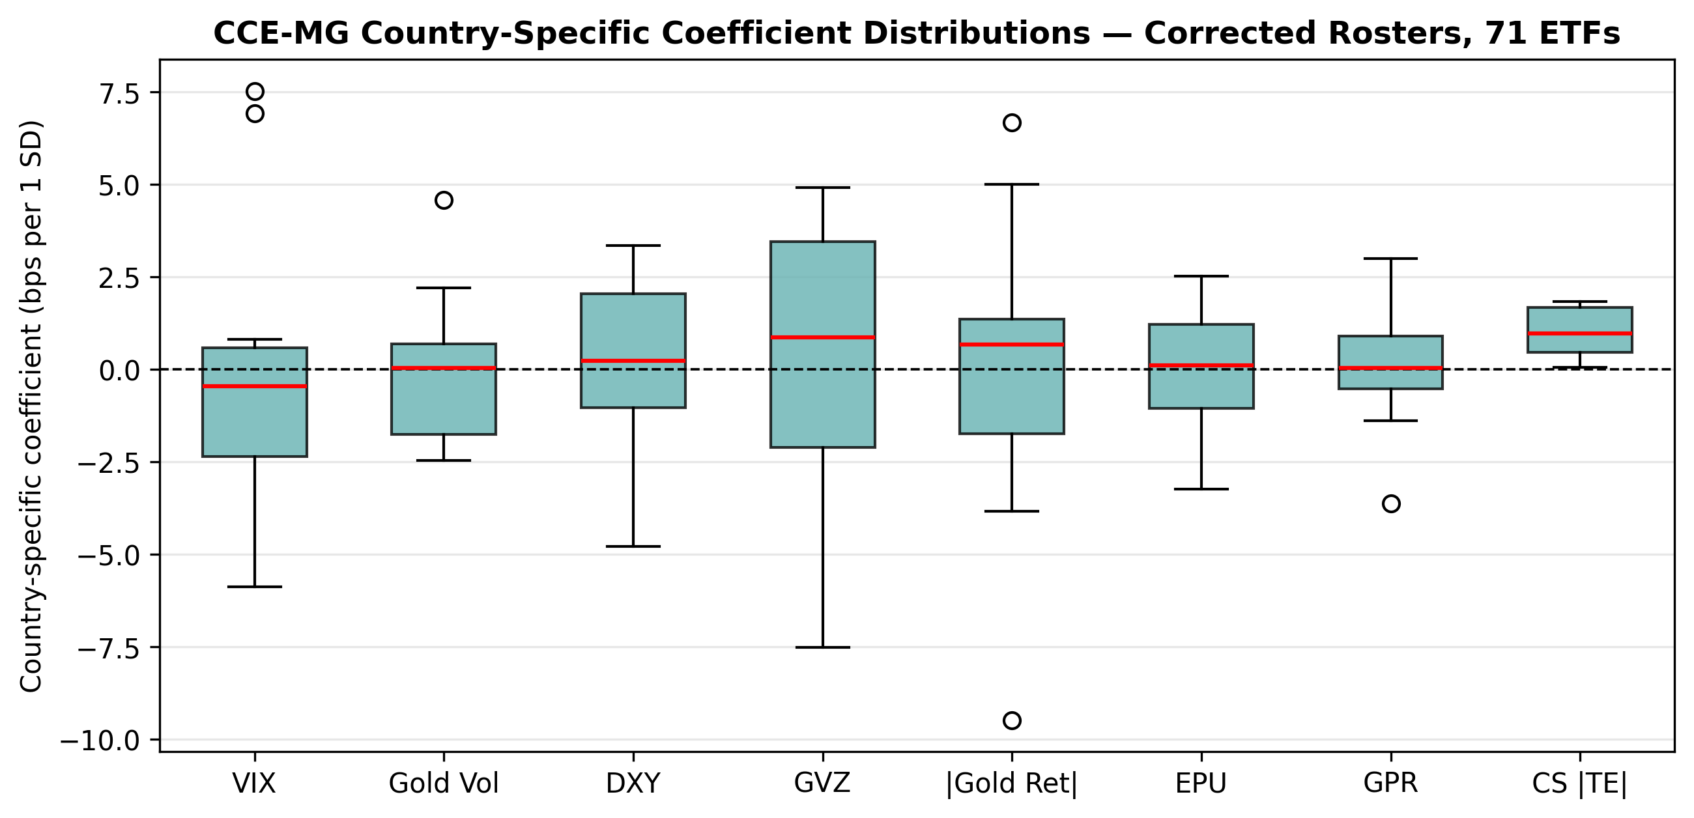
Figure A5: CCE-MG country-specific coefficient boxplots

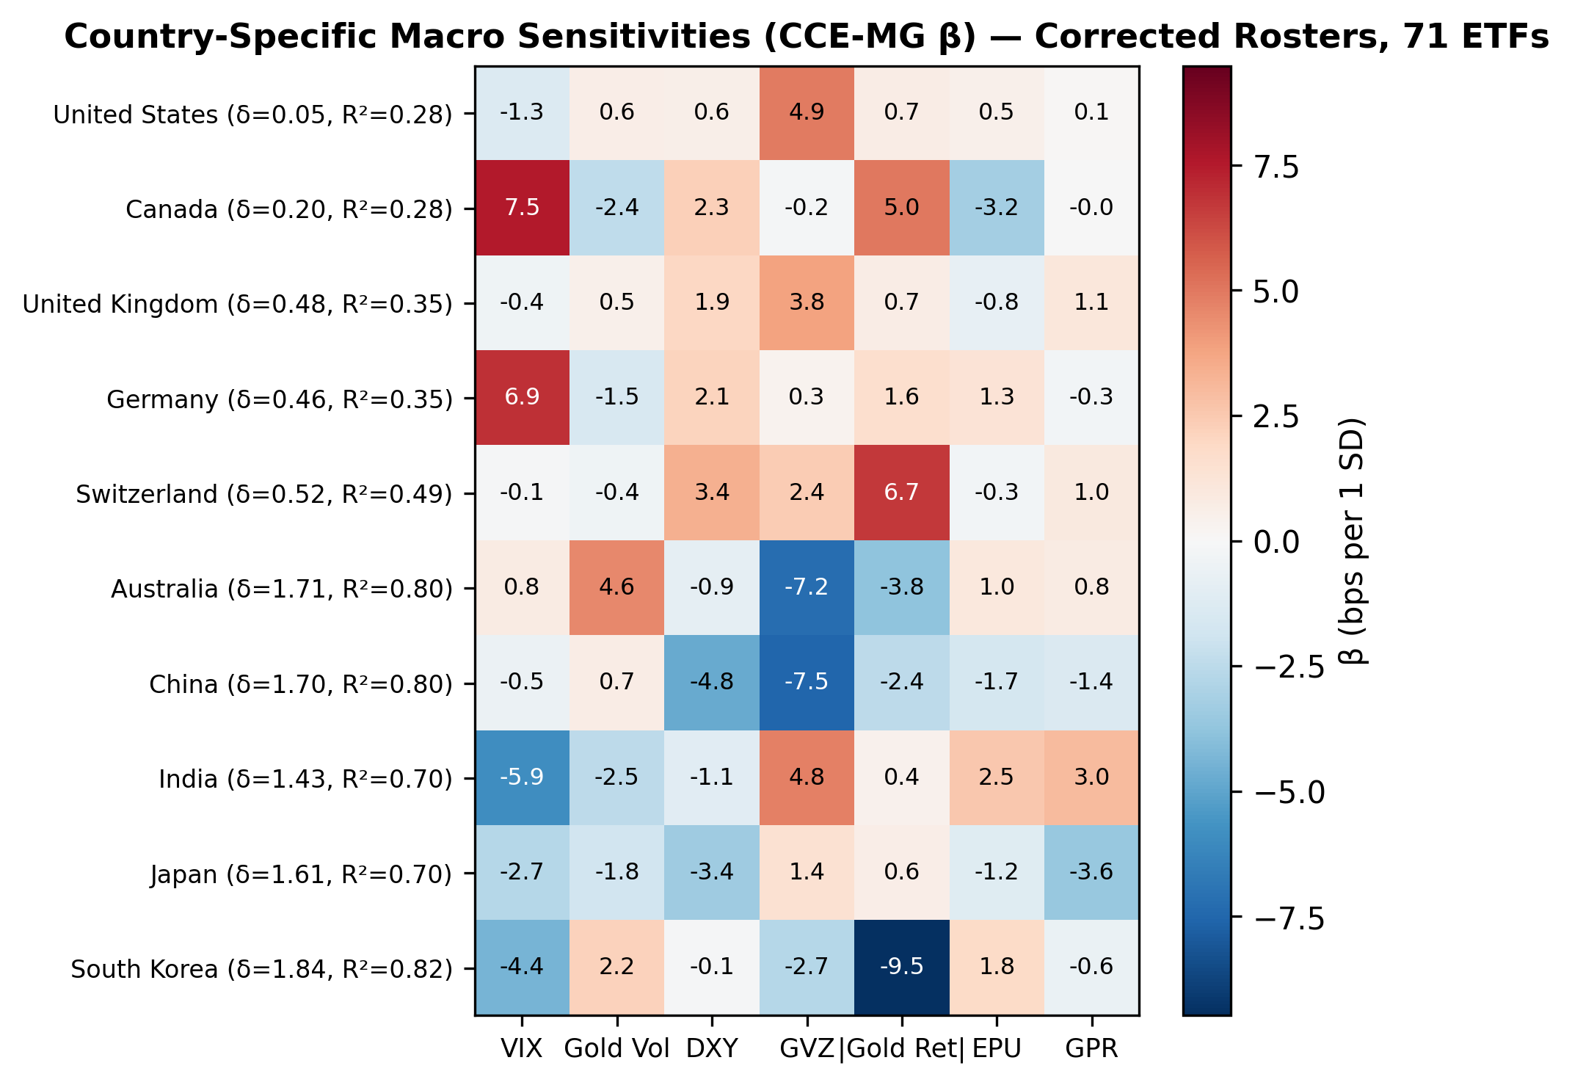
Figure A6: Country-Specific Macro Sensitivities (CCE-MG β Heatmap)
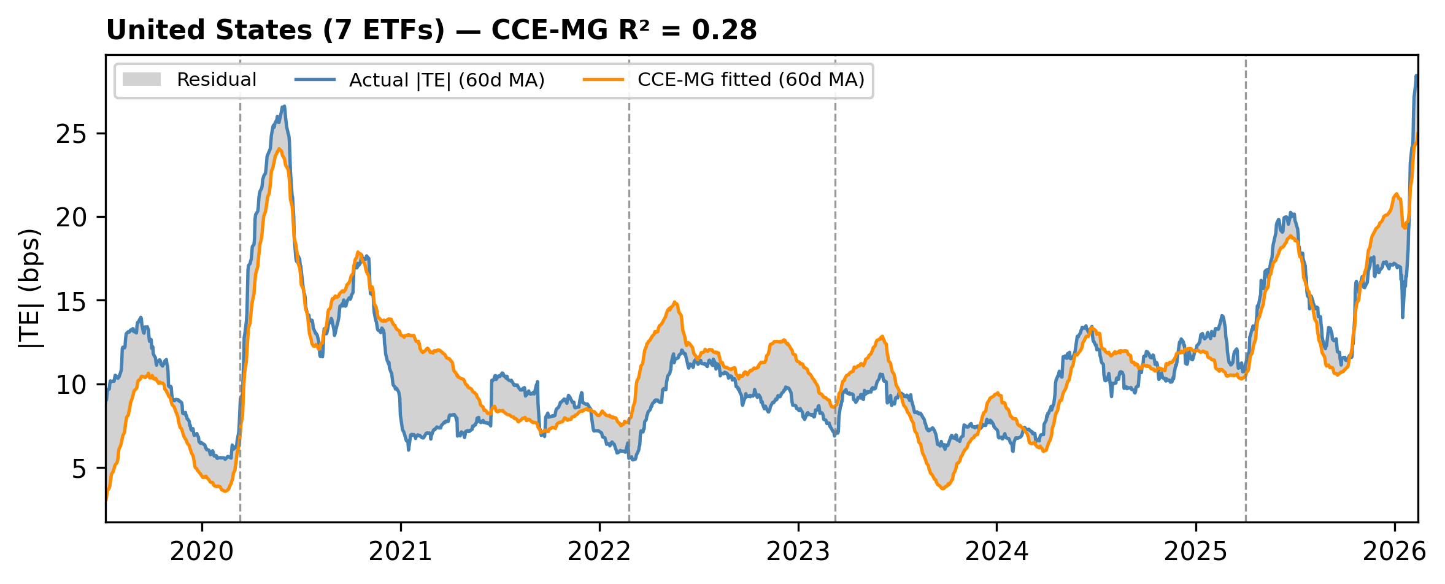
Actual vs CCE-MG fitted |TE| for United States (7 ETFs). 60-day rolling average. Grey shading shows model residual. Vertical lines mark crisis events.

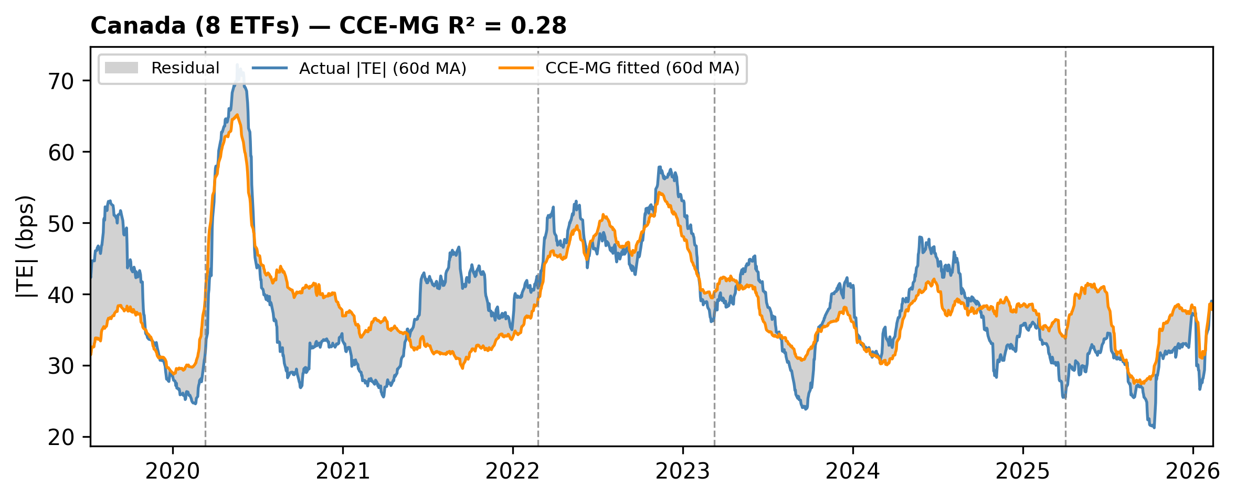
Actual vs CCE-MG fitted |TE| for Canada (8 ETFs). 60-day rolling average. Grey shading shows model residual. Vertical lines mark crisis events.

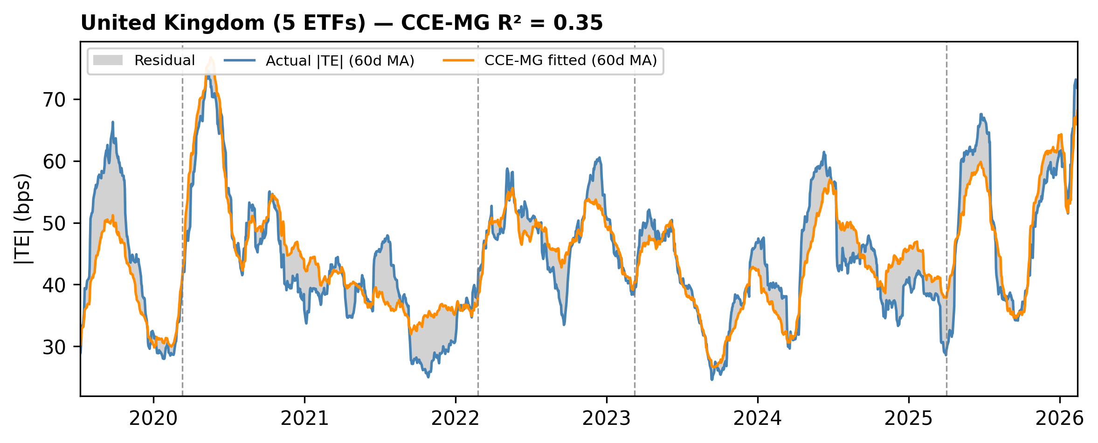
Actual vs CCE-MG fitted |TE| for United Kingdom (5 ETFs). 60-day rolling average. Grey shading shows model residual. Vertical lines mark crisis events.

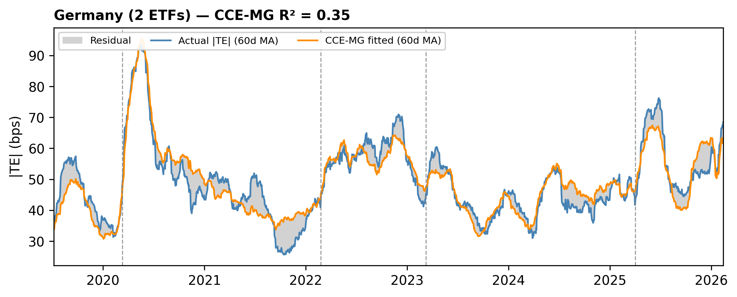
Actual vs CCE-MG fitted |TE| for Germany (2 ETFs). 60-day rolling average. Grey shading shows model residual. Vertical lines mark crisis events.

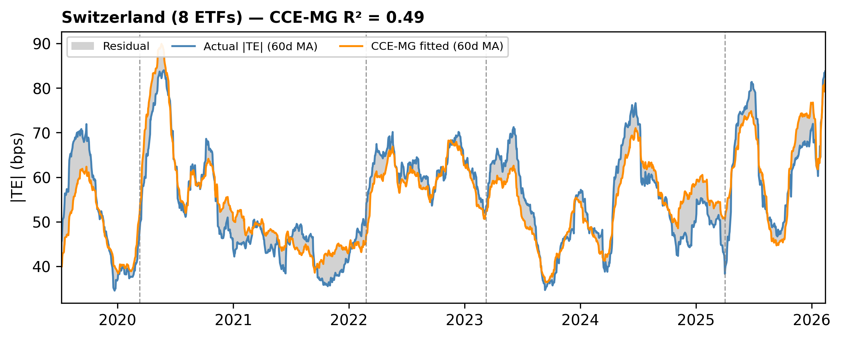
Actual vs CCE-MG fitted |TE| for Switzerland (8 ETFs). 60-day rolling average. Grey shading shows model residual. Vertical lines mark crisis events.

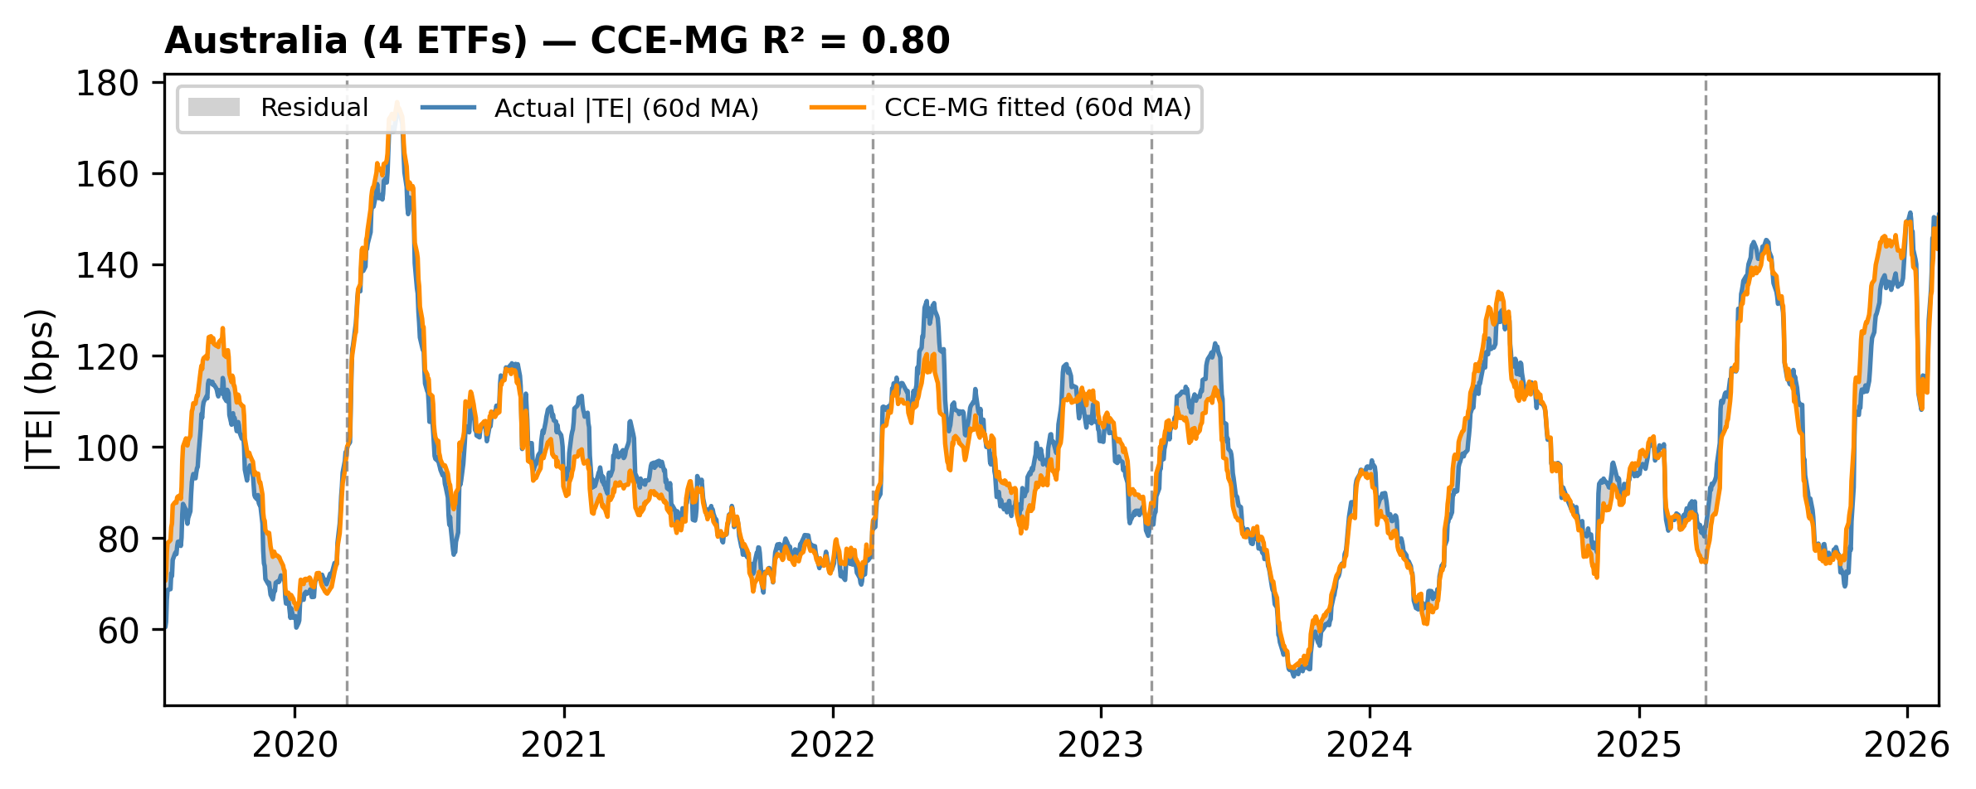
Actual vs CCE-MG fitted |TE| for Australia (4 ETFs). 60-day rolling average. Grey shading shows model residual. Vertical lines mark crisis events.
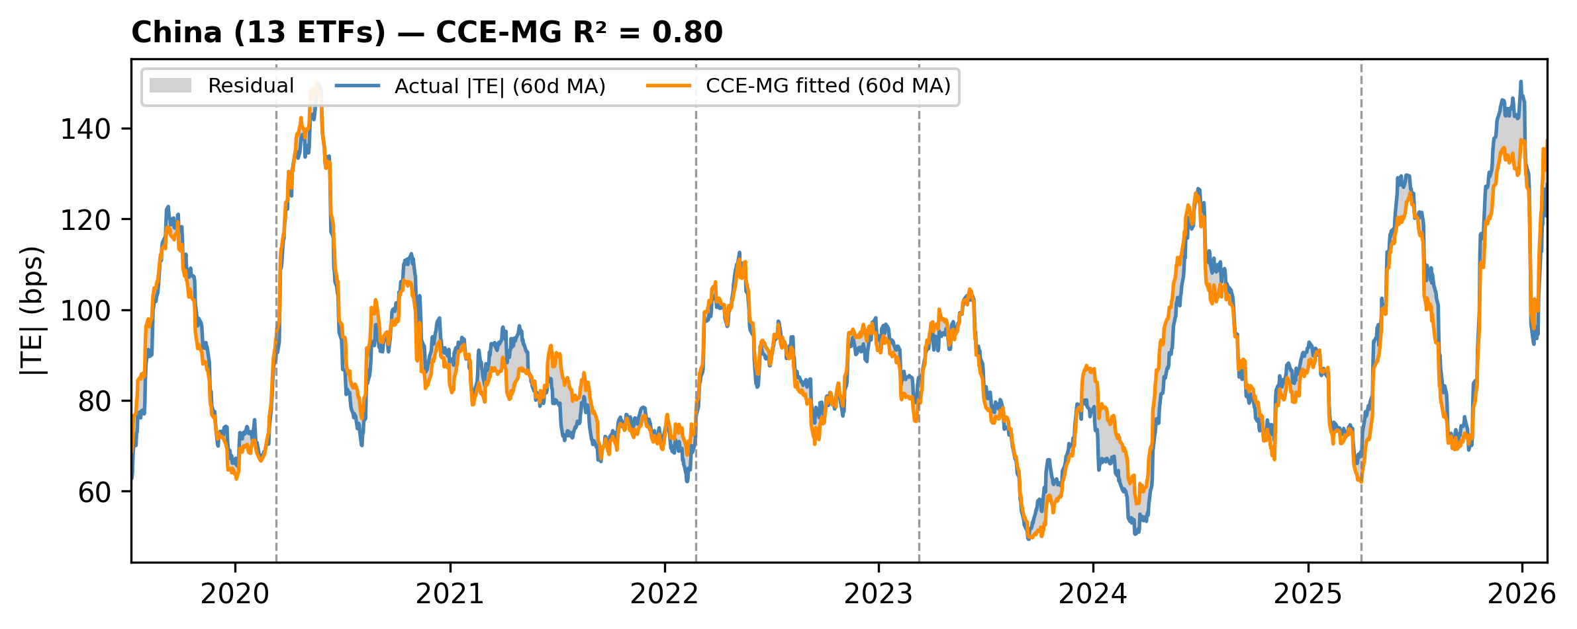
Actual vs CCE-MG fitted |TE| for China (13 ETFs). 60-day rolling average. Grey shading shows model residual. Vertical lines mark crisis events.

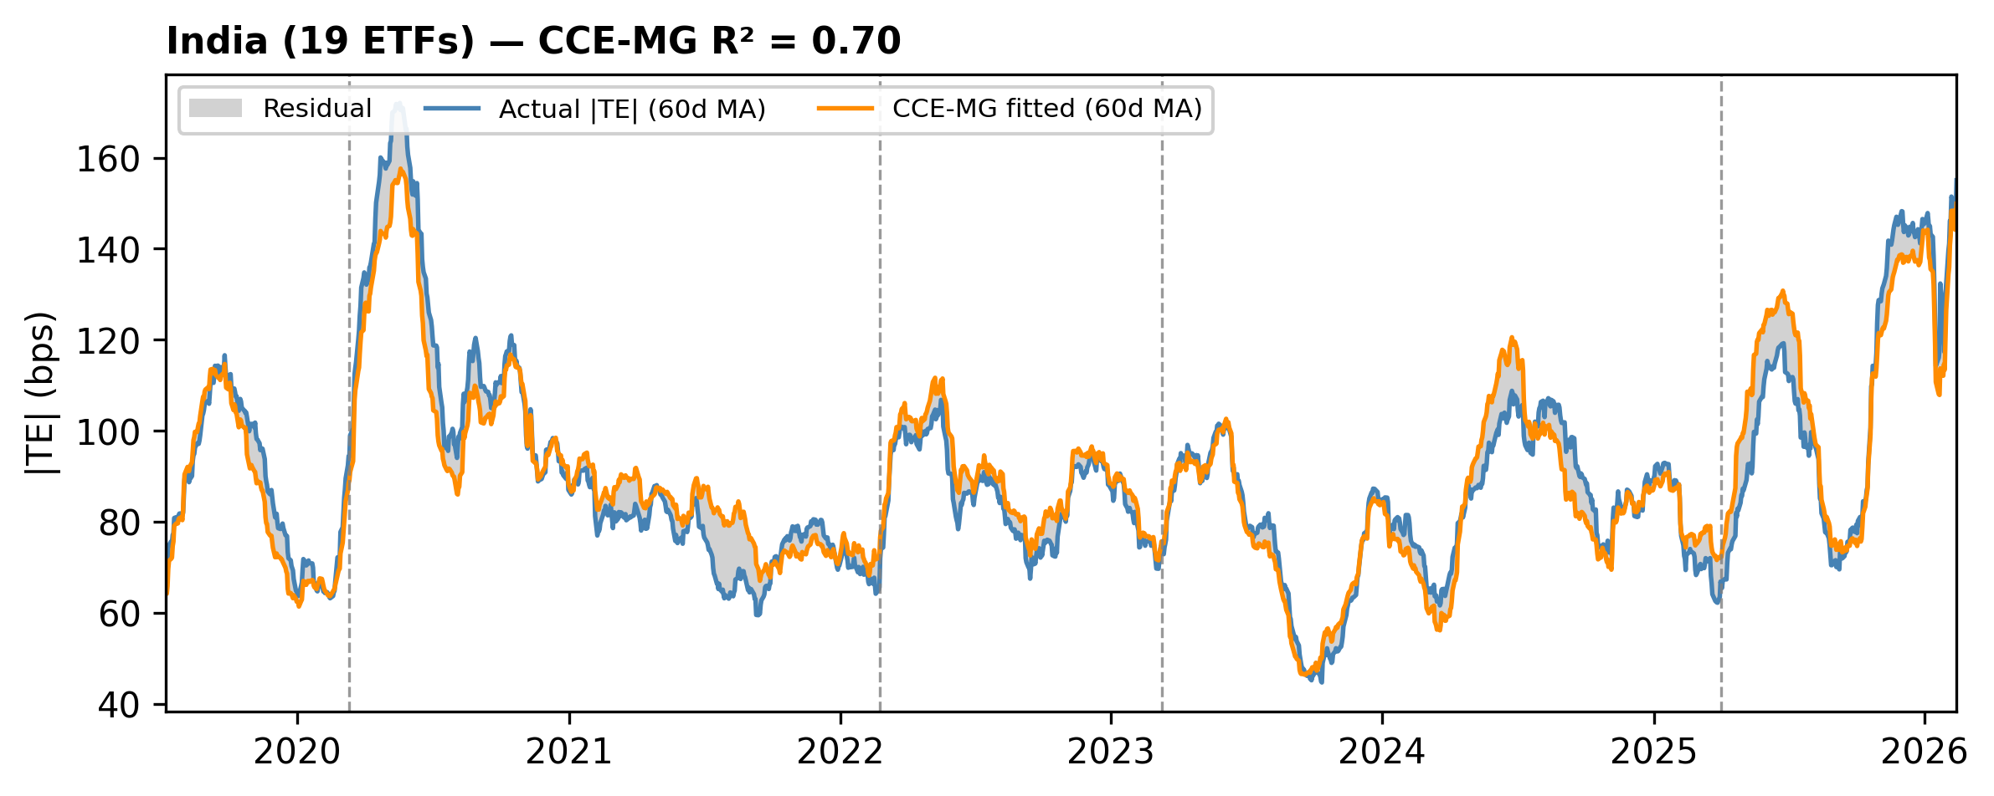
Actual vs CCE-MG fitted |TE| for India (19 ETFs). 60-day rolling average. Grey shading shows model residual. Vertical lines mark crisis events.

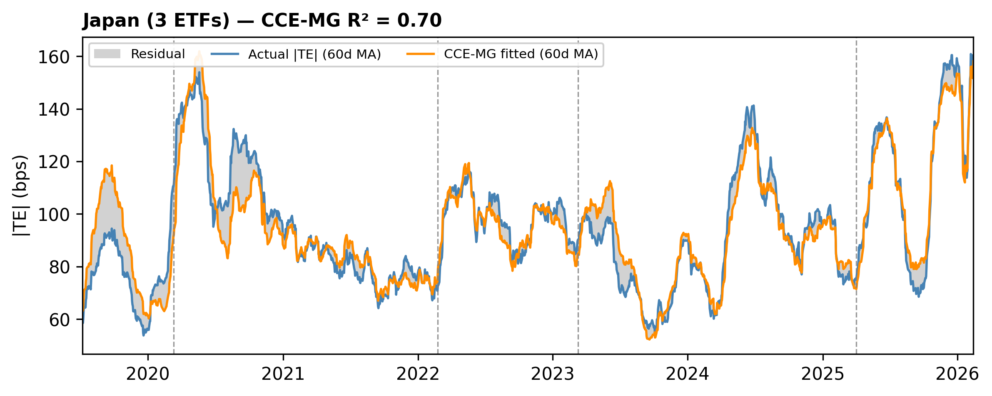
Actual vs CCE-MG fitted |TE| for Japan (3 ETFs). 60-day rolling average. Grey shading shows model residual. Vertical lines mark crisis events.

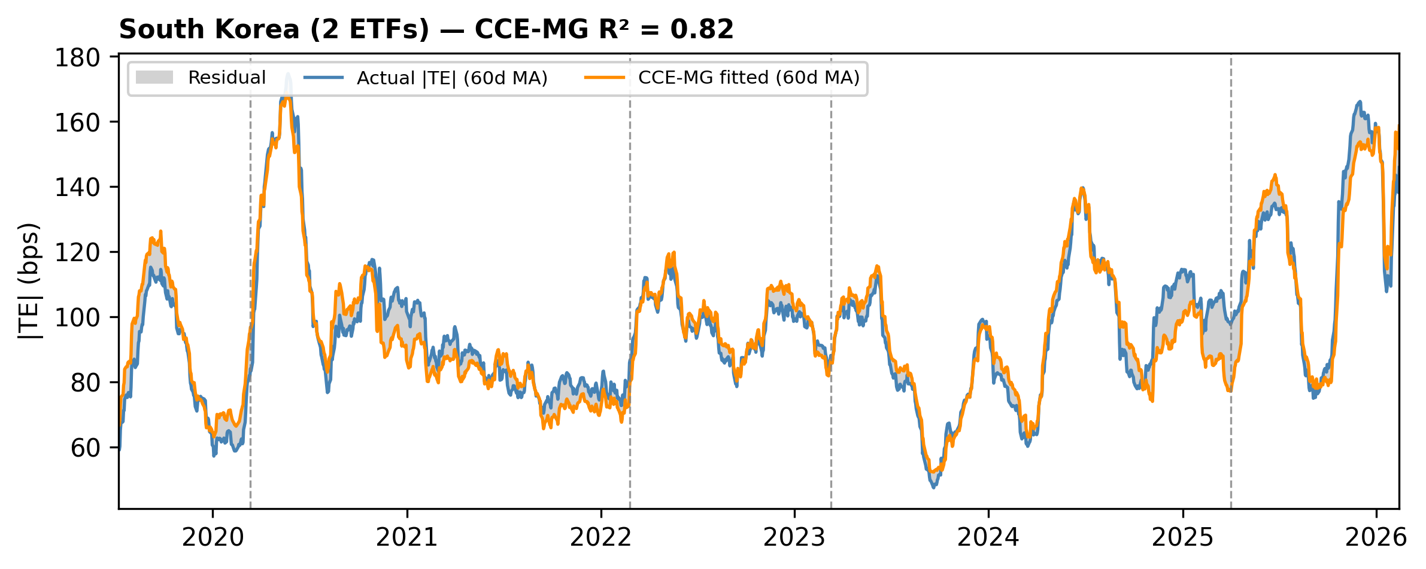
Actual vs CCE-MG fitted |TE| for South Korea (2 ETFs). 60-day rolling average. Grey shading shows model residual. Vertical lines mark crisis events.
Figure A7: Actual vs CCE-Fitted |TE| by Country (60-day Moving Average)

Table A12: BIC Model Selection for Number of Structural Breaks
Series | BIC(0) | BIC(1) | BIC(2) | BIC(3) | BIC(4) | BIC(5) | Optimal m
Mean | 10976.6 | 10816.3 | 10783.0 | 10622.2 | 10602.4 | 10531.7 | 5
US | 6886.6 | 6507.5 | 6400.0 | 6158.8 | 6090.2 | 6084.5 | 5
CA | 8935.9 | 8826.4 | 8706.9 | 8593.0 | 8528.8 | 8495.1 | 5
UK | 10087.5 | 9968.1 | 9934.0 | 9853.3 | 9818.0 | 9765.0 | 5
DE | 10079.9 | 10000.6 | 9882.1 | 9766.0 | 9685.5 | 9520.7 | 5
CH | 10207.7 | 10083.2 | 10052.6 | 9963.7 | 9862.9 | 9761.6 | 5
AU | 12516.7 | 12387.9 | 12345.6 | 12227.6 | 12197.0 | 12129.8 | 5
CN | 12316.8 | 12167.0 | 12125.8 | 12052.2 | 12038.0 | 11976.3 | 5
IN | 12500.4 | 12323.8 | 12197.0 | 12032.1 | 12025.9 | 11978.5 | 5
JP | 12724.3 | 12542.9 | 12489.3 | 12331.0 | 12290.2 | 12235.7 | 5
KR | 12756.2 | 12586.1 | 12523.1 | 12421.8 | 12370.2 | 12321.5 | 5
Notes: BIC = T ln(RSS/T) + (m+1) ln(T). Trimming parameter ε = 0.10. 20-day MA applied.

Table A13: Sequential Sup-F Test Statistics
Series | Opt. m | supF(1|0) | supF(2|1) | supF(3|2) | supF(4|3) | supF(5|4)
Mean | 5 | 175.86*** | 54.01*** | 128.79*** | 54.54*** | 109.03***
US | 5 | 432.05*** | 215.84*** | 380.12*** | 381.57*** | 73.71***
CA | 5 | 120.75*** | 76.98*** | 63.00*** | 179.10*** | 61.67***
UK | 5 | 131.41*** | 51.12*** | 71.76*** | 65.93*** | 84.47***
DE | 5 | 88.88*** | 86.25*** | 158.14*** | 85.63*** | 201.23***
CH | 5 | 136.88*** | 30.52*** | 90.60*** | 90.60*** | 85.33***
AU | 5 | 141.61*** | 45.85*** | 72.55*** | 38.54*** | 144.04***
CN | 5 | 164.33*** | 68.30*** | 46.71*** | 27.47*** | 111.20***
IN | 5 | 193.91*** | 197.71*** | 147.89*** | 28.70*** | 128.04***
JP | 5 | 199.14*** | 87.72*** | 240.51*** | 80.09*** | 132.54***
KR | 5 | 186.65*** | 58.57*** | 73.42*** | 164.31*** | 136.73***
Notes: *** p < 0.01, ** p < 0.05, * p < 0.10. supF(m|m−1) tests m breaks versus (m−1) breaks

Table A14: Estimated Break Dates and Associated Events
Series | Break | Date | Nearest Event | supF | p-value
Mean | 1 | 2020-02-28 | COVID-19 (2020-03-11) | 175.86*** | <0.001
 | 2 | 2020-11-03 | — | 54.01*** | <0.001
 | 3 | 2023-06-29 | — | 128.79*** | <0.001
 | 4 | 2024-04-01 | — | 54.54*** | <0.001
 | 5 | 2025-04-17 | Liberation Day (2025-04-02) | 109.03*** | <0.001
US | 1 | 2020-03-06 | COVID-19 (2020-03-11) | 432.05*** | <0.001
 | 2 | 2020-11-10 | — | 215.84*** | <0.001
 | 3 | 2023-07-27 | — | 380.12*** | <0.001
 | 4 | 2024-04-03 | — | 381.57*** | <0.001
 | 5 | 2025-04-09 | Liberation Day (2025-04-02) | 73.71*** | <0.001
CA | 1 | 2020-06-22 | — | 120.75*** | <0.001
 | 2 | 2021-04-16 | — | 76.98*** | <0.001
 | 3 | 2022-03-04 | Russia-Ukraine (2022-02-24) | 63.00*** | <0.001
 | 4 | 2023-01-25 | SVB Crisis (2023-03-10) | 179.10*** | <0.001
 | 5 | 2024-09-02 | — | 61.67*** | <0.001
UK | 1 | 2020-02-27 | COVID-19 (2020-03-11) | 131.41*** | <0.001
 | 2 | 2020-11-02 | — | 51.12*** | <0.001
 | 3 | 2022-02-11 | Russia-Ukraine (2022-02-24) | 71.76*** | <0.001
 | 4 | 2023-04-20 | SVB Crisis (2023-03-10) | 65.93*** | <0.001
 | 5 | 2025-04-17 | Liberation Day (2025-04-02) | 84.47*** | <0.001
DE | 1 | 2020-02-27 | COVID-19 (2020-03-11) | 88.88*** | <0.001
 | 2 | 2020-11-02 | — | 86.25*** | <0.001
 | 3 | 2022-02-24 | Russia-Ukraine (2022-02-24) | 158.14*** | <0.001
 | 4 | 2022-12-07 | — | 85.63*** | <0.001
 | 5 | 2025-04-09 | Liberation Day (2025-04-02) | 201.23*** | <0.001
CH | 1 | 2020-02-28 | COVID-19 (2020-03-11) | 136.88*** | <0.001
 | 2 | 2020-11-03 | — | 30.52*** | <0.001
 | 3 | 2022-02-11 | Russia-Ukraine (2022-02-24) | 90.60*** | <0.001
 | 4 | 2023-06-21 | — | 90.60*** | <0.001
 | 5 | 2025-04-15 | Liberation Day (2025-04-02) | 85.33*** | <0.001
AU | 1 | 2020-03-03 | COVID-19 (2020-03-11) | 141.61*** | <0.001
 | 2 | 2020-12-04 | — | 45.85*** | <0.001
 | 3 | 2023-06-28 | — | 72.55*** | <0.001
 | 4 | 2024-03-20 | — | 38.54*** | <0.001
 | 5 | 2025-04-09 | Liberation Day (2025-04-02) | 144.04*** | <0.001
CN | 1 | 2020-03-05 | COVID-19 (2020-03-11) | 164.33*** | <0.001
 | 2 | 2020-12-04 | — | 68.30*** | <0.001
 | 3 | 2023-06-30 | — | 46.71*** | <0.001
 | 4 | 2024-04-05 | — | 27.47*** | <0.001
 | 5 | 2025-04-17 | Liberation Day (2025-04-02) | 111.20*** | <0.001
IN | 1 | 2020-02-27 | COVID-19 (2020-03-11) | 193.91*** | <0.001
 | 2 | 2020-11-02 | — | 197.71*** | <0.001
 | 3 | 2023-06-30 | — | 147.89*** | <0.001
 | 4 | 2024-03-20 | — | 28.70*** | <0.001
 | 5 | 2025-04-17 | Liberation Day (2025-04-02) | 128.04*** | <0.001
JP | 1 | 2020-02-24 | COVID-19 (2020-03-11) | 199.14*** | <0.001
 | 2 | 2020-10-28 | — | 87.72*** | <0.001
 | 3 | 2023-04-26 | SVB Crisis (2023-03-10) | 240.51*** | <0.001
 | 4 | 2024-03-20 | — | 80.09*** | <0.001
 | 5 | 2025-04-17 | Liberation Day (2025-04-02) | 132.54*** | <0.001
KR | 1 | 2020-03-05 | COVID-19 (2020-03-11) | 186.65*** | <0.001
 | 2 | 2020-12-04 | — | 58.57*** | <0.001
 | 3 | 2023-06-29 | — | 73.42*** | <0.001
 | 4 | 2024-04-03 | — | 164.31*** | <0.001
 | 5 | 2025-04-23 | Liberation Day (2025-04-02) | 136.73*** | <0.001
Notes: Nearest event identified within a 60-day window. *** p < 0.01.

Table A15: Segment Statistics - US (bps)
Seg. | Start | End | N | Mean | Median | SD | Skew | Kurt.
1 | 2019-05-08 | 2020-03-06 | 216 | 9.0 | 7.9 | 3.7 | 0.64 | -0.89
2 | 2020-03-09 | 2020-11-10 | 176 | 18.6 | 17.5 | 7.8 | 1.34 | 1.32
3 | 2020-11-11 | 2023-07-27 | 699 | 8.9 | 8.6 | 2.5 | 0.57 | -0.03
4 | 2023-07-28 | 2024-04-03 | 176 | 7.2 | 7.1 | 1.5 | 0.19 | -0.75
5 | 2024-04-04 | 2025-04-09 | 263 | 12.1 | 12.4 | 2.8 | -0.08 | -0.65
6 | 2025-04-10 | 2026-02-18 | 222 | 19.9 | 15.7 | 12.5 | 2.48 | 6.05
Notes: Mean, Median, SD in basis points. Skew = Fisher skewness; Kurt. = excess kurtosis.

Table A16: Segment Statistics - CA (bps)
Seg. | Start | End | N | Mean | Median | SD | Skew | Kurt.
1 | 2019-05-08 | 2020-06-22 | 291 | 44.1 | 38.9 | 20.5 | 1.72 | 3.05
2 | 2020-06-23 | 2021-04-16 | 211 | 29.8 | 29.2 | 5.2 | 0.48 | 0.24
3 | 2021-04-19 | 2022-03-04 | 229 | 40.7 | 38.9 | 5.9 | 0.62 | -0.87
4 | 2022-03-07 | 2023-01-25 | 230 | 49.8 | 47.1 | 8.2 | 0.78 | -0.54
5 | 2023-01-26 | 2024-09-02 | 414 | 37.8 | 37.7 | 9.2 | 0.17 | -0.63
6 | 2024-09-03 | 2026-02-18 | 377 | 32.6 | 30.8 | 9.1 | 1.38 | 2.27
Notes: Mean, Median, SD in basis points. Skew = Fisher skewness; Kurt. = excess kurtosis.

Table A17: Segment Statistics - UK (bps)
Seg. | Start | End | N | Mean | Median | SD | Skew | Kurt.
1 | 2019-05-08 | 2020-02-27 | 210 | 39.9 | 34.8 | 18.5 | 0.74 | -0.50
2 | 2020-02-28 | 2020-11-02 | 176 | 56.0 | 52.7 | 17.4 | 0.70 | -0.23
3 | 2020-11-03 | 2022-02-11 | 330 | 35.9 | 33.3 | 9.9 | 0.57 | -0.49
4 | 2022-02-14 | 2023-04-20 | 305 | 48.6 | 46.9 | 12.4 | 0.13 | -0.91
5 | 2023-04-21 | 2025-04-17 | 515 | 39.5 | 36.7 | 14.4 | 1.79 | 4.26
6 | 2025-04-21 | 2026-02-18 | 216 | 56.7 | 47.7 | 25.6 | 1.17 | 0.37
Notes: Mean, Median, SD in basis points. Skew = Fisher skewness; Kurt. = excess kurtosis

Table A18: Segment Statistics - Germany (bps)
Seg. | Start | End | N | Mean | Median | SD | Skew | Kurt.
1 | 2019-05-08 | 2020-02-27 | 210 | 40.9 | 39.6 | 13.0 | 0.39 | -0.29
2 | 2020-02-28 | 2020-11-02 | 176 | 65.4 | 58.8 | 27.6 | 1.36 | 1.20
3 | 2020-11-03 | 2022-02-24 | 339 | 40.4 | 41.6 | 10.4 | 0.16 | -0.46
4 | 2022-02-25 | 2022-12-07 | 203 | 61.3 | 60.9 | 10.3 | 0.14 | -0.49
5 | 2022-12-08 | 2025-04-09 | 602 | 43.1 | 40.5 | 11.3 | 1.12 | 1.30
6 | 2025-04-10 | 2026-02-18 | 222 | 58.9 | 52.2 | 20.0 | 1.22 | 0.60
Notes: Mean, Median, SD in basis points. Skew = Fisher skewness; Kurt. = excess kurtosis

Table A19: Segment Statistics - CH (bps)
Seg. | Start | End | N | Mean | Median | SD | Skew | Kurt.
1 | 2019-05-08 | 2020-02-28 | 211 | 48.9 | 45.5 | 17.0 | 0.41 | -1.09
2 | 2020-03-02 | 2020-11-03 | 176 | 66.3 | 61.6 | 19.9 | 0.71 | -0.29
3 | 2020-11-04 | 2022-02-11 | 329 | 43.3 | 42.5 | 8.4 | 0.52 | -0.51
4 | 2022-02-14 | 2023-06-21 | 349 | 62.2 | 60.7 | 10.6 | 0.49 | -0.24
5 | 2023-06-22 | 2025-04-15 | 469 | 49.9 | 45.7 | 15.4 | 1.59 | 3.20
6 | 2025-04-16 | 2026-02-18 | 218 | 68.0 | 58.6 | 25.9 | 1.21 | 0.43
Notes: Mean, Median, SD in basis points. Skew = Fisher skewness; Kurt. = excess kurtosis.

Table A20: Segment Statistics - AU (bps)
Seg. | Start | End | N | Mean | Median | SD | Skew | Kurt.
1 | 2019-05-08 | 2020-03-03 | 213 | 79.9 | 74.9 | 25.3 | 0.60 | -0.67
2 | 2020-03-04 | 2020-12-04 | 197 | 120.8 | 112.0 | 46.7 | 0.84 | -0.17
3 | 2020-12-07 | 2023-06-28 | 660 | 94.4 | 88.9 | 24.4 | 1.21 | 1.41
4 | 2023-06-29 | 2024-03-20 | 188 | 68.1 | 64.3 | 20.2 | 0.40 | -0.84
5 | 2024-03-21 | 2025-04-09 | 272 | 97.0 | 91.2 | 20.6 | 0.52 | -0.92
6 | 2025-04-10 | 2026-02-18 | 222 | 122.2 | 103.3 | 51.5 | 0.82 | -0.12
Notes: Mean, Median, SD in basis points. Skew = Fisher skewness; Kurt. = excess kurtosis.

Table A21: Segment Statistics - CN (bps)
Seg. | Start | End | N | Mean | Median | SD | Skew | Kurt.
1 | 2019-05-08 | 2020-03-05 | 215 | 82.1 | 78.6 | 26.9 | 0.76 | -0.35
2 | 2020-03-06 | 2020-12-04 | 195 | 107.2 | 96.9 | 42.0 | 0.93 | 0.07
3 | 2020-12-07 | 2023-06-30 | 662 | 85.0 | 81.9 | 19.0 | 1.21 | 2.38
4 | 2023-07-03 | 2024-04-05 | 197 | 61.3 | 59.7 | 15.2 | 0.40 | -0.85
5 | 2024-04-08 | 2025-04-17 | 267 | 89.2 | 83.9 | 22.8 | 0.59 | -0.71
6 | 2025-04-21 | 2026-02-18 | 216 | 115.0 | 93.8 | 55.9 | 1.03 | 0.08
Notes: Mean, Median, SD in basis points. Skew = Fisher skewness; Kurt. = excess kurtosis.

Table A22: Segment Statistics - IN (bps)
Seg. | Start | End | N | Mean | Median | SD | Skew | Kurt.
1 | 2019-05-08 | 2020-02-27 | 210 | 81.9 | 79.5 | 23.6 | 0.27 | -1.32
2 | 2020-02-28 | 2020-11-02 | 176 | 125.4 | 110.7 | 43.8 | 0.56 | -0.87
3 | 2020-11-03 | 2023-06-30 | 686 | 82.3 | 79.7 | 19.4 | 1.30 | 2.75
4 | 2023-07-03 | 2024-03-20 | 186 | 63.5 | 62.9 | 18.4 | 0.28 | -0.30
5 | 2024-03-21 | 2025-04-17 | 278 | 85.8 | 82.9 | 20.8 | 0.31 | -0.97
6 | 2025-04-21 | 2026-02-18 | 216 | 119.5 | 98.4 | 57.0 | 1.25 | 0.71
Notes: Mean, Median, SD in basis points. Skew = Fisher skewness; Kurt. = excess kurtosis.

Table A23: Segment Statistics - JP (bps)
Seg. | Start | End | N | Mean | Median | SD | Skew | Kurt.
1 | 2019-05-08 | 2020-02-24 | 207 | 73.5 | 69.7 | 20.0 | 0.41 | -1.07
2 | 2020-02-25 | 2020-10-28 | 176 | 124.4 | 111.7 | 39.4 | 0.95 | -0.11
3 | 2020-10-29 | 2023-04-26 | 642 | 89.3 | 85.1 | 23.0 | 0.74 | 0.56
4 | 2023-04-27 | 2024-03-20 | 233 | 69.2 | 69.6 | 17.2 | 0.09 | -0.80
5 | 2024-03-21 | 2025-04-17 | 278 | 99.4 | 88.7 | 30.8 | 1.10 | 0.75
6 | 2025-04-21 | 2026-02-18 | 216 | 126.6 | 107.6 | 61.7 | 0.92 | -0.21
Notes: Mean, Median, SD in basis points. Skew = Fisher skewness; Kurt. = excess kurtosis.

Table A24: Segment Statistics - KR (bps)
Seg. | Start | End | N | Mean | Median | SD | Skew | Kurt.
1 | 2019-05-08 | 2020-03-05 | 215 | 77.3 | 71.6 | 26.6 | 0.59 | -0.78
2 | 2020-03-06 | 2020-12-04 | 195 | 120.1 | 112.6 | 47.7 | 0.99 | 0.53
3 | 2020-12-07 | 2023-06-29 | 661 | 90.3 | 85.9 | 20.0 | 1.08 | 1.39
4 | 2023-06-30 | 2024-04-03 | 196 | 68.9 | 65.1 | 21.8 | 0.37 | -0.87
5 | 2024-04-04 | 2025-04-23 | 272 | 105.3 | 96.8 | 29.7 | 0.47 | -1.07
6 | 2025-04-24 | 2026-02-18 | 213 | 128.3 | 103.9 | 59.4 | 0.96 | -0.35
Notes: Mean, Median, SD in basis points. Skew = Fisher skewness; Kurt. = excess kurtosis.

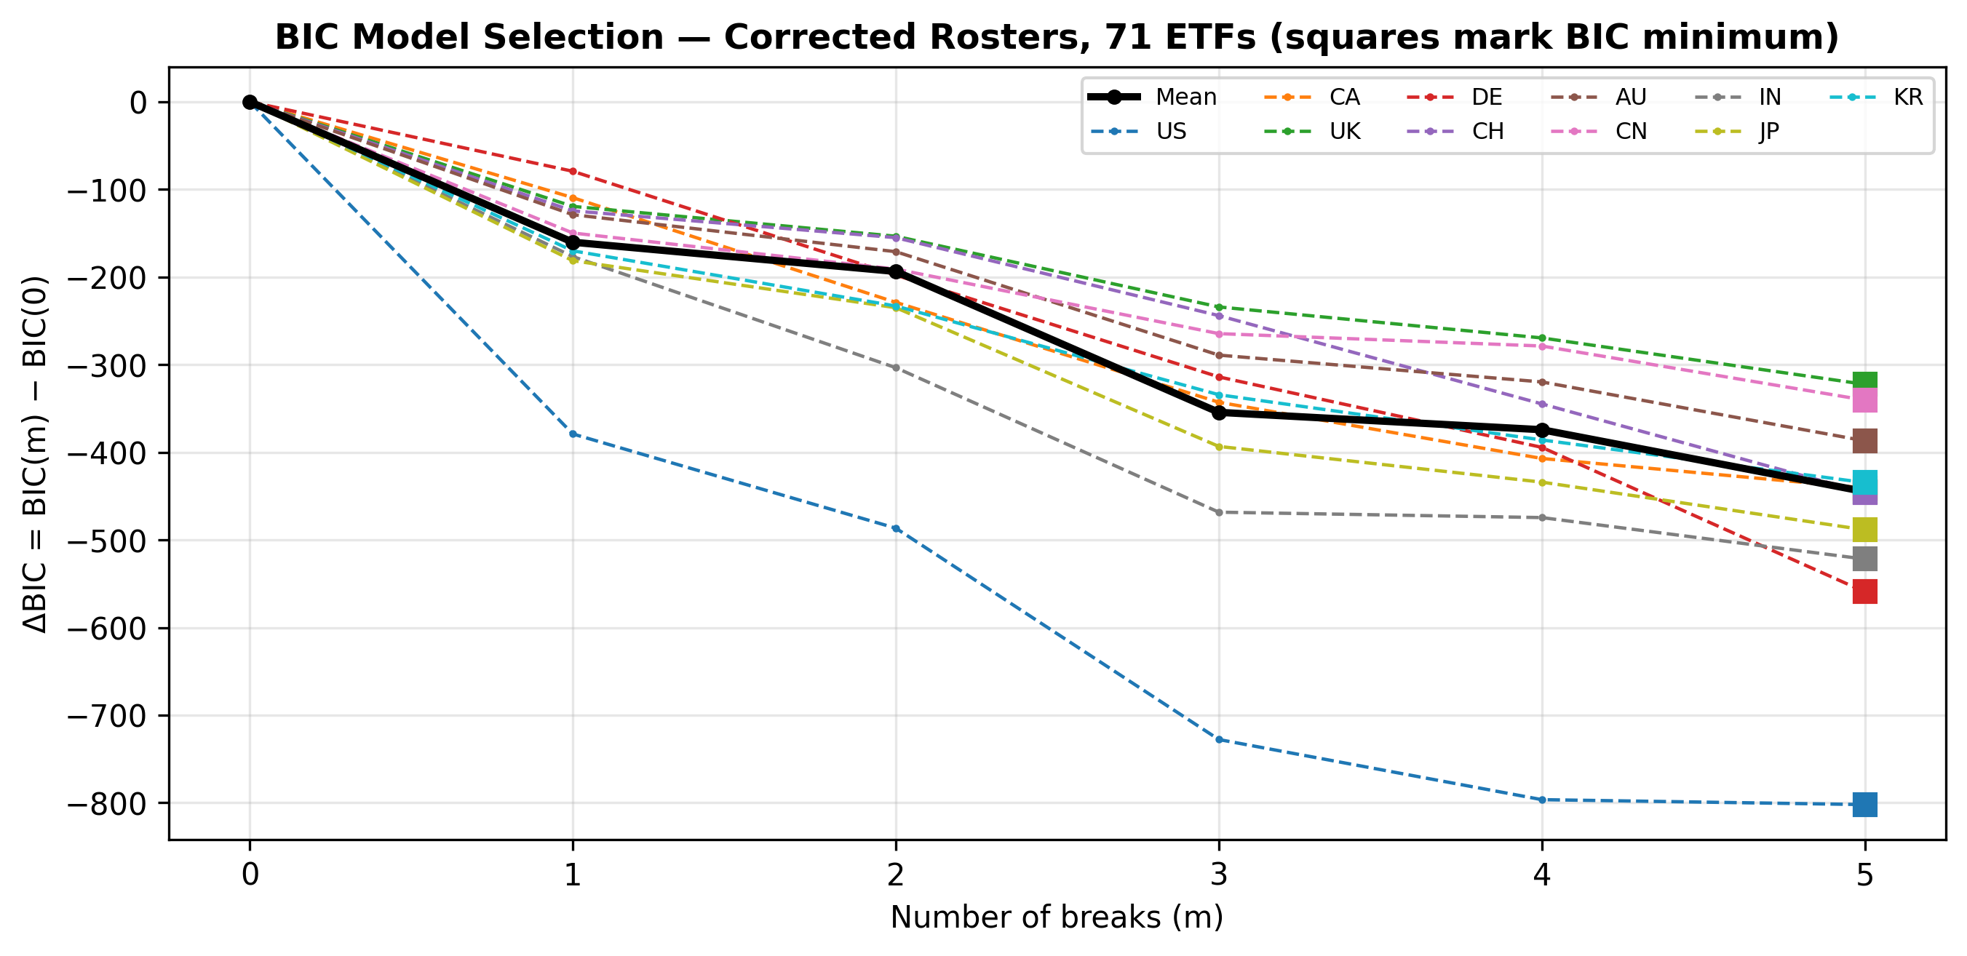
Notes: BIC values normalised relative to 0-break model (ΔBIC = BIC(m) - BIC(0)). Square markers indicate BIC minimum. All series achieve minimum BIC at m = 5 breaks. Solid black line = cross-country mean; dashed coloured lines = individual countries.
Figure A8: BIC Model Selection

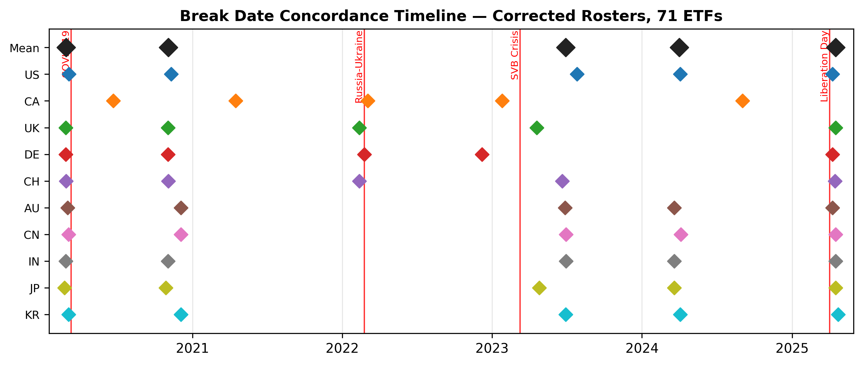
Notes: Diamonds mark estimated Bai-Perron break dates. Larger dark diamonds = cross-country mean. Red vertical lines = major crisis events. Tight vertical clustering reveals cross-country synchronisation.
Figure A9: Break Date Concordance Timeline

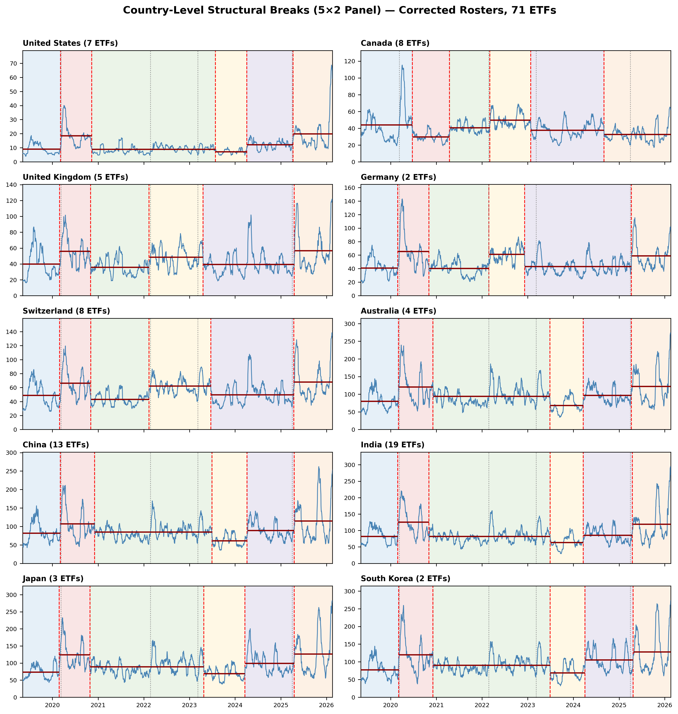
Notes: Each panel shows 20-day MA |TE| for one country. Red dashed lines = estimated break dates. Horizontal dark red lines = segment means. Grey dotted lines = crisis events. Coloured shading distinguishes regimes.
Figure A10: Country-Level Structural Breaks (5×2 Panel)

