Supplementary materials
Table S1 Baseline characteristics of 21534 septic patients grouped by abdominal palpation (unshown in the main text).
Variables | All patients  (n=21534) | Non-abdominal  obesity  (n=14454) | Abdominal  obesity  (n=7080) | p | Missing  data (%)
Age | 68(56-79) | 68(55-80) | 67(57-76) | 0.273 | 0.0
Smoking history, n(%) |  |  |  | 0.001 | 0.0
Former smoker | 3848(17.9%) | 2477(17.1%) | 1371(19.4%)
Current smoker | 2973(13.8%) | 2041(14.1%) | 932(13.2%)
Non-smoker | 3943(18.3%) | 2666(18.4%) | 1277(18.0%)
Unknown | 10770(50.0%) | 7270(50.3%) | 3500(49.4%)
Marital status, n(%) |  |  |  | <0.001 | 0.0
Single | 9677(44.9%) | 6438(44.5%) | 3239(45.7%)
Married | 9663(44.9%) | 6611(45.7%) | 3052(43.1%)
Unknown | 2194(10.2%) | 1405(9.7%) | 789(11.1%)
Ethnicity, n(%) |  |  |  | <0.001 | 0.0
WHITE | 14407(66.9%) | 9669(66.9%) | 4738(66.9%)
BLACK | 1648(7.7%) | 1071(7.4%) | 577(8.1%)
ASIAN | 610(2.8%) | 548(3.8%) | 62(0.9%)
HISPANIC/LATINO | 679(3.2%) | 456(3.2%) | 223(4.1%)
Other/unknown | 4190(19.5%) | 2710(18.7%) | 1480(20.9%)
Service unit, n (%) |  |  |  | <0.001 | 0.0
SICU/NICU  CVICU  CCU | 11690(54.3%)  4696(21.8%)  1860(8.6%) | 7949(55.0%)  3060(21.2%)  1197(8.3%) | 3741(52.8%)  1636(23.1%)  663(9.4%)
TSICU | 2529(11.7%) | 1735(12.0%) | 794(11.2%)
Neuro SICU | 759(3.5%) | 513(3.5%) | 246(3.5%)
Vital sign
MAP(mmHg) | 109(95-136) | 106(93-129) | 114(97-156) | 0.692 | 44.2
Heart rate | 87(76-102) | 87(76-102) | 88(77-103) | 0.010 | 0.1
Temperature(℃) | 36.1(35.2-37.0) | 36.0(35.1-37.2) | 36.2(35.4-37.2) | 0.170 | 81.5
Respiratory rate | 18(15-23) | 18(15-23) | 19(15-23) | <0.001 | 0.2
Laboratory tests
pO₂(mmHg) | 121(66-278) | 128(66-290) | 113(66-254) | <0.001 | 18.8
pCO₂(mmHg) | 40(35-47) | 40(35-46) | 42(36-48) | <0.001 | 18.8
Sodium(mEq/L) | 139(136-141) | 139(136-141) | 139(136-141) | 0.534 | 0.9
Potassium(mEq/L) | 4.1(3.7-4.6) | 4.1(3.7-4.5) | 4.2(3.8-4.7) | <0.001 | 0.9
PH | 7.38(7.31-7.43) | 7.38(7.32-7.43) | 7.37(7.30-7.42) | <0.001 | 17.1
Chloride(mEq/L) | 105(101-109) | 106(101-110) | 105(100-109) | <0.001 | 0.8
CRP(mg/L) | 24.7(4.1-88.2) | 21.0(3.3-85.9) | 31.5(6.1-94.2) | <0.001 | 79.5
SICU/NICU, Medical/Surgical Intensive Care Unit; CVICU, Cardiac Vascular Intensive Care Unit; CCU, Coronary Care Unit; TSICU, Trauma SICU; MAP, mean arterial pressure; CRP, C-reactive protein

Table S2 Baseline characteristics and prognoses of 14208 patients with sepsis according to BMI
variable | Underweight  BMI<18.5  (N=444) | Normal  18.5≤BMI<25  (N=4043) | Overweight  25≤BMI<29.9  (N=4654) | Obesity  BMI≥30  (N=5067) | P
Age(year) | 71(60-82) | 69(57-80) | 68(57-78) | 64(55-73) | .000
Gender(female) | 247(55.6%) | 1697(42.0%) | 1539(33.1%) | 2145(42.3%) | .000
Emergency, n (%) | 356(80.2%) | 3213(79.5%) | 3593(77.2%) | 3913(77.2%) | .020
Ethnicity |  |  |  |  | .000
WHITE | 287(64.6%) | 2643(65.4%) | 3198(68.7%) | 3418(67.5%)
BLACK | 58(13.1%) | 286(7.1%) | 263(5.7%) | 371(7.3%)
ASIAN | 16(3.6%) | 195(4.8%) | 112(2.4%) | 41(0.8%)
HISPANIC/LATINO | 8(1.8%) | 114(2.8%) | 136(2.9%) | 169(3.3%)
Other/unknown | 75(16.9%) | 805(19.9%) | 945(20.3%) | 1068(21.1%)
Service unit, n (%) |  |  |  |  | .000
MICU/SICU | 275(61.9%) | 1872(46.3%) | 1922(41.3%) | 2306(45.5%)
CVICU | 60(13.5%) | 1159(28.7%) | 1651(35.5%) | 1600(31.6%)
CCU | 47(10.6%) | 392(9.7%) | 436(9.4%) | 454(9.0%)
TSICU | 42(9.5%) | 478(11.8%) | 518(11.1%) | 569(11.2%)
Neuro SICU | 20(4.5%) | 142(3.5%) | 127(2.7%) | 138(2.7%)
Comorbidities, n (%)
Diabetes mellitus | 84(18.9%) | 876(21.7%) | 13217(28.3%) | 2083(41.1%) | .000
Hypertension | 101(22.7%) | 1113(27.5%) | 1560(33.5%) | 1769(34.9%) | .000
COPD | 53(11.9%) | 321(7.9%) | 328(7.0%) | 517(10.2%) | .000
CHD | 106(23.9%) | 1386(34.3%) | 1899(40.8%) | 1922(37.9%) | .000
CHF | 93(20.9%) | 930(23.0%) | 1063(22.8%) | 1269(25%) | .020
AF | 125(28.2%) | 1332(32.9%) | 1585(34.1%) | 1662(32.8%) | .069
CKD | 74(16.7%) | 617(15.3%) | 725(15.6%) | 877(17.3%) | .035
Liver disease | 23(5.2%) | 259(6.4%) | 292(6.3%) | 385(7.6%) | .019
malignancy | 86(19.4%) | 650(16.1%) | 689(14.8%) | 624(12.3%) | .000
Laboratory results
WBC(K/uL) | 12.7(9.0-16.9) | 13.2(9.5-17.9) | 13.6(10.1-18.2) | 14.6(10.6-19.3) | .000
platelet(K/uL) | 196(135-283) | 166(118-235) | 117(122-226) | 179(131-241) | .000
Hemoglobin(g/dL) | 10.1(8.7-11.2) | 10.1(8.7-11.8) | 10.3(8.9-11.9) | 10.5(9.0-12.1) | .000
Plasma glucose(mg/dL) | 110(92-139) | 114(95-148) | 117(97-153) | 126(101-169) | .000
HbA1c(%) | 5.7(5.4-6.3) | 5.7(5.4-6.2) | 5.8(5.5-6.5) | 6.1(5.7-7.1) | .000
HDL-C(mg/dL) | 49(34-63) | 44(33-56) | 42(32-51) | 38(30-49) | .000
LDL-C(mg/dL) | 80(55-104) | 87(64-112) | 85(61-113) | 84(61-109) | .044
TG(mg/dL) | 98(65-150) | 111(79-158) | 125(86-182) | 137(93-218) | .000
TC(mg/dL) | 161(124-192) | 162(130-195) | 159(128-195) | 157(128-192) | .372
TB(mg/dL) | 0.5(0.3-0.9) | 0.7(0.4-1.4) | 0.7(0.4-1.4) | 0.7(0.4-1.5) | .000
AST(IU/L) | 50(29-115) | 55(29-156) | 52(28-151) | 55(29-158) | .010
ALT(IU/L) | 33(21-92) | 41(22-141) | 40(23-112) | 44(25-113) | .404
Creatinine(mg/dL) | 0.9(0.6-1.4) | 0.9(0.7-1.4) | 1.0(0.8-1.4) | 1.1(0.8-1.6) | .000
BUN (mg/dL) | 22(13.8-37) | 19(13-31) | 19(14-29) | 20(14-32) | .000
Albumin(g/dL) | 2.8(2.3-3.4) | 3.0(2.6-3.5) | 3.1(2.6-3.5) | 3.1(2.6-3.5) | .010
Lactate(mmol/L) | 1.8(1.2-2.5) | 1.9(1.3-2.9) | 1.9(1.3-2.9) | 1.9(1.3-2.9) | .365
Blood culture, n(%) |  |  |  |  | .000
Positive | 61(13.7%) | 479(11.8%) | 544(11.7%) | 736(14.5%)
Negative | 281(63.3%) | 2324(57.5%) | 2536(54.5%) | 2886(57.0%)
Untested | 102(23.0%) | 1240(30.7%) | 1574(33.8%) | 1445(28.5%)
Disease severity scores
SOFA | 3(2-4) | 3(2-4) | 3(2-5) | 3(2-5) | .000
CCI | 6(4-8) | 5(4-7) | 5(4-7) | 5(3-7) | .001
SASP II | 57(42-75) | 50(36-71) | 50(25-75) | 51(35-75) | .441
Interventions, n (%)
Oxygen inhalation | 389(87.6%) | 3600(89.0%) | 4242(91.1%) | 4635(91.5%) | .000
MV | 292(67.3%) | 3235(76%) | 3698(79.4%) | 4165(82.1%) | .000
Vasopressor use | 260(59.9%) | 2732(64.2%) | 3125(67.1%) | 3409(67.2%) | .000
RRT | 14(3.2%) | 188(4.4%) | 222(4.8%) | 284(5.6%) | .017
Drug use, n(%)
Lipid-lowering agents | 208(47.9%) | 2505(58.8%) | 3022(64.9%) | 3334(65.7%) | .000
Hypoglycemic agents | 205(47.2%) | 2677(62.9%) | 3266(70.1%) | 3752(74.0%) | .000
Aspirin | 191(44.0%) | 2312(54.3%) | 2824（60.7%） | 2886（56.9%） | .000
Antihypertensive agents | 322(72.5%) | 3230(79.9%) | 3897(83.7%) | 4390(86.6%) | .000
MetS disorders
Elevated BP | 160(36.9%) | 1425(33.8%) | 1509(32.9%) | 1753(35.1%) | .076
Abdominal obesity | 27(6.2%) | 441(10.4%) | 1362(29.3%) | 3825(75.4%) | .000
Hyperglycemia | 51(24.9%) | 489(27.9%) | 714(36.5%) | 1001(43.5%) | .000
Low HDL-C | 55(40.7%) | 625(46.9%) | 808(52.5%) | 1067(63.2%) | .000
Impaired FBG/diabetes | 259(59.7%) | 2825(67%) | 3277(70.4%) | 3859(76.1%) | .000
MetS | 26(5.9%) | 262(6.5%) | 613(13.2%) | 1485(29.3%) | .000
Clinical outcomes
28 day mortality, n(%) | 105(23.6) | 653(16.2%) | 664(14.3%) | 772(15.2%) | .000
Hospital mortality, n (%) | 99(22.8%)* | 691(16.2%) | 658(14.1%)* | 767(15.1%) | .000
60 day mortality, n(%) | 111(25%)* | 690(17.1%) | 692(14.9%)* | 813(16.0%) | .000
90 day mortality, n(%) | 111(25%)* | 694(17.2%) | 696(15.0%)* | 816(16.1%) | .000
ICU LOS (days) | 3.62(1.87-7.43)* | 3.38(1.71-7.24) | 3.15(1.47-6.77)* | 3.55(1.80-7.94)* | .000
Hospital LOS (days) | 9.35(5.71-17.29)* | 9.00(5.46-15.79) | 8.27(5.17-14.67)* | 9.25(5.58-16.42) | .000
MV‑free days in 28 days | 25.75(21.02-27.25)* | 26.49(22.83-27.62) | 26.96(23.49-27.73)* | 26.31(22.08-27.61)* | .000
Vasopressor‑free days in 28 days | 26.85(25.08-27.63)* | 26.99(24.99-27.74) | 26.96(23.49-27.73) | 26.93(24.55-27.73)* | .000
Serum lactate reduction | 0.8(0.1-0.7)* | 1.1(0.1-3.0) | 1.25(0.2-3.1)* | 0.9(0.2-2.7) | .033
MICU/SICU: Medical/Surgical Intensive Care Unit; CVICU: Cardiac Vascular Intensive Care Unit; CCU: Coronary Care Unit; TSICU: Trauma SICU; Neuro SICU: Neuro Surgical Intensive Care Unit; CKD: Chronic kidney disease; COPD, chronic obstructive pulmonary disease; CHF, congestive heart failure; CHD, coronary heart disease; AFIB, atrial fibrillation; WBC, white blood cell; HDL, high density lipoprotein; LDL, low density lipoprotein; TG, triglyceride; TC, total cholesterol; TB, total bilirubin; BUN, blood urea nitrogen; SOFA, Sequential Organ Failure Assessment; CCI, Charlson Comorbiditv Index; SAPS II, Simplified Acute Physiology Score II; MV, mechanical ventilation; RRT, renal replacement therapy; MetS, metabolic syndrome; FBG, fasting blood glucose; LOS: length of stay

Table S3 International Classification of Diseases, 10th Edition, Clinical Modification System (ICD-10-CM) codes for conditions included in the Charlson Comorbidity Index (CCI)

Disease | IDC-10 | Score
Myocardial infarction | I21; I22; I23 | 1
Congestive heart failure | I50; I11.0; I13.0; I13.2 | 1
Peripheral vascular disease | I70; I71; I72; I73; I74; I77 | 1
Cerebrovascular disease | I60–I69; G45; G46 | 1
Dementia | F00–F03; F05.1; G30 | 1
Chronic pulmonary disease | J40–J47; J60–J67; J68.4; J70.1; J70.3; J84.1; J92.0;  J96.1; J98.2; J98.3 | 1
Connective tissue disease | M05; M06; M08; M09; M30; M31; M32; M33;  M34; M35; M36; D86 | 1
Ulcer disease | K22.1; K25-K28 | 1
Mild liver disease | B18; K70.0-K70.3; K70.9; K71; K73; K74; K76.0 | 1
Diabetes type 1/type 2 | E10.0, E10.1; E10.9; E11.0; E11.1; E11.9 | 1
Hemiplegia | G81; G82 | 2
Moderate to severe renal  disease | I12; I13; N00–N05; N07; N11; N14; N17–N19; Q61 | 2
Diabetes with end-organ  damage (type 1/type 2) | E10.2-E10.8; E11.2-E11.8 | 2
Any tumor | C00-C75 | 2
Leukemia | C91-C95 | 2
Lymphoma | C81-C85; C88; C90; C96 | 2
Moderate/severe liver disease | B15.0; B16.0; B16.2; B19.0; K70.4; K72; K76.6; I85 | 3
Metastatic solid tumor | C76-C80 | 6
AIDS | B21-B24 | 6

Table S4 Medications Used in Study (antihypertensive drugs, vasopressors, hypoglycemic agents and lipid-lowering agents)

Antihypertensive drugs
Angiotensin converting enzyme inhibitors (ACEI)
Benazepril, Captopril, Enalapril, Fosinopril, Lisinopril, Monopril, Quinapril, Ramipril, Trandolapril, Perindopril, Imidapril
Angiotensin-II receptor blockers (ARB)
Losartan, Valsartan, Olmesartan, Telmisartan, Candesartan, Irbesartan
Beta-receptor blockers (βRB)
Metoprolol, Bisoprolol, Atenolol, Esmolol, Propranolol, Carvedilol, Labetalol, Arotinolol, Acebutolol, Nebivolol, Penbutolol, Pindolol
Calcium channel blockers (CCB)
Nifedipine, Felodipine, Amlodipine, Lacidipine, Nimodipine, Nitrendipine, Nicardipine, Diltiazem, Verapmil, Clevidipine, Isradipine, Nisoldipine
Diuretics
Furosemide, Torasemide, Hydrochlorothiazide, Indapamide, Spironolactone/Antisterone, Amiloride
Vasopressors
Norepinephrine, Epinephrine, Dopamine, Dobutamine, Vasopressin, Phenylephrine
Hypoglycemic agents
IV hypoglycemic agents
Novolin, Humulin, Cansulin, Insulin
PO hypoglycemic agents
Gliclazide, Glipizide, Gliquidone, Glimepiride, Glyburide, Repaglinide, Nateglinide, Metformin, Rosiglitazone, Pioglitazone, Acarbose, Voglibose, Sitagliptin, Exenatide, Linagliptin, Liraglutide, Saxagliptin
Lipid-lowering agents
Statins
Atorvastatin, Pravastatin, Fluvastatin, Rosuvastatin, Simvastatin, Lovastatin
Fibrates
Bezafibrate, Fenofibrate, Gemfibrozil

TABLE S5 Odds ratio (95% confidence interval) and p-values for primary outcome and all co-variates from the doubly robust model.
Covariate | Odds Ratio (95% CI) | p value
Abdominal obesity | 1.041 (0.962~1.125) | 0.320
Age | 1.019 (1.017~1.022) | <0.001
Gender (Female) | 0.879 (0.816~0.947) | 0.001
Smoke | 1.308 (1.129~1.517) | <0.001
Emergency | 2.122 (1.898~2.374) | <0.001
Charlson Comorbiditv Index | 1.172 (1.158~1.187) | <0.001
SAPS Score | 1.072 (1.069~1.076) | <0.001
SOFA Score | 1.236 (1.216~1.256) | <0.001
Mechanical Ventilation use | 1.814 (1.669~1.972) | <0.001
Vasopressor use | 2.844 (2.616~3.092) | <0.001
RRT use | 3.300 (2.876~3.786) | <0.001
Oxygen inhalation | 0.304 (0.278~0.332) | <0.001
Antihypertensive agents use | 0.580 (0.534~0.629) | <0.001
Aspirin use | 0.477 (0.442~0.515) | <0.001
Lipid-lowering agents | 0.486 (0.451~0.523) | <0.001
Hypoglycemic agents | 0.823 (0.774~0.887) | <0.001
Diabetes | 1.023 (0.944~1.109) | 0.575
Hypertension | 1.040 (0.960~1.127) | 0.333
CHD | 0.788 (0.726~0.855) | <0.001
CHF | 1.309 (1.203~1.424) | <0.001
AFIB | 1.367 (1.265~1.477) | <0.001
Renal | 1.400 (1.276~1.536) | <0.001
Liver | 3.441 (3.056~3.874) | <0.001
COPD | 1.430 (1.268~1.612) | <0.001
Malignancy | 1.793 (1.635~1.966) | <0.001
MAP | 1.000 (1.000~1.000) | 0.847
Heart Rate | 1.014 (1.012~1.015) | <0.001
Respiratory Rate | 1.056 (1.050~1.062) | <0.001
Temperature (C) | 0.967 (0.944~0.991) | 0.007
WBC | 1.018 (1.015~1.021) | <0.001
Hemoglobin | 0.952 (0.934~0.970) | <0.001
Platelet | 1.000 (1.000~1.001) | 0.181
Serum glucose | 1.002 (1.002~1.003) | <0.001
HbA1c | 0.986 (0.941~1.033) | 0.546
HDL-C | 0.999 (0.995~1.003) | 0.534
LDL-C | 0.997 (0.995~0.998) | 0.002
TG | 1.000 (1.000~1.001) | 0.231
BUN | 1.020 (1.019~1.022) | <0.001
Lactate | 1.301 (1.278~1.325) | <0.001
Creatinine | 1.180 (1.156~1.204) | <0.001
ALT | 1.000 (1.000~1.001) | <0.001
AST | 1.000 (1.000~1.001) | <0.001
TC | 0.997 (0.995~0.998) | <0.001
PO2 | 0.996 (0.995~0.996) | <0.001
PCO2 | 1.023 (1.021~1.025) | <0.001
TB | 1.062 (1.053~1.071) | <0.001
Albumin | 0.577 (0.520~0.641) | <0.001
Impaired FBG/diabetes | 2.372 (2.177~2.585) | <0.001
Elevated BP | 1.013 (0.936~1096) | 0.752
Low HDL-C | 1.012 (0.877~1.167) | 0.875
Hyperglycemia | 0.857 (0.756~0.971) | 0.015
MetS | 0.921 (0.768~1.105) | 0.376
Blood culture(positive) | 0.927 (0.828~1.037) | 0.186
COPD, chronic obstructive pulmonary disease; CHF, congestive heart failure; CHD, coronary heart disease; AFIB, atrial fibrillation; MAP, mean arterial pressure; WBC, white blood cell; HDL, high density lipoprotein; LDL, low density lipoprotein; TG, triglyceride; TC, total cholesterol; TB, total bilirubin; BUN, blood urea nitrogen; SOFA, Sequential Organ Failure Assessment; CCI, Charlson Comorbiditv Index; SAPS II, Simplified Acute Physiology Score II; MV, mechanical ventilation; RRT, renal replacement therapy; BP: blood pressure; MetS, metabolic syndrome; FBG, fasting blood glucose

Table S6 Association between abdominal obesity and 28-day mortality using an extended model method

We conducted a sensitivity study to exclude individuals whose BMI <18.5 and applied the extended logistic regression model to validate the results. We observed similar signals as compared to our primary study.

 | OR of abdominal obesity | 95% CI | p
Model 1 | 1.049 | 0.964-1.140 | 0.266
Model 2 | 1.019 | 0.931-1.115 | 0.682
Model 3 | 1.241 | 0.891-1.728 | 0.202
Model 4 | 1.743 | 1.036-2.932 | 0.036
Model 5 | 1.949 | 1.085-3.500 | 0.026
Adjusted covariates: Model 1 = abdominal obesity. Model 2 = Model 1 + (SOFA score, SAPS II score, comorbidities including hypertension, CHF, CKD, AFIB, CHD and malignancy). Model 3 = Model 2 + (gender, age, Laboratory examination results including WBC count, lactate level, HbA1c, albumin, total bilirubin, blood culture on ICU admission). Model 4 = Model 3 + (MetS parameters including impaired FBG/diabetes, elevated blood pressure, low-HDL-c, hypertriglyceridemia). Model 5 = Model 4 + (pharmaceutical therapies including hypoglycemic agents, lipid-lowering agents, vasopressors and clinical interventions including MV, RRT, oxygen inhalation).

Table S7 Association between abdominal obesity and 28-day mortality using an extended model method

We conducted a sensitivity study to exclude individuals whose serum albumin <2.1g/dL and applied the extended logistic regression model to validate the results. We observed similar signals as compared to our primary study.

 | OR of abdominal obesity | 95% CI | p
Model 1 | 1.066 | 0.987-1.150 | 0.105
Model 2 | 0.989 | 0.910-1.074 | 0.793
Model 3 | 1.337 | 0.976-1.832 | 0.071
Model 4 | 1.712 | 1.016-2.884 | 0.043
Model 5 | 1.929 | 1.072-3.474 | 0.028
Adjusted covariates: Model 1 = abdominal obesity. Model 2 = Model 1 + (SOFA score, SAPS II score, comorbidities including hypertension, CHF, CKD, AFIB, CHD and malignancy). Model 3 = Model 2 + (gender, age, Laboratory examination results including WBC count, lactate level, HbA1c, albumin, total bilirubin, blood culture on ICU admission). Model 4 = Model 3 + (MetS parameters including impaired FBG/diabetes, elevated blood pressure, low-HDL-c, hypertriglyceridemia). Model 5 = Model 4 + (pharmaceutical therapies including hypoglycemic agents, lipid-lowering agents, vasopressors and clinical interventions including MV, RRT, oxygen inhalation).

Table S8 The Multicollinearity Test (VIF test) between 28-day mortality and the selected variables

Variables | Tolerance | VIF
Abdominal obesity | 0.706 | 1.416
Age | 0.590 | 1.695
Gender (Female) | 0.845 | 1.184
Emergency | 0.939 | 1.065
Charlson Comorbiditv Index | 0.534 | 1.873
SAPS Score | 0.324 | 3.085
SOFA Score | 0.609 | 1.643
Mechanical Ventilation use | 0.705 | 1.417
Vasopressor use | 0.710 | 1.408
RRT use | 0.786 | 1.271
Oxygen inhalation | 0.900 | 1.111
Antihypertensive agents use | 0.802 | 1.247
Aspirin use | 0.687 | 1.456
Lipid-lowering agents | 0.687 | 1.456
Hypoglycemic agents | 0.678 | 1.474
Diabetes | 0.433 | 2.308
Hypertension | 0.821 | 1.218
CHD | 0.688 | 1.454
CHF | 0.773 | 1.294
AFIB | 0.754 | 1.326
Renal | 0.727 | 1.376
Liver | 0.798 | 1.253
COPD | 0.917 | 1.091
Malignancy | 0.893 | 1.120
WBC | 0.935 | 1.069
HbA1c | 0.647 | 1.545
TB | 0.643 | 1.555
BUN | 0.507 | 1.971
Lactate | 0.778 | 1.285
Creatinine | 0.405 | 2.469
Albumin | 0.806 | 1.240
Impaired FBG/diabetes | 0.887 | 1.127
Elevated BP | 0.690 | 1.448
Low HDL-C | 0.669 | 1.495
Hyperglycemia | 0.642 | 1.559
MetS | 0.198 | 3.356
Blood culture(positive) | 0.940 | 1.064
VIF: variable inflation factor; COPD, chronic obstructive pulmonary disease; CHF, congestive heart failure; CHD, coronary heart disease; AFIB, atrial fibrillation; MAP, mean arterial pressure; WBC, white blood cell; HDL, high density lipoprotein; TB, total bilirubin; BUN, blood urea nitrogen; SOFA, Sequential Organ Failure Assessment; CCI, Charlson Comorbiditv Index; SAPS II, Simplified Acute Physiology Score II; RRT, renal replacement therapy; BP: blood pressure; MetS, metabolic syndrome; FBG, fasting blood glucose

Table S9 Comparisons of the baseline characteristics between patients with and without abdominal obesity after PSM
 | Non-abdominal  obesity (n=6523) | Abdominal  obesity (n=6523) | P
Age | 68(56-79) | 67(57-76) | 0.183
Gender(male),n(%) | 3363(51.6%) | 3419(52.4%) | 0.310
Emergency, n(%) | 5222(80.1%) | 4910(75.3%) | <0.001
Comorbidities, n(%) | 3363(51.6%) | 3419(52.4%)
Diabetes | 2206(33.8%) | 2715(41.6%) | <0.001
Hypertension | 1891(29.0%) | 2302(33.6%) | <0.001
COPD | 637(8.8%) | 750(11.5%) | <0.001
CHF | 1573(24.1%) | 1786(27.4%) | 0.001
CHD | 1749(26.8%) | 2302(35.3%) | <0.001
AFIB | 1919(29.4%) | 2285(35.0%) | <0.001
Renal | 1244(19.1%) | 1295(19.9%) | 0.262
Liver | 436(6.7%) | 440(6.7%) | 0.916
Malignancy | 1005(15.4%) | 860(13.2%) | <0.001
Laboratory tests
WBC(K/uL) | 12.3(8.4-17.3) | 13.9(10.1-18.9) | <0.001
Hemoglobin(g/dL) | 10.3(8.8-11.9) | 10.5(9.0-12.0) | 0.001
Platelet(K/uL) | 179(121-249) | 184(132-251) | 0.002
Plasma glucose(mg/dL) | 116(96-154) | 126(101-170) | <0.001
HbA1c(%) | 6.0(5.6-7.1) | 6.1(5.7-7.1) | <0.001
HDL-c(mg/dL) | 44(34-56) | 40(31-50) | <0.001
LDL-c(mg/dL) | 84(62-111) | 85(62-112) | 0.427
TG(mg/dL) | 115(83-166) | 134(93-207) | <0.001
TC(mg/dL) | 163(131-196) | 158(128-195) | 0.736
TB(mg/dL) | 0.7(0.4-1.6) | 0.7(0.4-1.4) | 0.045
AST(IU/L) | 58(31-156) | 56(30-155) | 0.463
ALT(IU/L) | 43(23-114) | 42(24-110) | 0.490
Creatinine(mg/dL) | 1.0(0.7-1.7) | 1.1(0.8-1.7) | <0.001
BUN(mg/dL) | 22(14-37) | 22(15-35) | 0.429
Albumin(g/dL) | 2.8(2.4-3.2) | 2.8(2.3-3.2) | 0.379
Lactate(mmol/L) | 1.9(1.3-3.0) | 1.9(1.3-2.9) | 0.143
Blood culture, n(%) |  |  | <0.001
Positive | 728(11.2%) | 977(15.0%)
Negative | 4202(64.4%) | 3971(60.9%)
Untested | 1539(24.4%) | 1575(24.1%)
Severity of illness
SOFA | 3(2-5) | 3(2-5) | 0.055
CCI | 6(4-8) | 6(4-7) | 0.261
SAPS II | 39(30-49) | 39(31-49) | 0.078
Interventions, n(%)
Oxygen inhalation | 5198(79.7%) | 5843(89.6%) | <0.001
MV use | 2845(43.6%) | 4779(73.3%) | <0.001
Vasopressor use | 2823(43.3%) | 4129(63.3%) | <0.001
RRT use | 472(7.2%) | 780(1.0%) | <0.001
Drug use, n(%)
Lipid-lowering agents | 1870(28.7%) | 2586(39.6%) | <0.001
Aspirin | 2593(39.8%) | 3578(54.9%) | <0.001
Hypoglycemic agents | 2641(40.5%) | 4110(63.0%) | <0.001
Antihypertensive agents | 4428(67.9%) | 5575(85.5%) | <0.001
MetS disorders
Impaired FBG/diabetes | 2623(40.0%) | 3246(49.8%) | <0.001
Elevated blood pressure | 2384(36.5%) | 2296(25.2%) | 0.114
Hypertriglyceridemia | 833(12.8%) | 1275(19.5%) | <0.001
Low HDL-c | 1143(17.5%) | 1355(20.8%) | <0.001
MetS (any 3 of the MetS  parameters) | 522(8.0%) | 2352(36.1%) | <0.001
COPD, chronic obstructive pulmonary disease; CHF, congestive heart failure; CHD, coronary heart disease; AFIB, atrial fibrillation; WBC, white blood cell; HDL, high density lipoprotein; LDL, low density lipoprotein; TG, triglyceride; TC, total cholesterol; TB, total bilirubin; BUN, blood urea nitrogen; SOFA, Sequential Organ Failure Assessment; CCI, Charlson Comorbiditv Index; SAPS II, Simplified Acute Physiology Score II; MV, mechanical ventilation; RRT, renal replacement therapy; MetS, metabolic syndrome; FBG, fasting blood glucose; LOS, length of stay

Figure S1 Flow chart of the study participants grouped by BMI.
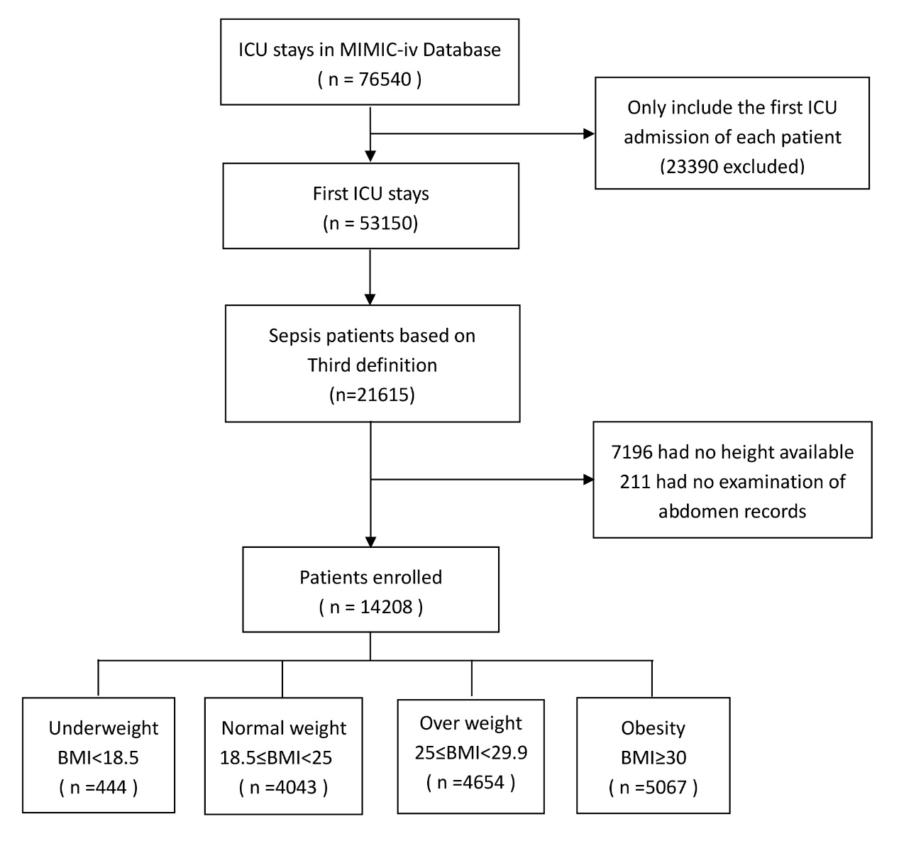

Figure S2 Subgroup analysis of the association between abdominal obesity and 28-day mortality.
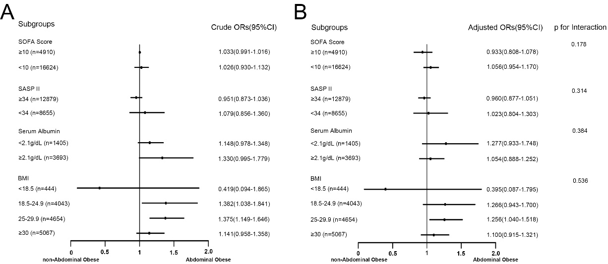

Abbreviations: OR, odd ratios; CI, confidence interval; SOFA, Sequential Organ Failure Assessment; SAPS II, Simplified Acute Physiology Score II

Figure S3 Cumulative 90-day mortality among 14208 patients with sepsis grouped by BMI.

