Supporting Information
Liquid-mediated mechanosynthesis of Zn-BDC coordination polymers via water- and DMF-assisted ball milling
Shi-Qiang Wang,*ª Shaza Darwish,^{b} Fan Feng,ª Shan Xu,ª Kunli Goh,ª Rong Wang,*^{a,c} and Michael J. Zaworotko*^{b}
ªSingapore Membrane Technology Centre, Nanyang Environment and Water Research Institute, Nanyang Technological University, 1 Cleantech Loop, 637141, Singapore.
^{b}Bernal Institute, Department of Chemical Sciences, University of Limerick, Limerick V94 T9PX, Ireland.
^{c}School of Civil and Environmental Engineering, Nanyang Technological University, Singapore, 639798, Singapore.
*E-mail: shiqiang.wang@ntu.edu.sg; rwang@ntu.edu.sg; xtal@ul.ie

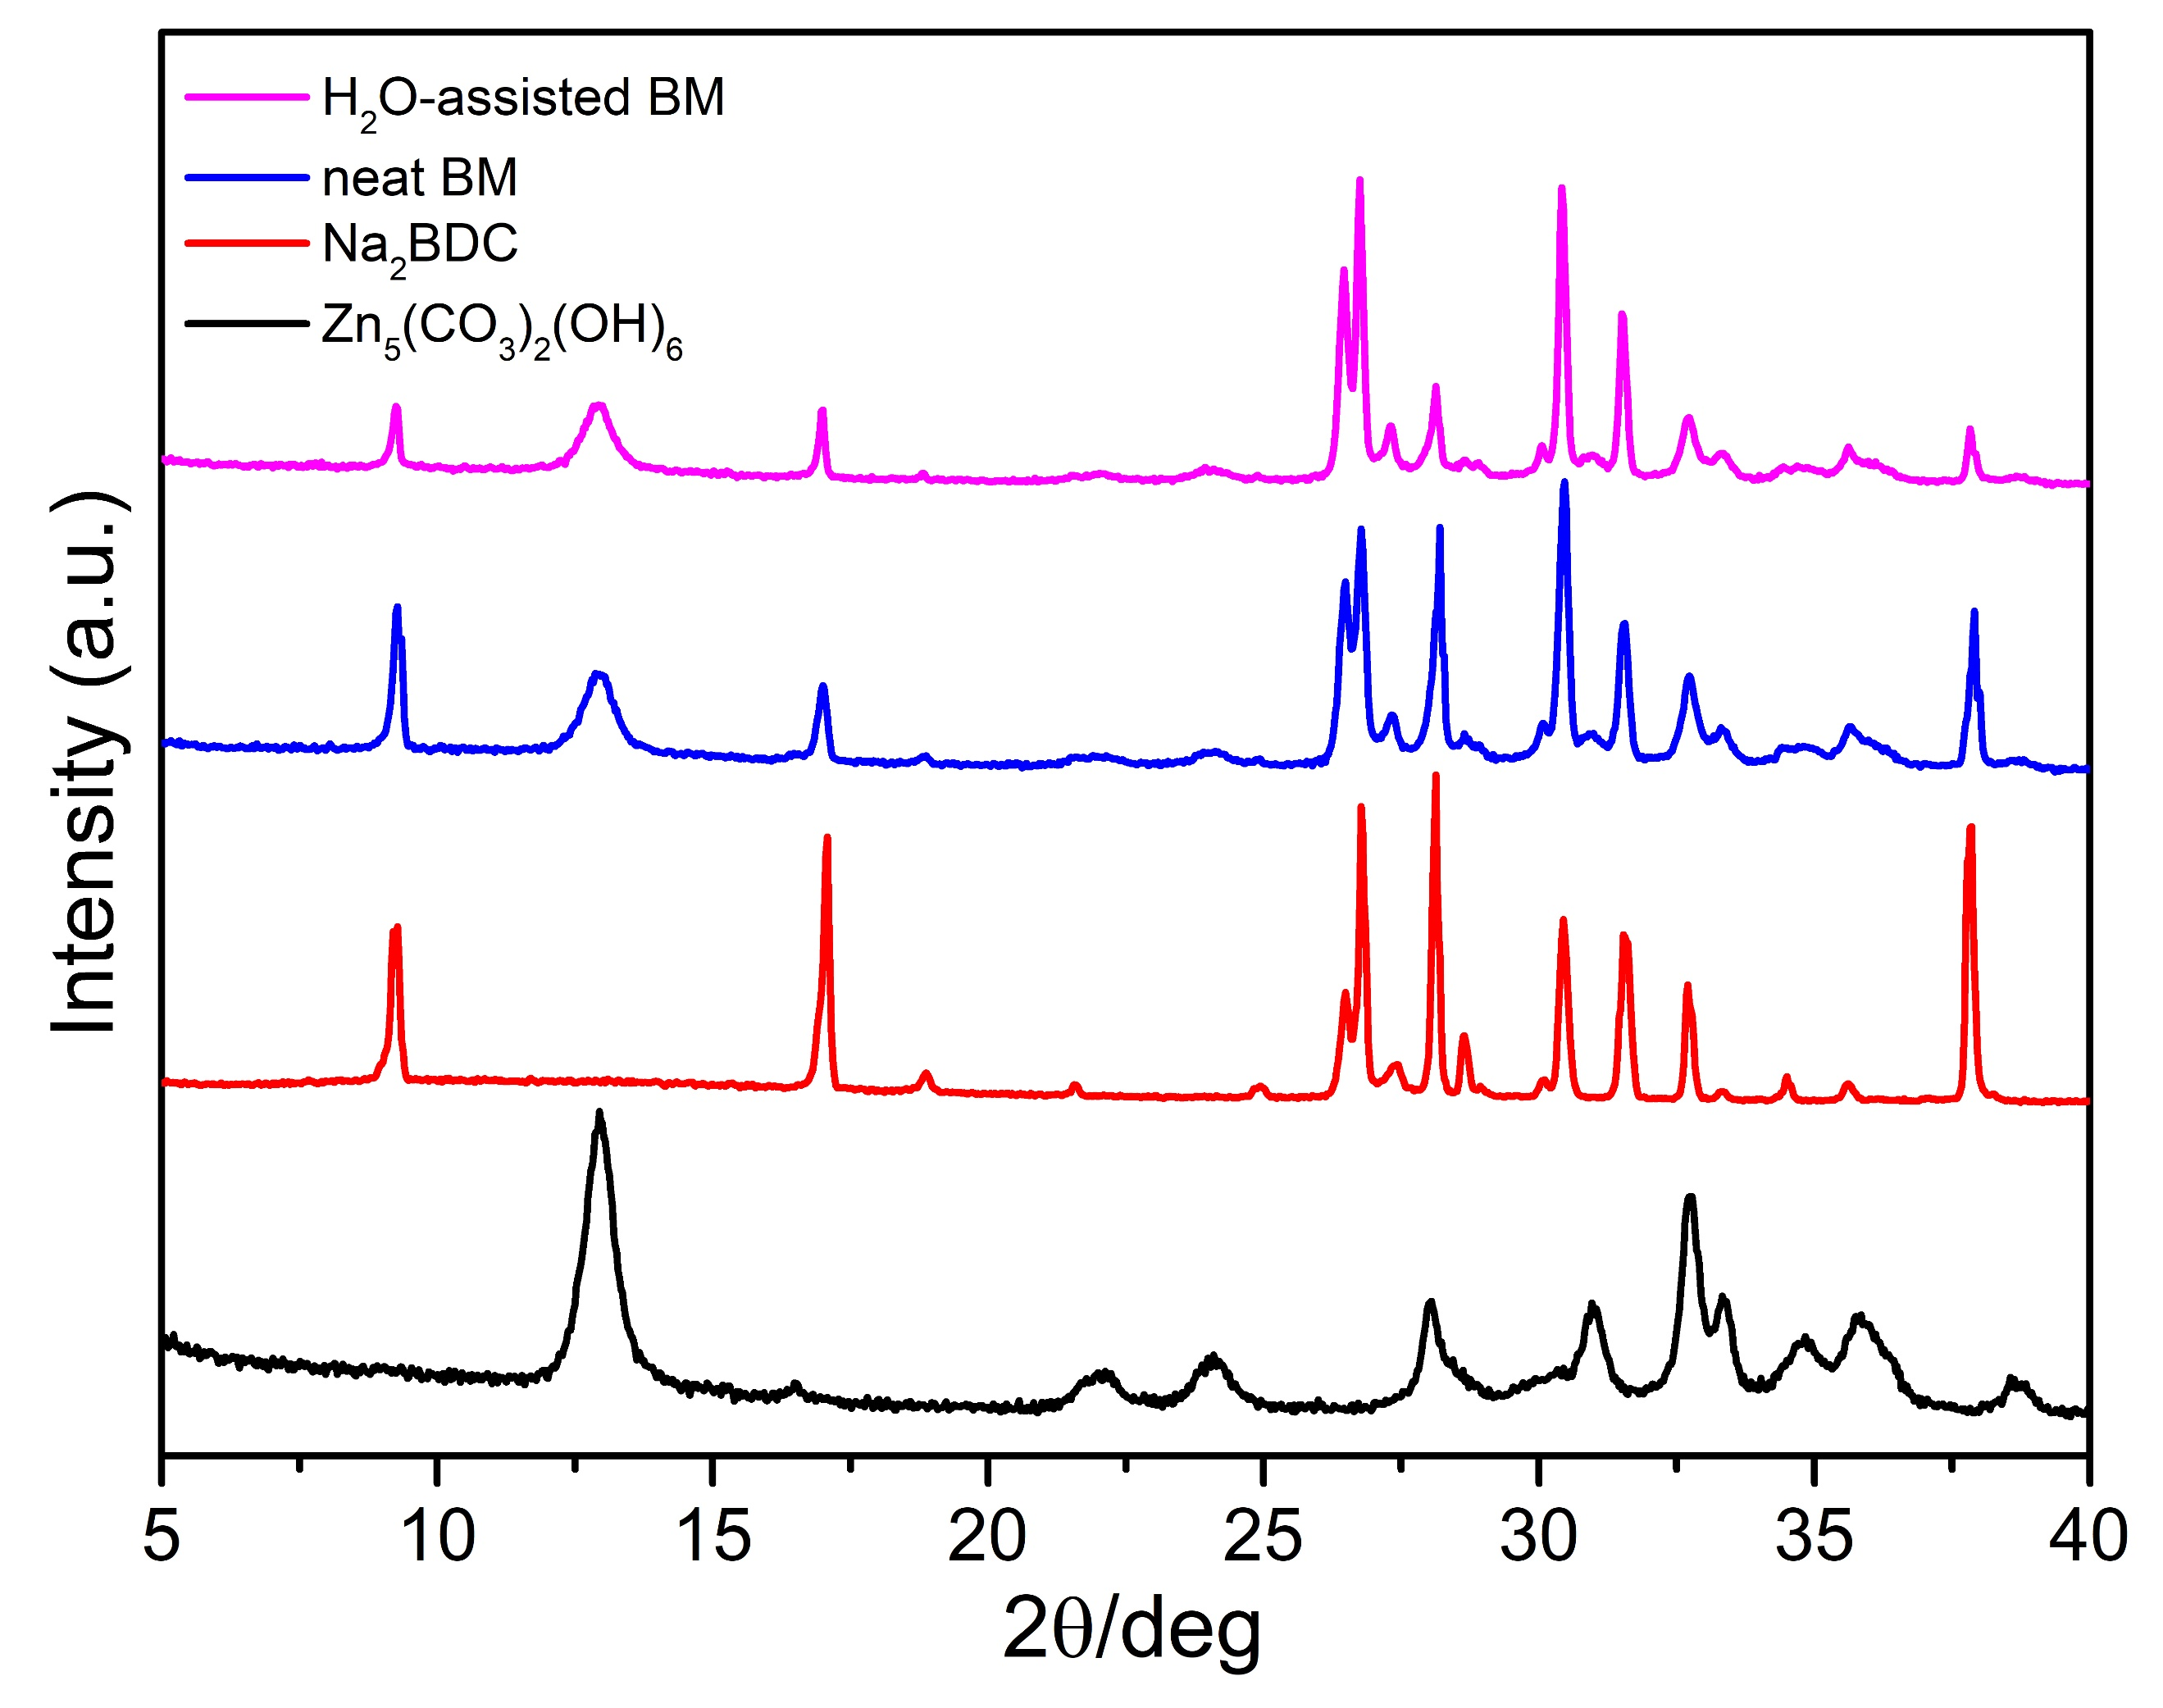
Figure S1. PXRD patterns of the starting materials and products obtained by neat and water-assisted BM using Zn₅(CO₃)₂(OH)₆ and Na₂BDC.
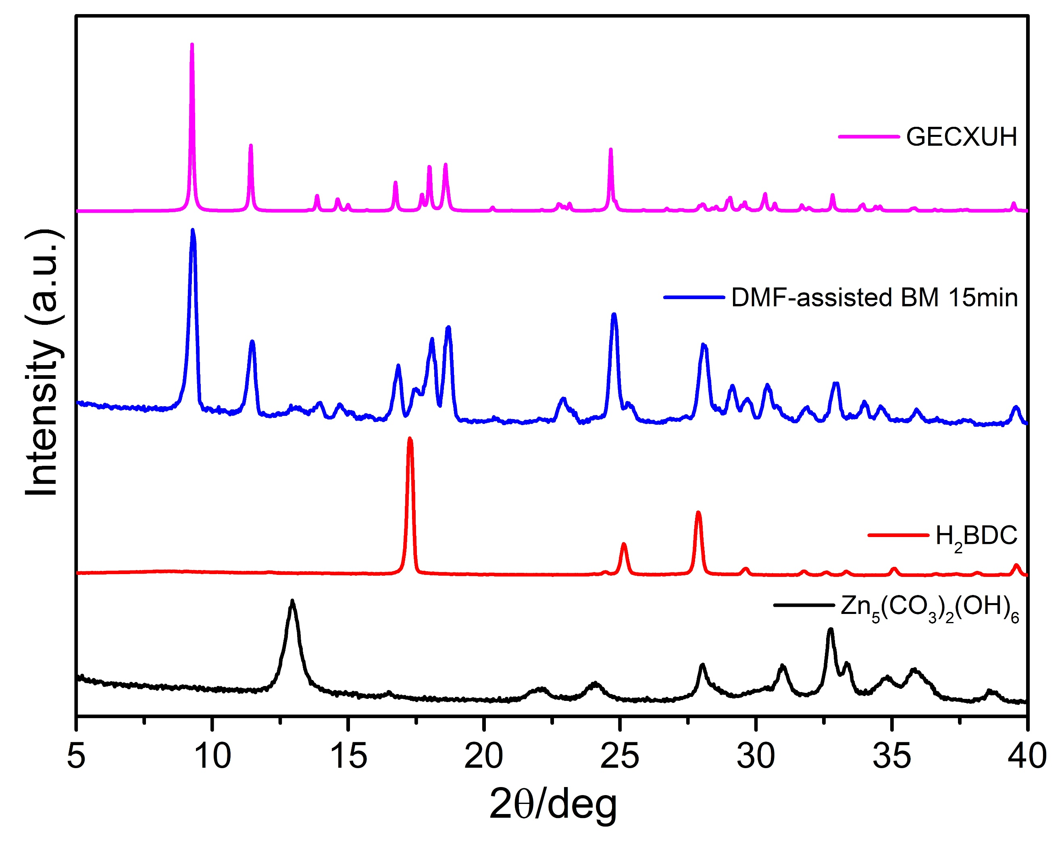
Figure S2. PXRD patterns of the starting materials and product obtained by DMF-assisted BM using Zn₅(CO₃)₂(OH)₆ and H₂BDC.
.
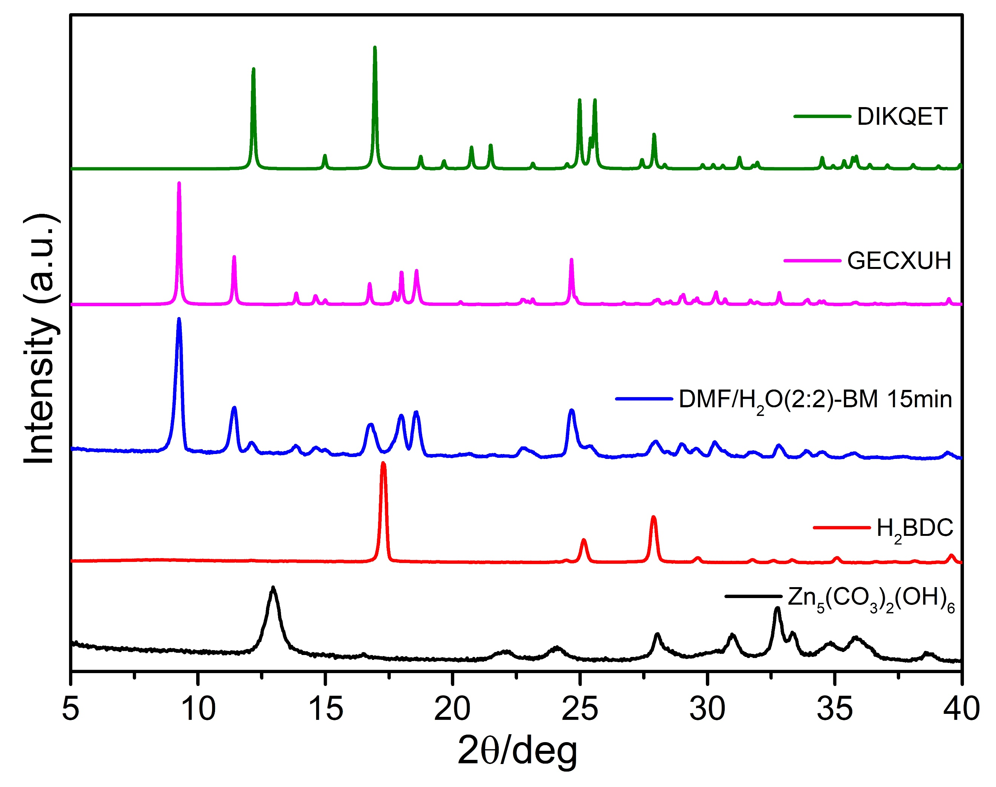
Figure S3. PXRD patterns of the starting materials and product obtained by DMF/H₂O-assisted BM using Zn₅(CO₃)₂(OH)₆ and H₂BDC.
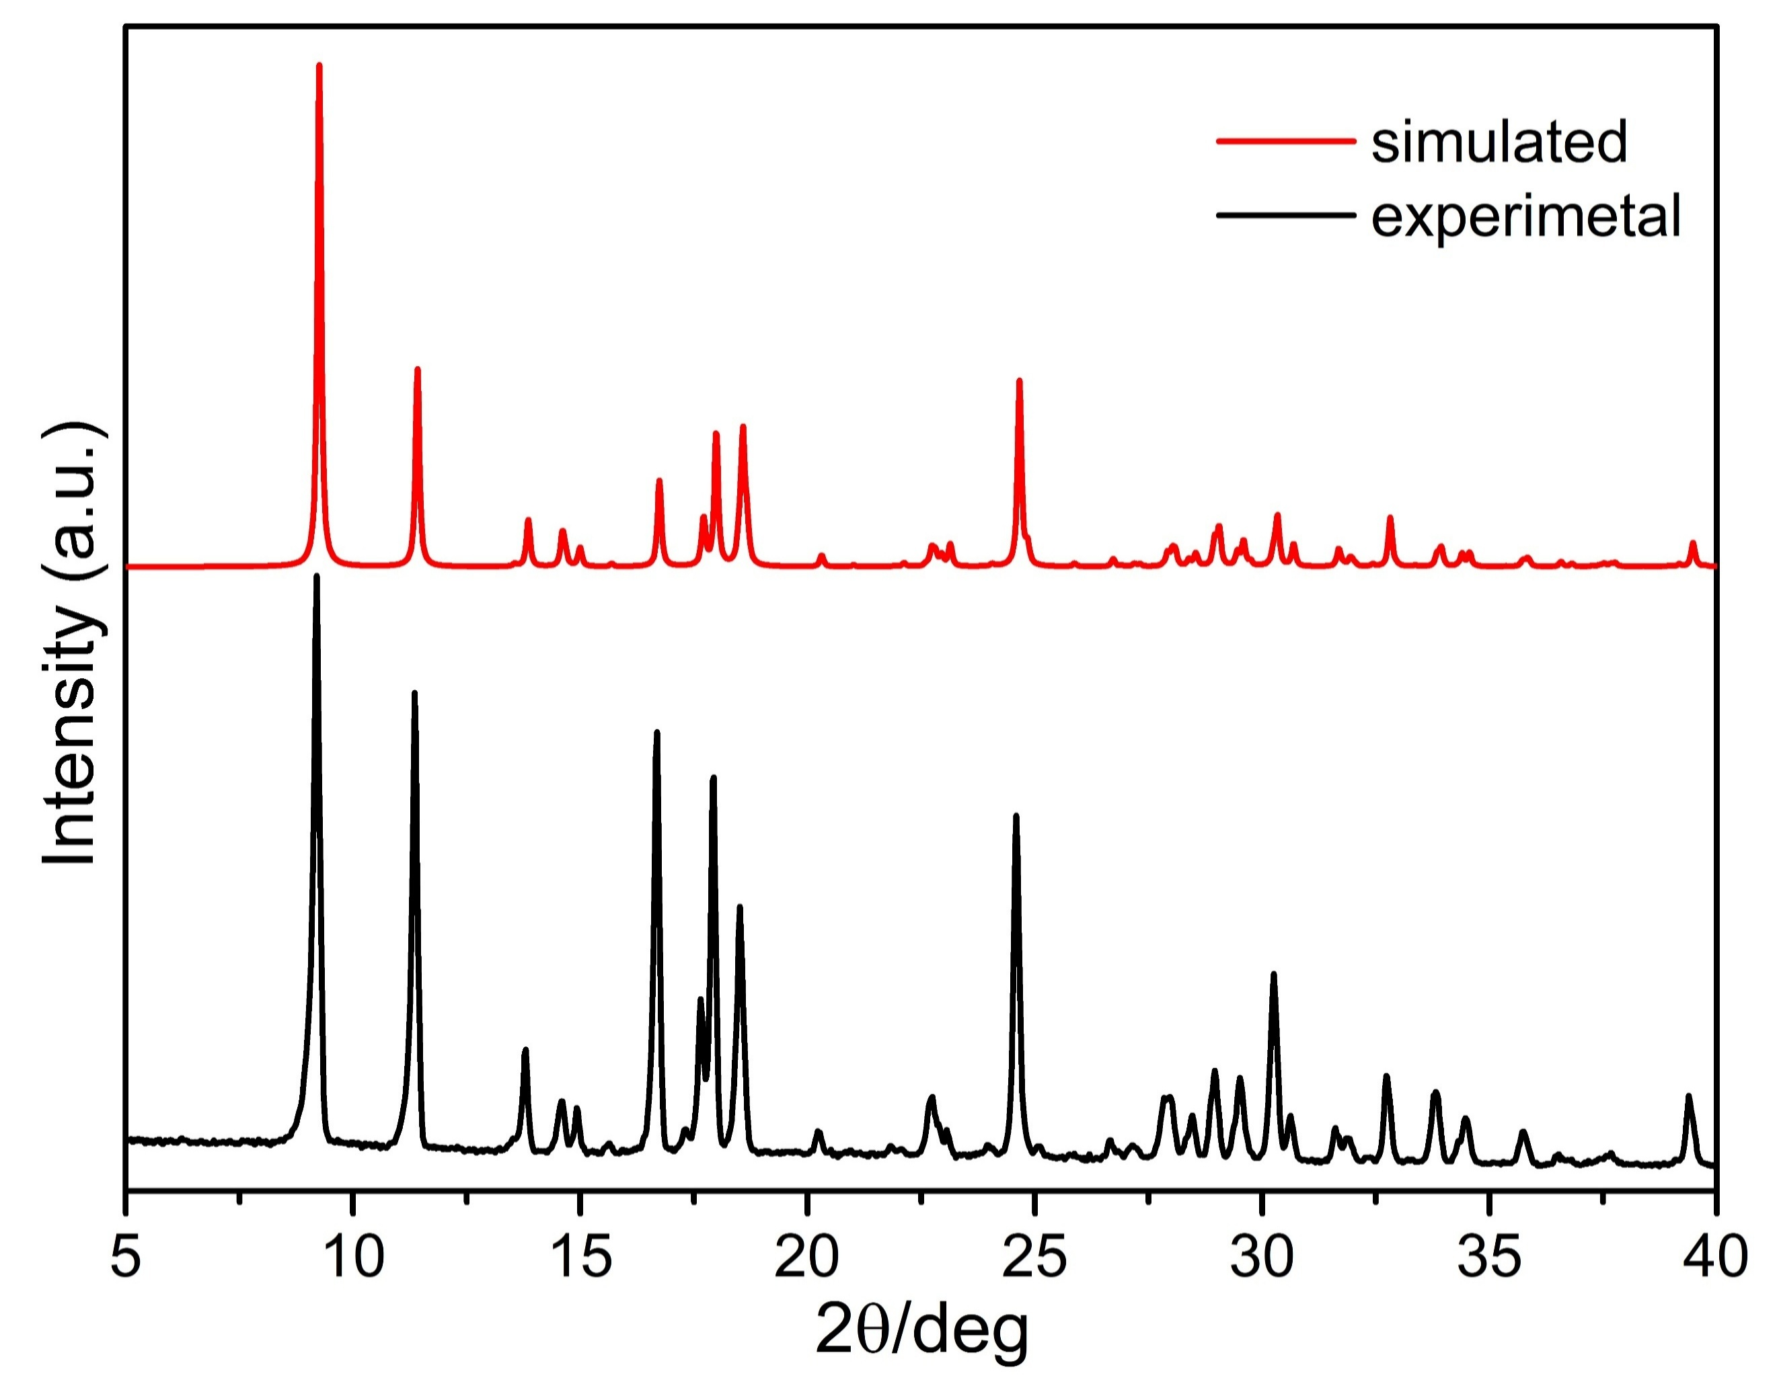
Figure S4. PXRD patterns of the experimental MOF-2 sample synthesized by rapid solution-mixing and the corresponding simulated pattern.

Table S1. Summary of reported Zn-BDC coordination polymers using DMF and/or water as the solvents.
Zn-BDC systems | Year | refcode | SG | a/Å | b/Å | c/Å | α/º | β/º | γ/º | Z | V/Å³
[Zn(BDC)(H₂O)]·DMF  (MOF-2)  2D | 1998 | GECXUH | P2₁/n | 6.72 | 15.49 | 12.43 | 90 | 102.8 | 90 | 4 | 1261.0
[Zn(BDC)(H₂O)]·DMF  (MOF-2)  2D | 2001 | GECXUH01 | P2₁/n | 6.73 | 15.52 | 12.45 | 90 | 102.8 | 90 | 4 | 1268.7
[Zn(BDC)(H₂O)]·DMF  (MOF-2)  2D | 2005 | GECXUH02 | P2₁/n | 6.65 | 15.22 | 12.61 | 90 | 104.1 | 90 | 4 | 1237.7
[Zn(BDC)(H₂O)]·DMF  (MOF-2)  2D | 2009 | GECXUH02 | P2₁/n | 6.72 | 15.48 | 12.44 | 90 | 102.8 | 90 | 4 | 1261.9
[Zn₄O(BDC)₃]  (MOF-5)  3D | 1999 | SAHYOQ | Fm-3m | 25.88 | 25.88 | 25.88 | 90 | 90 | 90 | 24 | 17343.6
[Zn(BDC)(H₂O)₂]_{n}  1D | 1999 | DIKQET | C2/c | 14.95 | 5.00 | 12.16 | 90 | 103.6 | 90 | 4 | 883.9
[Zn(BDC)(H₂O)₂]_{n}  1D | 2001 | DIKQET01 | C2/c | 14.99 | 5.03 | 12.10 | 90 | 103.82 | 90 | 4 | 886.0
[Zn(BDC)(H₂O)₂]_{n}  1D | 2002 | DIKQET02 | C2/c | 15.09 | 5.06 | 12.19 | 90 | 103.6 | 90 | 4 | 904.7
[Zn(BDC)(H₂O)₂]_{n}  1D | 2003 | DIKQET03 | C2/c | 15.03 | 5.05 | 12.13 | 90 | 103.8 | 90 | 4 | 892.7
[Zn(BDC)(H₂O)₂]_{n}  1D | 2016 | DIKQET04 | Cc | 14.99 | 5.04 | 12.11 | 90 | 103.8 | 90 | 4 | 888.5
[Zn(BDC)(H₂O)]_{n}  3D | 2001 | IFABIA | C2/c | 17.98 | 6.35 | 7.26 | 90 | 91.5 | 90 | 4 | 828.6
[Zn(BDC)(H₂O)]_{n}  3D | 2001 | IFABIA01 | C2/c | 17.98 | 6.36 | 7.26 | 90 | 91.5 | 90 | 4 | 829.4
[Zn(BDC)(H₂O)]_{n}  3D | 2003 | IFABIA02 | Cc | 18.01 | 6.34 | 7.25 | 90 | 91.4 | 90 | 4 | 828.4
[Zn(BDC)(H₂O)]_{n}  3D | 2015 | IFABIA03 | C2/c | 17.95 | 6.35 | 7.25 | 90 | 91.4 | 90 | 4 | 826.8
[Zn₃(BDC)₃(H₂O)₂]·4DMF  2D | 2001 | IFACAT | P2₁/c | 13.06 | 9.66 | 18.46 | 90 | 106.9 | 90 | 2 | 2229.2
[Zn₃(BDC)₃(H₂O)₂]·4DMF  2D | 2006 | IFACAT01 | P2₁/c | 13.05 | 9.66 | 18.46 | 90 | 106.9 | 90 | 2 | 2224.9
[Zn₃(BDC)₃(H₂O)₂]·4DMF  2D | 2006 | IFACAT02 | P2₁/c | 12.97 | 9.76 | 18.34 | 90 | 108.7 | 90 | 2 | 2198.6
[Zn(BDC)(DMF)]_{n}  2D | 2005 | DAXNOG | C2/m | 11.14 | 14.02 | 7.99 | 90 | 106.3 | 90 | 4 | 1197.3
[Zn(BDC)(DMF)]_{n}  2D | 2006 | DAXNOG01 | P-1 | 7.99 | 8.96 | 9.06 | 103.2 | 100.7 | 99.8 | 2 | 603.9
[Zn(BDC)(DMF)]_{n}  2D | 2016 | DAXNOG02 | C2/m | 11.19 | 14.14 | 7.98 | 90 | 106.9 | 90 | 4 | 1197.3
[Zn(BDC)(DMF)]_{n}  2D | 2016 | DAXNOG03 | P2₁/c | 7.91 | 14.17 | 11.54 | 90 | 107.6 | 90 | 4 | 1107.6
Zn₅(OH)₄(BDC)₃·2DMF  3D | 2006 | REDROI | P2₁/c | 6.41 | 14.16 | 20.10 | 90 | 95.3 | 90 | 2 | 1815.5

