Fig. S1 Manhattan and Q-Q plot for spot blotch resistance
Note: This figure presents the GWAS results for spot blotch resistance from all three year-specific analyses, complementing the representative results shown in Fig. 5. Manhattan plots display SNP associations across 21 chromosomes, and Q-Q plots illustrate the observed versus expected p-value distributions.

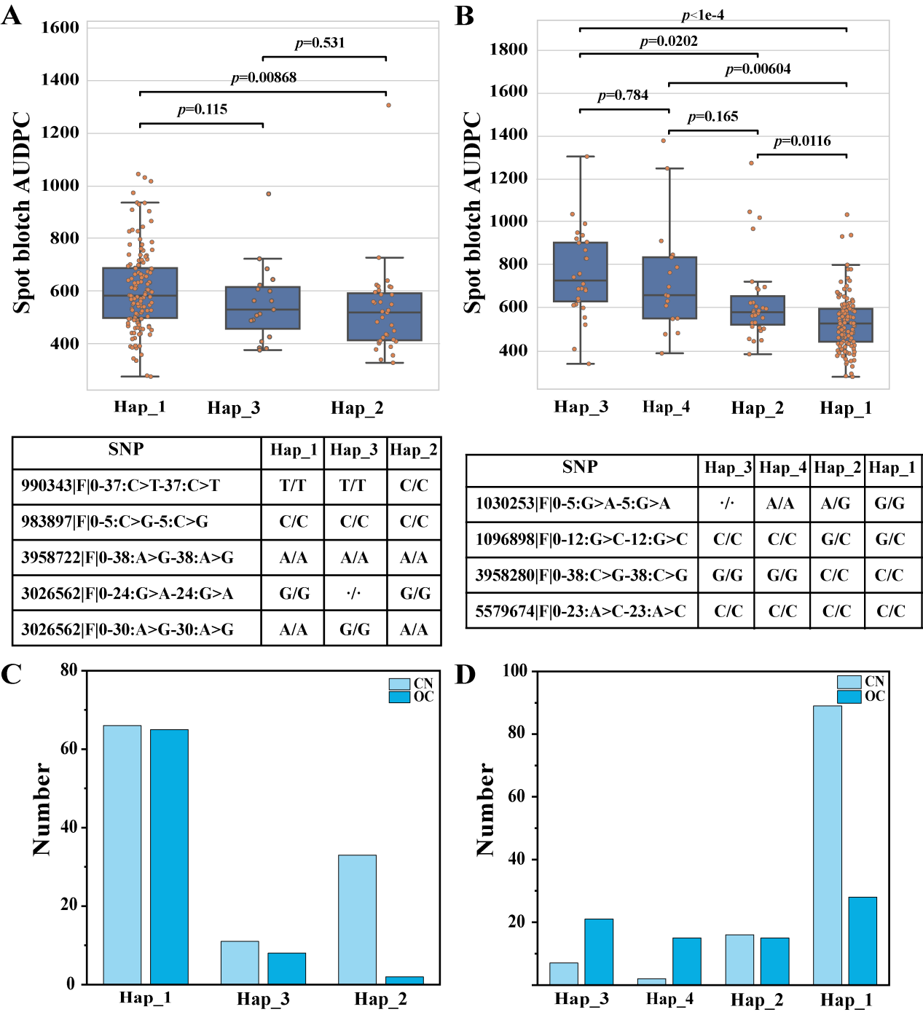
Fig. S2. Haplotype analysis of QTL_SB-1 (A and C) and QTL_SB-19 (B and D) across different years
Note: CN indicates Chinese wheat accessions, while OC represents accessions from CIMMYT and other countries.

Fig. S3. GO enrichment analysis of candidate genes for the SB.
Note: A: Bar plot showing the top 20 significantly enriched terms in the cellular component ontology. B: Bar plot showing the top 20 significantly enriched terms in the molecular function ontology. Bar length represents the gene ratio or gene count. Color intensity corresponds to the statistical significance (-log₁₀(qvalue)).

Fig. S4 Genomic prediction accuracy for spot blotch resistance using SNPs that were significant in at least two environments (Matrix 2)
Note: Scatter plots display the relationship between observed and predicted values estimated by Bayesian ridge regression. Panels A: SB21adj; B:SB22adj; C: SB23adj; D: SBadj_BLUE.

