Supplementary Materials
A systems thinking approach to improve participatory processes in small-scale fisheries management

Figure S1. The two study geographies in southern Peru and northern Chile for the octopus fisheries. Data collection was focused in Ilo, Peru and between the two cities Tocopilla and Caldera in Chile.

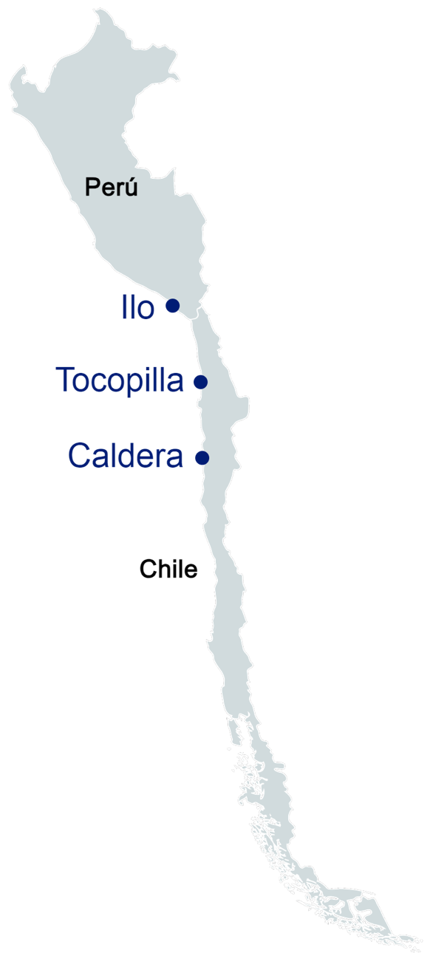

Causal Loop Diagram Data Structure
The finalized causal loop diagrams were converted into a standardized Google Sheets format that serves as the underlying data structure for the Ripple Maps platform. The spreadsheet consists of two linked worksheets: FACTORS, which lists each system variable with a unique identifier, domain classification, and supporting metadata (e.g., definitions and intervention status), and RELATIONSHIPS, which records each directed connection between variables, including the source and target nodes, polarity (same or opposite), qualitative relationship strength (weak, medium, or strong), and optional descriptive information. The platform reads these worksheets to reconstruct the causal network, generate visualizations, perform token diffusion simulations, calculate network centrality metrics, and support other interactive analyses. Separating the network structure from the software code allows users to modify or develop new causal maps by editing the spreadsheet without changing the underlying platform.

Table S1. Characteristics of participatory causal loop diagrams of the octopus fishery in Peru and Chile. The total number of nodes are shown and their distribution across five domains (i.e., biology (B), economics-markets (EM), environmental (E), management (M), and social (S)). Total number of relationships (Rs) and percentage of strong relationships (S-Rs), along with number of balancing (BLs) and reinforcing feedback loops (RLs).

Country | #Nodes | B | EM | E | M | S | Rs | S-Rs | BLs | RLs
Peru | 66 | 12% | 47% | 2% | 51% | 22% | 97 | 85% | 23 | 39
Chile | 49 | 12% | 22% | 2% | 39% | 24% | 75 | 61% | 13 | 23

