Supplementary material
Seasonal arsenic dynamics in a shallow eutrophic lake from a naturally enriched region: links between sediment mobilization and bioaccumulation across trophic levels
Leila Natalia Chiodi Boudet, María Belén Romero, Eduardo Fernández, Emilio Brambilla, Juan Pablo Lancia, Agustín Costas, Sandra Medici, Marcela Gerpe, Paula Polizzi

Table S1. Summary table of analyzed samples
Matrix / Species | Trophic level | Sample type | N samples (total) | Seasonal sampling | Notes
Surface water | – | Triplicates per site | 60 | 5 sites × 4 seasons × 3 replicates | Total As, Fe, Mn
Surface sediments | – | Triplicates per site | 60 | 5 sites × 4 seasons × 3 replicates | Grain size, OC, pH, As, Fe, Mn
Ricciocarpos natans | Primary producer | Composite (50 liverworts) | 28 | 7 samples x 4 seasons | Floating; not site-associated
Palaemon argentinus – LS (≥15 mm) | Primary consumer | 3 pools (≈15 ind.) | 12 | 3 pools x 4 seasons | Adults
Palaemon argentinus – SS (<15 mm) | Primary consumer | 3 pools (≈15 ind.) | 6 | 3 pools x 2 seasons (summer and winter) | Juveniles absent in spring and autumn
Odontesthes bonariensis | Secondary consumer (fish) | Individual | 17 | Winter (4), Spring (4), Summer (5), Autumn (4) | Gills, liver, and muscle analyzed

Table S2. Moisture content of R. natans and the calculation of the conversion factor (CF)
CF = 100 – 94.01 / 100 = 0.06

 | Humidity (H%) |  |  | Humidity (H%)
Winter | 95.9 |  | Summer | 96.1
 | 95.1 |  |  | 93.9
 | 93.21 |  |  | 95.1
 | 92.1 |  |  | 93.7
 | 94.2 |  |  | 92.9
 | 94.7 |  |  | 93.5
 | 93.2 |  |  | 94.1
Spring | 93.67 |  | Autumn | 96.4
 | 93.15 |  |  | 93.3
 | 94.23 |  |  | 93.9
 | 92.8 |  |  | 95.0
 | 93.48 |  |  | 94.6
 | 93.83 |  |  | 93.3
 | 92.75 |  |  | 94.0
Mean: 94.01

Table S3. Total length (TL), measured from the anterior end of the rostrum to the posterior tip of the telson, in P. argentinus to classify individuals into two groups: small shrimp (SS, TL < 15 mm) and large shrimp (LS, TL ≥ 15 mm), corresponding to juveniles and adults.
Winter -POOL 1 SS  n=20 | TL (mm) | Winter -POOL 2 SS  n=20 | TL (mm) | Winter -POOL 3 SS  n=19 | TL (mm)
Juv 1 | 11.1 | Juv 1 | 12.0 | Juv 1 | 11.9
Juv 2 | 12.8 | Juv 2 | 13.3 | Juv 2 | 13.2
Juv 3 | 13.4 | Juv 3 | 14.1 | Juv 3 | 14.7
Juv 4 | 14.5 | Juv 4 | 12.8 | Juv 4 | 12.9
Juv 5 | 14.3 | Juv 5 | 12.7 | Juv 5 | 12.4
Juv 6 | 13.9 | Juv 6 | 13.6 | Juv 6 | 13.5
Juv 7 | 12.5 | Juv 7 | 13.1 | Juv 7 | 13.2
Juv 8 | 12.9 | Juv 8 | 14.4 | Juv 8 | 14.8
Juv 9 | 14.7 | Juv 9 | 12.6 | Juv 9 | 13.7
Juv 10 | 14.2 | Juv 10 | 11.9 | Juv 10 | 12.6
Juv 11 | 13.9 | Juv 11 | 13.8 | Juv 11 | 12.0
Juv 12 | 14.8 | Juv 12 | 13.5 | Juv 12 | 13.8
Juv 13 | 12.0 | Juv 13 | 14.3 | Juv 13 | 12.7
Juv 14 | 11.9 | Juv 14 | 13.7 | Juv 14 | 12.8
Juv 15 | 13.3 | Juv 15 | 13.4 | Juv 15 | 13.4
Juv 16 | 13.0 | Juv 16 | 11.8 | Juv 16 | 12.8
Juv17 | 14.6 | Juv17 | 13.3 | Juv17 | 12.3
Juv 18 | 12.1 | Juv 18 | 12.9 | Juv 18 | 11.8
Juv 19 | 11.9 | Juv 19 | 14.1 | Juv 19
Juv 20 | 14.2 | Juv 20 | 14.3
Winter -POOL 1 - LS  n=15 | TL (mm) | Winter -POOL 2 - LS  n=15 | TL (mm) | Winter -POOL 3 - LS  n=15 | TL (mm)
Adult 1 | 22.0 | Adult 1 | 16.8 | Adult 1 | 16.6
Adult 2 | 24.3 | Adult 2 | 16.2 | Adult 2 | 15.4
Adult 3 | 15.9 | Adult 3 | 15.8 | Adult 3 | 19.9
Adult 4 | 16.7 | Adult 4 | 17.5 | Adult 4 | 23.1
Adult 5 | 17.7 | Adult 5 | 18.5 | Adult 5 | 22.4
Adult 6 | 18.4 | Adult 6 | 23.4 | Adult 6 | 17.2
Adult 7 | 16.3 | Adult 7 | 22.1 | Adult 7 | 21.6
Adult 8 | 15.8 | Adult 8 | 20.1 | Adult 8 | 18.6
Adult 9 | 24.1 | Adult 9 | 18.4 | Adult 9 | 18.0
Adult 10 | 23.3 | Adult 10 | 19.5 | Adult 10 | 16.2
Adult 11 | 22.7 | Adult 11 | 19.9 | Adult 11 | 23.6
Adult 12 | 24.2 | Adult 12 | 23.1 | Adult 12 | 22.7
Adult 13 | 24.6 | Adult 13 | 22.8 | Adult 13 | 21.1
Adult 14 | 23.1 | Adult 14 | 16.7 | Adult 14 | 24.2
Adult 15 | 18.4 | Adult 15 | 18.1 | Adult 15 | 17.0

SPRING -POOL 1 LS  n=15 | TL (mm) | SPRING -POOL 2 LS  n=15 | TL (mm) | SPRING -POOL 3 LS  n=15 | TL (mm)
Adult 1 | 18.8 | Adult 1 | 22.3 | Adult 1 | 23.0
Adult 2 | 16.3 | Adult 2 | 21.0 | Adult 2 | 21.8
Adult 3 | 21.0 | Adult 3 | 18.7 | Adult 3 | 22.5
Adult 4 | 20.4 | Adult 4 | 19.2 | Adult 4 | 24.9
Adult 5 | 24.2 | Adult 5 | 19.9 | Adult 5 | 21.8
Adult 6 | 19.6 | Adult 6 | 20.1 | Adult 6 | 23.1
Adult 7 | 18.5 | Adult 7 | 22.3 | Adult 7 | 20.8
Adult 8 | 16.2 | Adult 8 | 20.4 | Adult 8 | 19.4
Adult 9 | 20.9 | Adult 9 | 22.6 | Adult 9 | 18.0
Adult 10 | 22.1 | Adult 10 | 20.8 | Adult 10 | 24.0
Adult 11 | 24.0 | Adult 11 | 23.4 | Adult 11 | 21.8
Adult 12 | 21.3 | Adult 12 | 20.9 | Adult 12 | 23.0
Adult 13 | 17.8 | Adult 13 | 17.7 | Adult 13 | 21.9
Adult 14 | 16.5 | Adult 14 | 16.6 | Adult 14 | 22.5
Adult 15 | 17.4 | Adult 15 | 20.1 | Adult 15 | 23.0
SUMMER -POOL 1 SS  n=20 | TL (mm) | SUMMER -POOL 2 SS  n=19 | TL (mm) | SUMMER -POOL 3 SS  n=19 | TL (mm)
Juv 1 | 14.5 | Juv 1 | 13.0 | Juv 1 | 14.1
Juv 2 | 13.2 | Juv 2 | 12.4 | Juv 2 | 13.9
Juv 3 | 13.0 | Juv 3 | 14.8 | Juv 3 | 12.5
Juv 4 | 11.9 | Juv 4 | 13.3 | Juv 4 | 11.9
Juv 5 | 12.8 | Juv 5 | 14.2 | Juv 5 | 14.7
Juv 6 | 14.1 | Juv 6 | 13.7 | Juv 6 | 13.8
Juv 7 | 11.5 | Juv 7 | 12.7 | Juv 7 | 13.5
Juv 8 | 13.4 | Juv 8 | 12.4 | Juv 8 | 12.8
Juv 9 | 13.8 | Juv 9 | 13.6 | Juv 9 | 13.4
Juv 10 | 14.1 | Juv 10 | 14.1 | Juv 10 | 14.6
Juv 11 | 14.8 | Juv 11 | 12.9 | Juv 11 | 14.0
Juv 12 | 12.4 | Juv 12 | 13.4 | Juv 12 | 11.8
Juv 13 | 13.6 | Juv 13 | 12.1 | Juv 13 | 13.3
Juv 14 | 13.3 | Juv 14 | 12.4 | Juv 14 | 12.5
Juv 15 | 14.1 | Juv 15 | 13.5 | Juv 15 | 14.9
Juv 16 | 12.0 | Juv 16 | 13.0 | Juv 16 | 12.7
Juv17 | 13.9 | Juv17 | 14.6 | Juv17 | 13.6
Juv 18 | 12.7 | Juv 18 | 14.0 | Juv 18 | 14.3
Juv 19 | 13.1 | Juv 19 | 13.6 | Juv 19 | 13.8
Juv 20 | 14.0

SUMMER -POOL 1 - LS  n=15 | TL (mm) | SUMMER -POOL 2 - LS  n=15 | TL (mm) | SUMMER -POOL 3 - LS  n=15 | TL (mm)
Adult 1 | 17.2 | Adult 1 | 16.6 | Adult 1 | 19.9
Adult 2 | 18.5 | Adult 2 | 19.2 | Adult 2 | 27.6
Adult 3 | 16.7 | Adult 3 | 24.1 | Adult 3 | 29.4
Adult 4 | 19.8 | Adult 4 | 22.4 | Adult 4 | 26.0
Adult 5 | 20.5 | Adult 5 | 23.3 | Adult 5 | 19.8
Adult 6 | 23.0 | Adult 6 | 24.0 | Adult 6 | 16.7
Adult 7 | 24.9 | Adult 7 | 28.4 | Adult 7 | 22.8
Adult 8 | 19.4 | Adult 8 | 26.1 | Adult 8 | 24.3
Adult 9 | 22.1 | Adult 9 | 28.8 | Adult 9 | 28.0
Adult 10 | 26.4 | Adult 10 | 26.7 | Adult 10 | 26.4
Adult 11 | 25.0 | Adult 11 | 18.7 | Adult 11 | 22.5
Adult 12 | 26.4 | Adult 12 | 15.9 | Adult 12 | 18.9
Adult 13 | 20.9 | Adult 13 | 24.1 | Adult 13 | 16.6
Adult 14 | 19.7 | Adult 14 | 25.6 | Adult 14 | 20.7
Adult 15 | 18.4 | Adult 15 | 19.9 | Adult 15 | 24.4

AUTUMN -POOL 1 - LS  n=15 | TL (mm) | AUTUMN -POOL 2 - LS  n=15 | TL (mm) | AUTUMN -POOL 3 - LS  n=15 | TL (mm)
Adult 1 | 15.8 | Adult 1 | 23.0 | Adult 1 | 22.3
Adult 2 | 16.3 | Adult 2 | 22.1 | Adult 2 | 20.4
Adult 3 | 19.7 | Adult 3 | 24.0 | Adult 3 | 19.8
Adult 4 | 21.3 | Adult 4 | 16.4 | Adult 4 | 16.6
Adult 5 | 22.0 | Adult 5 | 18.3 | Adult 5 | 17.5
Adult 6 | 19.9 | Adult 6 | 17.6 | Adult 6 | 19.3
Adult 7 | 22.4 | Adult 7 | 19.1 | Adult 7 | 15.8
Adult 8 | 20.5 | Adult 8 | 16.6 | Adult 8 | 16.6
Adult 9 | 19.6 | Adult 9 | 20.3 | Adult 9 | 23.0
Adult 10 | 22.6 | Adult 10 | 24.1 | Adult 10 | 24.1
Adult 11 | 22.0 | Adult 11 | 21.8 | Adult 11 | 22.9
Adult 12 | 17.7 | Adult 12 | 18.8 | Adult 12 | 19.8
Adult 13 | 18.2 | Adult 13 | 16.4 | Adult 13 | 17.5
Adult 14 | 16.5 | Adult 14 | 15.5 | Adult 14 | 16.1
Adult 15 | 19.1 | Adult 15 | 17.4 | Adult 15 | 19.9

Table S4. Length, weight, and sex of Individuals of Odontesthes bonariensis
WINTER
 | Total weight (gr) | Total lenght (TL, mm) | Standard lenght (SL, mm) | Sex
P-1 | 174.8 | 297 | 257 | Male
P-2 | 264.5 | 331 | 295 | Female
P-3 | 150.1 | 282 | 251 | Female
P-4 | 201.3 | 287 | 253 | Male
SPRING
P-5 | 202.2 | 294 | 257 | Male
P-6 | 159.4 | 241 | 211 | Male
P-7 | 161.1 | 249 | 215 | Male
P-8 | 115.8 | 268 | 236 | Female
SUMMER
P-9 | 330.3 | 342 | 294 | Male
P-10 | 185.9 | 302 | 265 | Female
P-11 | 170.7 | 288 | 254 | Male
P-12 | 132.2 | 263 | 232 | Male
P-13 | 216.2 | 311 | 272 | Male
AUTUMN
P-14 | 201.1 | 293 | 261 | Male
P-15 | 100.3 | 240 | 208 | Female
P-16 | 115.0 | 235 | 201 | Male
P-17 | 112.9 | 247 | 216 | Female

Table S5. Certified reference material MESS-3 (Sediments - National Research Council of Canada). Certified values: Arsenic (As): 21.2 ± 1.1, Iron (Fe): 324 ± 12, Manganese (Mn): 4.34 ± 0.11 (mg/kg)
CRM-MESS | As (mg/kg) | % recovery | Fe (mg/kg) | % recovery | Mn (mg/kg) | % recovery
 | 20.24 | 95.47 | 340 | 104.94 | 4.44 | 102.30
 | 19.89 | 93.82 | 312 | 96.30 | 4.75 | 109.45
 | 20.09 | 94.76 | 325 | 100.31 | 4.02 | 92.63
 | 21.75 | 102.59 | 330 | 101.85 | 3.98 | 91.71
 | 20.05 | 94.58 | 335 | 103.40 | 4.42 | 101.84
 | 22.65 | 106.84 | 319 | 98.46 | 4.59 | 105.76
Media |  | 98.01 |  | 100.87 |  | 100.61
SD |  | 5.39 |  | 3.19 |  | 7.10

Table S6. Certified reference material TORT-2 (lobster hepatopancreas - National Research Council of Canada). Certified values: As: 21.6 ± 1.8, Fe: 105 ± 13, Mn: 13.6 ± 1.2
TORT-2 | As (mg/kg) | % recovery | Fe (mg/kg) | % recovery | Mn (mg/kg) | % recovery
 | 19.04 | 88.15 | 120 | 114.29 | 11.79 | 86.69
 | 21.2 | 98.15 | 118 | 112.38 | 13.04 | 95.88
 | 21.08 | 97.59 | 98 | 93.33 | 13.98 | 102.79
 | 22.75 | 105.32 | 104 | 99.05 | 14.21 | 104.49
 | 19.9 | 92.13 | 110 | 104.76 | 11.98 | 88.09
 | 19.81 | 91.71 | 119 | 113.33 | 12.82 | 94.26
Media |  | 95.51 |  | 106.19 |  | 95.37
SD |  | 6.13 |  | 8.64 |  | 7.32

Figure S1. Correlations between As vs Fe concentrations in sediments
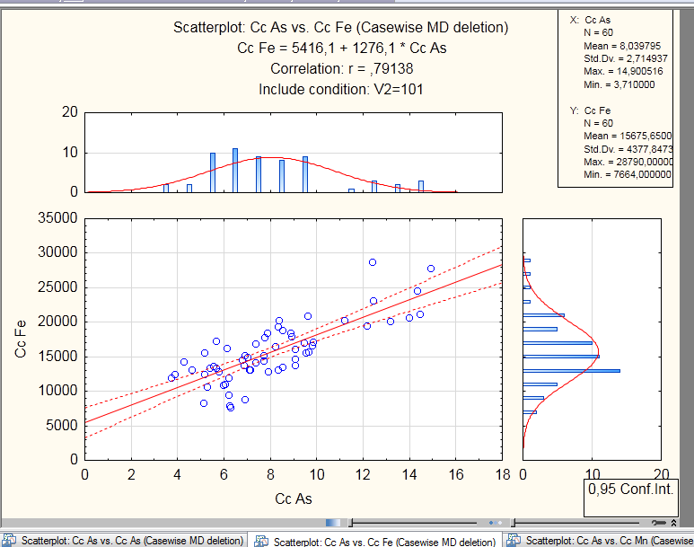
Figure S2. Correlation between As vs Mn concentrations in sediments
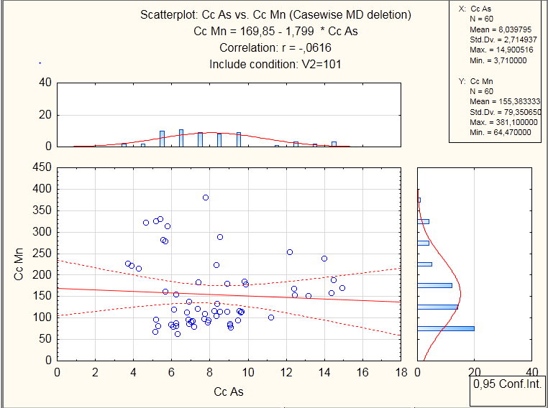

Table S7. Bioaccumulation factors (BAF) values calculated on a wet basis in aquatic biota from Los Padres Lake. SS: small shrimp, LS: large shrimp. -- SS shrimps were not captured during spring and autumn
 | Winter | Spring | Summer | Autumn
R. natans | 8.7 | 14.9 | 16.9 | 14.5
P. argentinus
LS cephalothorax | 5.8 | 6.0 | 7.7 | 5.8
abdomen | 3.9 | 4.0 | 4.4 | 3.6
SS cephalothorax | 6.0 | -- | 6.3 | --
abdomen | 5.2 | -- | 3.2 | --
O. bonariensis
liver | 2.7 | 4.1 | 2.3 | 3.3
muscle | 1.3 | 1.0 | 1.1 | 1.3

