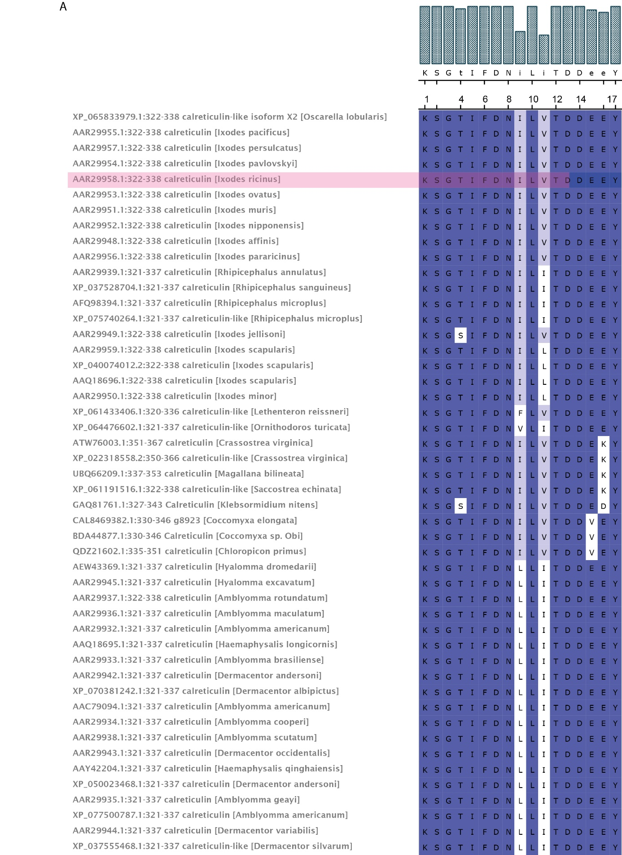
Supplementary figure 1. Multiple sequence alignments of an I. ricinus salivary peptide from Calreticulin
Multiple sequence alignment of CRT39 using the PAM30 matrix adjusted for short sequences.
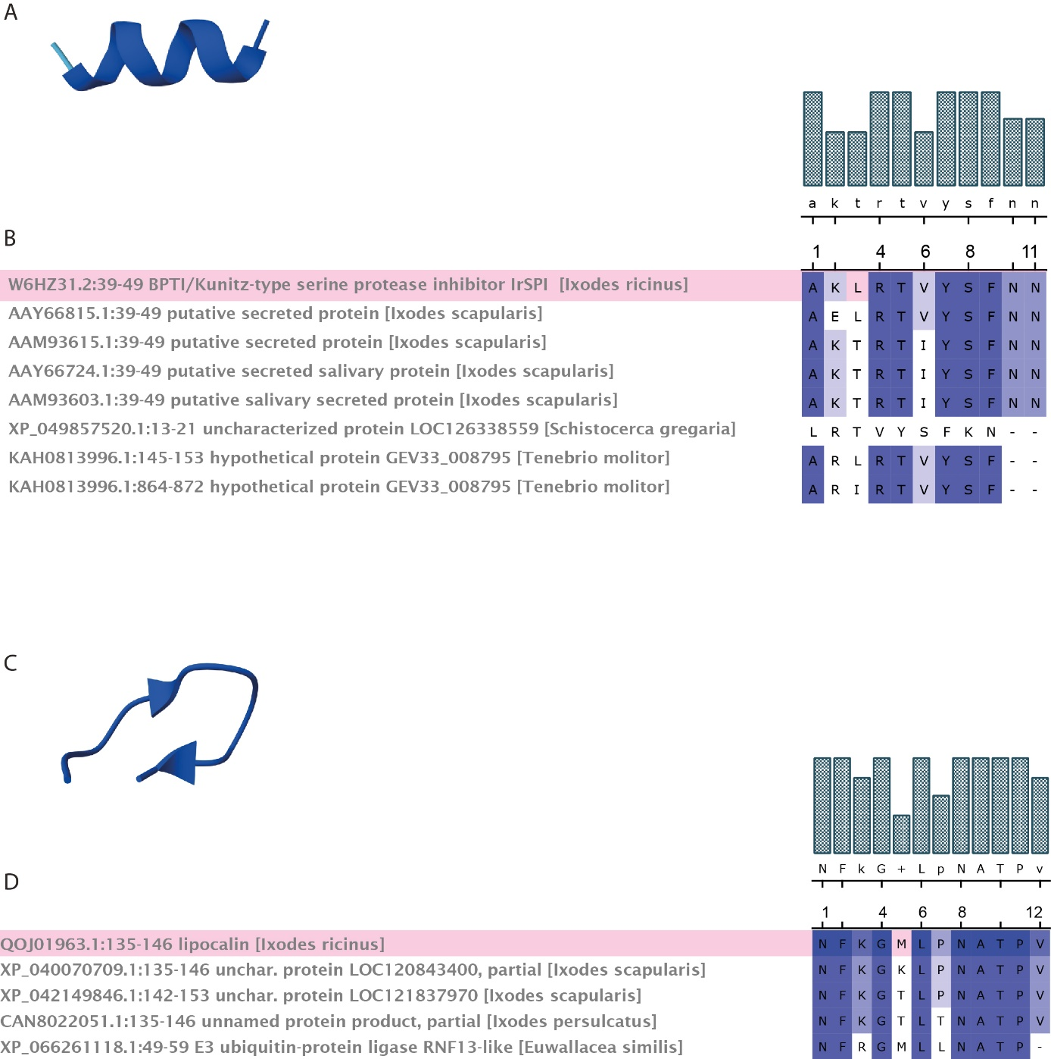
Supplementary figure 2. Multiple sequence alignments of I. ricinus salivary peptides
(a) Multiple sequence alignment of SPI01 using the PAM30 matrix adjusted for short sequences. (b) Multiple sequence alignment of LIP04 using the PAM30 matrix adjusted for short sequences
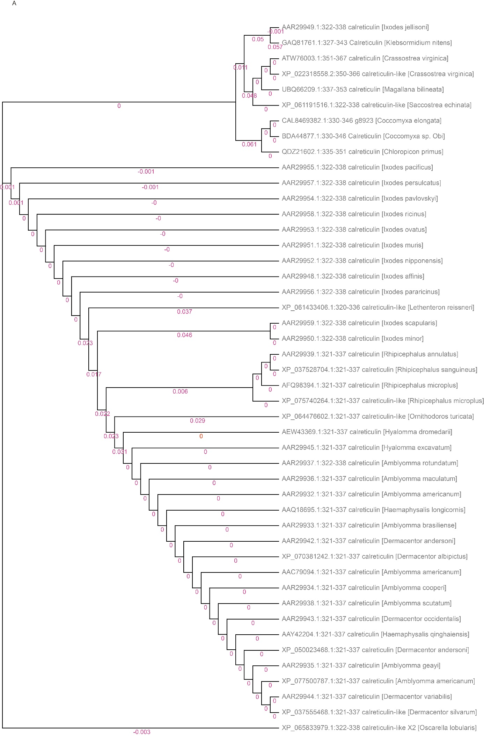
Supplementary figure 3. Phylogenetic tree constructed for sequences containing more than 80 percent identity with the I. ricinus sequence for CRT39, constructed in UGene using the PHYLIP Neighbor Joining method.
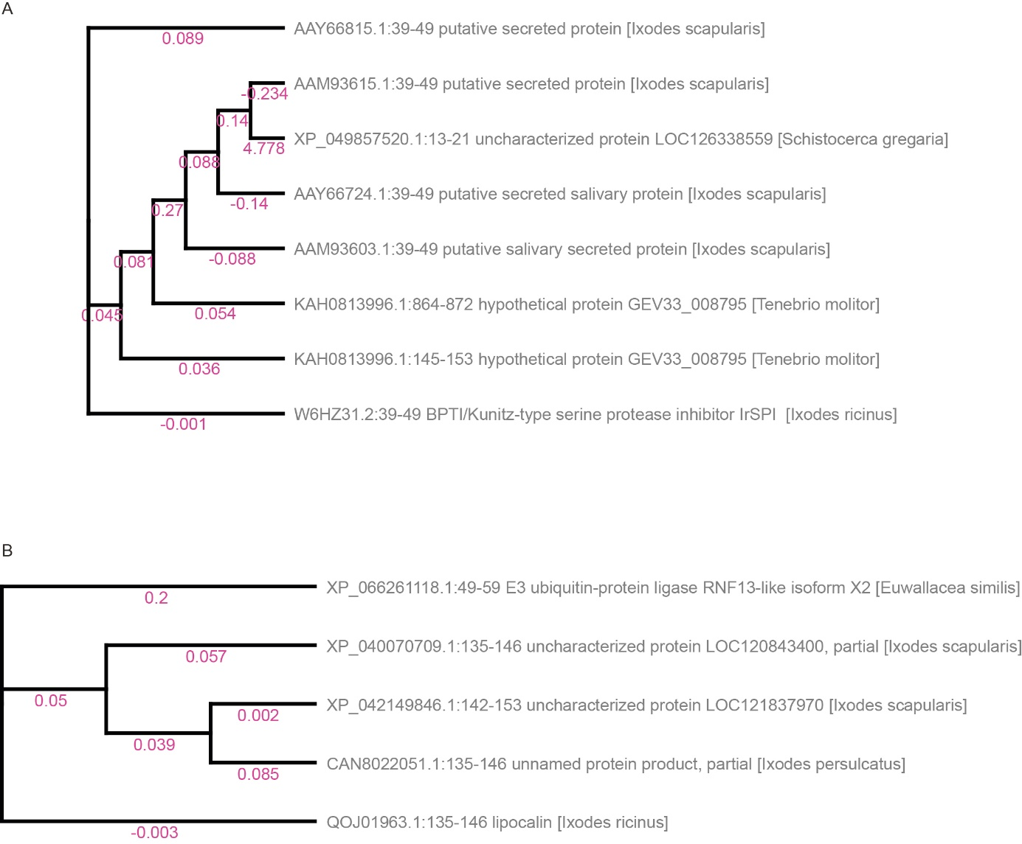
Supplementary figure 4. Phylogenetic tree constructed for sequences containing more than 80 percent identity with the I. ricinus sequence for (a) SPI01 and (b) LIP04, constructed in UGene using the PHYLIP Neighbor Joining method.
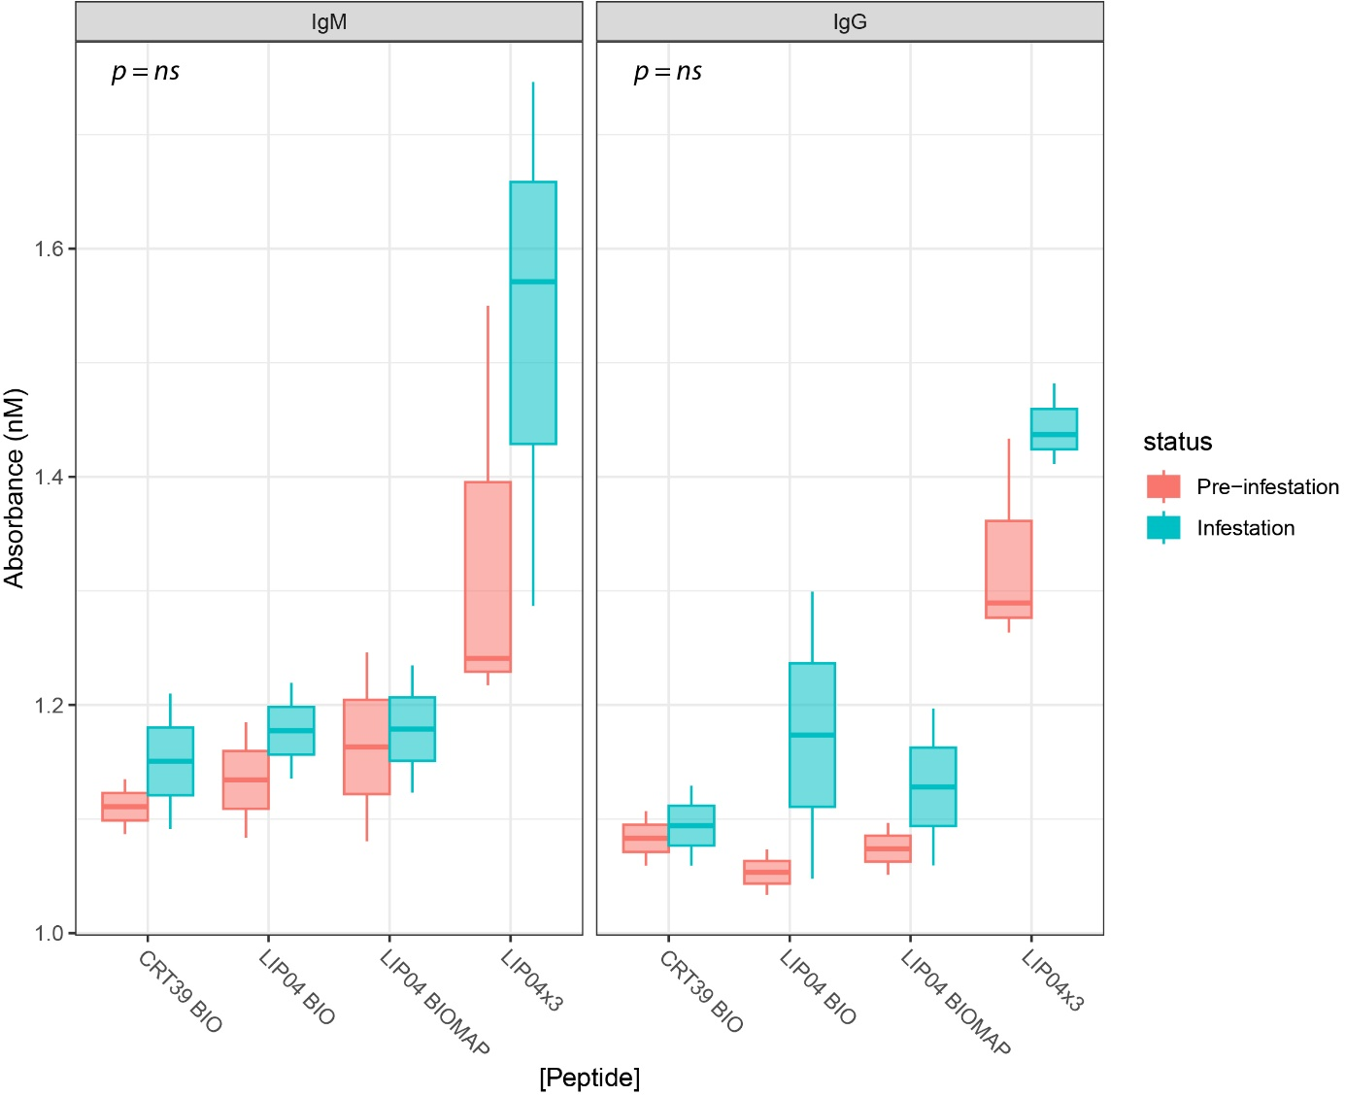
Supplementary figure 5. Pre- (Red) and post-infestation (blue) tick sera from sheep analyzed with ELISAs for determining the antigenicity of predicted immune epitopes. (a) Boxplots show ELISA absorbance values (450 nm) for individual peptides based on modified HLA epitopes with biotin (BIO) or biotin-multiple antigenic peptides (BIOMAP) additions to the peptide sequence. Responses were measured at a 1:600 serum dilution from sheep exposed to the Ixodes ricinus tick, separated by antibody isotype (IgM, left; IgG, right). Peptides are listed along the X axis and were analyzed using linear mixed-effects models (LMMs) with infestation status as a fixed effect and random intercepts to account for repeated measures and technical variation (sample ID, ELISA batch, and plate). Boxes indicate the interquartile range with the median; whiskers extend to 1.5×IQR. Asterisks indicate peptides with a significant difference between pre- and post-infestation responses (ns = not significant).

Immunoglobulin | Peptide | effect | Comparison | estimate | std.error | statistic | df | p.value | signif
IgM | LIP4a | fixed | Infested vs Pre-infested | 0,04 | 0,01 | 2,91 | 3,00 | 0,06 | .
IgM | SPI1a | fixed | Infested vs Pre-infested | 0,15 | 0,06 | 2,70 | 2,00 | 0,11 | ns
IgM | LIP2a | fixed | Infested vs Pre-infested | 0,05 | 0,02 | 2,10 | 3,00 | 0,13 | ns
IgM | LIP5a | fixed | Infested vs Pre-infested | 0,14 | 0,06 | 2,21 | 2,00 | 0,16 | ns
IgM | CRT1a | fixed | Infested vs Pre-infested | 0,03 | 0,02 | 1,70 | 3,00 | 0,19 | ns
IgM | SPI2a | fixed | Infested vs Pre-infested | 0,04 | 0,03 | 1,30 | 2,00 | 0,32 | ns
IgM | CRT6a | fixed | Infested vs Pre-infested | 0,02 | 0,04 | 0,39 | 3,00 | 0,72 | ns
IgM | CRT7a | fixed | Infested vs Pre-infested | 0,01 | 0,02 | 0,31 | 3,00 | 0,78 | ns
IgG | SPI1a | fixed | Infested vs Pre-infested | 0,11 | 0,02 | 6,83 | 4,00 | 0,00 | **
IgG | LIP4a | fixed | Infested vs Pre-infested | 0,06 | 0,02 | 2,58 | 4,00 | 0,06 | .
IgG | LIP5a | fixed | Infested vs Pre-infested | 0,10 | 0,03 | 3,55 | 2,00 | 0,07 | .
IgG | CRT1a | fixed | Infested vs Pre-infested | 0,05 | 0,02 | 2,23 | 4,00 | 0,09 | .
IgG | CRT7a | fixed | Infested vs Pre-infested | 0,04 | 0,02 | 2,18 | 2,00 | 0,16 | ns
IgG | SPI2a | fixed | Infested vs Pre-infested | 0,07 | 0,04 | 1,78 | 2,00 | 0,22 | ns
IgG | LIP2a | fixed | Infested vs Pre-infested | 0,05 | 0,05 | 1,06 | 4,00 | 0,35 | ns
IgG | CRT6a | fixed | Infested vs Pre-infested | 0,02 | 0,02 | 1,00 | 2,00 | 0,42 | ns

Supplementary table 1. Sheep-I. ricinus exposed tick sera IgM and IgG response to elongated I. ricinus salivary antigenic peptides derived from Bepipred predictions and assessed with linear mixed model.

Immunoglobulin | Peptide | effect | Comparison | estimate | std.error | statistic | df | p.value | signif
IgM | CRT39 BIO | fixed | Infected vs Uninfected | 0,03 | 0,03 | 1,14 | 1,00 | 0,46 | ns
IgM | LIP04 BIO | fixed | Infected vs Uninfected | 0,04 | 0,01 | 4,16 | 1,00 | 0,15 | ns
IgM | LIP04 BIOMAP | fixed | Infected vs Uninfected | 0,01 | 0,02 | 0,62 | 1,00 | 0,65 | ns
IgM | LIP04x3 | fixed | Infected vs Uninfected | 0,14 | 0,05 | 2,59 | 2,00 | 0,12 | ns
IgG | CRT39 BIO | fixed | Infected vs Uninfected | 0,01 | 0,01 | 1,00 | 1,00 | 0,50 | ns
IgG | LIP04 BIO | fixed | Infected vs Uninfected | 0,10 | 0,09 | 1,15 | 1,00 | 0,45 | ns
IgG | LIP04 BIOMAP | fixed | Infected vs Uninfected | 0,05 | 0,04 | 1,19 | 1,00 | 0,44 | ns
IgG | LIP04x3 | fixed | Infected vs Uninfected | 0,08 | 0,04 | 2,02 | 2,13 | 0,17 | ns

Supplementary table 2. Sheep-I. ricinus exposed tick sera IgM and IgG response to modified I. ricinus salivary antigenic peptides derived from alterations of select MHCII short peptide sequences and assessed with linear mixed model.

