Supplementary materials
Supplementary Method
Detailed segmentation baseline and auto-searched network architecture
The UNet backbone adopted in our work, i.e., the nnUNet ¹, includes a 5-block encoding path and a 4-block decoding path. Each encoding block consists of the following consecutive operations with residual connection: a convolution, a instance normalization ², a Leaky ReLu unit, followed by a 2x2x2 max-pooling operator. Each decoding block is composed of a 2x2x2 up-sampling process, followed by consecutive operations similar to the ones in the encoding block. The specific convolution operation in each block is automatically determined using network architecture search (NAS) ^{3,4} with the search space defined by 2D, 3D, pseudo-3D (P3D) convolutions with kernel size of 3 or 5. The detailed convolutional neural network architectures for each organ at risk (OAR) segmentation branch are described in Supplementary Fig 1.

Implementation details
Image preprocessing. A windowing of [-500, 1000] HU to every pCT scan is applied covering the intensity range of our target OARs. VOIs of 256×256×64 voxels are randomly extracted around the OAR foreground as training samples for NAS. The heat map labels in the detection module are 3D Gaussian distributions (zero mean with standard deviation of 8mm) centered at the center of each S&H OAR.
NAS training. We exploit NAS to search the optimal network architecture for each stratified OAR segmentation branch. The combined Dice and Cross-Entropy losses are adopted, and the stochastic gradient descent optimizer is used with a Nesterov momentum of 0.99. To train the NAS parameter α_{k}, we first fix α_{k} to 1/9 for 400 epochs. Then we alternatively update α_{k} and the network weights for another additional 600 epochs. The batch size is set to 2 for NAS training. Only the validation set is used for updating α. The ratio between the training set and the validation set is 2:1. The initial learning rates are set to 0.01 for the anchor and mid-level branches, and 0.005 for the S&H branch, respectively. The learning rate is decayed following the Polynomial learning rate policy.
Final segmentation network training. After NAS is completed, we retrain the searched segmentation network from scratch. Data augmentation is applied ¹, e.g., horizontal flipping, random rotations in the x-y plane within ±10 degrees, intensity scaling with a ratio between [0.75, 1.25], adding Gaussian noise with zero mean and (0, 0.1) variance. The batch size is 2. The optimizer is stochastic gradient descent with a Polynomial learning rate policy. The initial learning rate is 0.01 with a Nesterov momentum of 0.99. The S&H detection branch is trained using L2 loss with a 0.01 learning rate. The total number of training epochs for each module is 1000. The average training time is 9~10 GPU days. For inference, the average running time is normally less than 3 minutes per patient. All deep models are developed using PyTorch and trained on one NVIDIA Quadro RTX 8000 GPU.

Quantitative ablation results of SOARS in the training-validation dataset
Effect of processing stratification in SOARS. Processing stratification played a key role to improve the OAR segmentation performance. The processing stratification ablation results are shown in Table 2. The baseline is using 3D UNet model (implemented in the nnUNet framework)¹ trained on all 42 OARs together. When anchor OARs were stratified to train only on themselves, there was a 2.4% Dice similarity coefficient (DSC) improvement as compared to the baseline models. When focusing on mid-level OARs, with the help of anchor OAR guidance, there was a significant 37% Hausdorff distance (HD) error reduction (11.4 versus 18.0mm) as compared to the baseline model of training on all OARs. This demonstrated the intrinsic difficulty in segmenting a large number of various organs without explicitly taking their differences into account. It simultaneously indicated that anchor OARs served as effective references to better delineate the hard-to-discern boundaries of mid-level organs (most are soft-tissue organs). For S&H OARs, by cropping the volume of interest (VOI) using the detection module and with the support of anchor OAR predictions, there were remarkable accuracy improvements in segmenting S&H OARs, boosting DSC from 58.3% to 73.7%, as compared against directly segmenting from CT. This further demonstrated the merits and advantages of our stratified learning approach that adapted to provide the optimal handling of OAR categories with different characteristics. Fig. 3 depicts qualitative examples of segmenting anchor, mid-level and S&H OARs.
Effect of neural architecture search (NAS) associated with SOARS. Table 2 also outlines the performance improvements provided by NAS. As can be seen, all three branches trained with NAS consistently produced more accurate segmentation results than those trained using the baseline 3D UNet. This validated the effectiveness of NAS on more complicated segmentation tasks. For the three branches, mid-level and S&H OAR categories showed considerable performance improvements, from 72.6% to 74.2% and 73.7% to 76.2% in DSC scores respectively, while the anchor branch provides a marginal but consistent improvement (0.7% in DSC). Considering that anchor OARs are already relatively easy to segment, the fact that NAS can further boost the performance attested to its benefits.
The NAS searched neural network architectures are depicted in Supplementary Fig. 1. It is observed that, for the encoding path, the mid-level and S&H branches gradually involve more 3D or P3D convolution kernels as compared to the anchor branch. This indicates that 3D kernels may not always be the best choice for segmenting objects with reasonable size or contrast, as 2D kernels dominate the anchor branch. Consequently, appropriate 2D and P3D kernels can reduce the computation cost and memory consumption. For the S&H branch, our findings are consistent with the intuition that small or low contrast objects rely more on the 3D spatial information and context for better segmentation. As for the decoding path, all three branches are mainly equipped with 3D or P3D convolution kernels. This is an interesting result, as it implies that the decoding path tries to incorporate the convolutional features in a more 3D fashion for all three OAR categories.
References
1 Isensee, F., Jaeger, P. F., Kohl, S. A., Petersen, J. & Maier-Hein, K. H. nnU-Net: a self-configuring method for deep learning-based biomedical image segmentation. Nature methods 18, 203-211 (2021).
2 Ulyanov, D., Vedaldi, A. & Lempitsky, V. Instance normalization: The missing ingredient for fast stylization. arXiv preprint arXiv:1607.08022 (2016).
3 Liu, H., Simonyan, K. & Yang, Y. Darts: Differentiable architecture search. arXiv preprint arXiv:1806.09055 (2018).
4 Liu, C. et al. Auto-deeplab: Hierarchical neural architecture search for semantic image segmentation. Proceedings of the IEEE/CVF Conference on Computer Vision and Pattern Recognition. 82-92 (2019).

Supplementary Figures
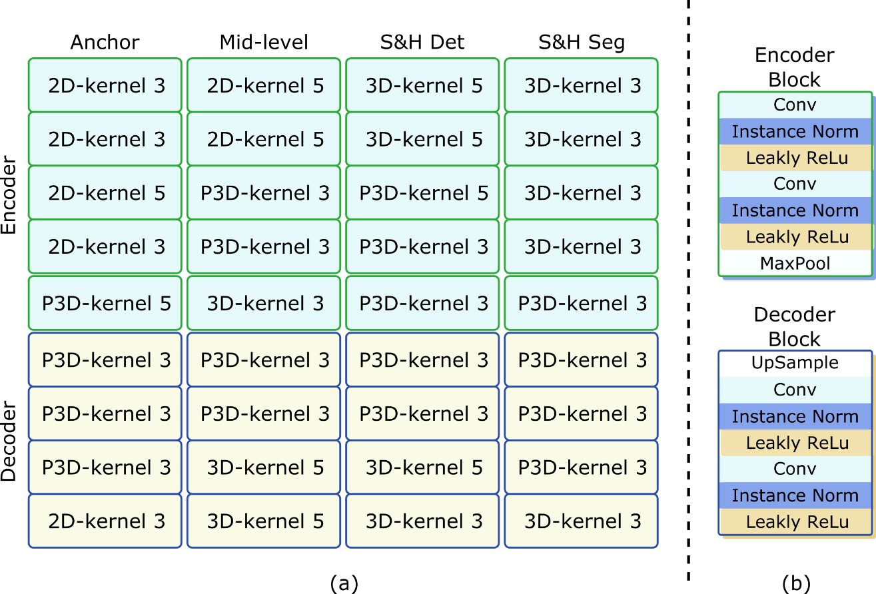
Supplementary Fig. 1 (a) illustrates the auto-searched backbone network architecture (UNet) for the anchor, mid-level, and small & hard (S&H) branches. The search space of the convolution operation includes 2D, 3D, and pseudo-3D (P3D) with either kernel size of 3 or 5. (b) lists the detailed operations in the encoder and decoder blocks. The auto-searched two convolution operations within each block are of the same type.

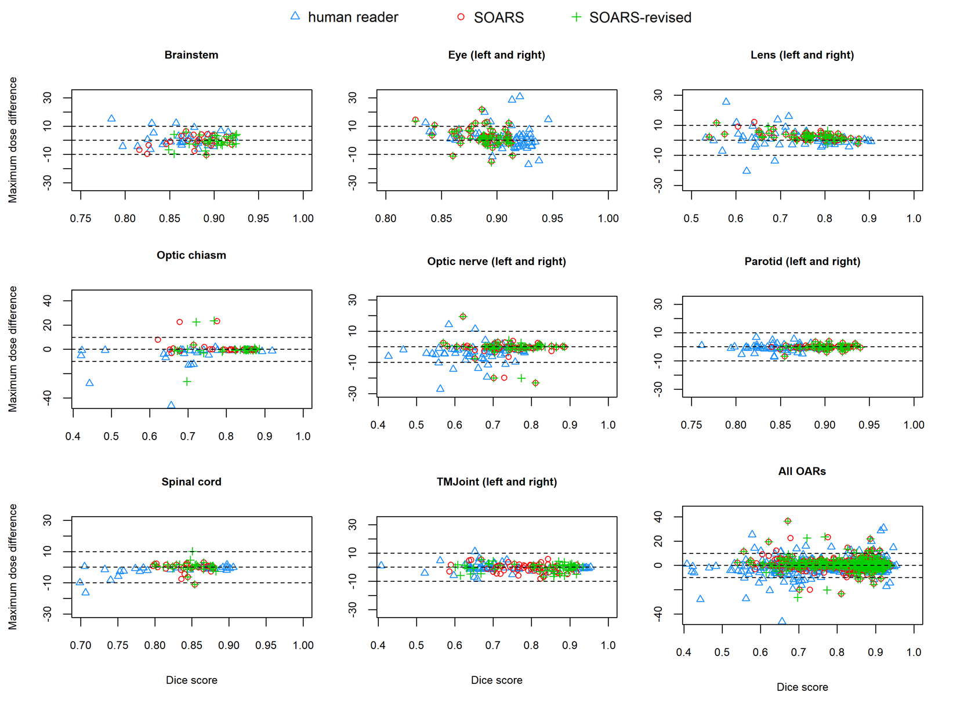
Supplementary Fig. 2. The scatter plot of differences in maximum dose brought by various OAR contour sets of SOARS, SOARS-revised, and human reader. Each OAR and all OAR results are plotted, respectively. Blue triangle, green cross and red circle represent results of human reader, SOARS-revised and SOARS, respectively.

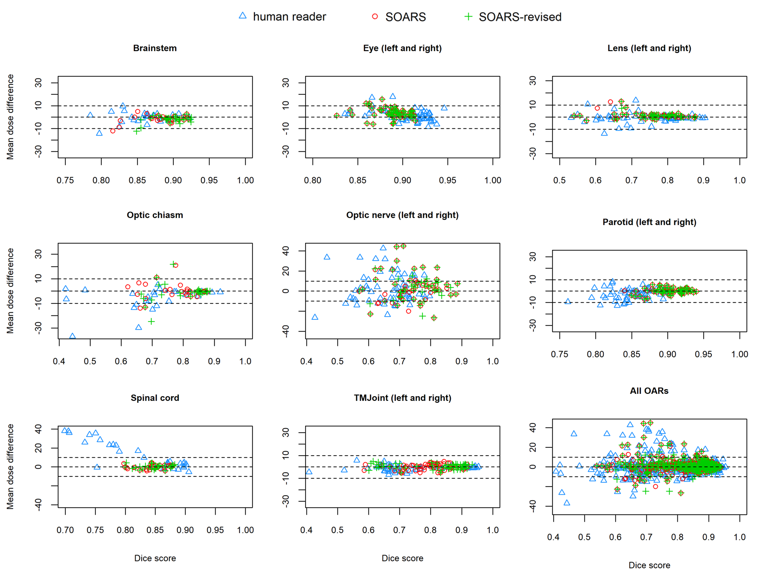
Supplementary Fig. 3. The scatter plot of differences in mean dose brought by various OAR contour sets of SOARS, SOARS-revised, and human reader. Each OAR and all OAR results are plotted, respectively. Blue triangle, green cross and red circle represent results of human reader, SOARS-revised and SOARS, respectively.

Supplementary Tables
Supplementary Table 1. Quantitative comparisons on the external FAH-XJU testing dataset of 82 patients. The proposed SOARS outperforms the previous leading approach UaNet in almost all metrics across different OARs. DSC, HD and ASD represent Dice similarity coefficient, Hausdorff distance, and average surface distance, respectively. Bold and highlighted values represent the best performance and significant improvement calculated using Wilcoxon matched-pairs signed rank test as compared between UaNet and SOARS, respectively.
OARs | UaNet |  |  | SOARS
OARs | DSC | HD (mm) | ASD (mm) | DSC | HD (mm) | ASD (mm)
BrainStem | 78.4% ± 6.4% | 9.2 ± 3.1 | 1.9 ± 0.8 | 80.5% ± 6.7% | 8.2 ± 3.0 | 1.8 ± 0.9
Eye_Lt | 86.7% ± 5.3% | 5.0 ± 5.3 | 0.8 ± 0.6 | 85.8% ± 5.7% | 5.4 ± 5.4 | 0.9 ± 0.7
Eye_Rt | 87.5% ± 2.6% | 4.1 ± 1.0 | 0.7 ± 0.2 | 86.1% ± 3.5% | 4.3 ± 1.2 | 0.7 ± 0.3
Lens_Lt | 68.4% ± 9.4% | 2.8 ± 0.6 | 0.6 ± 0.3 | 69.6% ± 7.0% | 2.7 ± 0.6 | 0.6 ± 0.2
Lens_Rt | 70.8% ± 8.2% | 2.8 ± 0.7 | 0.5 ± 0.3 | 72.9% ± 7.2% | 2.4 ± 0.7 | 0.5 ± 0.2
OpticChiasm | 57.6% ± 14.0% | 6.7 ± 2.4 | 1.5 ± 0.8 | 68.1% ± 7.0% | 6.5 ± 3.0 | 1.0 ± 0.5
OpticNerve_Lt | 66.0% ± 7.4% | 5.0 ± 2.6 | 0.8 ± 0.4 | 67.9% ± 6.9% | 6.2 ± 3.0 | 0.8 ± 0.3
OpticNerve_Rt | 65.5% ± 8.5% | 4.3 ± 1.1 | 0.8 ± 0.3 | 66.4% ± 6.0% | 4.8 ± 1.2 | 0.8 ± 0.2
Parotid_Lt | 78.2% ± 5.2% | 11.7 ± 3.0 | 1.9 ± 0.6 | 79.7% ± 5.0% | 10.5 ± 3.2 | 1.8 ± 0.6
Parotid_Rt | 77.6% ± 6.2% | 12.4 ± 4.5 | 2.0 ± 0.8 | 79.4% ± 5.2% | 10.9 ± 3.8 | 1.8 ± 0.6
Pituitary | 62.4% ± 12.8% | 4.4 ± 1.5 | 1.2 ± 0.6 | 75.6% ± 11.1% | 3.7 ± 1.6 | 0.6 ± 0.5
SpinalCord | 79.2% ± 14.2% | 7.5 ± 9.0 | 1.0 ± 1.2 | 82.3% ± 4.9% | 6.7 ± 9.4 | 0.9 ± 1.4
TMJ_Lt | 76.7% ± 5.2% | 12.5 ± 6.5 | 1.9 ± 1.5 | 77.8% ± 9.0% | 10.9 ± 7.0 | 1.5 ± 1.5
TMJ_Rt | 72.8% ± 12.4% | 11.3 ± 8.4 | 2.1 ± 1.6 | 81.4% ± 5.2% | 6.9 ± 1.5 | 0.9 ± 0.3
Average | 74.8% | 7.2 | 1.2 | 77.3% | 6.4 | 1.0

Supplementary Table 2. Quantitative comparisons on the external FAH-ZU testing dataset of 447 patients. The proposed SOARS outperforms the previous leading approach UaNet in almost all metrics across different OARs. DSC, HD and ASD represent Dice similarity coefficient, Hausdorff distance, and average surface distance, respectively. Bold and highlighted values represent the best performance and significant improvement calculated using Wilcoxon matched-pairs signed rank test as compared between UaNet and SOARS, respectively.
OARs | UaNet |  |  | SOARS
OARs | DSC | HD (mm) | ASD (mm) | DSC | HD (mm) | ASD (mm)
BrainStem | 77.8% ± 10.9% | 10.1 ± 6.2 | 2.6 ± 2.4 | 82.4% ± 11.3% | 8.3 ± 5.7 | 1.8 ± 2.2
Eye_Lt | 87.9% ± 3.0% | 3.8 ± 0.9 | 0.6 ± 0.2 | 87.9% ± 3.6% | 3.5 ± 1.0 | 0.5 ± 0.3
Eye_Rt | 86.8% ± 5.6% | 4.3 ± 5.7 | 0.9 ± 4.4 | 87.3% ± 2.2% | 3.7 ± 1.0 | 0.6 ± 0.2
Lens_Lt | 69.6% ± 10.5% | 3.0 ± 1.1 | 0.7 ± 0.5 | 71.4% ± 9.0% | 3.0 ± 1.0 | 0.6 ± 0.4
Lens_Rt | 70.5% ± 10.7% | 2.9 ± 1.2 | 0.7 ± 0.5 | 72.0% ± 8.4% | 2.9 ± 0.9 | 0.6 ± 0.4
OpticChiasm | 53.0% ± 15.7% | 9.9 ± 5.8 | 2.3 ± 1.6 | 65.9% ± 12.8% | 6.6 ± 4.9 | 1.1 ± 0.6
OpticNerve_Lt | 66.4% ± 9.7% | 8.9 ± 5.0 | 1.1 ± 1.9 | 66.3% ± 8.1% | 5.4 ± 2.9 | 0.7 ± 0.5
OpticNerve_Rt | 68.3% ± 8.4% | 7.6 ± 3.9 | 0.8 ± 0.4 | 66.1% ± 7.8% | 5.3 ± 2.3 | 0.7 ± 0.3
Parotid_Lt | 82.2% ± 4.8% | 12.8 ± 5.1 | 1.7 ± 0.7 | 85.4% ± 4.6% | 10.6 ± 4.7 | 1.2 ± 0.5
Parotid_Rt | 82.8% ± 5.2% | 12.1 ± 6.0 | 1.6 ± 0.8 | 84.8% ± 4.5% | 11.1 ± 5.3 | 1.3 ± 0.7
SpinalCord | 83.8% ± 7.6% | 13.1 ± 22.6 | 1.5 ± 6.0 | 86.3% ± 7.4% | 8.6 ± 22.0 | 1.3 ± 6.5
SMG_Lt | 64.3% ± 8.5% | 4.4 ± 1.0 | 1.3 ± 0.4 | 76.2% ± 7.7% | 3.7 ± 0.9 | 0.7 ± 0.4
SMG_Rt | 63.5% ± 10.1% | 4.5 ± 1.8 | 1.3 ± 0.5 | 74.6% ± 7.8% | 3.9 ± 1.7 | 0.8 ± 0.5
Average | 73.5% | 7.5 | 1.3 | 77.4% | 5.9 | 0.9

Supplementary Table 3. Quantitative comparisons on the external GPH testing dataset of 50 patients. The proposed SOARS outperforms the previous leading approach UaNet in almost all metrics across different OARs. DSC, HD and ASD represent Dice similarity coefficient, Hausdorff distance, and average surface distance, respectively. Bold and highlighted values represent the best performance and significant improvement calculated using Wilcoxon matched-pairs signed rank test as compared between UaNet and SOARS, respectively.
OARs | UaNet |  |  | SOARS
OARs | DSC | HD (mm) | ASD (mm) | DSC | HD (mm) | ASD (mm)
BrainStem | 77.1% ± 14.6% | 12.6 ± 7.2 | 2.4 ± 1.1 | 78.9% ± 10.5% | 11.7 ± 9.5 | 2.1 ± 1.4
Eye_Lt | 85.6% ± 3.5% | 4.0 ± 0.8 | 0.8 ± 0.3 | 92.1% ± 3.9% | 3.5 ± 0.7 | 0.4 ± 0.3
Eye_Rt | 85.3% ± 4.6% | 4.4 ± 1.2 | 0.8 ± 0.4 | 91.5% ± 4.2% | 3.3 ± 0.9 | 0.4 ± 0.3
Lens_Lt | 78.1% ± 8.2% | 2.1 ± 0.7 | 0.4 ± 0.2 | 82.2% ± 5.2% | 2.1 ± 0.5 | 0.3 ± 0.2
Lens_Rt | 79.6% ± 9.4% | 2.7 ± 0.9 | 0.3 ± 0.2 | 81.9% ± 7.5% | 2.0 ± 0.6 | 0.3 ± 0.2
Mandible_Lt | 89.8% ± 1.4% | 6.7 ± 2.7 | 0.8 ± 0.2 | 91.7% ± 1.1% | 6.7 ± 2.7 | 0.7 ± 0.1
Mandible_Rt | 88.8% ± 1.2% | 9.1 ± 2.1 | 0.8 ± 0.2 | 91.8% ± 1.2% | 6.2 ± 2.8 | 0.7 ± 0.1
OpticChiasm | 51.5% ± 16.0% | 9.1 ± 2.1 | 2.2 ± 1.0 | 60.1% ± 9.8% | 7.7 ± 2.2 | 1.1 ± 0.5
OpticNerve_Lt | 57.9% ± 16.7% | 6.4 ± 4.0 | 1.6 ± 1.4 | 69.9% ± 6.1% | 4.8 ± 1.5 | 0.6 ± 0.3
OpticNerve_Rt | 57.4% ± 18.5% | 6.5 ± 3.5 | 1.6 ± 1.5 | 69.2% ± 8.3% | 4.6 ± 1.6 | 0.6 ± 0.3
OralCavity | 69.0% ± 3.1% | 23.6 ± 4.5 | 5.3 ± 0.8 | 72.2% ± 4.7% | 26.9 ± 4.9 | 4.1 ± 0.8
Parotid_Lt | 87.1% ± 4.3% | 11.3 ± 6.2 | 0.9 ± 0.5 | 87.6% ± 4.4% | 9.8 ± 5.8 | 0.8 ± 0.6
Parotid_Rt | 86.5% ± 4.5% | 9.7 ± 5.8 | 0.9 ± 0.6 | 87.1% ± 4.4% | 8.8 ± 4.6 | 0.8 ± 0.5
Pituitary | 88.8% ± 3.3% | 2.3 ± 0.8 | 0.1 ± 0.1 | 89.0% ± 3.3% | 2.0 ± 0.3 | 0.1 ± 0.1
SpinalCord | 78.7% ± 5.4% | 6.6 ± 2.5 | 1.1 ± 0.5 | 78.9% ± 5.1% | 6.5 ± 2.5 | 1.1 ± 0.5
TMJ_Lt | 65.8% ± 17.1% | 8.1 ± 4.6 | 1.5 ± 0.8 | 73.1% ± 20.0% | 4.1 ± 1.7 | 0.9 ± 0.9
TMJ_Rt | 65.0% ± 17.2% | 7.2 ± 3.7 | 1.5 ± 0.8 | 75.3% ± 23.2% | 4.1 ± 1.7 | 0.8 ± 1.0
Average | 76.0% | 7.6 | 1.4 | 80.7% | 6.8 | 0.9

Supplementary Table 4. Quantitative comparisons on the external HHA-FU testing dataset of 195 patients. The proposed SOARS outperforms the previous leading approach UaNet in almost all metrics across different OARs. DSC, HD and ASD represent Dice similarity coefficient, Hausdorff distance, and average surface distance, respectively. Bold and highlighted values represent the best performance and significant improvement calculated using Wilcoxon matched-pairs signed rank test as compared between UaNet and SOARS, respectively.
OARs | UaNet |  |  | SOARS
OARs | DSC | HD (mm) | ASD (mm) | DSC | HD (mm) | ASD (mm)
BrainStem | 75.8% ± 13.2% | 13.3 ± 7.5 | 2.9 ± 1.8 | 78.4% ± 8.9% | 10.6 ± 6.8 | 2.3 ± 1.4
Eye_Lt | 85.3% ± 7.0% | 4.0 ± 1.2 | 0.9 ± 0.5 | 90.6% ± 5.7% | 3.7 ± 1.1 | 0.5 ± 0.4
Eye_Rt | 86.3% ± 6.6% | 3.8 ± 1.1 | 0.8 ± 0.5 | 90.9% ± 5.6% | 3.5 ± 1.1 | 0.5 ± 0.4
Lens_Lt | 78.4% ± 9.0% | 2.3 ± 0.7 | 0.4 ± 0.3 | 82.3% ± 6.9% | 2.1 ± 0.6 | 0.3 ± 0.2
Lens_Rt | 78.2% ± 8.0% | 2.3 ± 0.6 | 0.4 ± 0.2 | 82.4% ± 6.7% | 2.1 ± 0.6 | 0.3 ± 0.2
OpticChiasm | 50.1% ± 15.1% | 10.7 ± 3.5 | 2.5 ± 1.2 | 57.2% ± 10.2% | 9.5 ± 2.9 | 1.5 ± 0.7
OpticNerve_Lt | 52.4% ± 14.7% | 7.2 ± 4.1 | 1.6 ± 1.2 | 62.3% ± 8.5% | 6.2 ± 2.9 | 1.0 ± 0.4
OpticNerve_Rt | 56.2% ± 13.7% | 6.0 ± 3.1 | 1.2 ± 0.8 | 61.9% ± 9.7% | 6.2 ± 3.1 | 1.0 ± 0.4
Parotid_Lt | 85.1% ± 6.0% | 8.6 ± 4.1 | 1.1 ± 0.7 | 85.6% ± 6.0% | 7.7 ± 3.7 | 1.0 ± 0.7
Parotid_Rt | 84.1% ± 6.5% | 10.1 ± 12.9 | 1.6 ± 4.2 | 85.5% ± 5.8% | 9.2 ± 12.9 | 1.3 ± 4.0
SpinalCord | 74.9% ± 12.6% | 12.2 ± 26.7 | 1.9 ± 4.6 | 78.9% ± 6.8% | 7.6 ± 2.7 | 1.2 ± 0.6
SMG_Lt | 70.7% ± 5.2% | 13.5 ± 2.1 | 2.2 ± 0.2 | 78.3% ± 7.9% | 7.9 ± 1.5 | 1.3 ± 0.3
SMG_Rt | 76.2% ± 4.5% | 10.5 ± 6.4 | 1.6 ± 0.7 | 76.2% ± 9.1% | 7.5 ± 2.2 | 1.4 ± 0.9
Average | 73.2% | 8.0 | 1.5 | 77.7% | 6.4 | 1.0

Supplementary Table 5. Quantitative comparisons on the external SMU testing dataset of 227 patients. The proposed SOARS outperforms the previous leading approach UaNet in almost all metrics across different OARs. DSC, HD and ASD represent Dice similarity coefficient, Hausdorff distance, and average surface distance, respectively. Bold and highlighted values represent the best performance and significant improvement calculated using Wilcoxon matched-pairs signed rank test as compared between UaNet and SOARS, respectively.
OARs | UaNet |  |  | SOARS
OARs | DSC | HD (mm) | ASD (mm) | DSC | HD (mm) | ASD (mm)
BrainStem | 78.7% ± 7.9% | 12.6 ± 19.1 | 2.4 ± 3.2 | 81.2% ± 7.2% | 11.4 ± 19.9 | 2.1 ± 3.3
Eye_Lt | 85.8% ± 8.4% | 3.8 ± 0.9 | 0.7 ± 0.3 | 90.8% ± 4.7% | 3.6 ± 0.9 | 0.5 ± 0.3
Eye_Rt | 86.6% ± 8.5% | 3.7 ± 0.9 | 0.7 ± 0.3 | 90.5% ± 4.7% | 3.6 ± 0.9 | 0.5 ± 0.3
InnerEar_Lt | 55.1% ± 12.8% | 8.0 ± 7.4 | 1.9 ± 1.0 | 61.6% ± 14.0% | 4.9 ± 2.0 | 0.9 ± 0.6
InnerEar_Rt | 54.0% ± 14.5% | 9.4 ± 11.2 | 2.4 ± 2.4 | 64.0% ± 13.8% | 4.7 ± 1.9 | 0.8 ± 0.5
Lens_Lt | 81.1% ± 8.9% | 2.1 ± 0.8 | 0.3 ± 0.2 | 83.8% ± 5.9% | 2.0 ± 0.7 | 0.2 ± 0.2
Lens_Rt | 80.1% ± 9.4% | 2.1 ± 0.8 | 0.3 ± 0.2 | 82.5% ± 7.6% | 2.1 ± 0.8 | 0.3 ± 0.2
Mandible_Lt | 85.3% ± 12.5% | 9.4 ± 9.0 | 1.5 ± 2.7 | 88.8% ± 3.5% | 7.7 ± 7.6 | 1.2 ± 1.0
Mandible_Rt | 85.7% ± 7.2% | 9.5 ± 8.2 | 1.3 ± 1.2 | 89.1% ± 3.3% | 7.8 ± 7.8 | 1.2 ± 1.0
OpticChiasm | 53.0% ± 15.3% | 6.6 ± 2.0 | 1.4 ± 0.7 | 69.1% ± 10.9% | 5.8 ± 2.1 | 0.6 ± 0.4
OpticNerve_Lt | 63.9% ± 13.9% | 5.7 ± 5.4 | 1.0 ± 1.2 | 69.0% ± 7.6% | 4.8 ± 2.4 | 0.6 ± 0.4
OpticNerve_Rt | 64.7% ± 14.7% | 5.5 ± 4.6 | 1.0 ± 1.4 | 68.8% ± 8.1% | 4.6 ± 1.8 | 0.6 ± 0.3
OralCavity | 48.2% ± 6.9% | 29.4 ± 7.3 | 9.0 ± 1.7 | 50.9% ± 6.5% | 28.2 ± 5.0 | 7.5 ± 1.4
Parotid_Lt | 85.0% ± 6.7% | 10.6 ± 10.3 | 1.0 ± 0.9 | 87.4% ± 4.3% | 9.6 ± 10.9 | 0.7 ± 0.5
Parotid_Rt | 83.3% ± 8.0% | 12.4 ± 11.7 | 1.4 ± 2.7 | 87.6% ± 4.5% | 10.4 ± 11.1 | 0.8 ± 0.8
Pituitary | 66.7% ± 15.2% | 4.2 ± 1.3 | 0.9 ± 0.7 | 73.2% ± 10.1% | 3.7 ± 1.0 | 0.5 ± 0.4
SpinalCord | 80.3% ± 11.4% | 6.2 ± 5.4 | 0.8 ± 0.6 | 83.0% ± 4.8% | 4.6 ± 1.3 | 0.7 ± 0.2
SMG_Lt | 70.9% ± 2.1% | 5.4 ± 0.8 | 2.6 ± 0.2 | 75.3% ± 0.7% | 4.9 ± 1.9 | 1.3 ± 0.1
SMG_Rt | 74.2% ± 2.7% | 5.9 ± 3.4 | 1.3 ± 0.1 | 73.4% ± 1.7% | 6.6 ± 0.7 | 1.0 ± 0.0
TempLobe_Lt | 75.6% ± 4.1% | 22.5 ± 6.8 | 2.6 ± 1.1 | 78.8% ± 3.1% | 20.6 ± 5.5 | 2.2 ± 0.9
TempLobe_Rt | 78.4% ± 4.0% | 19.8 ± 5.6 | 2.0 ± 0.9 | 79.2% ± 3.1% | 20.1 ± 6.4 | 2.1 ± 0.8
Thyroid_Lt | 72.8% ± 10.3% | 12.8 ± 6.2 | 1.9 ± 1.3 | 74.2% ± 10.6% | 12.2 ± 6.9 | 1.8 ± 1.4
Thyroid_Rt | 73.7% ± 10.9% | 10.0 ± 4.4 | 1.6 ± 1.1 | 75.9% ± 10.0% | 9.4 ± 4.8 | 1.5 ± 1.1
TMJ_Lt | 68.9% ± 15.6% | 10.0 ± 6.5 | 2.3 ± 1.6 | 73.2% ± 11.9% | 5.1 ± 2.1 | 0.8 ± 0.5
TMJ_Rt | 68.7% ± 15.5% | 10.0 ± 7.3 | 2.5 ± 1.9 | 72.4% ± 12.3% | 5.2 ± 2.1 | 0.9 ± 0.6
Average | 72.4% | 9.5 | 1.8 | 76.9% | 8.1 | 1.3

