Supplementary Material

Outcome among participants with GP contact in previous 12 months | Overall |  |  | Men |  |  | Women
 | N | Adjusted RII (95% CI) | p-value | N | Adjusted RII (95% CI) | p-value | N | Adjusted RII (95% CI) | p-value
Less than 80% of eligible preventive services | 182742 | 1.13 (1.06-1.21) | <0.001 | 79573 | 1.11 (1.04-1.19) | 0.003 | 103169 | 1.14 (1.05-1.24) | 0.001
No colorectal cancer screening | 110271 | 1.21 (1.12-1.32) | <0.001 | 49186 | 1.28 (1.18-1.39) | <0.001 | 61085 | 1.16 (1.06-1.26) | 0.001
No mammography among eligible women | 49290 | 1.46 (1.32-1.62) | <0.001 | - | - | - | 49290 | 1.46 (1.32-1.62) | <0.001
No cervical smear testing among eligible women | 54969 | 1.92 (1.69-2.18) | <0.001 | - | - | - | 54969 | 1.92 (1.69-2.18) | <0.001
No influenza vaccination among eligible participants | 100984 | 1.04 (1.01-1.08) | 0.017 | 42851 | 1.03 (0.96-1.09) | 0.444 | 58133 | 1.05 (1.03-1.07) | <0.001
No blood pressure measurement | 182231 | 0.97 (0.83-1.14) | 0.739 | 79373 | 0.98 (0.83-1.17) | 0.852 | 102858 | 0.97 (0.82-1.14) | 0.680
No cholesterol measurement | 180829 | 1.02 (0.93-1.13) | 0.642 | 78845 | 1.07 (0.97-1.18) | 0.164 | 101984 | 0.99 (0.88-1.10) | 0.821
No blood sugar measurement | 180056 | 1.03 (0.95-1.13) | 0.431 | 78451 | 1.08 (0.99-1.18) | 0.076 | 101605 | 1.00 (0.91-1.09) | 0.931

Supplementary Table 1. Income-related inequity in missed preventive opportunities among participants with GP contact in the previous 12 months.
Analyses were restricted to participants who reported a GP/family doctor consultation during the previous 12 months. Outcomes are coded as adverse outcomes; therefore, RII > 1 indicates higher non-receipt of preventive care among lower-income individuals despite recent GP contact. Models were adjusted for age, sex and country, except women-specific outcomes, which were adjusted for age and country. RII: Relative Index of Inequality

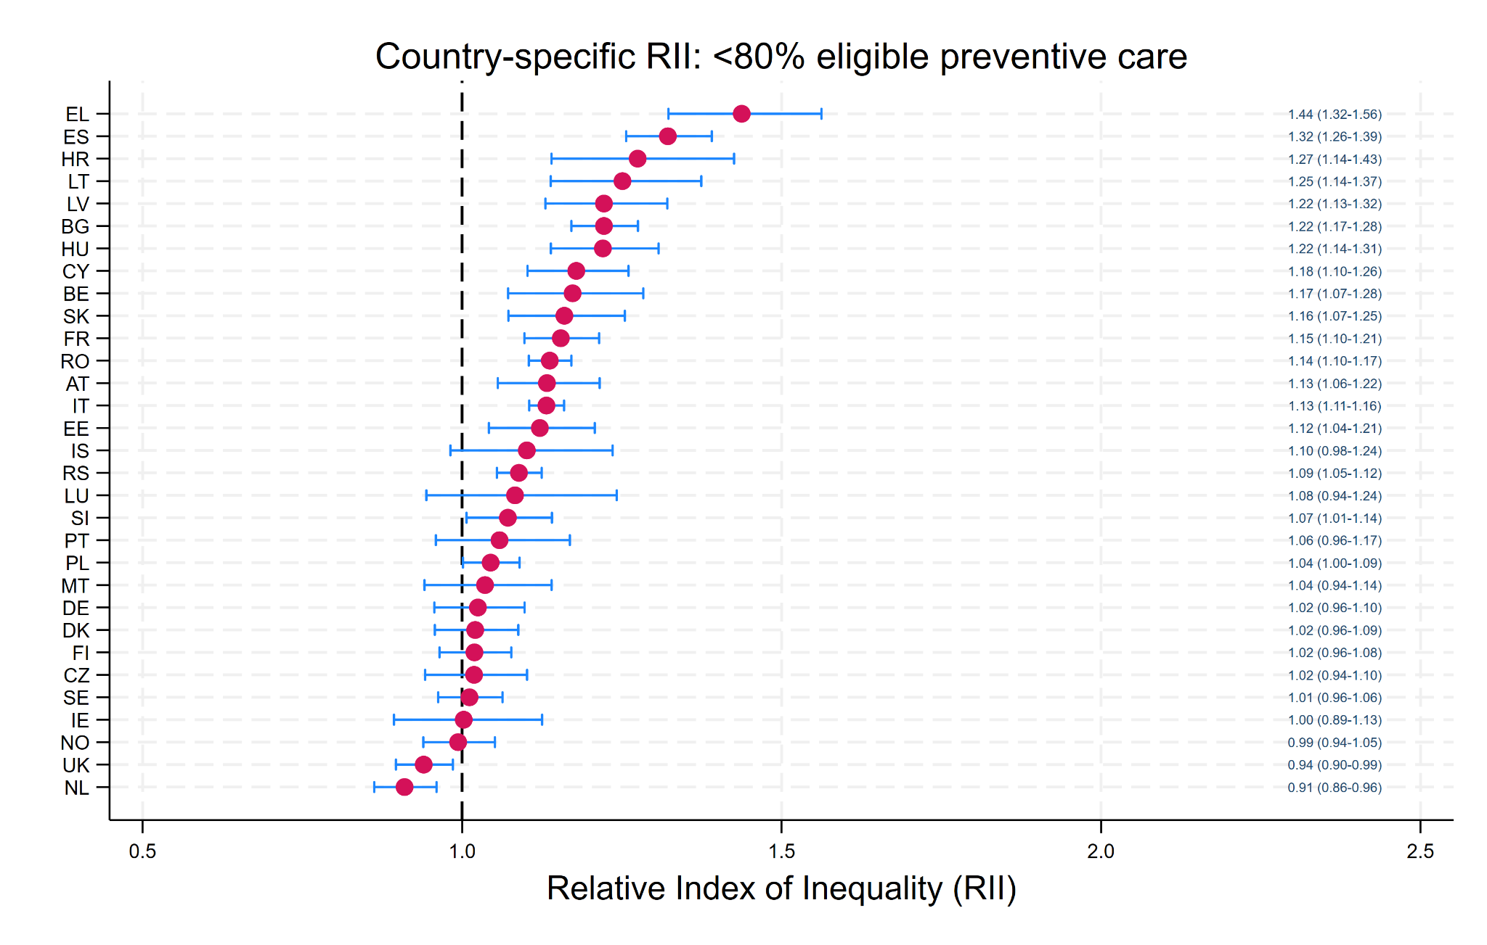 | 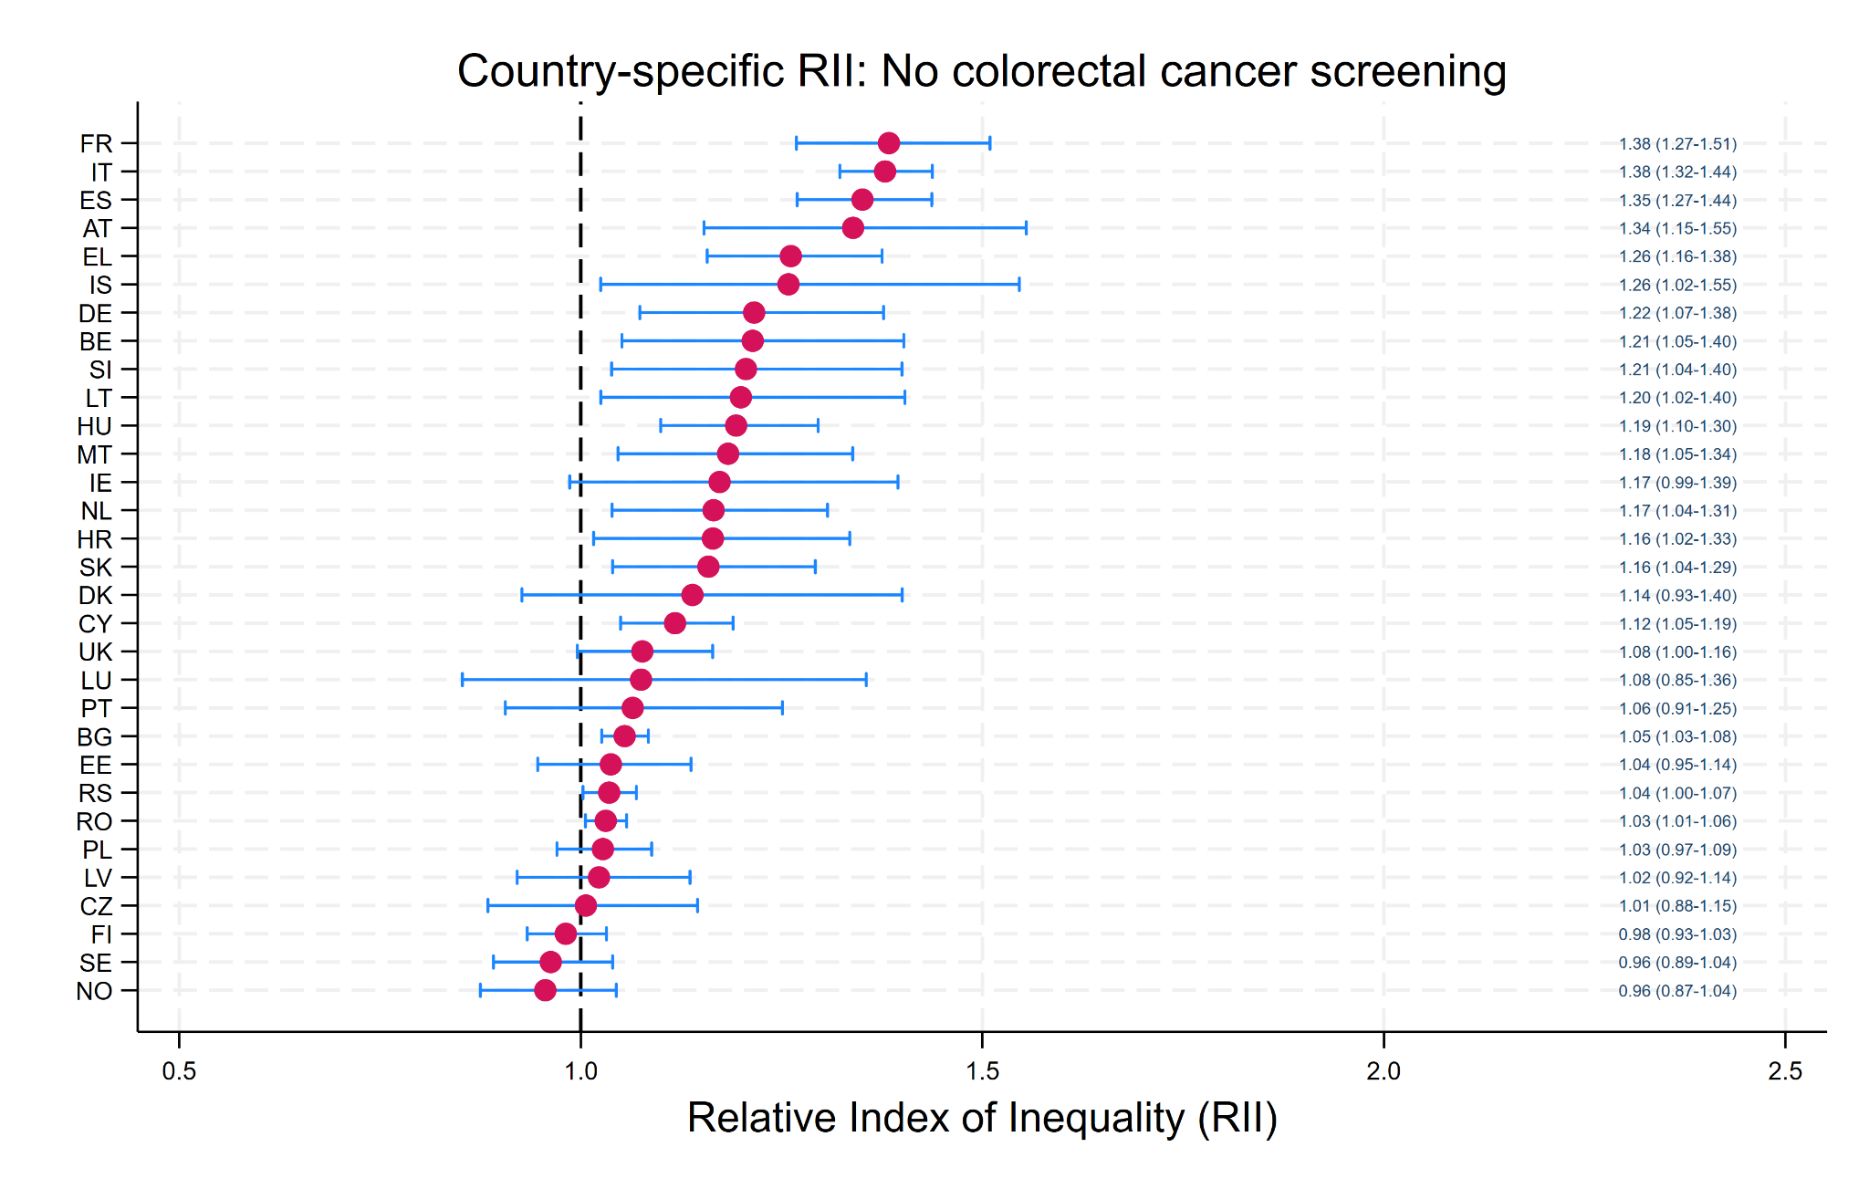
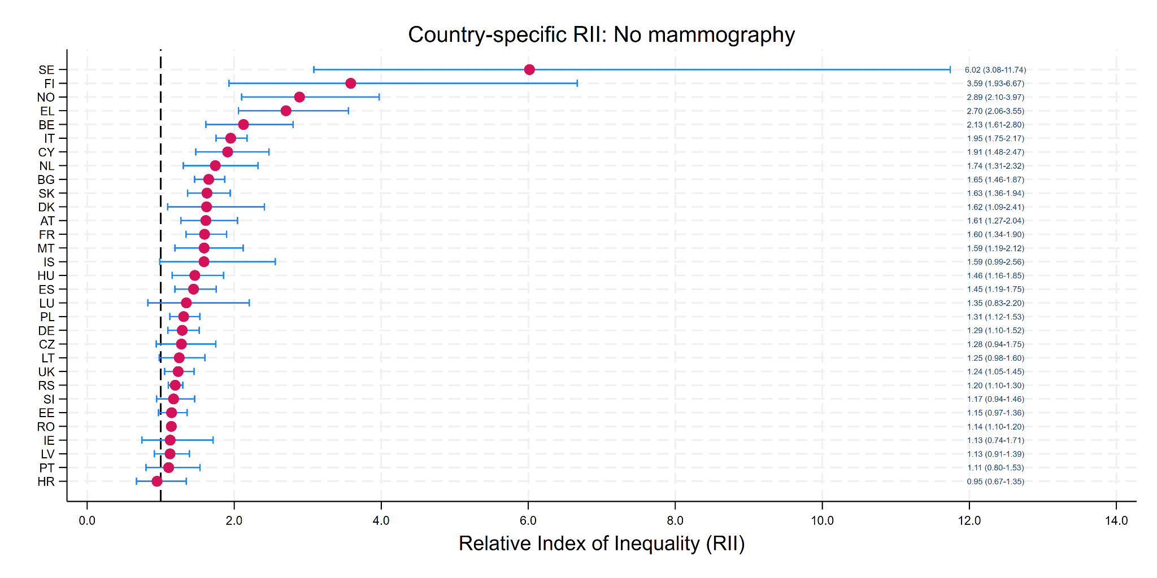 | 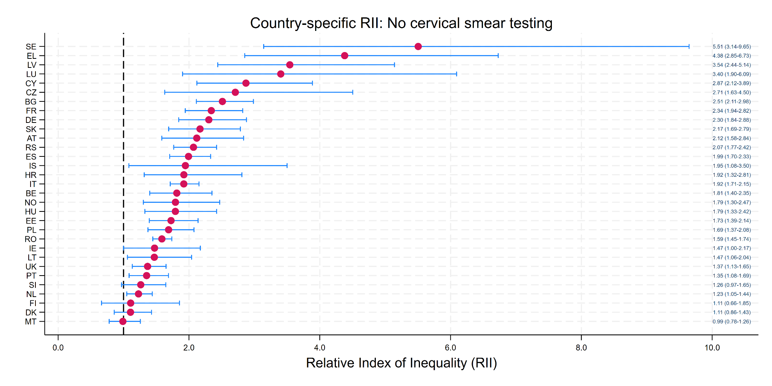
Supplementary Figure 1. Country-specific income-related inequity in selected preventive care outcomes.
Country-specific adjusted Relative Index of Inequality (RII) estimates are shown for: A) receiving less than 80% of eligible preventive care services; B) non-receipt of colorectal cancer screening; C) non-receipt of mammography; and D) non-receipt of cervical smear testing. Dots represent RII estimates and horizontal lines represent 95% confidence intervals. Exact RII values with 95% confidence intervals are displayed next to each estimate. Outcomes are coded as adverse outcomes; therefore, RII > 1 indicates higher non-receipt or incomplete preventive care among lower-income individuals.

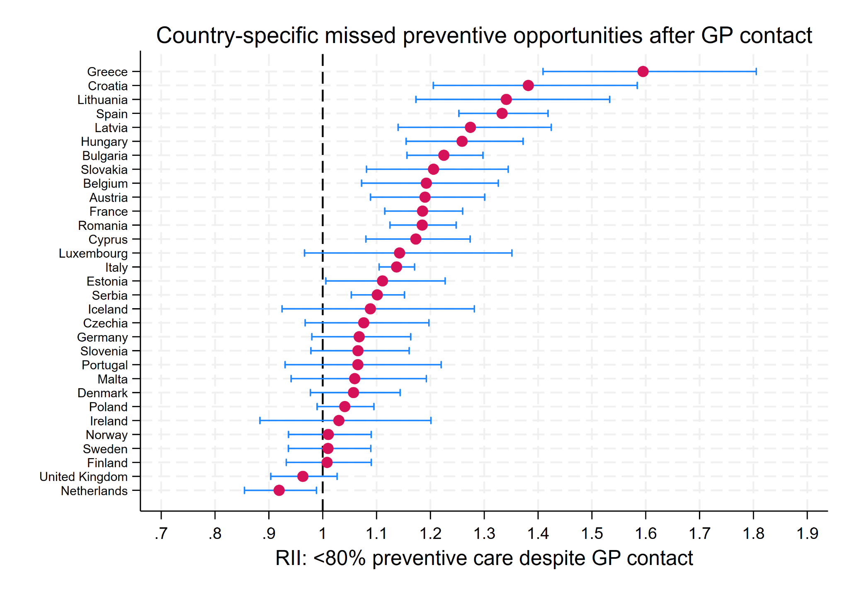
Supplementary Figure 2. Country-specific income-related inequity in missed preventive opportunities after primary care contact.
Country-specific adjusted Relative Index of Inequality (RII) for receiving less than 80% of eligible preventive care services among participants who had consulted a GP/family doctor during the previous 12 months. Dots represent RII estimates and horizontal lines represent 95% confidence intervals. The vertical dashed line indicates RII = 1. Values above 1 indicate that, despite recent GP contact, lower-income individuals were more likely to receive incomplete preventive care.

Outcome | Overall N | Overall RII (95% CI) | Overall p-value | Men N | Men RII (95% CI) | Men p-value | Women N | Women RII (95% CI) | Women p-value
Received less than 70% of eligible preventive services | 231112 | 1.11 (1.02-1.21) | 0.019 | 105194 | 1.10 (0.99-1.21) | 0.064 | 125918 | 1.12 (1.02-1.23) | 0.018
Received less than 80% of eligible preventive services | 231112 | 1.10 (1.03-1.18) | 0.006 | 105194 | 1.08 (1.00-1.16) | 0.037 | 125918 | 1.11 (1.03-1.21) | 0.010
Received less than 90% of eligible preventive services | 231112 | 1.06 (1.02-1.11) | 0.008 | 105194 | 1.06 (1.00-1.11) | 0.054 | 125918 | 1.07 (1.02-1.12) | 0.006

Supplementary Table 2. Sensitivity analysis using alternative thresholds for incomplete preventive care coverage. Adjusted Relative Index of Inequality (RII) estimates for receiving less than 70%, 80% and 90% of eligible preventive services. Outcomes are coded as adverse outcomes; therefore, RII > 1 indicates higher incomplete preventive care among lower-income individuals. Overall models were adjusted for age, sex and country; sex-stratified models were adjusted for age and country. RII: Relative Index of Inequality.

