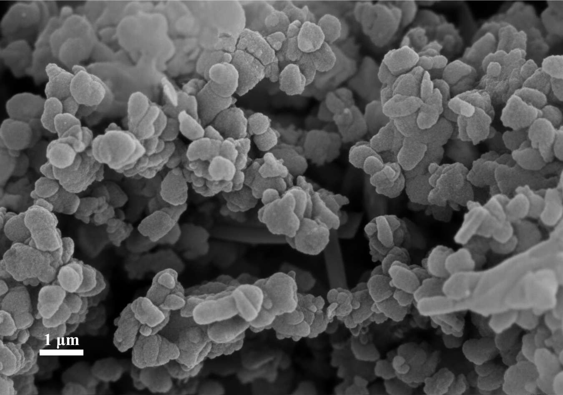  (a) | 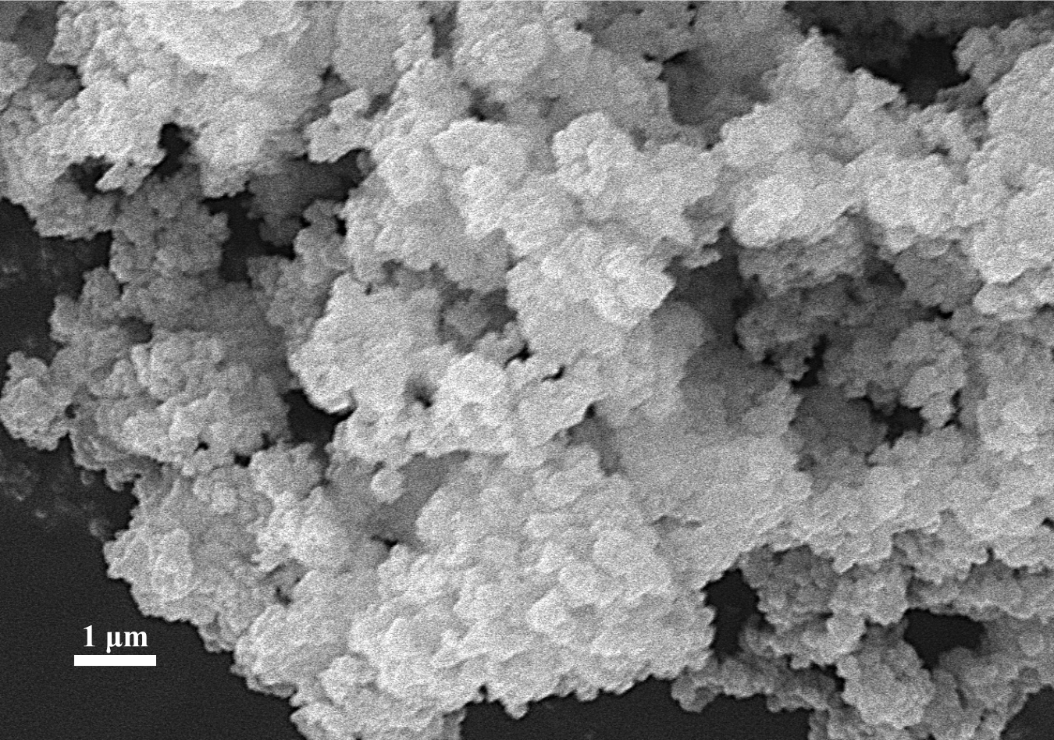  (b)
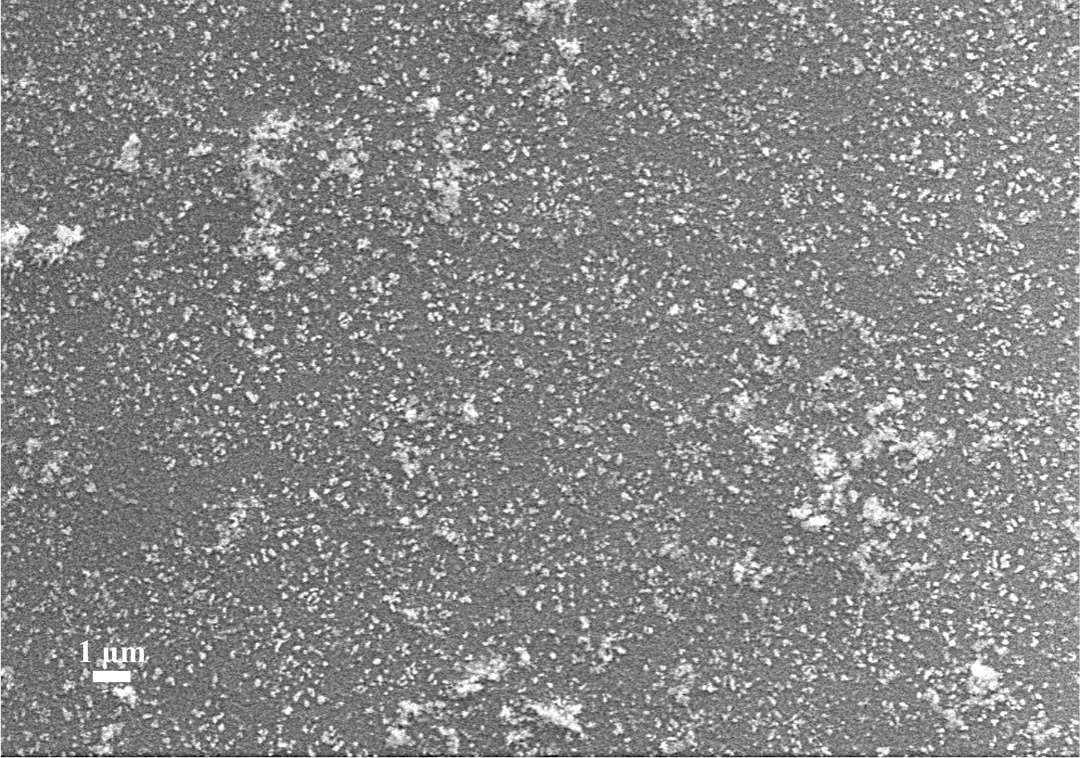  (c) | 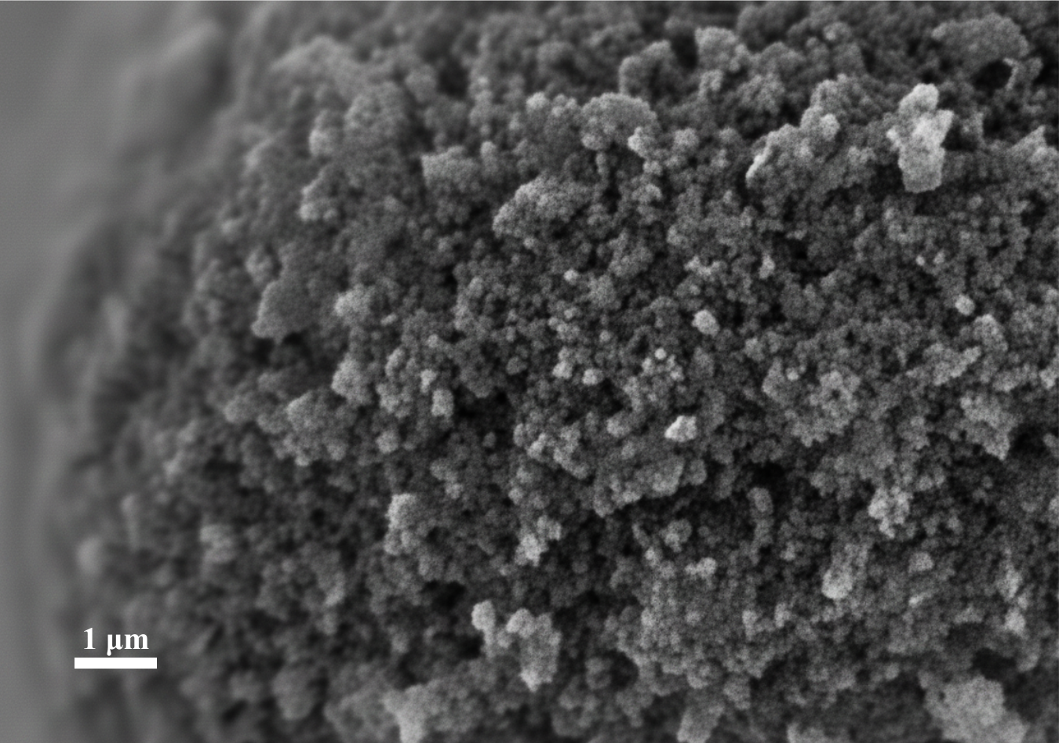  (d)
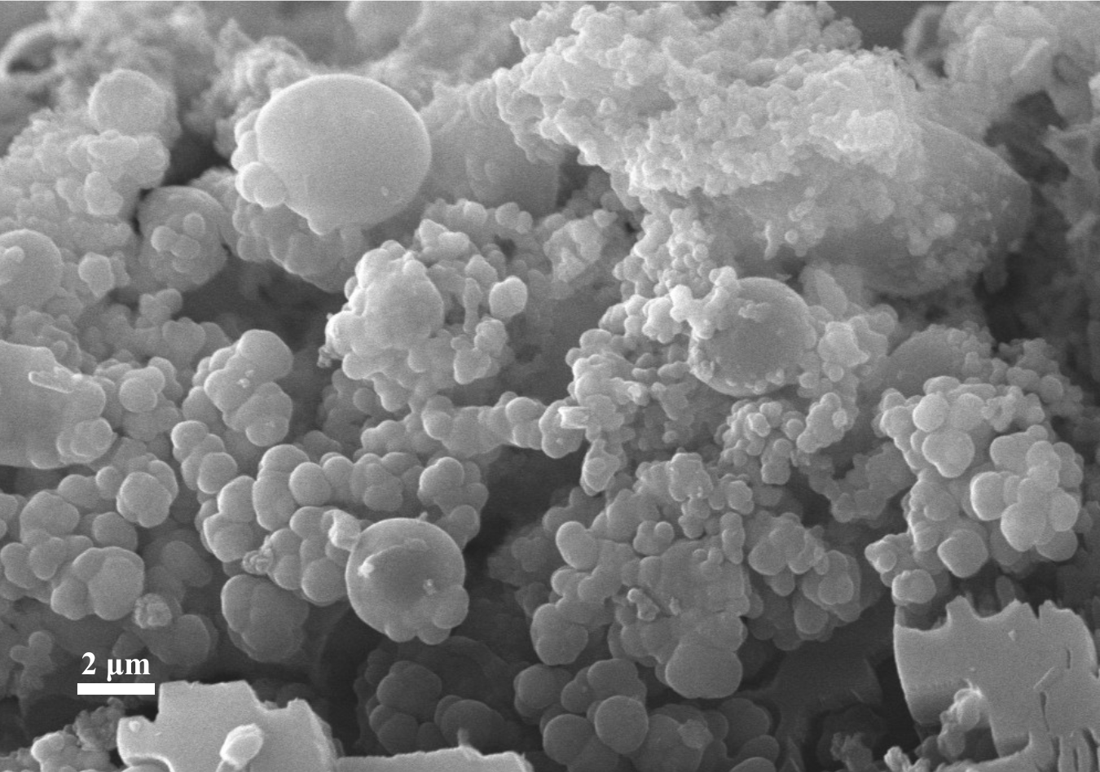
(e)
Figure S1. SEM images of the photocatalyst: (a) COF-5; (b) TiO₂; (c) AuNP; (d) TiO2@COF-5; (e) AuNP@COF-5

Figure S2. XPS spectra of COF-5
(b)
(a)
Figure S3. Photodegradation kinetic fitting (a) PFO and (b) PSO
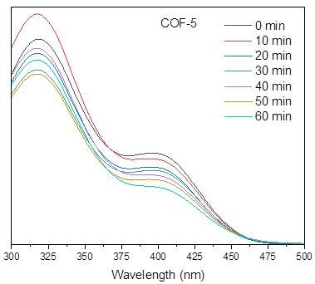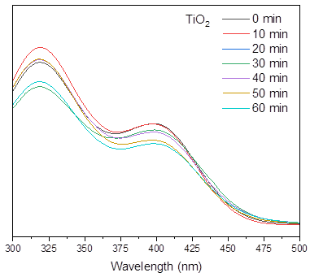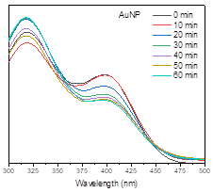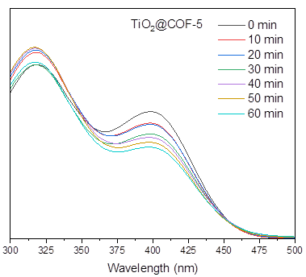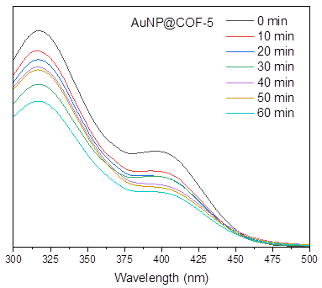
Figure S4. Absorbance spectrums of each photocatalysts

Table S1. Elemental concentration of composite COF-5 by XPS analysis
Atomic concentration (%) | AuNP@COF-5 | TiO2@COF-5
Atomic concentration (%) | O 1s : 30.82  C 1s : 69.16  Au 4f : 0.01 | O 1s : 28.97  C 1s : 70.48  Ti 2p : 0.56

Table S2. Parameters of photodegradation kinetic models
Photocatalysts | PFO | PSO | Bi-phasic
COF-5 | $A =$ 0.52  $k_{1}=$ 0.42  $R^{2}=$ 0.76 | $A =$ 0.56  $k_{2}=$ 1.18  $R^{2}=$ 0.88 | $A_{1} =$ 0.38  $k_{f}=$ 1.82  $A_{2} =$ 0.47  $k_{s}=$ 0.01  $R^{2}=$ 0.98
TiO₂ | $A =$0.64  $k_{1}=$ 0.43  $R^{2}=$ 0.67 | $A =$ 0.69  $k_{2}=$ 0.89  $R^{2}=$ 0.83 | $A_{1} =$ 0.44  $k_{f}=$ 3.33  $A_{2} =$ 0.56  $k_{s}=$ 0.01  $R^{2}=$ 0.99
AuNP | $A =$ 0.61  $k_{1}=$ 0.36  $R^{2}=$ 0.77 | $A =$ 0.66  $k_{2}=$ 0.92  $R^{2}=$ 0.90 | $A_{1} =$ 0.44  $k_{f}=$ 1.90  $A_{2} =$ 0.56  $k_{s}=$ 0.01  $R^{2}=$ 0.98
TiO2@COF-5 | $A =$ 0.81  $k_{1}=$ 0.51  $R^{2}=$ 0.83 | $A =$ 0.87  $k_{2}=$ 0.94  $R^{2}=$ 0.93 | $A_{1} =$ 0.62  $k_{f}=$ 1.54  $A_{2} =$ 0.38  $k_{s}=$ 0.03  $R^{2}=$ 0.98
AuNP@COF-5 | $A =$ 0.77  $k_{1}=$ 0.46  $R^{2}=$ 0.85 | $A =$ 0.82  $k_{2}=$ 0.92  $R^{2}=$ 0.95 | $A_{1} =$ 0.59  $k_{f}=$ 1.30  $A_{2} =$ 0.41  $k_{s}=$ 0.02  $R^{2}=$ 0.98

