Supplementary Information
Divergent hepatitis B neutralizing antibody trajectories after spontaneous control in people with and without HIV
Che-Min Lo, Eric C. Seaberg, Mark Anderson, Maraake Taddese, Jessica L. Mimms, Ernesto T. Marques, Mallory D. Witt, Steven M. Wolinsky, Gavin Cloherty, Justin R. Bailey, Chloe L. Thio

Contents
Supplementary Figures S1–S3
Extended Methods

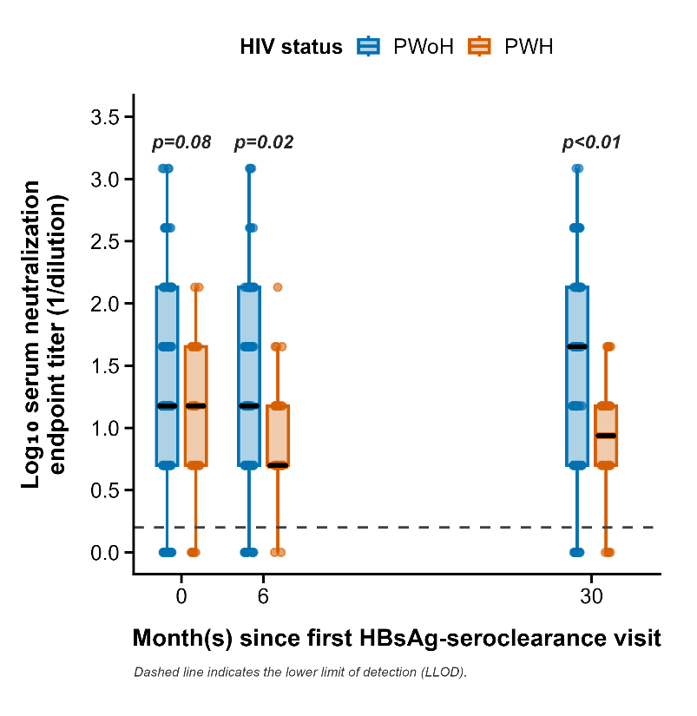
Figure S1. Endpoint serum neutralization titers after spontaneous HBV control by HIV status. Serum neutralizing activity against HBVcc, summarized as log₁₀ endpoint neutralization titer, is shown at the first HBsAg-seroclearance visit (PWoH n=87, PWH n=29), the 6-month visit (PWoH n=81, PWH n=26), and the 30-month visit (PWoH n=72, PWH n=26). Endpoint neutralization titer was defined as the highest serum dilution with percent neutralization greater than the mean of anti-HBs-negative control plasma plus 2 SD. Points represent individual participants; boxes show the median and IQR; whiskers extend to the most extreme values within 1.5×IQR. The dashed horizontal line indicates the lower limit of detection; points at or below this line represent samples without measurable endpoint titers under the assay conditions used. Group differences between PWoH and PWH at each visit were assessed using unpaired Mann–Whitney U tests, with p values shown. HBV=hepatitis B virus; HBVcc=cell culture-derived HBV; anti-HBs=antibody to hepatitis B surface antigen; IQR=interquartile range; PWH=people with HIV; PWoH=people without HIV; SD=standard deviation.
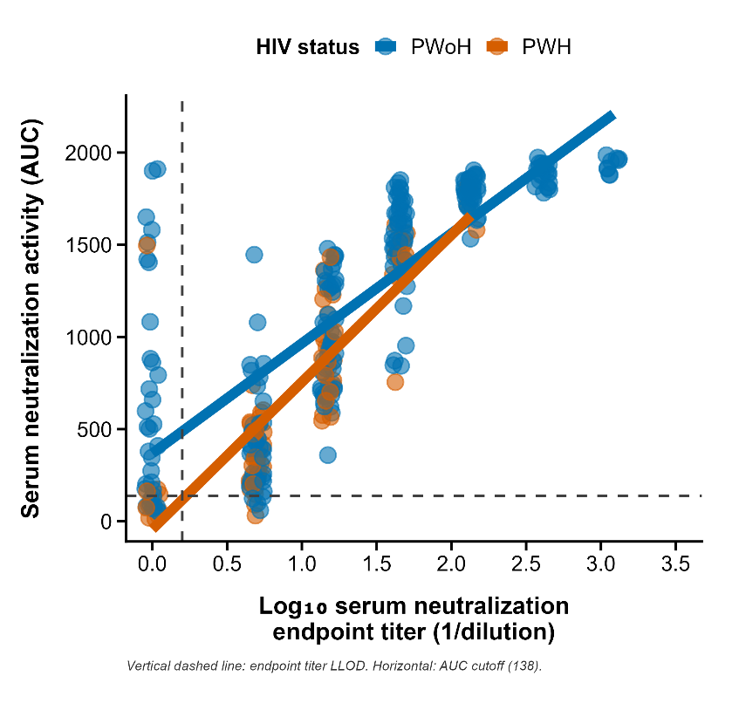
Figure S2. Relationship between neutralization AUC and endpoint neutralization titers by HIV status. Scatter plot of paired serum neutralization AUC and endpoint neutralization titers measured in the same samples across the first HBsAg-seroclearance visit, the 6-month visit, and the 30-month visit, stratified by HIV status (PWoH n=240 samples; PWH n=81 samples). Points represent individual samples. The horizontal dashed line indicates the mean AUC of pooled anti-HBs-negative plasma (AUC=138), and the vertical dashed line indicates the minimum measurable endpoint neutralization titer. Associations were assessed separately in PWoH and PWH using Spearman’s rank correlation; solid lines show least-squares regression fits for visualization only. AUC=area under the neutralization curve; PWH=people with HIV; PWoH=people without HIV.

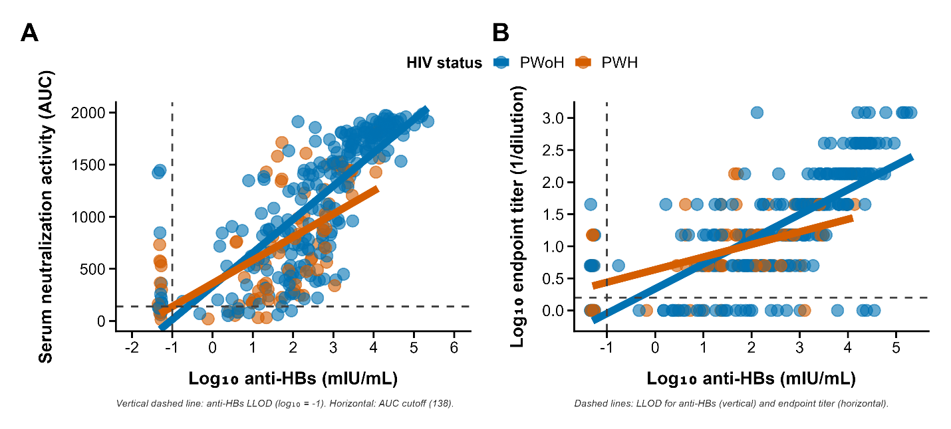
Figure S3. Relationship between anti-HBs concentrations and HBV neutralization measures by HIV status. (A) Scatter plot of paired anti-HBs concentrations and serum neutralizing activity against HBVcc, summarized as AUC, measured in the same samples across the first HBsAg-seroclearance visit, the 6-month visit, and the 30-month visit, stratified by HIV status (PWoH n=240 samples; PWH n=81 samples). (B) Scatter plot of paired anti-HBs concentrations and HBVcc endpoint neutralization titers measured in the same samples across the first HBsAg-seroclearance visit, the 6-month visit, and the 30-month visit, stratified by HIV status (PWoH n=240 samples; PWH n=81 samples). Points represent individual samples. In both panels, the vertical dashed line indicates the lower bound of the quantitative anti-HBs assay. In panel A, the horizontal dashed line indicates the mean AUC of pooled anti-HBs-negative plasma (AUC=138). In panel B, the horizontal dashed line indicates the lower limit of detection for endpoint neutralization titer. Associations were assessed separately in PWoH and PWH using Spearman’s rank correlation; solid lines show least-squares regression fits for visualization only. Anti-HBs=antibody to hepatitis B surface antigen; AUC=area under the neutralization curve; HBV=hepatitis B virus; HBVcc=cell culture-derived hepatitis B virus; PWH=people with HIV; PWoH=people without HIV.

1 Extended Methods
  - Serological assays
Serum anti-HBs was measured using a quantitative anti-HBs ELISA kit (XpressBio, Rockville, MD) calibrated with kit-provided standards spanning 0–160 mIU/mL. Samples were tested at neat, 1:5, and 1:25 dilutions; samples exceeding the quantifiable range at 1:25 were retested at higher dilutions (1:125, 1:625, and 1:3125). Anti-HBc was measured in a subset of participants (58% of PWoH and 61% of PWH) using a quantitative anti-HBc ELISA kit (Wantai Biological Pharmacy Enterprise Company, Beijing, China), with results reported in IU/mL against the WHO International Standard. For anti-HBc, samples were tested from 1:5 followed by 5-fold serial dilutions through 1:3125.
For both assays, dilution points falling within the reliable quantitative range of the standard curve were used to back-calculate the concentration in the neat sample, and the final reported concentration was the mean of all in-range back-calculated values. Dilution points outside this range were not used for quantification. If the OD remained below the 0-standard OD at the least diluted condition, the sample was considered negative or below the quantifiable range under the assay conditions used. The lowest kit calibrators (10 mIU/mL for anti-HBs and 0.1 IU/mL for anti-HBc) were used as practical lower bounds for quantitative reporting; samples below this range were assigned a value of 0.05 for statistical analysis.
  - HepG2-NTCP cells
The human hepatoma cell line HepG2-NTCP (provided by Dr. Charles M. Rice in The Rockefeller University) was cultured in T75 flasks coated with collagen (STEMCELL Technologies). The cells were grown in Dulbecco’s Modified Eagle Medium (DMEM) (Corning) supplemented with 10% fetal bovine serum (FBS) (Gibco, Thermo Fisher), 0.1 mM non-essential amino acids (NEAA) (Gibco, Thermo Fisher), 500 µg/mL geneticin (G418) (Gibco, Thermo Fisher), 100 U/mL penicillin, and 100 µg/mL streptomycin (Gibco, Thermo Fisher). Cultures were maintained at 37°C with 5% CO2.
  - HBVcc stock
The HepAD38 cell line was obtained from the American Type Culture Collection (ATCC) and cultured in T225 collagen-coated flasks using DMEM/F12 (Corning) complete medium. This medium was supplemented with 10% FBS, 0.1 mM NEAA, 2 mM L-glutamine (Quality Biological), 400 µg/mL G418, 100 U/mL penicillin, 100 µg/mL streptomycin, and 400 ng/mL tetracycline (Zymo Research). To initiate HBV replication, tetracycline was removed, and the cells were maintained in DMEM/F12 medium containing 3% FBS. The cell culture medium was collected every 2 days over a 2-week period following a 7-day incubation without tetracycline to promote HBV expression. After collection, the medium was centrifuged to clear cell debris and filtered through a 0.22 μm membrane (Millipore-Sigma, Merck KGaA). Viral particles were then precipitated using 8% PEG-8000 (Promega Corporation) for 18–24 h at 4°C. The resulting viral precipitate was concentrated by centrifugation, resuspended in DMEM basic medium, aliquoted, and stored at −80°C. One aliquot was used for HBV viral load assessment (Abbott Laboratories) and HBsAg quantitation (Novus Biologicals).
  - In vitro HBV neutralization
HepG2-NTCP cells were seeded in 96-well collagen-coated plates (STEMCELL Technologies) and cultured as described above. At about 80% confluence the next day, the medium was replaced with DMEM containing 3% FBS and 2% DMSO to limit proliferation. After 24 h, cells were infected with HBVcc either as a virus-only inoculum or after pre-incubation with participant serum samples at a multiplicity of infection (MOI) of 3e-05 ng HBsAg per cell.
Serum samples from participants and pooled plasma without anti-HBs from individuals without prior HBV infection or vaccination (negative control) were heat-inactivated at 56°C for 30 min, clarified by centrifugation, and diluted 1:5 in DMEM, followed by 1:3 serial dilutions to generate ten dilution points. Treatment agents—HBIg (positive control), purified human IgG (negative control), diluted sera, or negative-control plasma—were pre-incubated with HBVcc for 1 h at 37°C before addition to cells (50 µL per well). A virus-only inoculum (HBVcc without any treatment agent) was included on each plate and used as the reference for calculating neutralization.
After 24 h, the inoculum was removed, cells were washed four times with PBS, and fresh infection medium was added. Supernatants were collected at 4 days post-infection, stored at 4°C, and replaced with fresh medium; at 7 days post-infection, supernatants were collected again, pooled with the 4-day fractions, and assayed for HBsAg by qualitative ELISA (Abnova). Percent neutralization was calculated as % neutralization = (1 − [OD450 sample / OD450 virus-only]) × 100. The area under the neutralization curve (AUC) across the dilution series was used to summarize neutralization capacity. To define background neutralization, we also calculated the mean AUC from anti-HBs-negative donor plasma (mean AUC = 138). Endpoint titers were defined as the last dilution with % neutralization exceeding the mean of negative-control plasma plus 2 SD. HBIg and purified human IgG served as run-performance controls for each assay.
  - HBsAg-antibody immunocomplex assessment
Serum HBsAg IC were measured using a two-step chemiluminescent microparticle immunoassay on the ARCHITECT platform (Abbott Diagnostics, Chicago, IL). In the first step, a mouse anti-HBs monoclonal antibody captures either uncomplexed HBsAg or HBsAg bound to participant-derived anti-HBs. In the second step, an acridinium-labeled monoclonal antibody specific for human immunoglobulin G is added. After a wash to remove unbound material, the addition of pre-trigger and trigger solutions induces chemiluminescence from the acridinium label. The emitted signal, measured in relative light units (RLUs), reflects the presence of HBsAg ICs. Longitudinal changes in RLU values within individuals were used to infer dynamic variation in circulating HBsAg IC levels. In parallel, quantitative HBsAg (Abbott ARCHITECT) was measured. When qHBsAg was below 0.05 IU/mL, samples were reflex-tested with the qualitative ARCHITECT HBsAg NEXT assay (lower limit of detection 0.005 IU/mL) for ultrasensitive assessment.

