Wild Birds as Trypanosoma cruzi reservoirs in Pampa biome, Rio Grande do Sul-Brazil: occurrence and molecular detection

Gustavo Cardoso Ferreira Klann¹, William Cardoso Ferreira Zorrer², Bibiana Domingues de Freitas³, Estefani Rinaldi³, Nilseia Feijó da Silva¹, Pedro Albuquerque³, Raqueli Teresinha Franca³, Rodrigo Casquero Cunha³, Nathieli Bianchin Bottari¹

1 Graduate Program in Microbiology and Parasitology, Department of Microbiology and Parasitology, Institute of Biology, Federal University of Pelotas, Pelotas, Brazil.
2 Health and Technologies Program, Department of Medical and Sciences, University of Bologna, Bologna, Italy.
3 Graduate Program in Veterinary, Department of Veterinary Medicine, Veterinary School, Federal University of Pelotas, Pelotas, Brazil.

*Corresponding author: Nathieli Bianchin Bottari
Department of Microbiology and Parasitology, Federal University of Pelotas (UFPel), Capão do Leão Campus, Eliseu Maciel Avenue, ZIP Code 96160-000, Pelotas, RS, Brazil. E-mail: nathieli_bb@hotmail.com
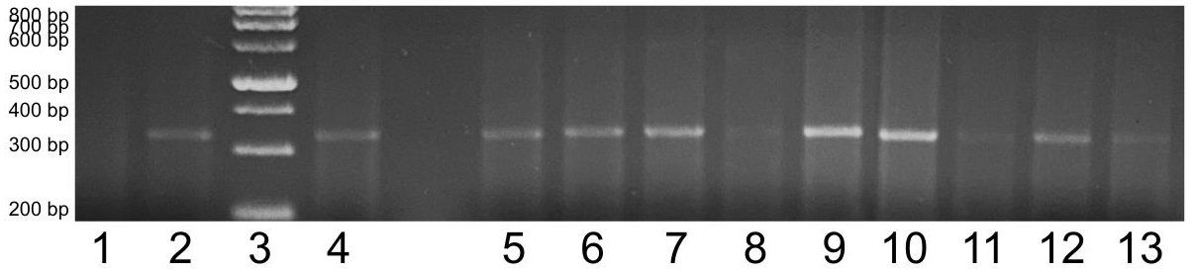
Supplementary Figure 1 - Trypanosoma cruzi kDNA (330 bp) from PCR products of wild birds samples.
Note: Lane 1 - Negative control; Lane 2 - Positive control; Lanes 3 - Ladder 100 bp; Lane 4 – F. peregrinus lungs; Lane 5 – A. saracura 1 intestine; Lane 6 – A. saracura 1 liver; Lane 7 - A. saracura 2 heart; Lane 8 -; A. saracura 2 spleen; Lane 9 - A. saracura 2 liver; Lane 10 – C. torquata spleen; Lane 11 – C. torquata liver; Lane 12 – C. torquata heart; Lane 13 – C. plancus 1 skeletal muscle.

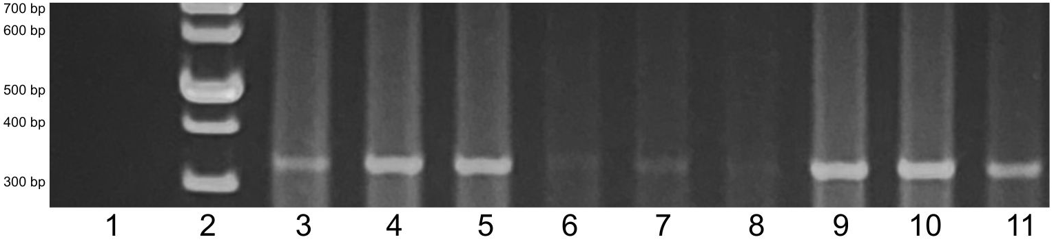
Supplementary Figure 2 - Trypanosoma cruzi kDNA (330 bp) from PCR products of wild birds samples.
Note: Lane 1 - Negative control; Lane 2 - Ladder 100 bp; Lanes 3 - Positive control; Lane 4 – C. plancus 1 heart; Lane 5 – P. sulphuratus 1 brain; Lane 6 – P. sulphuratus 1 intestine; Lane 7 - P. sulphuratus 1 spleen; Lane 8 -; P. sulphuratus 1 lungs; Lane 9 - P. sulphuratus 1 liver; Lane 10 – P. sulphuratus 1 kidneys; Lane 11 – P. sulphuratus 1 heart.

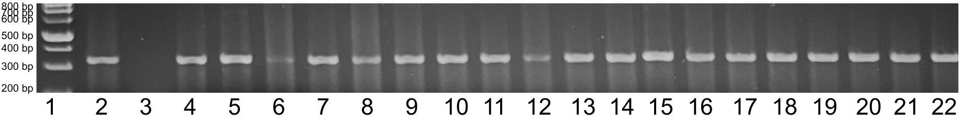
Supplementary Figure 3 - Trypanosoma cruzi kDNA (330 bp) from PCR products of wild birds samples.
Note: Lane 1 - Ladder 100 bp; Lanes 2 and 22 - Positive control; Lanes 3 - Negative control; Lane 4 – P. sulphuratus 2 brain; Lane 5 – P. sulphuratus 2 heart; Lane 6 – P. sulphuratus 2 skeletal muscle; Lane 7 - P. sulphuratus 2 ventricle; Lane 8 -; C. melacoryphus intestine; Lane 9 - C. melacoryphus heart; Lane 10 – C. melacoryphus kidneys; Lane 11 – C. livia 1 intestine; Lane 12- C. livia 1 liver; Lane 13 - C. livia 1 skeletal muscle; Lane 14 - C. livia 1 kidneys; Lane 14 - C. livia 1 heart; Lane 15 – M. monachus 6 intestine; Lane 16 - M. monachus 6 liver; Lane 17 - P. sulphuratus 4 brain; Lane 18 - P. sulphuratus 4 skeletal muscle; Lane 19 - P. sulphuratus 4 heart; Lane 20 – B. virginianus spleen; Lane 21 - B. virginianus intestine.

