Supplemental Table 1. Diagnostic codes used to categorize NDD disorders from the diagnostic and statistical manual of mental disorders, 5th Edition: DSM-5
NDD Categories | ICD-10-CM Codes
Autism Spectrum Disorder | F840, F843, F845, F849, F842
Intellectual Disorders | F70, F71, F72, F73, F79, R6250
Communication Disorders | F802, F800, F801, F8082, F8089, F809
Attention-Deficit/Hyperactivity Disorder | F900, F901, F902, F909, F908
Specific Learning Disorders | F810, F812, F8181, F8189, F819
Motor Disorders | F82, F984, F985
Tic Disorders | F952, F951, F950, F958, F959
Other Neurodevelopmental Disorders | F88, F89
Delayed Development | R620, R6259

Supplemental Table 2. Combinations of NDD categories among military-connected children with FASD and at least one co-occurring NDD (n=1248)
NDD Category Combination | Children  n (%)
ADHD | 200 (16.0)
ADHD, ASD | 72 (5.8)
ADHD, ID | 42 (3.4)
ADHD, other NDD | 35 (2.8)
ADHD, ASD, ID | 34 (2.7)
developmental delay | 27 (2.2)
ADHD, ASD, communication disorder, developmental delay, ID, motor disorders, other NDD | 20 (1.6)
ADHD, developmental delay | 20 (1.6)
communication disorder | 20 (1.6)
ADHD, ASD, other NDD | 19 (1.5)
ADHD, communication disorder | 19 (1.5)
ADHD, learning disorders | 19 (1.5)
communication disorder, developmental delay | 19 (1.5)
ID | 19 (1.5)
ADHD, ASD, communication disorder, developmental delay, ID, other NDD | 17 (1.4)
ADHD, ASD, ID, other NDD | 16 (1.3)
ADHD, communication disorder, ID | 16 (1.3)
ADHD, ID, other NDD | 14 (1.1)
ADHD, ASD, communication disorder | 12 (1.0)
ADHD, communication disorder, developmental delay | 12 (1.0)
ADHD, ASD, communication disorder, developmental delay | 11 (0.9)
ADHD, ASD, communication disorder, ID, other NDD | 11 (0.9)
ADHD, ASD, tic disorders | 11 (0.9)
Other combinations (n=187 out of 210) | 563 (45.11)
Caption: The table depicts all identified combinations (n=210) of nine neurodevelopmental disorder categories in eligible children with at least one other co-occurring NDD (n=1248). ADHD was the most frequent diagnosis (16% of children), followed by ADHD and autism (5.8%). ADHD was present in 70% (n=147) of the 210 unique combinations, while ASD was present in 11.4% (n=24). Over ninety percent of observed combinations (n=190) occurred in less than one percent of eligible children, respectively. Frequency is presented as n (number), % (percent). Combinations of NDD categories are mutually exclusive. FASD diagnosis includes ICD-10 codes for fetal alcohol syndrome and/or prenatal alcohol exposure. The final row, other combinations, aggregates 187 unique combinations of NDD categories due to counts <10.
Abbreviations: ADHD: attention-deficit/hyperactivity disorder; ASD: autism spectrum disorder; ID: intellectual disorders; FASD: fetal alcohol spectrum disorders; NDD: neurodevelopmental disorders.
Supplemental Figure 1. Race differences within co-occurring neurodevelopmental disorder categories among military-connected children with a FASD diagnosis (n=1423)
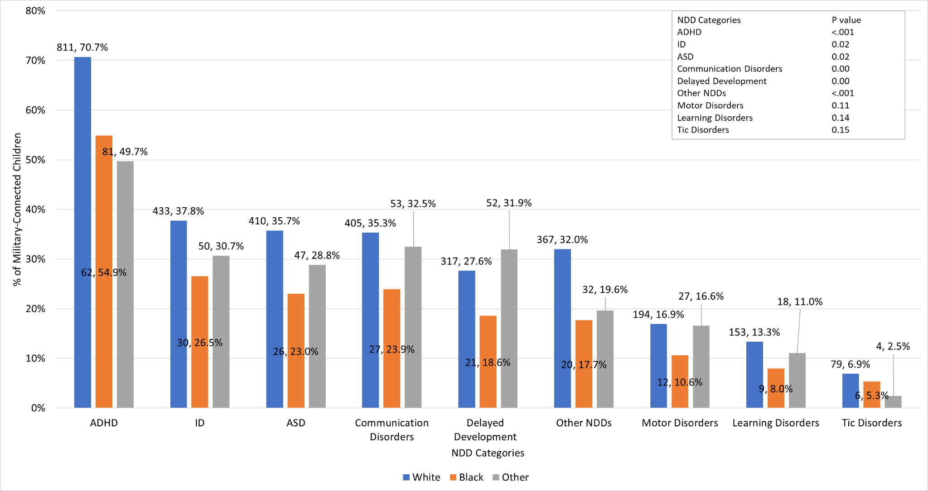
Caption: The bar graph depicts the distribution of race (White, Black, other) within each NDD category. P-value results of chi-square tests for differences in race by NDD category are provided in the upper righthand key. Differences in race were statistically significant for categories of ADHD, ID, ASD, communication disorders, delayed development, and other NDDs. Small sample size for motor, learning, and tic disorders may have reduced power to detect differences. Frequency is presented as n (number), row % (percent) for White, Black, and other races. Other races include Asian or Pacific Islander, American Indian, Alaskan Native, or Other. Children with a missing race (n=53, 3.6%) are not depicted.
Abbreviations: ADHD: attention-deficit/hyperactivity disorder; ASD: autism spectrum disorder; FASD: fetal alcohol spectrum disorders; ID: intellectual disorders; NDD: neurodevelopmental disorders.

Supplemental Figure 2. Sex differences in co-occurring neurodevelopmental disorder categories among military-connected children with a FASD diagnosis (n=1476)
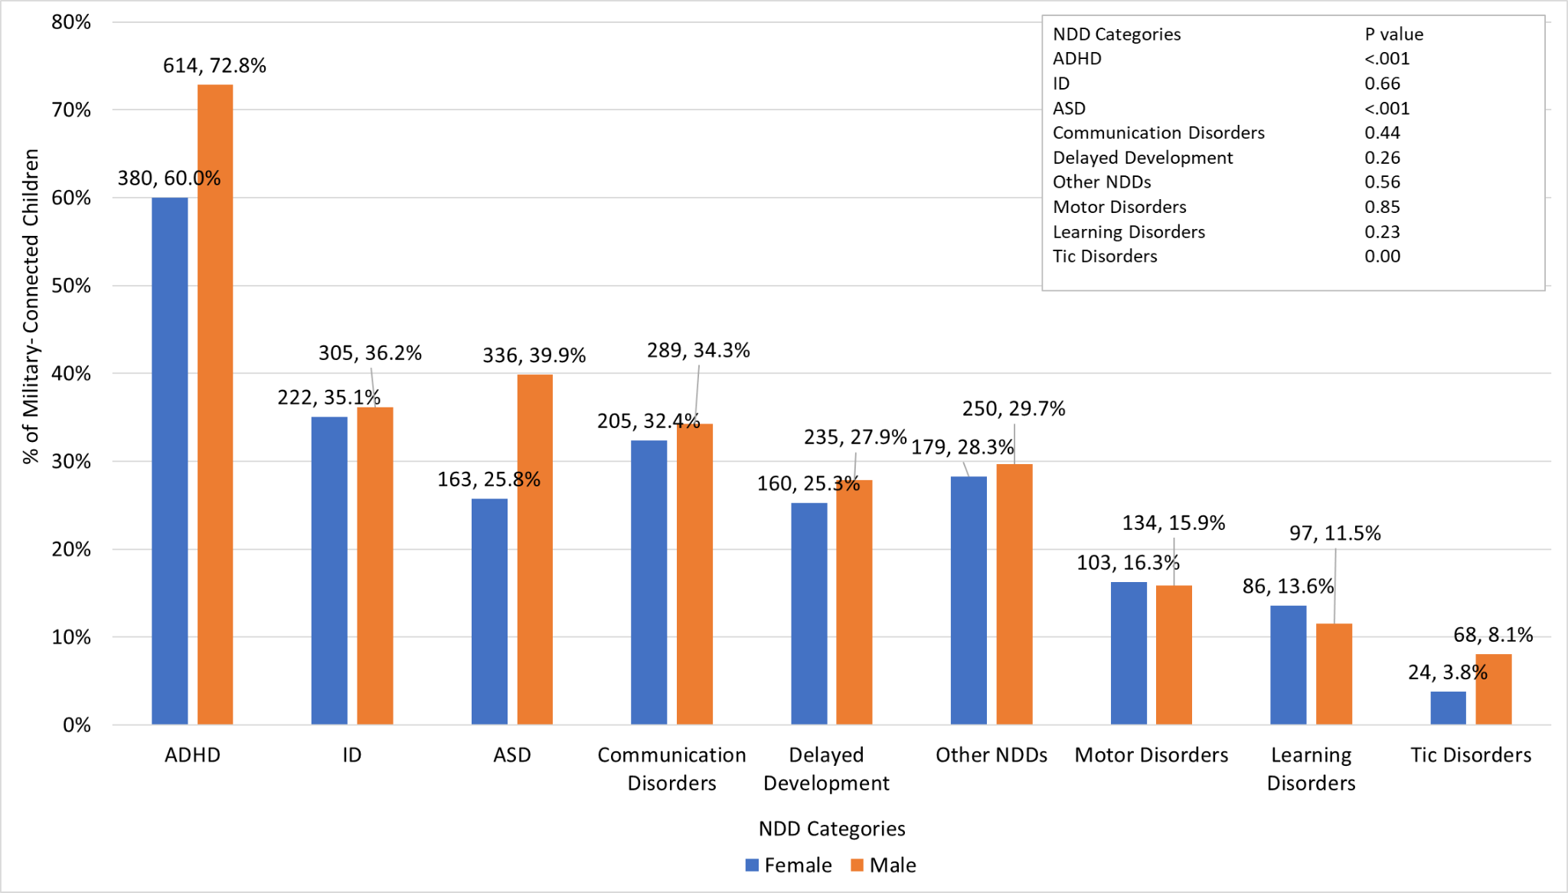
Caption: The bar graph depicts the distribution of biological sex within each NDD category. P-value results of chi-square tests for differences in sex by NDD category are provided in the upper righthand key. Male children were significantly more likely than females to be diagnosed with ADHD, ASD, and Tic disorders. Frequency is presented as n (number), row % (percent) for sex.
Abbreviations: ADHD: attention-deficit/hyperactivity disorder; ASD: autism spectrum disorder; FASD: fetal alcohol spectrum disorders; ID: intellectual disorders; NDD: neurodevelopmental disorders.

