Enzymatic tailoring of potato proteins establishes multiscale structure–functionality relationships for plant-based meat analogue texture formation
Mingqin Li^{1,2*}, Carol Bouvard¹, Yi Zhang³, Tonghui Jin¹, Hans Jörg Limbach², Raffaele Mezzenga^{1,4, *}
- Department of Health Sciences and Technology, ETH Zurich, Schmelzbergstrasse 9, Zurich, 8092, Switzerland
- Food Science, Adolphe Merkle Institute, University of Fribourg, Chemin de Vermin 4, Fribourg, 1700, Switzerland
- Department of Food Science, The Pennsylvania State University, University Park, PA 16802, USA
- Department of Materials, ETH Zurich, Wolfgang‐Pauli‐Strasse 10, Zurich, 8093, Switzerland
*Corresponding authors: mingqin.li@unifr.ch; raffaele.mezzenga@hest.ethz.ch

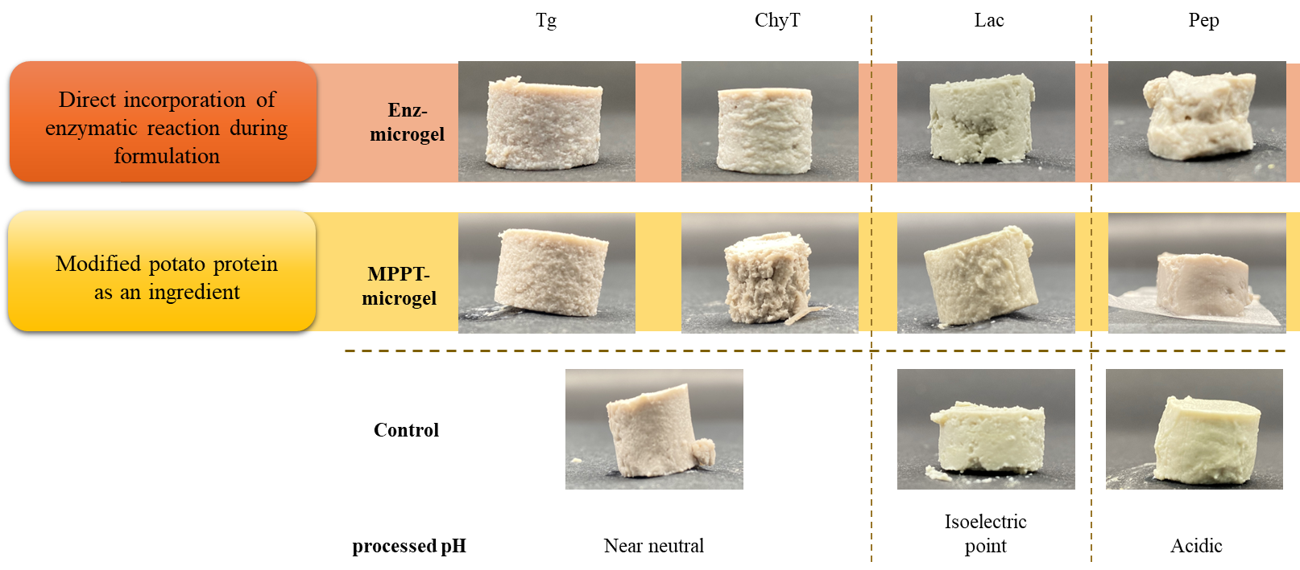
Fig. S1. Macroscopic images of PPT microgels-based PBMA prototypes prepared with various enzymatic processes

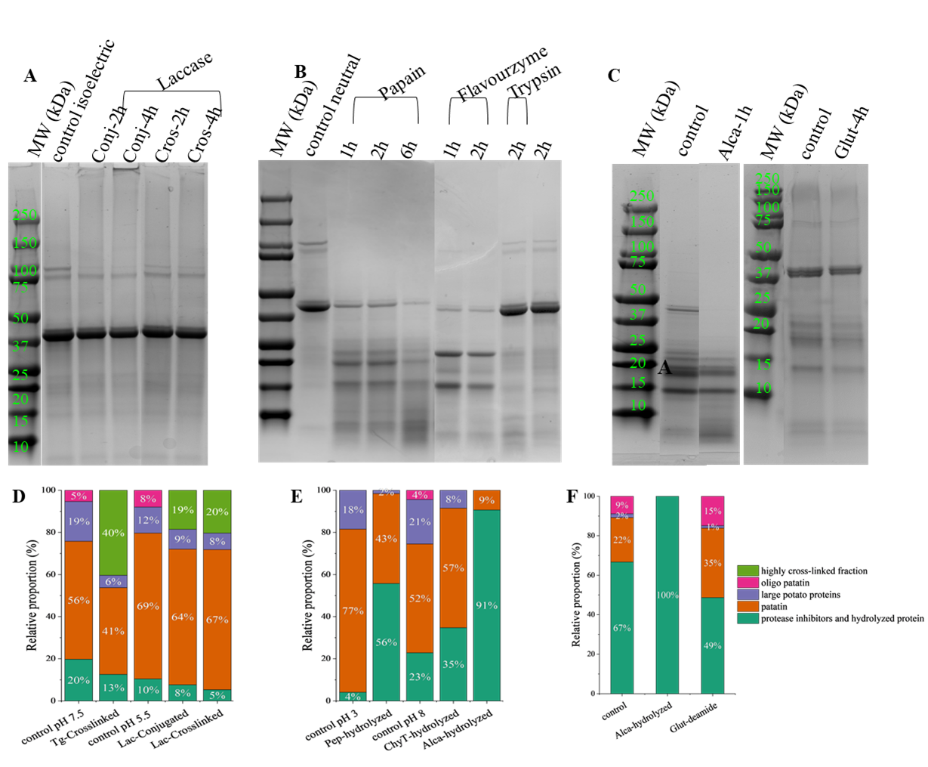
Figure S2. Electrophoretic pattern and molecular weight distribution of potato proteins. A-C, electrophoretic patterns from SDS-PAGE analysis of laccase crosslinking/conjugation of commercial PPT at pH around protein isoelectric point (A), enzymatic hydrolysis treatment of commercial PPT under neutral conditions (B) and treatments of in-house-PPT by Alcalase (Alca) and protein glutaminase (Glut). D-F, the molecular weight distribution of PPTs upon modified by selected enzymatic crosslinking/conjugation and proteolytic reactions.

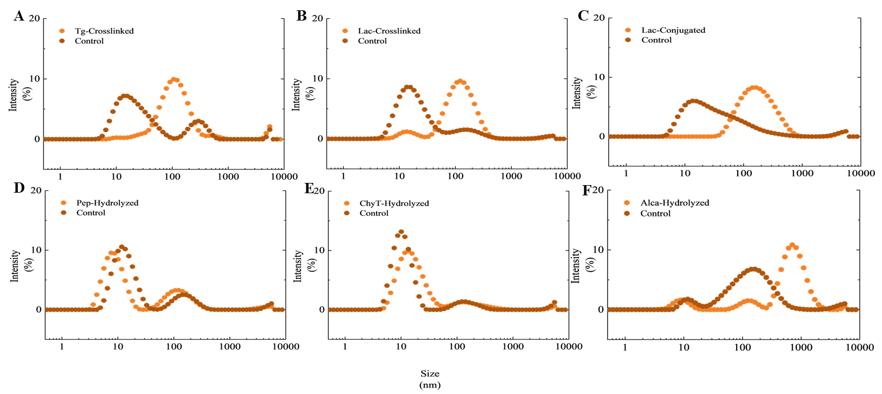
Figure S3. Changes in particle size distribution upon enzymatic treatments. A. Transglutaminase-catalyzed crosslinking of commercial PPT; B. Laccase-catalyzed crosslinking of commercial PPT; C. Laccase-catalyzed conjugation of commercial PPT and citrus pectin; D. Pepsin-catalyzed hydrolysis of commercial PPT; E. Chymotrypsin-catalyzed hydrolysis of commercial PPT; D. Alcalase-catalyzed hydrolysis of inhouse PPT
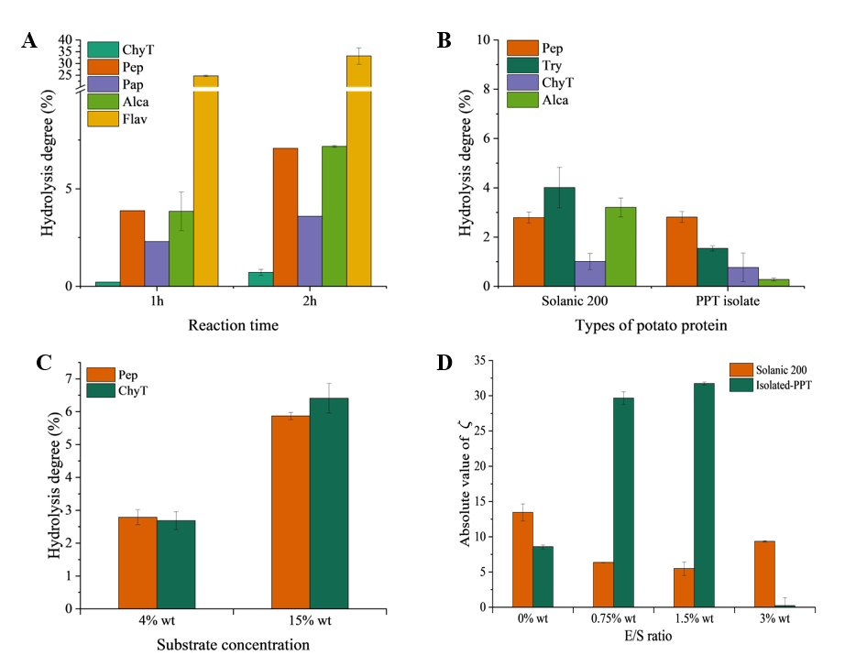

Figure S4. Physicochemical characterization of enzymatic hydrolysis and deamidation reactions. A. effect of the protease type; B. effect of type of PPTs as substrate, C. effect of substrate concentration on pepsin-hydrolysis for 1h (Pep) and chymotrypsin hydrolysis for 2h (ChyT); D. monitoring the effect of enzyme concentration on deamidation via changes on protein zeta potential.

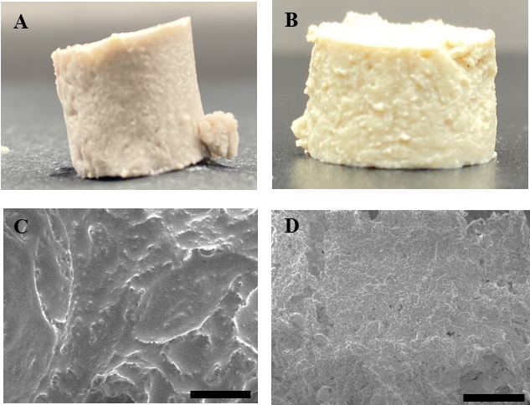
Figure S5. Macroscopic image of PBMA prototypes and micromorphology of protein networks from commercial PPT (A, C) and from in-house PPT (B, D).

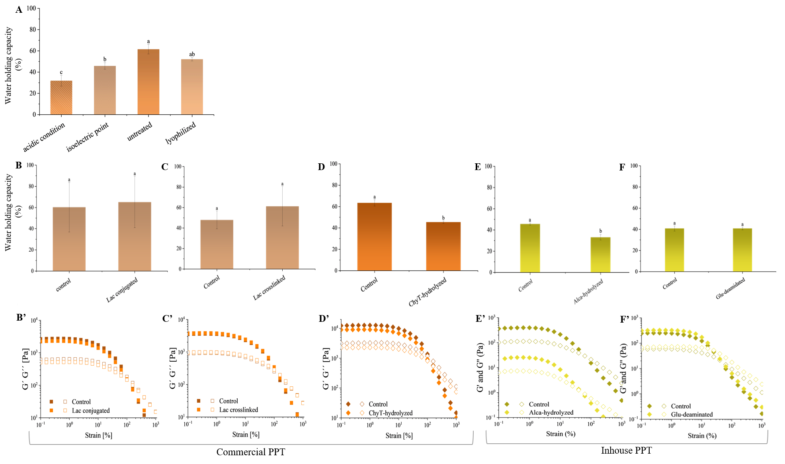

Figure S6. Gelling performance of potato proteins under varies processing environment and enzymatic treatments. A. water-holding capacity of potato microgels varies by pH and processing routes. Water holding capacity and changes in rheological properties of the protein microgel as an effect of enzymatic treatments: conjugation with citrus pectin (B & B’), or protein crosslinking (C & C’) by laccase, hydrolysis by chymotrypsin (D & D’), hydrolysis by Alcalase (E & E’) and deamidation by protein glutaminase (F & F’). Treatments B, C, D were performed on commercial potato proteins, treatments E and F were performed on in-house PPT.
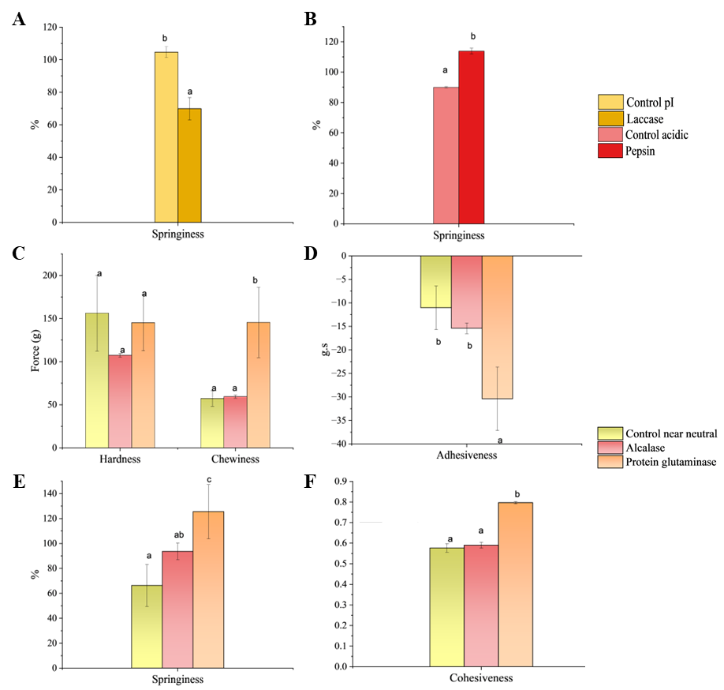

Figure S7. Textural profile analysis of PPT microgel PBMA. Effect of in situ laccase-catalyzed conjugation (A) and in situ pepsin-hydrolysis (B) on springiness. C-F, Changes on textural profile of in-house PPT based prototypes caused by Alcalase-hydrolysis and protein glutaminase-deamidation.

Processes | pH of incubation | particle size  (nm) | average MW (kDa) | water-holding capacity | G'  (Pa) | Hardness  (g) | Chewiness  (g) | Adhesiveness | Springiness  (%) | Cohesiveness  (g∙s)
control pH 3 | 3 | 29.6 ± 1.0 | 56.7 | 31.9 ± 5.1 | 12.2 | 119.2 ± 52.1 | 148.2 ± 43.7 | -21.8 ± 8.9 | 124.4 ± 43.0 | 1.18 ± 0.42
control pH 5.5 | 5.5 | 17.6 ± 0.6 | 56.3 | 49.9 ± 8.7 | 3520 | 168.6 ± 38.6 | 111.5 ± 28.8 | -4.2 ± 0.5 | 104.7 ± 3.4 | 0.65 ± 0.02
control pH 7.5 | 7.5 | 32.0 ± 3.5 | 55 | 63.2 ± 6.1 | 12333 | 583.2 ± 15.9 | 510.0 ± 4.9 | -31.8 ± 8.4 | 99.7 ± 2.8 | 0.89 ± 0.01
Tg-crosslinked | 7.5 | 100.1 ± 1.8 | 56.5 | 84.9 ± 10.4 | 22700 | 479.1 ± 3.5 | 444.0 ± 48.2 | -35.8 ± 16.2 | 103.5 ± 4.3 | 0.90 ± 0.05
Lac-conjugated | 5.5 | 127.3 ± 4.4 | 69.7 | 65.2 ± 24.3 | 2215 | 176.9 ± 20.7 | 89.4 ± 19.4 | -3.4 ± 0.4 | 69.9 ± 6.9 | 0.63 ± 0.09
Pep-hydrolyzed | 3 | 11.9 ± 0.2 | 49.4 | 30.3 ± 0.3 | 8.05 | 87.7 ± 1.4 | 106.0 ± 7.0 | -8.6 ± 0.2 | 113.6 ± 2.6 | 1.07 ± 0.06
ChyT-hydrolyzed | 8 | 15.8 ± 0.5 | 45.9 | 45.5 ± 1.2 | 8920 | 581.7 ± 26.6 | 541.4 ± 2.1 | -10.5 ± 1.8 | 103.6 ± 6.1 | 0.87 ± 0.01
MPPT control | 7.5 | 29.9 ± 8.9 | 55 | 52.1 ± 1.6 | 4530 | 101.5 ± 30.5 | 85.7 ± 10.8 | -4.9 ± 0.4 | 102.3 ± 8.9 | 0.85 ±0.08
MPPT-Tg | 7.5 | 98.1 ± 4.0 | 194.2 | 62.6 ± 1.2 | 9840 | 226.2 ± 16.1 | 223.1 ± 33.6 | -5.0 ± 0.9 | 105.5 ± 4.7 | 0.94 ± 0.04
MPPT-Lac | 5.5 | 83.3 ± 6.2 | 115.4 | 32.1 ± 0.4 | 3430 | 171.7 ± 12.5 | 156.4 ± 3.7 | -15.8 ± 7.1 | 101.3 ± 6.2 | 0.90 ± 0.03
MPPT-Pep | 3 | 13.2 ± 1.0 | 28.5 | 25.0 ± 0.0 | 11 | 31.0 ± 17.3 | 72.4 ± 69.7 | -8.3 ± 0.2 | 151.4 ± 32.2 | 1.29 ± 0.47
MPPT-ChyT | 8 | 15.8 ± 0.6 | 42 | 39.0 ± 0.5 | 3300 | 46.2 ± 14.1 | 83.7 ± 63.2 | -2.7 ± 0.5 | 97.5 ± 13.4 | 1.20 ± 0.27
Isolated PPT | 8 | 87.7 ± 28.7 | 55.4 | 45.6 ± 1.1 | 244.515 | 156.2 ± 43.99 | 57.1 ± 8.9 | -11.0 ± 4.7 | 66.3 ± 16.7 | 0.58 ± 0.02
Isolated PPT-Alca | 8 | 370.2 ± 47.6 | 13.6 | 34.5 ± 1.1 | 25.5 | 107.4 ± 2.3 | 59.4 ± 1.8 | -15.4 ± 1.13 | 93.7 ± 6.7 | 0.59 ± 0.01
Isolated PPT-Gluta | 7.5 | 103.0 ± 19.9 | 50.2 | 40.8±1.4 | 313.675 | 145.2 ± 32.6 | 145.5 ± 40.7 | -30.4 ± 6.8 | 125.5 ± 21.7 | 0.80 ± 0.01
Table S1. Colloidal property, water-holding capacity, viscoelasticity and mechanical property of potato protein materials for principle component analysis

