Supplementary file 1: eggs of cestode and trematode parasites ofsheep
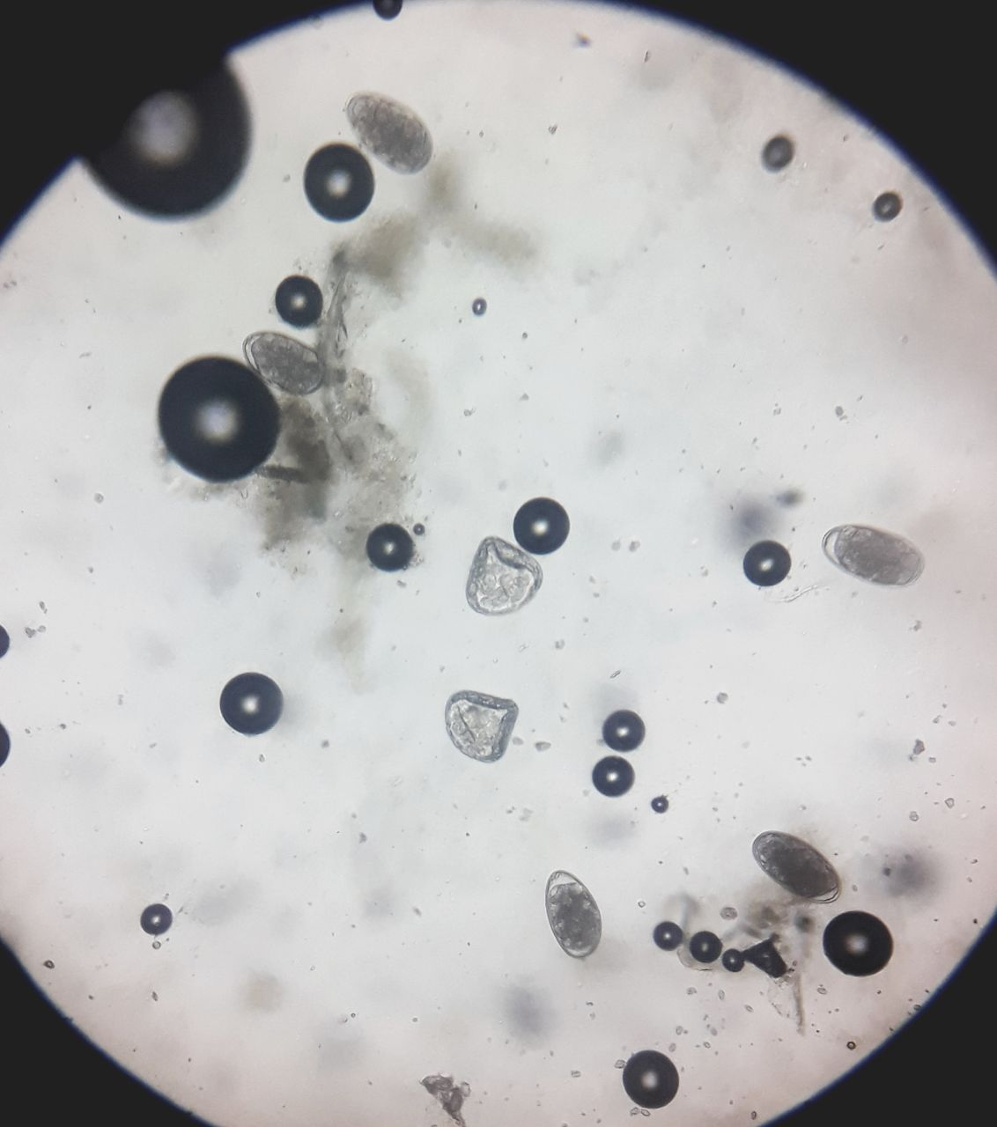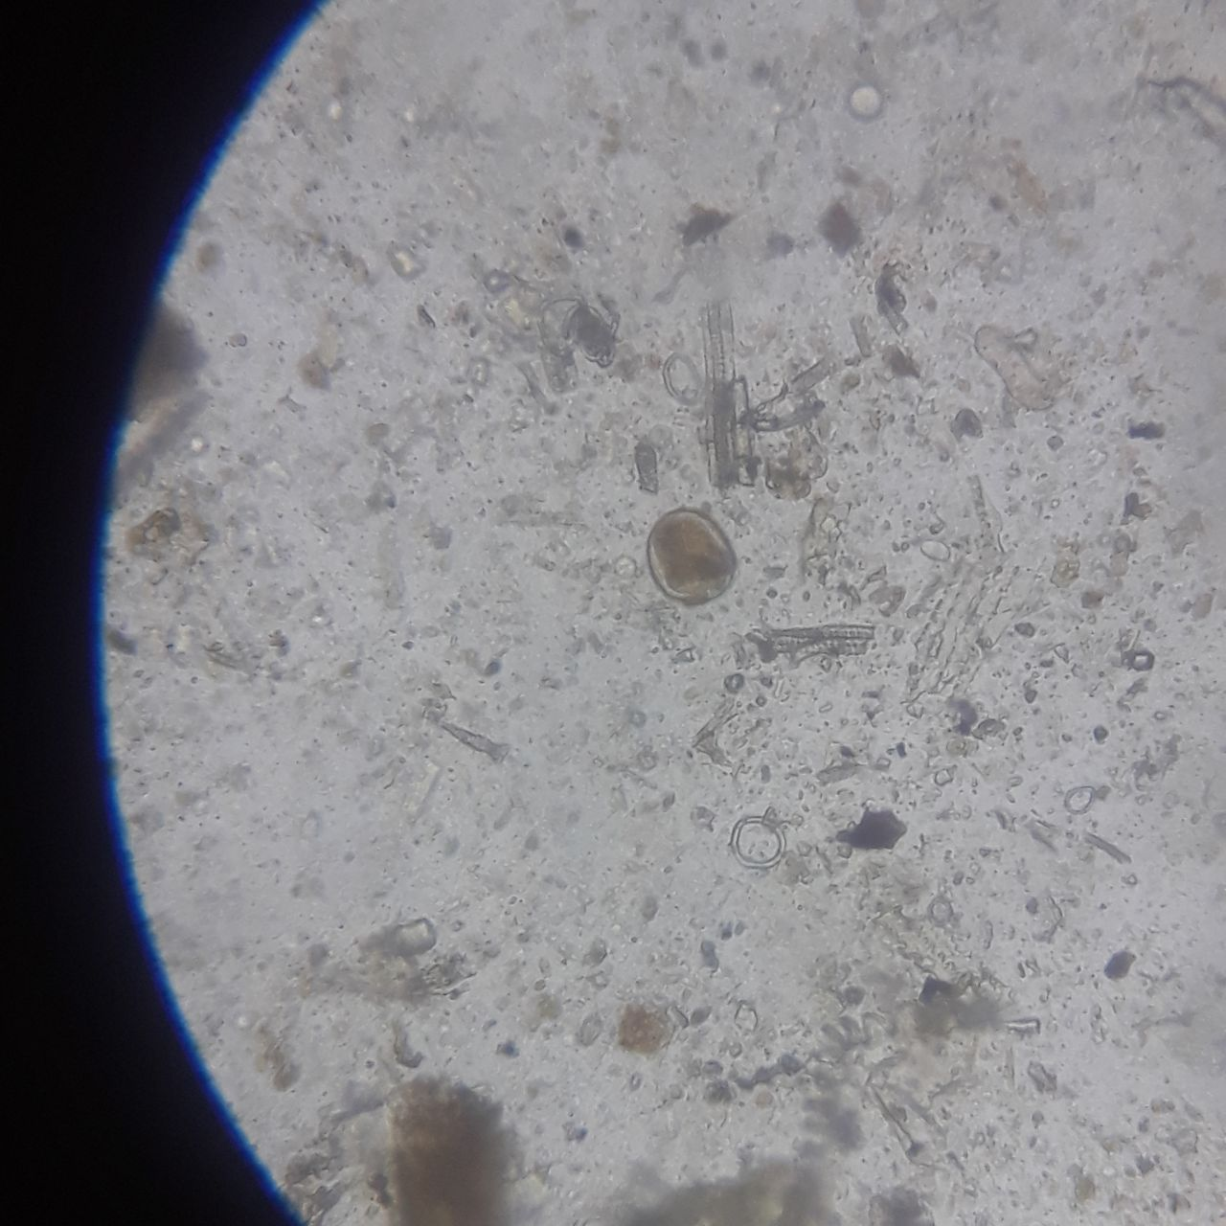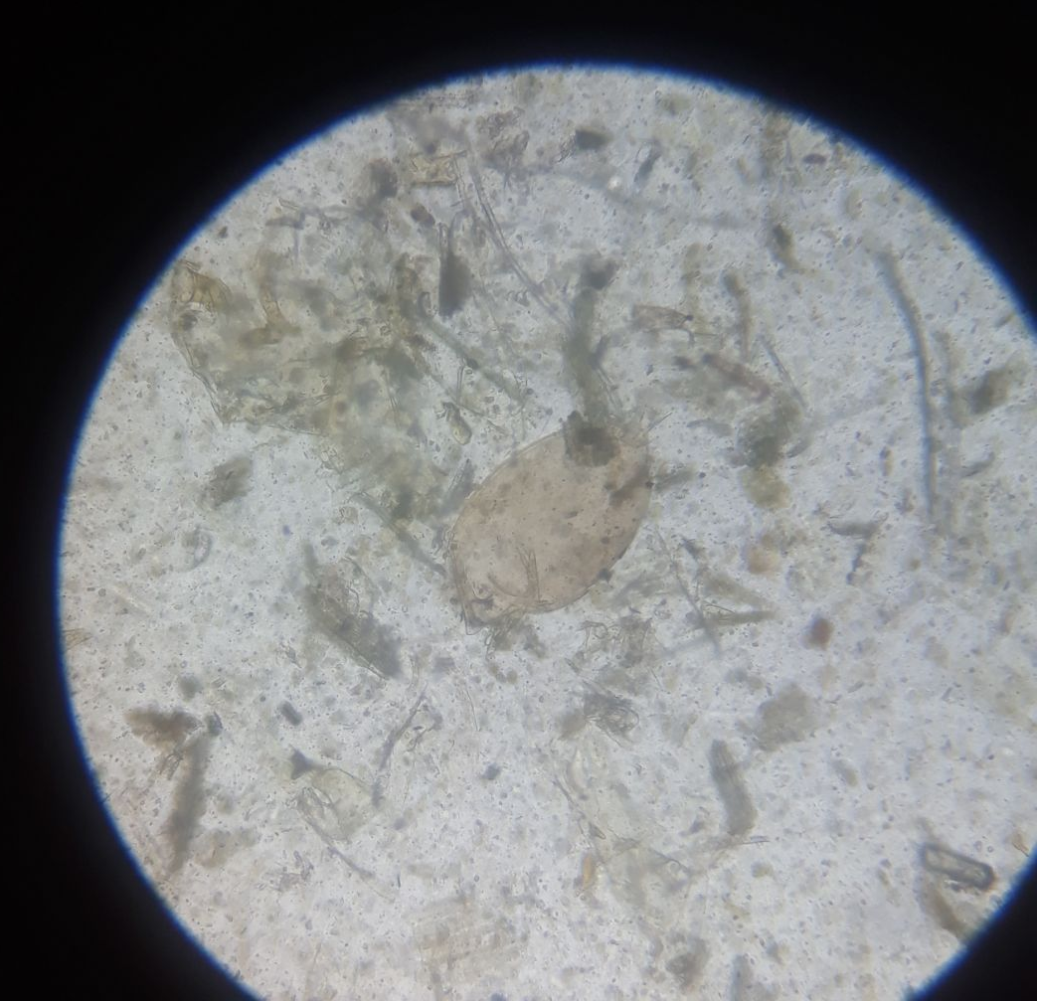
Monezia expansa egg Schistosoma japonicum egg, Schistosma haematobium egg
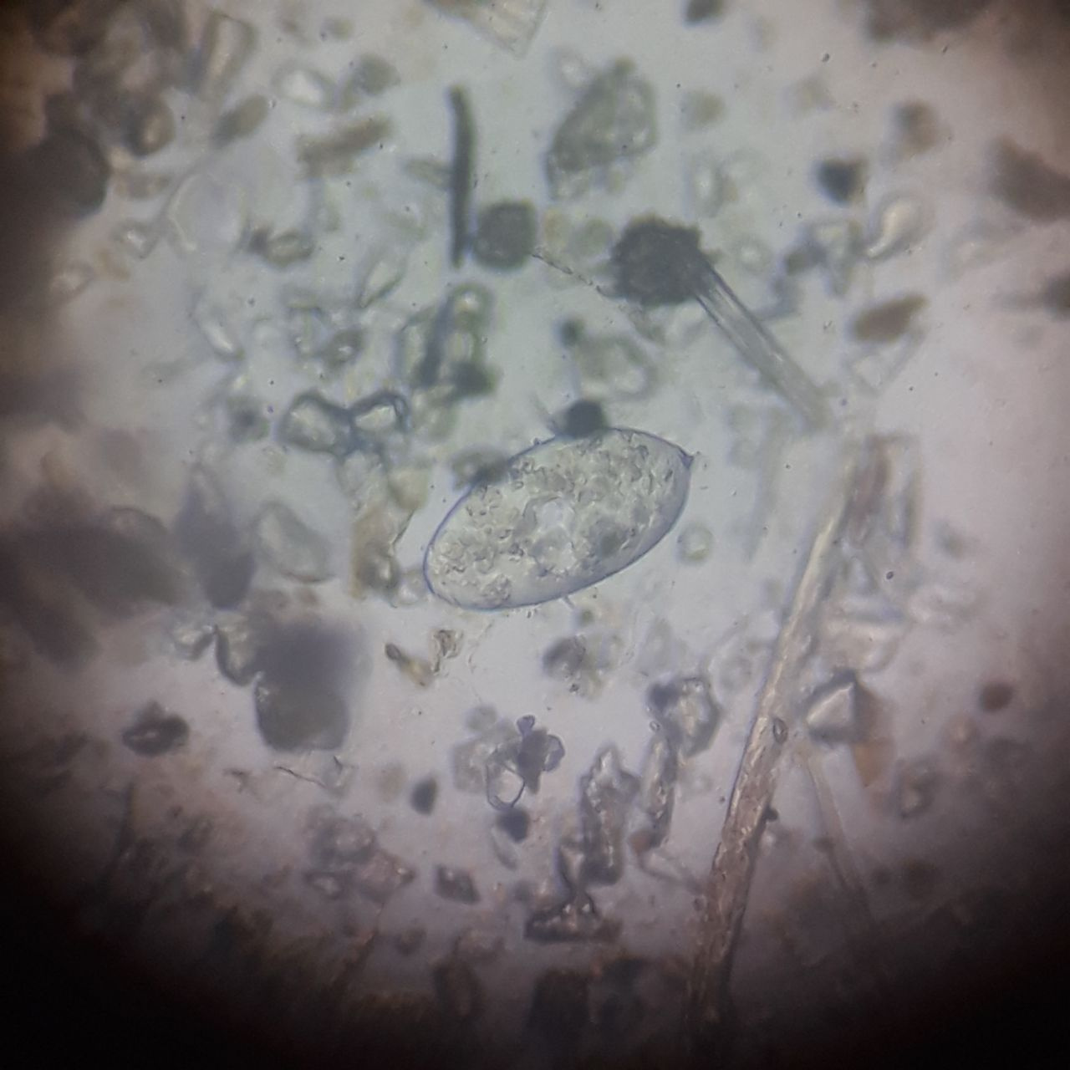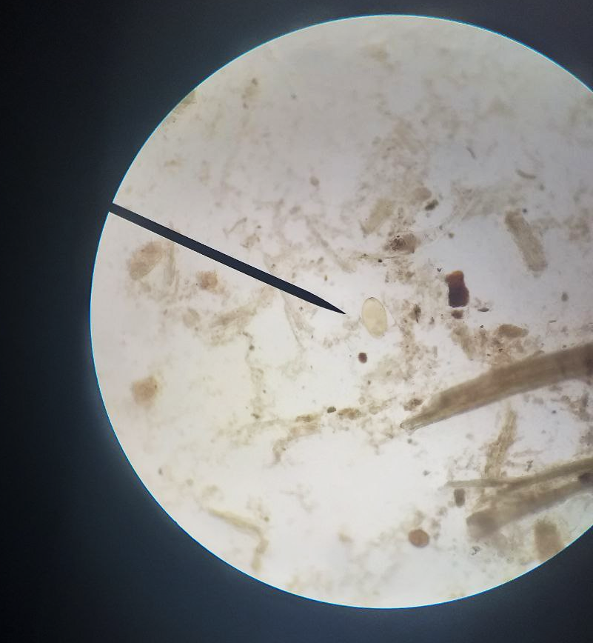
Paramphistomum egg Fasciola egg

Supplementary file 2: Economic Impact Assessment question on Live Sheep (10 Questions)
- Have your sheep been affected by parasitic infections (e.g., worms) in the past 12 months?
☐ Yes ☐ No
- What clinical or production problems have you observed in infected sheep? (Multiple answers allowed)
☐ Weight loss ☐ Poor growth ☐ Weakness ☐ Diarrhea ☐ Reduced fertility
- Approximately how many sheep were affected in the last year?
☐ 1–5 ☐ 6–10 ☐ >10
- Do infected sheep show reduced body weight compared to healthy ones?
☐ Yes ☐ No
- If yes, estimate the average weight loss per sheep (kg):
☐ <2 kg ☐ 2–5 kg ☐ >5 kg
- Does parasitic infection reduce the market price of your sheep?
☐ Yes ☐ No
- If yes, by how much does the selling price decrease per sheep (ETB)?
☐ <200 ☐ 200–500 ☐ >500
- Have you experienced sheep mortality associated with parasitic infections?
☐ Yes ☐ No
- If yes, how many sheep died due to parasitic infections in the past year?
☐ 1–2 ☐ 3–5 ☐ >5
- What is your average annual cost for treating parasitic infections (drugs and services) per sheep?
☐ <50 ETB ☐ 50–100 ETB ☐ >100 ETB

B. Parasite Control Practices (10 Questions)
- Do you practice deworming of your sheep?
☐ Yes ☐ No
- How often do you deworm your sheep?
☐ Every 3 months ☐ Every 6 months ☐ Once a year ☐ Irregular
- Who administers the deworming drugs?
☐ Veterinarian ☐ Animal health worker ☐ Self
- What type of drugs do you commonly use?
☐ Albendazole ☐ Ivermectin ☐ Other __________
- How do you determine the dose of the drug?
☐ By weight ☐ Guessing ☐ Following advice
- Where do you obtain veterinary drugs?
☐ Veterinary clinic ☐ Private shop ☐ Market
- Do you rotate (change) deworming drugs regularly?
☐ Yes ☐ No
- What grazing system do you practice?
☐ Communal grazing ☐ Private grazing ☐ Cut-and-carry
- Do you separate sick animals from healthy ones?
☐ Yes ☐ No
- Do you have access to veterinary services?
☐ Regular ☐ Occasional ☐ None

