Supplementary Materials
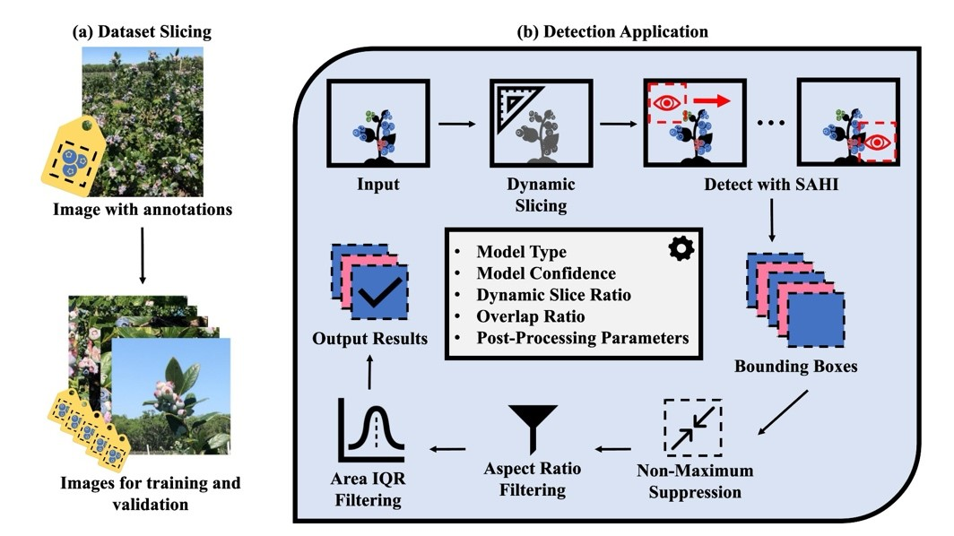
Figure S1: (a) Creation of the sliced dataset from full-size photos using SAHI. (b) Diagram of the blueberry detection pipeline. The detection application contains the implementation of the proposed detection pipeline, in which a YOLOv8 network trained on the dataset sliced using SAHI is then deployed within the pipeline alongside initialized parameters. This includes the type and confidence of model, the dynamic slice ratio, image overlap ratio, and post-processing settings for the detection results.

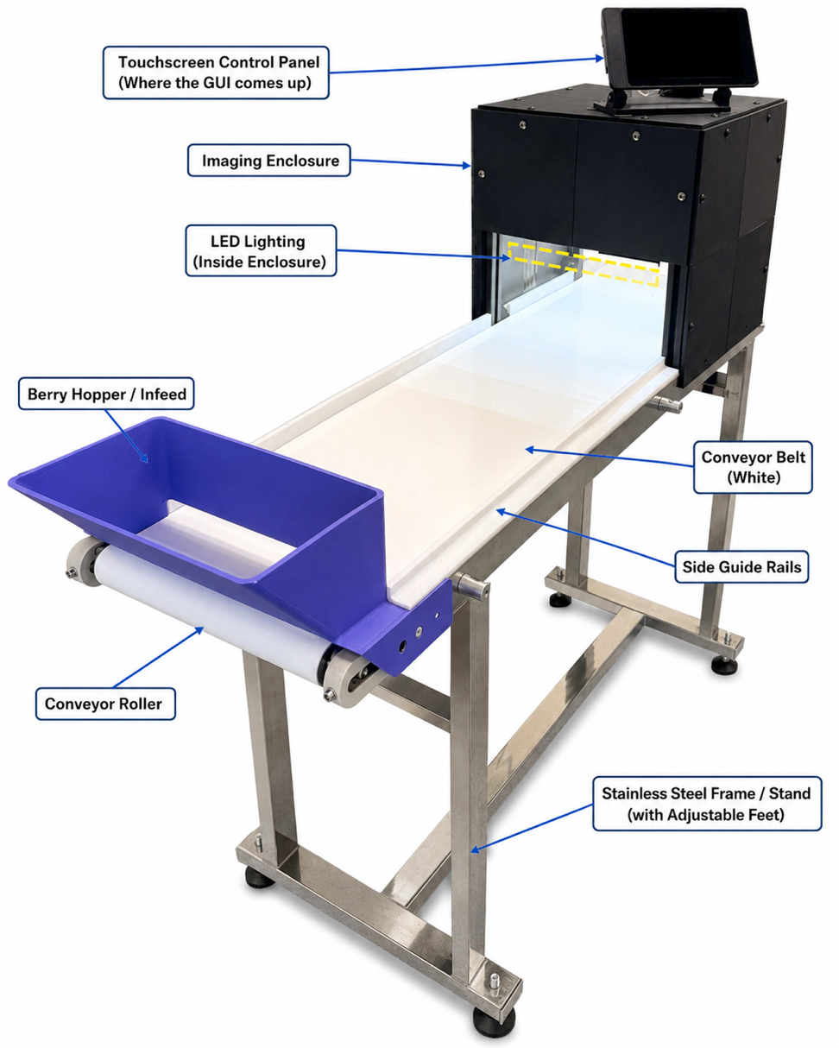
Fig S2: In-house built conveyor system for detecting, classifying and counting immature and mature berries
A conveyor-based phenotyping system was developed for automated blueberry detection and counting. The system consists of a berry segregation unit positioned at the beginning of the conveyor to distribute blueberries uniformly before imaging. A white conveyor belt was selected to create a high-contrast background. The conveyor operates at a constant speed to ensure stable berry motion and consistent image acquisition under controlled conditions. A custom graphical user interface (GUI) was developed to monitor and control the counting process in real time. The GUI was designed to distinguish and count ripe and unripe blueberries independently as they moved along the conveyor. The detection framework was implemented using the YOLO5n object detection model operating on live video streams.
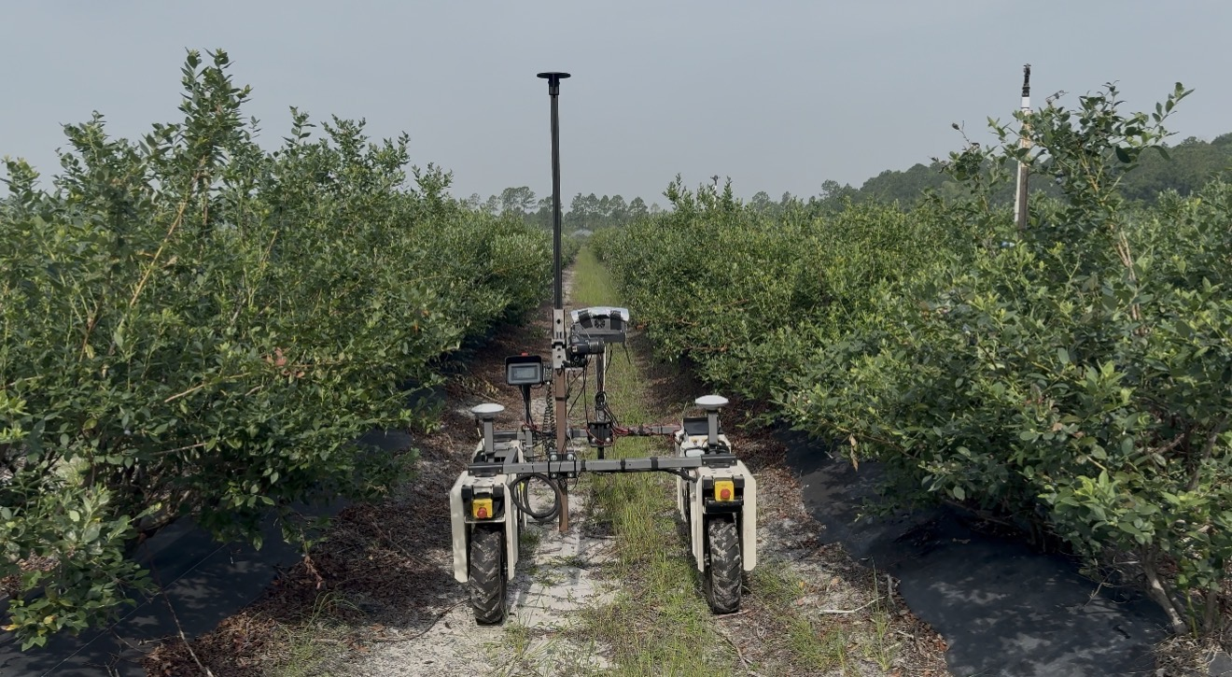
Fig S3: Farm NG Amiga rover mounted with Canon EOS Rebel T6 taking blueberry plant pictures autonomously, approximately 170 cm from the plants

