Supplementary Information

Laser Induced Graphene (LIG) antenna on Kapton
LIG antennas were fabricated on 50 µm thick Kapton sheets and characterized using Scanning Electron Microscope (SEM) and Raman spectroscopy. Figure S1 reveals the porous surface of the LIG patterns. The Raman spectrum shows intensity peaks for the D, G, and 2D bands characteristic of LIG. The intensity ratios I(D)/I(G) and I(2D)/I(G) provide insights into the carbon structure. A higher I(D)/I(G) ratio indicates a greater degree of structural defects, while a higher I(2D)/I(G) ratio suggests a larger number of graphene layers and improved quality. The measured I(2D)/I(G) ratio is 0.78, which is above the threshold of 0.5, indicating good-quality laser-induced graphene (LIG) formation.
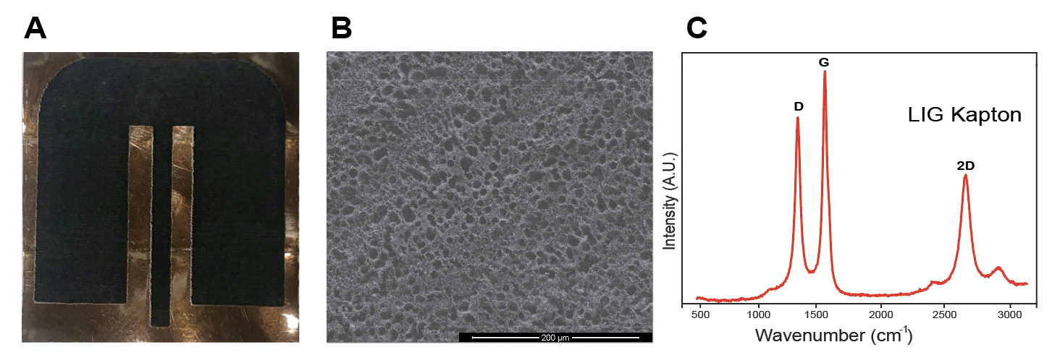
Figure S1 LIG on Kapton antenna 2 cm x 2 cm with 0.4 cm edge curving. (A) Optical image (B) SEM image (C) Raman spectra

Performance of LIG antenna on Kapton
LIG on Kapton antenna with a 2 cm x 2 cm footprint and edge curving of 0.4 cm was experimentally measured using VNA. The S11 (return loss) parameters match both in simulation and experimental. The obtained simulated frequency is 4.56 GHz with a return loss of -28.69 dB. Return loss demonstrates the amount of power that is reflected compared to the transmitted power. Our simulated results tell that 99.35% of the power is transmitted, demonstrating a very low loss percentage. Even though our antenna is fabricated on a very thin substrate of 50 um, our simulated gain results are 3.22 dB, as this value is positive, it shows that our antenna can effectively transmit a high amount of power. Measured results are consistent showing antenna performance at 4.5 GHz frequency with a return loss less than -37 dB.

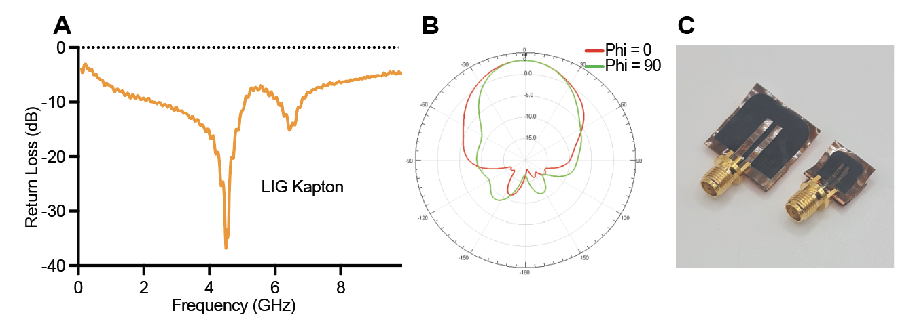
Figure S2 (A) Measured return loss (S₁₁) for 2 cm x 2 cm antenna with 0.4 cm curved edges (B) Simulated results for radiation patterns (C) LIG on Kapton antennas of 2 cm x 2 cm and 1 cm x 1 cm with 0.4 cm edge curving

