Biocontrol potential of the phloridin-degrading Bacillus licheniformis XNRB-3 against apple replant disease
Yanan Duan ¹, Lei Zhao¹, Weitao Jiang¹, Ran Chen¹, Rong Zhang¹, Xuesen Chen¹, Chengmiao Yin^{1*}, and Zhiquan Mao^{1*}
¹National Key Laboratory of Crop Biology, College of Horticulture Science and Engineering, Shandong Agricultural University, Shandong 271018, PR China
*Correspondence:
Zhiquan Mao, Email: mzhiquan@sdau.edu.cn
Chengmiao Yin, E-mail: yinchengmiao@163.com

Supplementary information
Figure S1: Optimal results of single-factor fermentation conditions. A: Effect of inoculation amount (3%-10%) on the growth of strain XNRB-3 under different time conditions. The abscissa is the fermentation time, the left ordinate is the OD600 value of the fermentation broth, and the right ordinate is the number of bacteria. B: Growth curve of strain XNRB-3 after optimization of fermentation conditions. The abscissa was the fermentation time, the ordinate was the OD₆₀₀ value of the fermentation broth. C-I:The growth and antibacterial effect of strain XNRB-3 under single-factor fermentation. Using Fusarium oxysporum as the indicator bacteria to determine the inhibition rate. The abscissa is the fermentation condition, the left ordinate is the antibacterial rate, and the right ordinate is the OD₆₀₀ value of the fermentation broth. Lowercase letters above the columns indicate a significant difference at p < 0.05. Values are mean ± SD.

Figure S2: The isolated strain XNRB-3 was cultured on LB agar at 37 ℃ for 24 h (A) and the cellular morphological character were observed by Nikon fluorescence microscope BX-51 (B-C) and SU-8010 scanning electron microscope (D-I).
Note: A Single colony morphology; B-C The shape and size of the bacteria and spores, bar=100×/1.30 oil; D-I The shape and size of the bacteria, D bar=11.7 mm×5.00 SE (L), 10 μm. E bar=11.8 mm×5.00 k SE (L), 10 μm. G, H bar=11.8 mm×20.0 k SE (L), 2 μm. F,I bar=11.7 mm×20.0 k SE (L), 2 μm.

Figure S3: The ML consensus tree inferred from the combined 16S rDNA, gyrA, gyrB, and rpoB sequence alignment. Support for each branch in the inferred tree was evaluated using 1000 bootstrap replications. Support values (ML bootstrap and posterior probability values) are indicated at the branches. The scale bar indicates 0.4 expected changes per site. Clade numbers and Latin name are provided on the right of the tree and these are used for reference in the treatment of the species. The combined sequence dataset included 35 ingroup taxa, with Paenibacillus polymyxa (BLB267) as the outgroup taxon. Strain XNRB-3 was indicated in bold and red.

Figure S4: Amplification products of the lipopeptide genes. M: DL2000 Marker.

Figure S5: Total ion chromatogram of extracellular metabolites. The abscissa represents the peak time, and the ordinate represents the peak height. The figure is marked with retention time. After detection, select the Area% >0.62 and Retention index RI> 700 to mark.
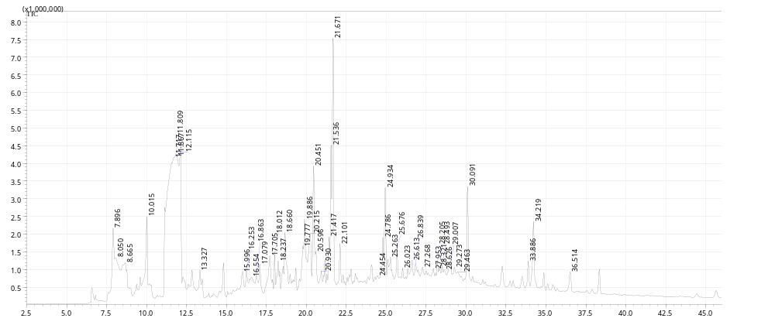

Figure S6: Mass spectrum of the representative compounds. Mass spectrum of the compound obtained by GC-MS analysis was compared with the NIST17 spectral database. If the ion fragment size and height similarity of the mass spectrum are above 95, the molecular formula, molecular weight and molecular structure of the substance can be determined. The abscissa represents the mass of the ion; the ordinate represents the intensity of the ion current. The left side was the mass spectrum of the compound, and the right side was the result after comparison with NIST17 spectral database. A 2,3-Butanediol (GC RT 11.867 min); B 1,2-Benzenedicarboxylic acid, bis(1-methylethyl) ester (RT 28.205 min); C 2,4-Di-tert-butylphenol (RT 25.263 min); D Butanedioic acid, monomethyl ester (RT 17.705 min); E .alpha.-Bisabolol (RT 26.613 min); F Acetoin (RT 10.015 min); G Dibutyl phthalate (RT 34.219 min); H 3-Nonen-2-one (RT 19.886 min); I Benzoic acid, 3,4-dimethyl-, methyl ester (RT 21.671 min).

Figure S7: A: Microscopic observation of the longitudinal section of the plant root. Fusarium verticillioides and Fusarium solani: The roots of the plants were soaked with the conidia suspension for 12h. C-E, H, L, N, P Dense mycelium appeared in the epidermis of the root system, and the epidermal and cortical cells appeared ruptured, shedding and deformed (arrows), and the cells were arranged irregularly. M Cauliflower-like structure appeared in the infected root areas (arrows). A, F, K, O The conidia and hyphae of Fusarium appeared in the cortex and vascular column. B, I, J Viscous substances and starch granules appear in the cortex and vascular columns, which are densely accumulated on the cell wall. B: Population sizes of strain XNRB-3 recovered from root tissues of Malus hupeheusis Rehd. Seedlings after root-dip inoculation with bacterial suspensions. Lowercase letters above the columns indicate a significant difference at p < 0.05. Values are mean ± SD. C: Effect of strain XNRB-3 on the number of Fusarium in the rhizosphere soil of plants at 7, 21, and 35 days after transplanting. CK: control, inoculated with Fusarium, XNRB-3: inoculated with Fusarium and the strain XNRB-3. “*” above the columns indicate a significant difference at p < 0.05.

Figure S8: Effect of different treatments on seedling biomass of Malus hupehensis Rehd. Seedlings, including plant height, ground diameter, fresh weight, and dry weight. Lowercase letters above the columns indicate a significant difference at p < 0.05. Values are mean ± SD. CK1 25-year-old orchard soil, CK2 Methyl bromide fumigation, T1 Fertilizer carrier, T2 XNRB-3 bacterial fertilizer.

Figure S9: Effects of different treatments on the physical and chemical properties of rhizosphere soil in October 2021, including organic matter (%), total nitrogen (%), total phosphorus (g kg⁻¹), total potassium (g kg⁻¹), available potassium (mg kg⁻¹), available phosphorus (mg kg⁻¹), NH₄⁺-N (mg kg⁻¹), nitrate nitrogen (mg kg⁻¹), and soil pH. Lowercase letters above the columns indicate a significant difference at p < 0.05. Values are mean ± SD. CK1 25-year-old orchard soil, CK2 Methyl bromide fumigation, T1 Fertilizer carrier, T2 XNRB-3 bacterial fertilizer.

