Supplementary Figures

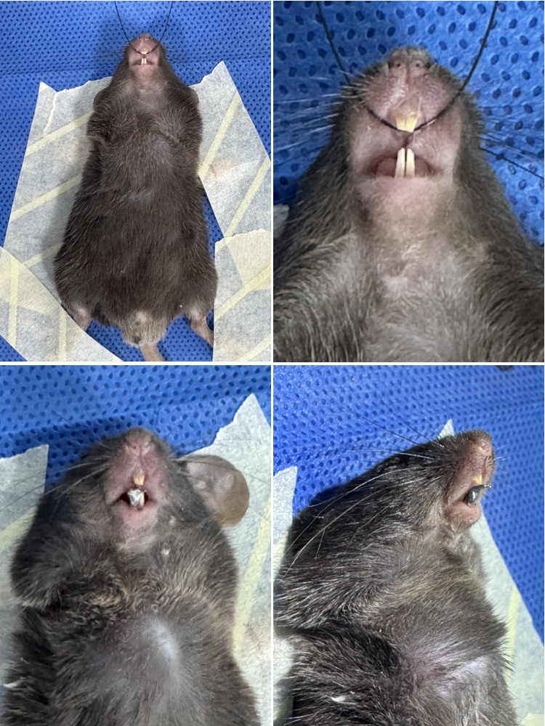
Fig. S1: Establishment of UAC model.

Fig. S2: Weights of mice at BL, day 7, and 10. Data were expressed as means ± SD. (n=4; ns, P > 0.05; two-tailed unpaired Student’s t-test).

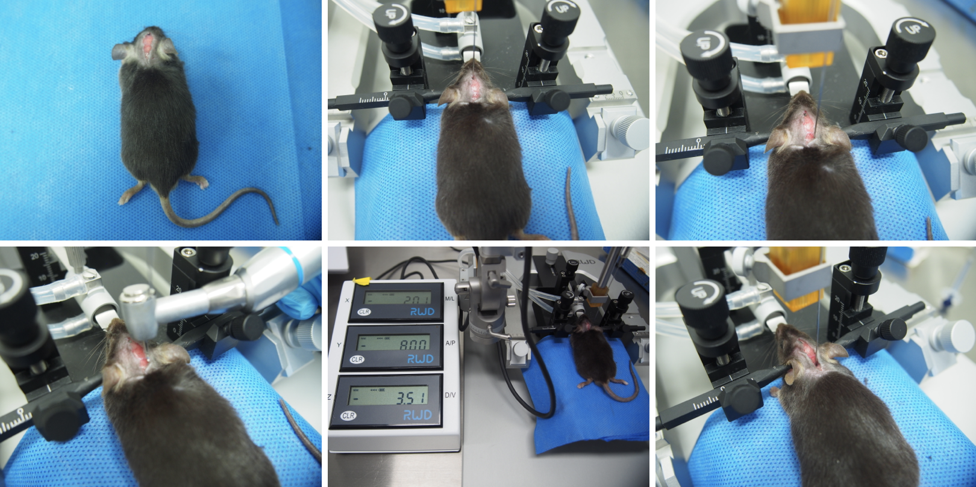
Fig. S3: Stereotaxic viral delivery into the SpV of mice.

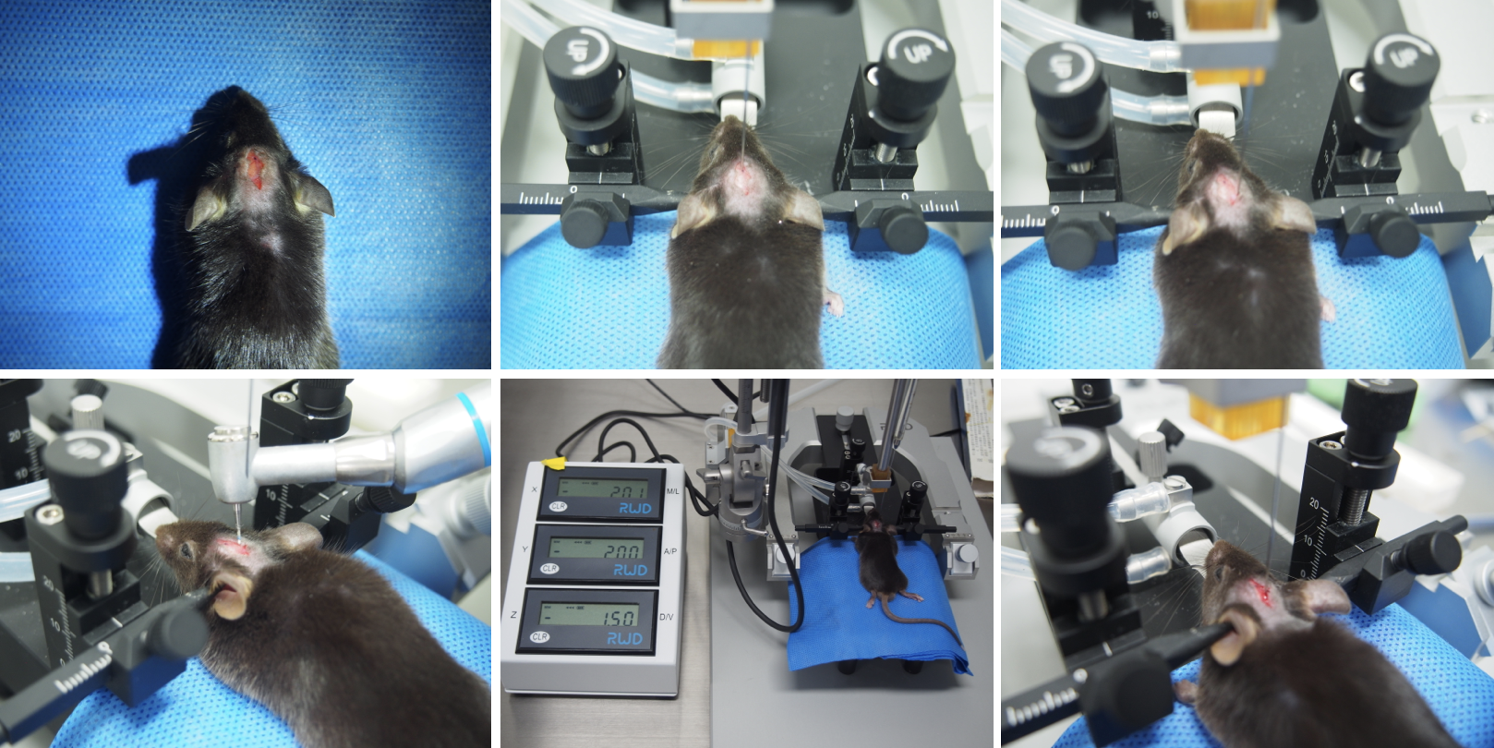
Fig. S4: Stereotaxic viral delivery into the HPC of mice.

Fig. S5: HWT in the MM region of male mice at BL and day 10 post-modeling. Data were expressed as means ± SD. (n=6; ns, P > 0.05 for two groups at BL; **P < 0.01 vs. CTL in Day10; ***P < 0.001 vs. UAC at BL; two-tailed unpaired Student’s t-test).

Fig. S6: HWT in the TMJ region of male mice at BL and day 10 post-modeling. Data were expressed as means ± SD. (n=6; ns, P > 0.05 for two groups at BL; ***P < 0.001 vs. CTL in Day10; ***P < 0.001 vs. UAC at BL; two-tailed unpaired Student’s t-test).

Fig. S7: HWT in the MM region of female mice at BL and day 10 post-modeling. Data were expressed as means ± SD. (n=6; ns, P > 0.05 for two groups at BL; ***P < 0.001 vs. CTL in Day10; **P < 0.01 vs. UAC at BL; two-tailed unpaired Student’s t-test).

Fig. S8: HWT in the TMJ region of female mice at BL and day 10 post-modeling. Data were expressed as means ± SD. (n=6; ns, P > 0.05 for two groups at BL; ***P < 0.001 vs. CTL in Day10; ***P < 0.001 vs. UAC at BL; two-tailed unpaired Student’s t-test).

Fig. S9: Immobile time of female mice in CTL and UAC groups at BL, day 7, and 10 in FST. Data were expressed as means ± SD. (n=4; ns, P > 0.05 at BL; *P < 0.05 at day 7 and 10; two-tailed unpaired Student’s t-test).

Fig. S10: Sucrose preference index of female mice in CTL and UAC groups at BL, day 7, and 10 in SPT. Data were expressed as means ± SD. (n=4; ns, P > 0.05 at BL; **P < 0.01 at day 7; *P < 0.05 at day 10; two-tailed unpaired Student’s t-test).

Fig. S11: Center cumulative duration of female mice in CTL and UAC groups at BL, day 7, and 10 in OFT. Data were expressed as means ± SD. (n=4; ns, P > 0.05 at BL; **P < 0.01 at day 7 and 10; two-tailed unpaired Student’s t-test).

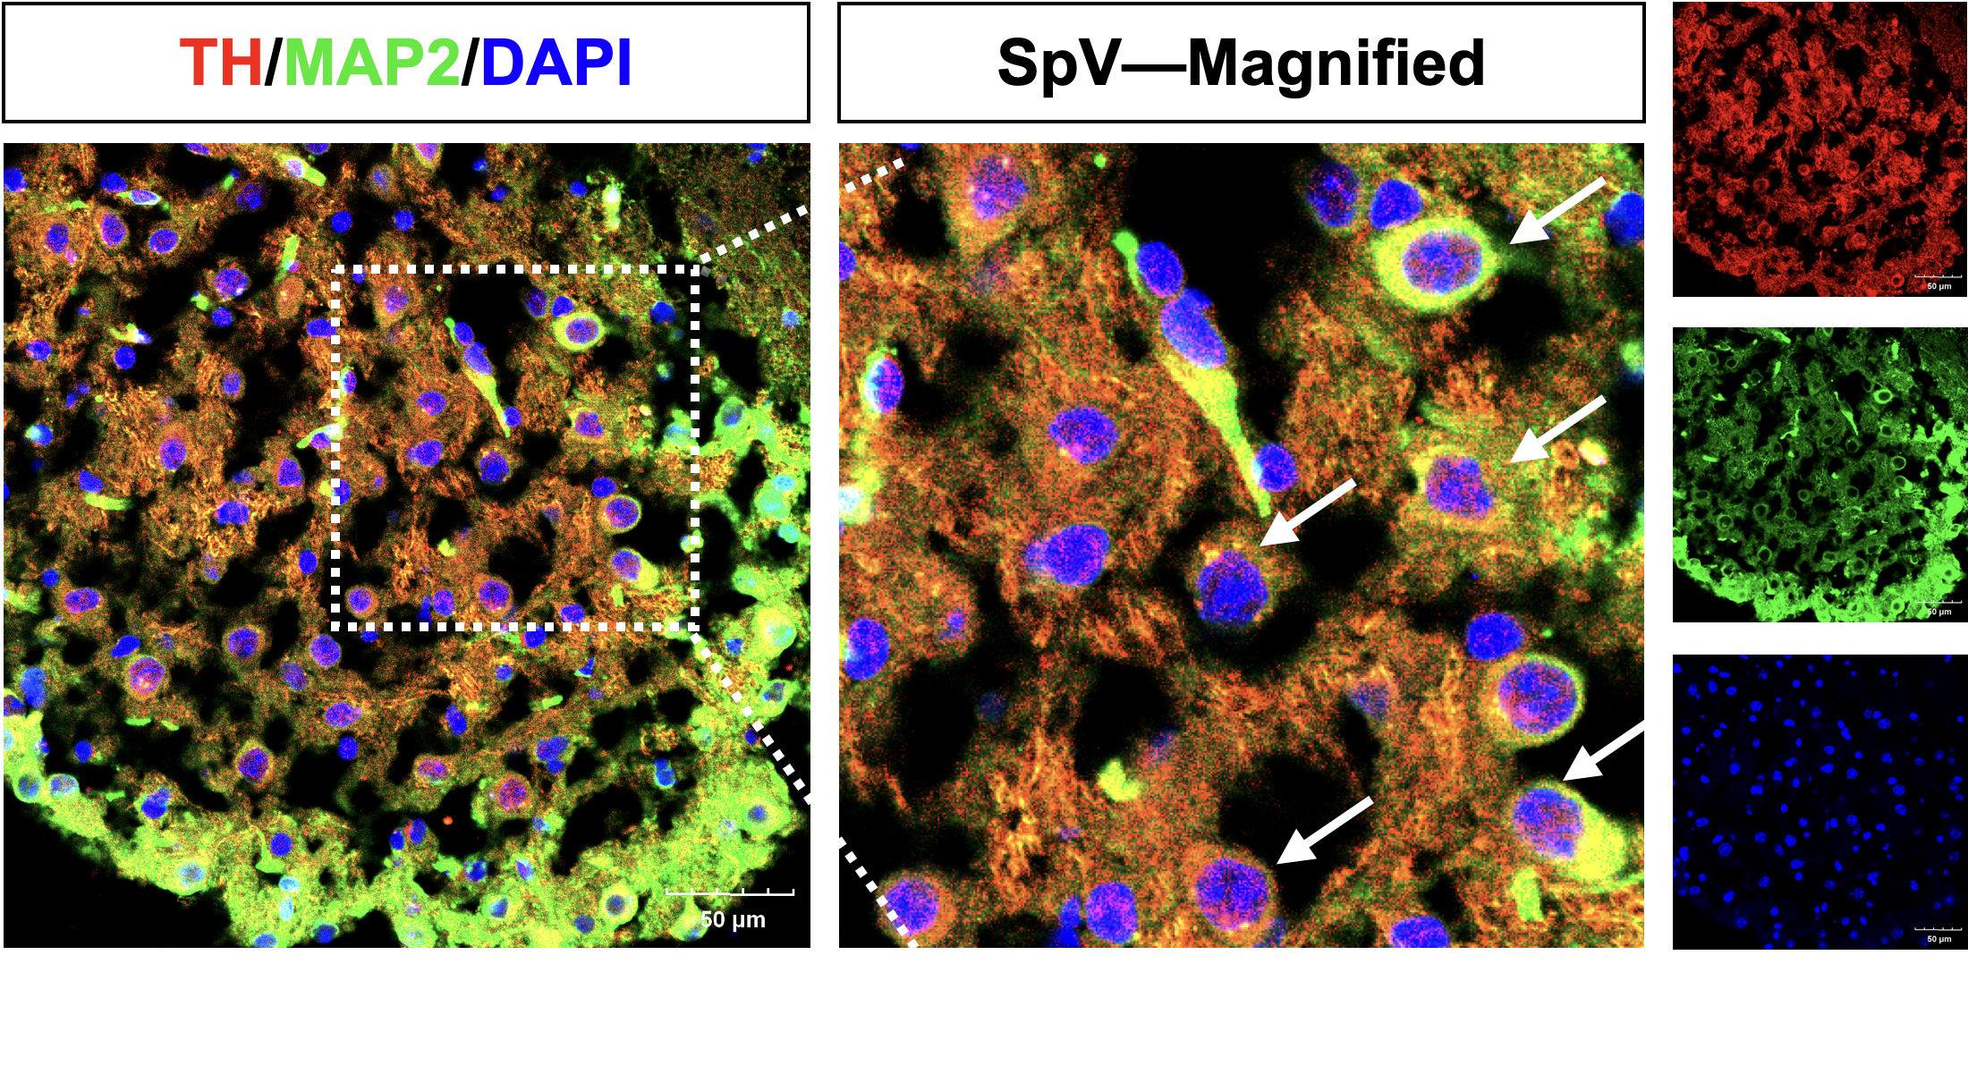Fig. S12: TH and MAP2 co-localized on SpV neurons. (red: TH; green: MAP2; blue: DAPI). Scale bars: 50 μm.

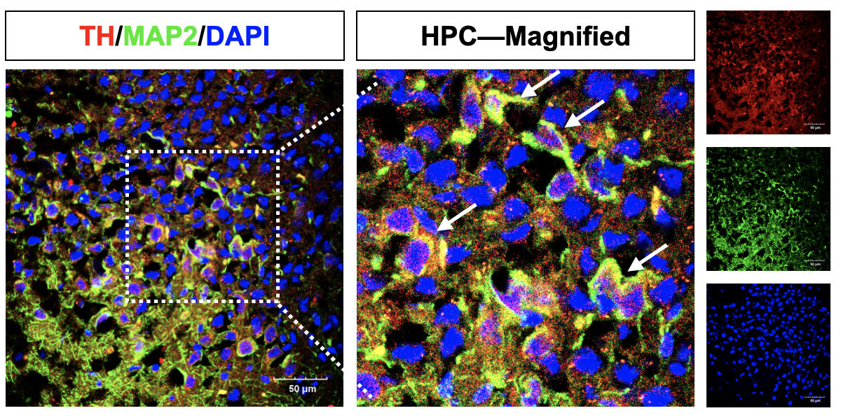
Fig. S13: TH and MAP2 co-localized on HPC neurons. (red: TH; green: MAP2; blue: DAPI). Scale bars: 50 μm.

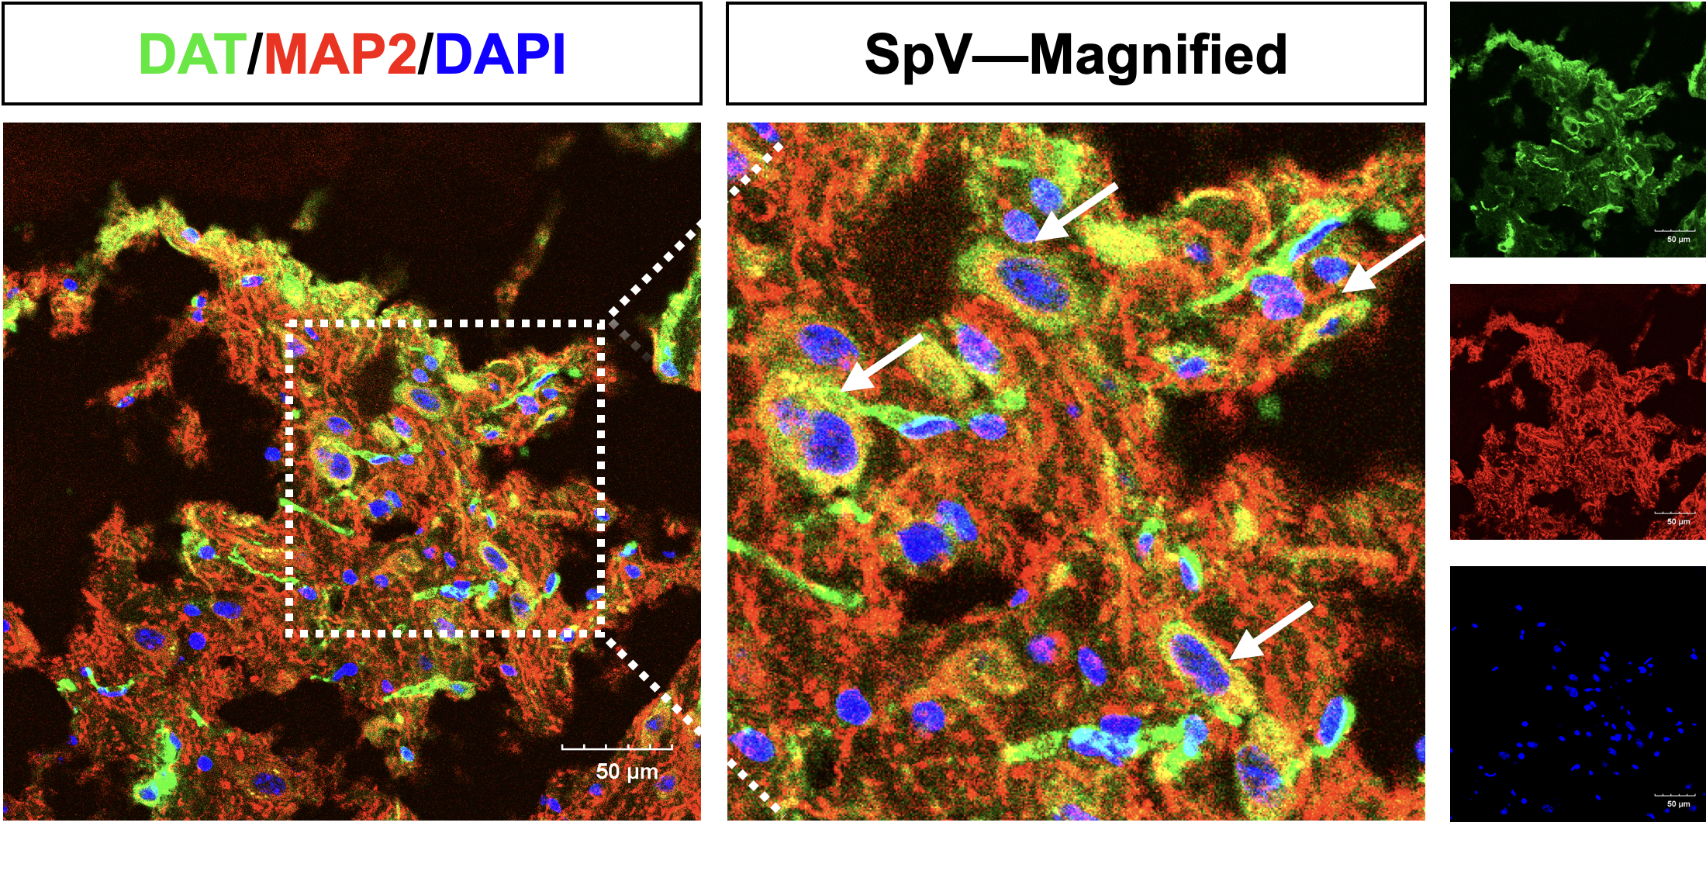
Fig. S14: DAT and MAP2 co-localized on SpV neurons. (green: DAT; red: MAP2; blue: DAPI). Scale bars: 50 μm.

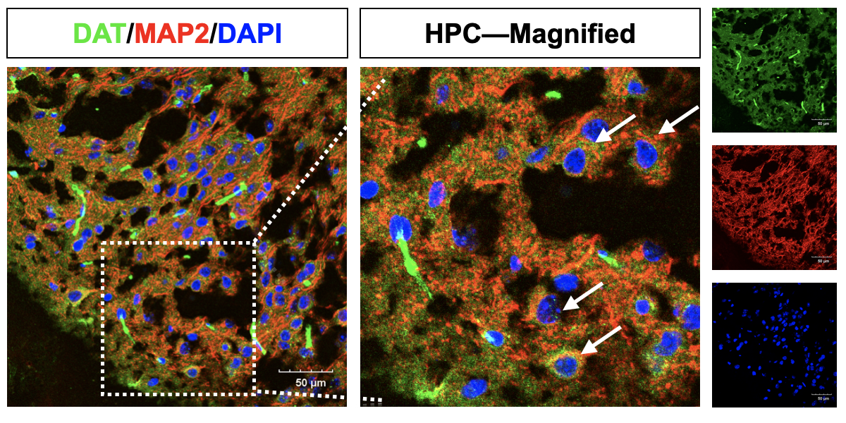
Fig. S15: DAT and MAP2 co-localized on HPC neurons. (green: DAT; red: MAP2; blue: DAPI). Scale bars: 50 μm.

Fig. S16: Female mice in CTL and UAC groups showed a significant difference in DRD2 mRNA. Data were expressed as means ± SD. (n=4; ***P < 0.001; two-tailed unpaired Student’s t-test).

Fig. S17: Female mice in CTL and UAC groups presented a significant difference in LEPR mRNA. Data were expressed as means ± SD. (n=4; ***P < 0.001; two-tailed unpaired Student’s t-test).

Fig. S18: CCK-8 viability assays identified an optimal LV-DRD2 MOI of 5. Data were expressed as means ± SD. (n=4; ns P > 0.05; two-tailed unpaired Student’s t-test).

Fig. S19: RT-qPCR showed LEPR mRNA levels following pathway-specific inhibitors administration. (n=4; ***P < 0.001; ** P < 0.01; *P < 0.05; two-tailed unpaired Student’s t-test).

