ADDITIONAL FILE 1
Assessing The Feasibility and Acceptability of Ecological Momentary Assessment in Measuring the Everyday Experiences of Young Adults with Tuberous Sclerosis Complex
Table A1. An Adapted STROBE Checklist for Reporting EMA Studies (CREMAS) (Liao et al., 2016).
Topic | Item # | Checklist item | Page number reported
 | 1 | Include ecological momentary assessment/experience sample in title and key words | 1
Rationale | 2 | Briefly introduce the concept of EMA and provide reasons for utilizing EMA for this study or topic of interests (eg, to examine time-varying predictors of unhealthy eating occasions in children’s daily lives) | 4
Training | 3 | Indicate if, and by what methods, training of participants for EMA protocol was used | Supplementary materials
Technology | 4 | Describe what technology, if any, was used. Include the following information: device (eg, mobile phone, portable computer), model (eg, Nexus 4, iPod), operating system (eg, Android, Windows), and EMA program name | 10 and Supplementary materials
Wave duration | 5 | State the number of waves for the study (eg, 2 monitoring periods over the course of 1 year) | 10
Monitoring period | 6 | State the number of days each wave of the study lasted, and how many weekdays versus weekend days | 10
Prompting design | 7 | Indicate the prompting strategy used for the study (eg, event-based, interval-based, or a combination of the two). If using interval-based strategy, indicate what type of schedule is used (eg, fixed, random, or hybrid interval) | 10
Prompt frequency | 8 | Intended frequency of prompts per day. Break down by weekdays and weekend days if applicable | 10
Design features | 9 | Describe any design feature to address potential sources of bias (eg, reactivity) or participant burden (eg, EMA questions appearing in different orders) | Supplementary materials
Attrition | 10 | Indicate participant attrition throughout the study; report attrition rates both by monitoring days and waves, if applicable | Figure 2, page 9
Prompt delivery | 11 | Report number of EMA prompts that were planned to be delivered. If possible, also report the number of EMA prompts that were actually received by participants and indicate reasons for why prompts were not sent out (eg, technical issues or participant noncompliance reason such as phone was powered off) | 13
Latency | 12 | Report the amount of time from prompt signal to answering of prompt | NA
Compliance rate | 13 | Report total answered EMA prompts across all subjects and the average number of EMA prompts answered per person. Report compliance rate both by monitoring days and waves, if applicable. Indicate reasons for noncompliance, if known | 13
Missing data | 14 | Report whether EMA compliance is related to demographic or time-varying variables | 14
Limitations | 15 | Discuss limitations of the study, taking into account sources of potential bias when using EMA methods (eg, reactivity, use of technology) | 24
Conclusions | 16 | Provide a general interpretation of results and discuss the benefits of using EMA (eg, improving understanding of daily behaviors) | 26

Table A2 Co-Production Discussions and Decisions in Stage 1.
Meeting | Discussion | Decision
1a – Research and advisory group introduction | What do you need to be involved in the group? | - Email reminders – day before meetings  - PDF of presentation sent  - Email check ins and contact  - Reflection diaries in word format  - Online meetings  - One in-person meeting (workshop)
1a – Research and advisory group introduction | What do you want to be involved in? | - Planning the EMA app  - Piloting the app  - Planning the dissemination documents  - Evaluate the group in an in-person meeting.
1a – Research and advisory group introduction | When and how do you want to be paid? | - After each block  - By bank transfer
1b – Smartphone study introduction | What should we change to the recruitment advert, flowchart, manual, video and PIS? | - Added definition of ‘Smartphone’.  - Added how much money the voucher is worth*  - Change title to Assessing Young “Adults with Tuberous Sclerosis Complex Using Smartphones”
1b – Smartphone study introduction | How should we recruit? | - Social media  - TSA  - Video
2a – EMA training and protocol development | What questions should we ask and how should we ask them? | - Questions to include mood, social experiences, brain functioning (memory and concentrating) and TSC specific (epilepsy and medication).  - Add other option  - Changed wording of “Who are you with?” to “Are you with anything right now?”  - Changed wording of “What time did you go to bed?” to “What time did you go to sleep”  - Picked text colour and size of questions.  - Don’t allow skip  - Multiple choice instead of open questions (apart from miss and medication question)  - Sliding scale not numbers  - Sliding scale for seizure recovery question not yes/no.
2b – EMA protocol development | How can participants personalise the EMA? | - 1 personal question to add  - 2 sound options  - 3 reward symbol options  - 3 reward text options  - 3 notification text options
2b – EMA protocol development | What should the EMA protocol be for the 2-day testing stage (piloting?) | - 4 prompts for the first day, 5 prompts for the second day  - 30-minute reminder  - 60 minutes expires  - Different morning and evening questionnaires
2c – EMA piloting reflections | What should be the final EMA protocol? | - 2 weeks of questionnaires  - 4 prompts a day  - 30-minute reminder  - 60 minutes expires  - Different morning and evening questionnaires  - Add in a question about experience of EMA in evening questionnaire “How did you feel about answering today’s questionnaires?”
3a – Dissemination – participant feedback | How should we show the participants their results after the EMA? | - Line graph and bar graph together to show all the question results  - Pie chart to show the category questions – Who are you with, what are you doing, where you were and wanting to be alone or not.
3b – Dissemination – community | How should we show the TSC community the results of the EMA study? | Who to share with | What to share | How to share
3b – Dissemination – community |  | Young adults with TSC | Videos, social media posts, poster | Social media
3b – Dissemination – community |  | Researchers | Research posters, infographics, conference presentation | Targeted emails, conferences, meetings
3b – Dissemination – community |  | Carers/families/key support persons of young adults with TSC | Videos, social media posts, poster | Informal talk via TSA, social media posts
3b – Dissemination – community |  | Charities | Posters, blogs, social media | Social media, targeted emails
*This was later removed to reduce the risk of bots signing up for the study.
Table A3. GRIPP2 short form
Section and topic | Item | Reported on page No
1: Aim | Report the aim of PPI in the study | 8
2: Methods | Provide a clear description of the methods used for PPI in the study | 8
3: Study results | Outcomes—Report the results of PPI in the study, including both positive and negative outcomes | Supplementary Materials
4: Discussion and conclusions | Outcomes—Comment on the extent to which PPI influenced the study overall. Describe positive and negative effects | 26-27
5: Reflections/critical perspective | Comment critically on the study, reflecting on the things that went well and those that did not, so others can learn from this experience | 27
PPI=patient and public involvement

Process
Screening - TSC
Participants interested in the study followed a link or QR code to a Qualtrics form, which gathered the participants' full name and contact information. Participants were then emailed by the researcher with the full study information sheet (and an easy-read version), and a screening telephone call was organised. If participants did not respond to the email, they were telephoned by the researcher twice before marking them as “could not contact”. At the screening call, the researcher reviewed the study information sheet, eligibility criteria and the capacity checklist, and then participants were allowed to ask questions. If participants were eligible, a video call was organised to complete the reading test. At the reading test video call, the words were shared on the screen and participants completed the test. Eligible participants were given one week to inform the researcher of their decision to participate or not. Participants then completed an online consent form and were asked if they wanted a chosen Key Support Person (KSP) to support them during the study. KSP’s were defined as parents, carers (informal and formal), partners or other family members. This was offered to increase recruitment, as individuals with TSC are more likely to experience social, intellectual or communication difficulties that may prevent them from accessing research study activities. If participants indicated they wanted a KSP to support them, the KSP was contacted and consented to act as a ‘KSP non-participant. The KSP non-participants were there only to offer support to the young adult and were not asked about their opinions or experiences. They were asked to consent as the video calls were being recorded. In total four participants with TSC requested a KSP.
Screening – Participants without TSC
Participants interested in the study emailed the research team, who responded with a screening email asking for their age, gender and gender assigned at birth. If they matched a participant with TSC, they were emailed to organise a screening telephone call. If they did not match, they were sent a holding email until a participant with TSC consented to match them or until the recruitment period ended. If participants did not respond to the email, they were emailed by the researcher twice before marking them as “could not contact”. At the screening call, the researcher reviewed the study information sheet and eligibility criteria, then participants were allowed to ask questions. Eligible participants were given one week to inform the researcher of their decision to participate. Participants then completed an online consent form.
Baseline assessments
A video call was then arranged to complete the cognitive assessment. Participants with TSC could complete this in one session (1.5 hours) or two sessions (45 minutes each). Participants without TSC could only choose one session and also completed the TOPFUK at this stage. Once this was completed, participants were sent the baseline questionnaires via a Qualtrics link and were given three weeks to complete them (participants without TSC had two weeks).
Training
Once the baseline questionnaires were completed, the participants were invited to an EMA training session video call. This lasted up to 1 hour. The researcher provided a brief explanation of what EMA is and then guided the participant in downloading the m-Path app on their personal smartphone (Android or IOS) (Mestdagh et al., 2023). Participants were then guided through a practice questionnaire via the app, containing all the potential questions (and shown on the screen simultaneously). Once participants were comfortable with the app, they were asked to decide on their personalisation. This included reward type, notification text, notification sound and an optional personal question. The participants then decided with the researcher on their timing structure (when they usually wake up, go to sleep, and any standing commitments to be avoided, e.g., religious commitments). Once the training was completed, the participants were also sent a manual containing all the details from the training, in case they required support during the two weeks.
EMA Protocol
Participants were emailed to confirm the day before the planned two-week start date. They were then emailed the day after the start date to check that there were no technical difficulties and to answer any final questions. Participants were then emailed the day after the end date to confirm their finish and to organise the post-interview. During the two weeks, participants could contact the researcher via email if they had any difficulties or questions.
EMA questions were sent through the m-Path smartphone app. As per the advisors' decisions (see Appendix, Table A2), participants were prompted with a notification four times a day, semi-randomised over a two-hour block with at least one hour between each notification over a maximum 14-hour block. Participants were sent a reminder notification 30 minutes after the initial prompt, and the questionnaire became unavailable 60 minutes after the first notification. This timeframe was decided by the advisory group to reduce participant burden. The questionnaire included up to 29 questions, depending on branching and time of day notification. All questionnaires contained items assessing mood (e.g., “How happy do you feel right now?”), context (e.g., “What are you doing right now?”), TSC symptoms (e.g., “Have you had a seizure since the last questionnaire?”), subjective cognition (e.g., “Have you had a memory problem since the last questionnaire?”), social context, e.g., If you were with others “Would you prefer to be alone?”) and subjective feasibility (e.g., “Why did you miss the last questionnaire?”). In the morning questionnaire, three extra items were asked regarding the previous night's sleep (e.g., “How well did you sleep last night), and the evening questionnaire asked two questions on medication and the impact of EMA on the day (“How did you feel about answering today’s questionnaires”). The mood questions were chosen based on the Positive and Negative Affect Scale (PANAS) (Crawford & Henry, 2004) which has been extensively used in previous EMA studies (Hall et al., 2021) and has recently been proven to detect within and between-person change (Haney et al., 2023). The other questions were based on previous EMA literature and TSC-specific questions designed by the advisory group (see Chapter 5). The Flesch-Kincaid grade level for the EMA questionnaires was 1.5 or equal to a 6–7-year-old expected reading ability. See Appendix, Table A4 for full description of the EMA questionnaires and Figure A1 for examples of question modes. The EMA protocol lasted two weeks (14 days).
Post-EMA
Once the two weeks were completed, participants with TSC completed a post-study usability questionnaire, debrief survey and a post-study interview via video call. They were asked questions about their experience of the EMA. The interviews were semi-structured using a topic guide (See Appendix) and adapted from a previous qualitative study (Fifield et al., 2025) (in review). In the interviews participants had the option to see some of their results from the EMA. This included one line graph consisting of all EMA questions and five pie charts showing proportion of answers to context questions (What are you doing, where are you and who are you with) and social questions (When you were with others, do you want to be alone and when you are alone, do you want to be with others). These graphs were interactive and were sent to the participants after the interview if requested. See Appendix, Figure A2 to see example participant feedback.
Participants were compensated with a £75 shopping voucher for their time completing the study.
Instruments
Administered at screening
Test of Premorbid Functioning (TOPF) (Wechsler, 2009): an individual assessment of word-reading ability designed to provide an estimate of premorbid cognitive functioning. The participants read aloud 70 single words, and the total score is summed and age corrected. The TOPF total standard scores were used alone, without considering demographic characteristics, to predict cognitive functioning (including a Full-Scale IQ). Participants were required to achieve a predicted FSIQ score of 70 or higher to ensure they could read the questions sent in the EMA and to participate in the study. (Administered at cognitive assessment for participants without TSC).
Administered at baseline
Self-report measures for all participants
Technology use:
The Modified Computer Self-Efficacy (Laver et al., 2012): a ten-item self-report measure used to assess hypothetical self-efficacy in using a EMA app. This scale has been validated in individuals with disabilities (Laver et al., 2012). Minor modifications were made to the wording of the scale (‘Unfamiliar technology’ was changed to ‘smartphone app’). Total scores are summed out of 100 with higher scores indicating greater technology efficacy.
Quality of life:
The MOS 36-Item Short-From Health Survey (SF-36) (Ware Jr & Sherbourne, 1992): a self-report measure used to assess general health. It comprises of 36 items measuring social functioning, role limitations due to physical problems, role limitations due to emotional problems, mental health, energy/fatigue, pain, and general health perception. For each item, scores are coded and transformed on to a scale from 0 (worst possible health state measured by the questionnaire) to 100 (best possible health state). Two standardised summary scores are calculated: the physical component summary (PCS) and the mental health component summary (MCS).
Neurodevelopment:
Social Responsiveness Scale - Second Edition Adult (SRS-2 Adult) (Constantino, 2013): a self-report measure used to assess autism traits. It comprises of 65 items within five subscales: social awareness, social cognition, social communication, social motivation, and restricted interests and repetitive behaviours. Items are rated on a 4-point Likert scale from 0 (not true), to 3 (almost always true). A total score is calculated from summing all items, and total standard scores of 60 or higher are clinically significant, with scores above 75 indicating severe social impairment.
Conner’s Adult ADHD Rating Scales - Short Version (CAARS-Adult) (Conners et al., 2012): a self-report measure used to screen for and assess ADHD traits in individuals aged 18 and older. It comprises 30 items measuring five subscales: Inattention/Memory Problems, Hyperactivity/Restlessness, Impulsivity/Emotional Liability, Problems with Self-Concept and a total ADHD Index. Total standard scores of 60 or higher are clinically significant.
Internalising symptoms:
Beck Anxiety Inventory (BAI) (Beck et al., 1993): a 21-item self-report measure used to assess the severity of anxiety symptoms. Items are rated on a 4-point scale, asking how much the participant has been bothered by each symptom over the past week. All items are summed to calculate a total score, with scores greater than 30 scored as severe.
Beck Depression Inventory- Second edition (BDI-II) (Beck et al., 1996) a 21-item self-report measure used to assess the severity of depression symptoms. Each item has four different statements asking participants to select the option which best represents them. All items are summed to calculate a total score, with scores greater than 29 scored as severe.
Strengths and Difficulties Questionnaire (SDQ) (Goodman, 1997): a self-report measure assessing emotional symptoms. The ‘Emotional’ subscale was used to characterise emotional symptoms in the sample. This subscale consists of five items: item 3 (headaches), item 8 (many worries), item 13 (often unhappy), item 16 (nervous or clingy) and item 24 (many fears). The SDQ has been widely used in children (Goodman et al., 2000) and young adult populations (Brann et al., 2018) and has been used in children and adolescents with ID (Emerson, 2005; Kaptein et al., 2008). For severity, SDQ cut points: Close to average, slightly raised, high and very high were used to categorise scores.
Self-report TSC specific measures for participants with TSC
Tuberous Sclerosis Complex-Associated Neuropsychiatric Disorders Checklist – Self Report (TAND-SQ) (Heunis et al., 2023): a validated self-report screening tool identifying TAND symptoms. It consists of eight sub-sections covering developmental history (question 1), current level of functioning (question 2), behavioural difficulties (question 3), psychiatric disorders (question 4), intellectual ability (question 5), school learning difficulties (question 6), neuropsychological difficulties (question 7), and psychosocial challenges for the individuals with TSC (question 8.1) and their caregivers (question 8.2). Individuals with TSC completing the TAND-SQ on their own behalf do not answer questions 1,2 or 8.2. Items with question 3,6 and 7 are associated with one of the seven TAND Clusters.
Early Childhood Epilepsy Severity Scale (E-chess) (Humphrey et al., 2008): an interview-based questionnaire that quantifies the severity of epilepsy by collecting information on frequency of seizures, number of seizure types, antiseizure medication used, and treatment response. Epilepsy severity was assessed for three time points; Current epilepsy severity (based on the 3 months prior to assessment), Lifetime epilepsy severity (based on the time since birth) and most severe severity (based on the time when epilepsy was reported as most intense).
Cognitive assessment
Wechsler Abbreviated Scale of Intelligence (WASI-II) (Wechsler, 2011): a cognitive assessment used to measure estimated IQ. Participants completed the following subtests: Vocabulary, Similarities, and Matrix Reasoning to determine the 2-Scale Full Scale IQ (FSIQ) and the Verbal Comprehension Index (VCI). Block design was not completed as it could not be done remotely over video call.
Bespoke demographic, medical investigation, and service use questionnaires, based on previous TS 2000 assessments, were also completed by the participants with TSC. The medical investigation questionnaire calculated a total and current TSC symptom score, including brain, renal, cardiac, skin, nervous system and TAND symptoms.
Post EMA
Post-Study System Usability Questionnaire (PSSUQ, Lewis (2002)): a 16-item self-report measure widely used to assess users’ perceived satisfaction of a website, software, system or product at the end of a study. Participants are asked to indicate how satisfied they were with different aspects of the app using a seven-point Likert-type scale ranging from ‘Strongly agree’ 8 (1) to ‘Strongly disagree’ (7). An overall score is calculated by averaging all items, with lower scores indicating better satisfaction. The questionnaire was slightly adapted with wording “the system” changed to “the app”, e.g., “It was simple to use this system” to “It was simple to use this app”.

Table A4. EMA Questions
Question |  |  | Choice responses | Mode
All questionnaires
- What are you doing right now? |  |  | - Working/studying  - Hobbies  - Socialising with family  - Socialising with friends  - Travelling  - Watching/listening to something  - Resting  - Exercising  - Health appointments  - Other | Multiple choice
- Do you like what are you doing right now? |  |  | 0-10  I don’t like it, I don’t mind it, I do like it | Likert scale
- Where are you? |  |  | - Home  - Work/School  - Travelling  - Hobbies  - Other | Multiple choice
- Are you with anyone right now? |  |  | - Family  - Friends  - Work colleagues/classmates  - Acquaintances  - Strangers  - By myself  - Other | Multiple choice
If answer anyone but myself to Q4 | 4a. How do you feel being with these people? |  | 0-10  Not happy, I don’t mind, Happy | Likert scale
If answer anyone but myself to Q4 | 4b. How well do you know these people? |  | 0-10  Not at all, Well, Very well | Likert scale
If answer anyone but myself to Q4 | 4c. Would you prefer to be alone |  | Yes No | Yes/No
If answer myself to Q4 | 4d. Would you prefer to be with others |  | Yes No | Yes/No
- How stressed do you feel right now? |  |  | 0-100 | Smiley
- How happy do you feel right now? |  |  | 0-100 | Smiley
- How angry do you feel right now? |  |  | 0-100 | Smiley
- How confident do you feel right? |  |  | 0-100 | Smiley
- How anxious do you feel right now? |  |  | 0-100 | Smiley
- How excited do you feel right now? |  |  | 0-100 | Smiley
- How tired do you feel right now? |  |  | 0-100 | Smiley
- How relaxed do you feel right now? |  |  | 0-100 | Smiley
- Are you concentrating on what you are doing right now? |  |  | 0-10  I’m not concentration, I am concentrating | Likert scale
- Personalised question
- Have you had any memory problems since the last questionnaire? (If it your first questionnaire please click No) |  |  | Yes No | Yes/No
If answered yes to Q15 |  | 15a. Has this upset you? | 0-10  Not at all, a bit, it’s really upset me | Likert scale
- Have you had a seizure since the last questionnaire? |  |  | - Yes  - No  - Not sure | Multiple choice
If answered yes or not sure to Q16 |  | 16a. How many seizures have you had since the last questionnaire? | - 1  - 2  - 3  - 4+  - Not sure | Multiple choice
 |  | 16b. Have you fully recovered from the seizures? | 0-10  No, a bit, yes | Likert scale
- Did you miss the last questionnaire? |  |  | - Yes  - No  - Not sure | Multiple choice
If answered yes or not sure to Q17 |  | 17a. Why did you miss the questionnaire | Free text box | Free text
Extra morning questions
- How well did you sleep last night? |  |  | 0-100  Not very well, OK, Very well | Likert scale
- What time did you go to sleep? |  |  | Time selection  HH:MM | Time
- What time did you wake up this morning? |  |  | Time selection  HH:MM | Time
Extra evening questions
- What medication have you taken today? |  |  | Free multiple choice text box (answers are saved for next day) | Free text
- How did you feel about answering today’s questionnaires? |  |  | 0-10  I didn’t like it, I didn’t mind it, I liked it | Likert scale
Figure A1. EMA Example Mode of Questions
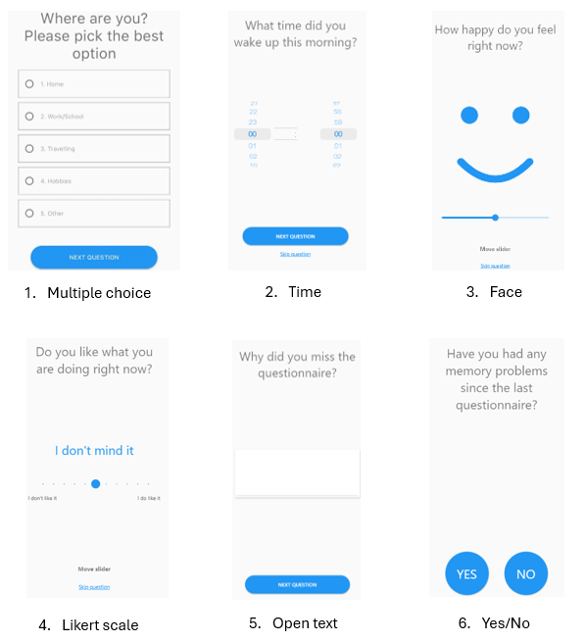
Debrief Interview Survey
Thank you again for taking part in the study. We’re really grateful for your involvement. This conversation is to learn about your experience doing the daily questionnaires so we can understand how to better assess mood in everyday life. No right or wrong answers; looking for honest and open feedback. Conversation will take 30 mins. Tell me if that’s ok, if you need to stop or break.

- Can you tell me how you got along overall with completing the questionnaires every day?

- Was it different to what you expected?

- Over the past 2 weeks were there any changes in your experience of doing the questionnaires?
  - Study schedule timeline.
  - Experience at the start / once familiar / over time / during difficult moments.
  - Explore changes in compliance and motivation.
  - Explore contextual factors across each.

- Can you tell me more about the moments when it was difficult to complete the questionnaires?
  - Barriers.
  - Across contexts appropriate/inappropriate.
  - Factors that impact compliance

- Can you tell me more about the moments when it was easier to do the questionnaires?
  - Exploring what factors supported compliance, motivation.
  - Exploring across contexts / environments / places / people involved.

- Can you tell me how you felt about answering the questionnaires?

- Did you need any support from anyone to answer the questions? If yes, can you tell me a bit more about it?

- Were there any questions you thought were relevant?

- Were there any questions you thought were not relevant?

- What do you think kept you interested in going back to the app and completing the questionnaires?
  - Exploring what specific factors supported compliance, motivation.
  - Exploring across contexts / environments / places / people involved.

- To what extent do you think the M-Path app impacted your ability and interest in doing the questionnaires?
Set-up and support
- How did you feel about the training session?
  - Anything missing?

- How did you feel about the personalisation and rewards?
  - Did it impact your ability or interest in completing the questionnaires

- Did you use the study handbook?
  - Explore when used, why.
  - Explore level to which it was helpful or information was missing.

- Would you have wanted any other support before or during the study?
Long term
- How would you feel about continuing to use the study app for longer?

- What would keep you interested in taking part over that time?

- What would you want to happen with the information, so your answers to the questions?

- How do you feel about your answers or data being used to assess your mood and daily experiences?
Feedback (only if requested feedback)
Here is your end of study report. Talk through feedback.
- What do you think about the feedback I’ve just given you?
  - For each piece of information:
  - Level of understanding.
  - Interest in information.
  - Impact on motivation.

- Can you tell me what you understand this data is telling you? Does this sound right to you?

- If you had this feedback as you went along in the study, would this have affected you answering the questions?

- What else would you be interested in seeing in your feedback?

- To what extent do you feel that knowing about the fact that you would get feedback have an impact on your taking part over the past couple of weeks?
  - Explore impact on compliance and motivation.
  - Explore any feedback expected.

- I’ve only shown you a small amount of the information we’ve got but hypothetical, would you want to use this feedback?
  - How would you want to use it?

- Now having this feedback, would this change your thoughts about continuing to use the app for longer?

- Do you have any final questions or comments for me?

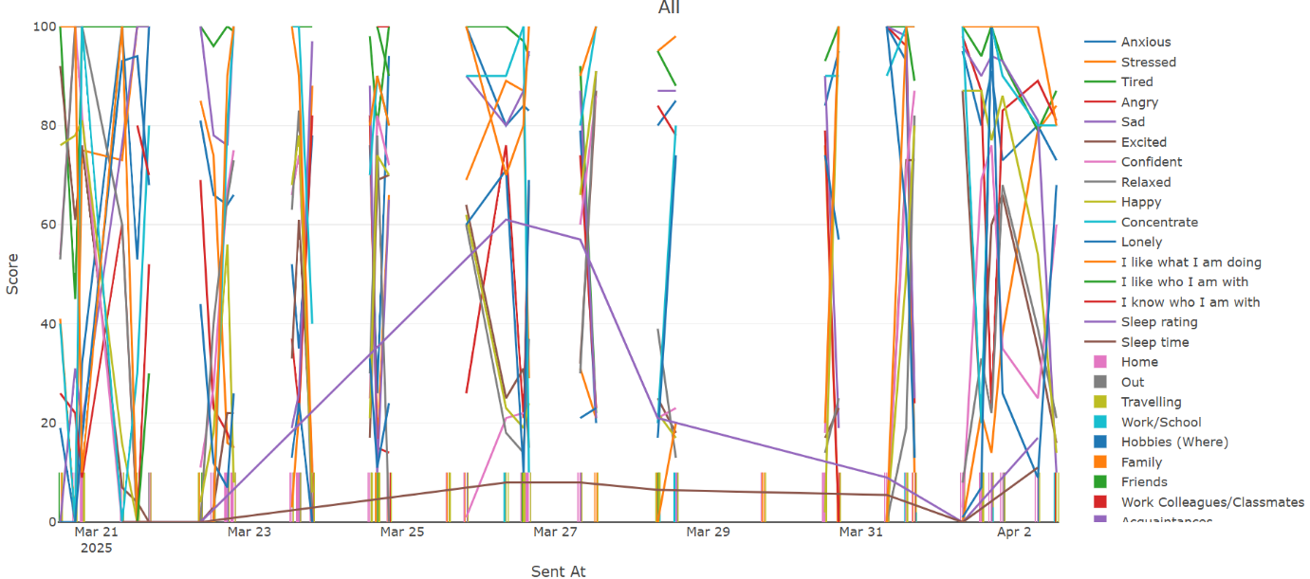
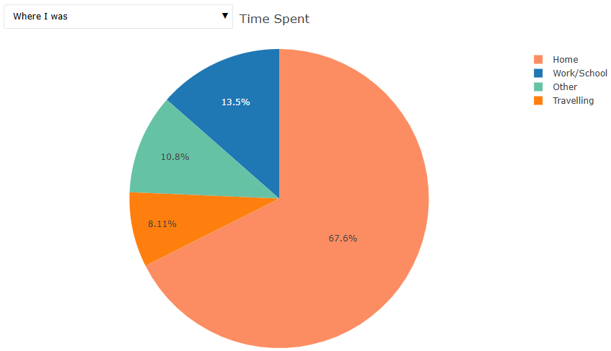
Figure A2 Example of EMA Participant Feedback

Table A5. EMA Post Interview Codebook
EMA Post Interview Codebook
1. EMA Experience
1.1 Convenience or accessibility
1.1.1 Barriers
1.1.1.1 Forgetfulness
1.1.1.2 Lack of support from others
1.1.1.3 Life routine and distractions
1.1.1.4 Poor network coverage or tech difficulties
1.1.1.5 Timings of prompts
1.1.1.6 Not alone
1.1.1.7 Lack of routine or structure
1.1.2 Facilitators
1.1.2.1 Familiarity and knowledge
1.1.2.2 Suitability of current protocol
1.1.2.3 Routine
1.1.2.4 Didn't affect daily life
1.1.2.5 Notifications & reminders
1.1.2.6 Readily available and EASE
1.1.2.7 Tailored or personalised
1.1.2.8 Limited distractions
1.1.2.9 Support from external commitments
Neutral about app
1.2 Health status
1.2.1 Barriers
1.2.1.1 Physical Health
1.2.1.2 Cognitive symptoms
1.2.1.3 Mental Health
1.2.2 Facilitators
1.2.2.1 Mental Health
1.3 Usability
1.3.1 Barriers
1.3.1.1 Repetitiveness
1.3.1.2 Complacent
1.3.1.3 EMA didn't translate real life
1.3.1.4 Technical limitations
1.3.1.5 Too much EMA
1.3.1.6 Questions and answers unsuitable
1.3.1.7 Difficult to explain feelings
1.3.1.8 EMA influence
1.3.1.8.1 EMA feedback influencing feelings
1.3.1.8.2 EMA feedback would have influenced responses
1.3.1.8.3 EMA influencing current feelings
1.3.1.8.4 EMA influencing responses
1.3.1.9 More training needed
1.3.2 Facilitators
1.3.2.1 Training and support sufficient
1.3.2.2 Support from loved ones to use app
1.3.2.3 No support from loved ones needed
1.3.2.4 EMA characteristics
Simple questions
Computer not person
Individual mood questions
Mode of answering
Visual app
1.3.2.5 Impact of EMA
No impact of EMA on current feelings
No impact of feedback
Positive impact of EMA on current feelings
1.3.3 Data privacy
1.4 Perceived utility
1.4.1 Barriers
1.4.1.1 Not relevant questions
1.4.1.2 Previous experience of assessment or intervention
1.4.2 Facilitators
1.4.2.1 Relevancy of app and questions - young adult
1.4.2.2 Previous experience of assessment or intervention
1.4.2.3 Reflective opportunity
1.4.2.4 Enabled positive outcomes
1.4.2.5 Promoting individual personal values
1.4.2.6 Participant effort & perceived competence
1.4.3 No perceived utility
1.5 Motivation
1.5.1 Barriers
1.5.1.1 No impact of manual
1.5.1.2 No impact of personalisation
1.5.1.3 No impact of rewards
1.5.1.4 Reduce burden if used for longer
1.5.2 Facilitators
1.5.2.1 Happy to continue
1.5.2.2 No impact of feedback
1.5.2.3 Extrinsic
Extrinsic motivation (commitment)
Extrinsic motivation (help others via research)
Extrinsic motivation (Incentives)
Extrinsic motivation (rewards & personalisation)
1.5.2.4 Intrinsic
Enjoyment
Interested in seeing answers
Personal benefits (Cognitive and emotion)
Personal control and responsibility
1.5.2.5 Support from researcher (availability and personal)
1.6 Suggestions for improvement
1.6.1 Personalise timings and reminders
1.6.2 Time period
1.6.3 Questions
1.6.4 Answers (Categories)
1.6.5 View answers (Review)
1.6.6 Increase burden
1.6.7 Intervention - self-help
1.6.8 Mode of answering

Table A6. TSC Epilepsy Characteristics Spearman's Rho Associations with Completion
Variable (n=13) | rho | statistic | p
CURRENT Total | 0.28 | 263.51 | 0.361
Types | 0.1 | 326.94 | 0.741
Frequency | 0.3 | 253.39 | 0.313
Drugs | 0.42 | 209.81 | 0.149
Response | 0.33 | 243.41 | 0.269
Other treatment | -0.23 | 448.6 | 0.445
LIFETIME Total | 0.69 | 113.4 | 0.009**
Types | -0.03 | 374.21 | 0.928
Duration | 0.41 | 214.76 | 0.164
Frequency | 0.54 | 167.33 | 0.057
Drugs | 0.29 | 258.92 | 0.339
Response | 0.2 | 292.66 | 0.521
Infantile Spasms | 0.4 | 217.27 | 0.172
Other treatment | -0.04 | 379.8 | 0.888
SEVERITY Total | 0.2 | 291.01 | 0.511
Types | 0.16 | 304.64 | 0.595
Duration | -0.46 | 529.9 | 0.118
Frequency | 0.57 | 158.16 | 0.044*
Drugs | 0.34 | 241.89 | 0.262
Response | 0.01 | 360.29 | 0.974
Other treatment | -0.06 | 386.61 | 0.84
Note. *p < .05. **p < .01. ***p < .001.

Table A7. Post-Study Debrief Assessment and Influence of EMA.
Debrief Questions | TSC |  | Non-TSC
Debrief Questions | Mean | Range | Mean | Range
Were these a normal two weeks? | 5.00 | 2:7 | 5.94 | 3:7
Did any special events occur during the two weeks? | 3.72 | 1:7 | 2.69 | 1:6
Were you able to express your experiences via the app? | 5.61 | 4:7 | 5.81 | 1:7
Did the EMA period influence your mood? | 3.28 | 1:6 | 2.19 | 1:5
Did the EMA period influence your daily routine? | 2.89 | 1:6 | 2.13 | 1:7
Did the EMA period influence your contact with other people? | 2.00 | 1:5 | 1.56 | 1:4
Did you have any epileptic seizures over the two weeks? | N
NA – I do not have epilepsy | 4
Yes | 6
No | 6
Not sure | 2
Over the two weeks, were your seizures typical?
Yes, they were like the ones I usually have | 8
Note. 1 (not at all) - 7 (very much).

Table A8. Qualitative Acceptability Themes and Quotes
Theme | Sub theme | Quote
Convenience or accessibility | Barriers:  The most common reason for participants not completing the EMA questionnaires was the participants' life routine and distractions, such as doing chores in the garden or being distracted by watching TV.  Being with other people was also described as a barrier to completion as participants either didn’t want to interrupt the social interaction or they didn’t want to explain what they were doing using the app.  Although notifications were designed to fit into participants' daily lives, the restricted time to answer notifications (1 hour) remained a common barrier to their completion. | “I think I missed one 'cause. I was in the. I was taking up all my decking in the garden. So my phone was inside” T3.  “Sometimes it was like if I was in the middle of a conversation, I didn't really want to stop the conversation, and sometimes I did just miss it.” T11  “A little bit in terms of the, like…amount of time to interact with like the notification that kind of…like I was aware of it, but it kind of caught me off guard a little bit in terms of…I left I think there was like one of them where I was like 5 minutes too late, and I was like ‘right’. (smirk) Do you know what I mean? That's just I think that's more just because of I've missed it by so little” T14
Convenience or accessibility | Facilitators:  The most common facilitator to access the app was how easy and straightforward the m-path app was to use and how quick the assessments were, increasing the familiarity of the app early on in the two-week study.  Having limited distractions when the prompts came through, either due to the time of day (evening) or when participants were by themselves, also improved accessibility. But some participants also spoke about having the support and understanding from external commitments, such as work which allowed them to access the app during the day as well.  For some participants, being able to tailor or personalise the app, either via the personalised question, colour of the app or personalising the rewards, supported the participants in completing the EMA. | “Yeah, I mean, it was a lot easier to, it was a lot easier to follow through than other questionnaires I've been given in the past about moods. I think it was because it was straightforward. It was really easy. I'd have a short attention span, so it was something really complex written. I struggled to keep focus, whereas that was really easy because it was interactive…It was easy like tick boxes as well.” T7  “Well, it's quite easy. I took the letter in and manager read it and just yeah, no, that's fine. Just obviously don't use it if unless it's for that basically.” T13  “I mean, it did help because it was personalised by me. So it's kind of like I felt more comfortable with it.” T5
Health status |  | “Just cause I've I'd spend most of the day f****** working on on stuff and then I'm sat there and just like I'm like, knackered and then I'll just go down. I'm like, right. OK, now I've got to go through and kind of like recap kind of how I was feeling doing these things.” T14  “It was like I'd have a seizure and then it would pop up and I was like what's this to do? I completely forget what I'm what it was for. This is what happens. It's just like I completely forget what's this?” T13  “I think, or maybe when I was feeling stressed or the memory of, like, last year came up, I think in that time it was more difficult to put on paper how I was feeling and what level of stress I was.” T7.
Usability | Barriers: The repetitive nature of the EMA was reported as the most significant barrier to using the app, both due to the same questions being asked repeatedly and the participant’s answers also not changing, which often led to feelings of complacency with their responses.  This was further exacerbated by some of the questions that had multiple-choice answers that did not effectively convey the young adults’ experiences. They felt the categories meant they had limited flexibility to expand on their answers, which caused frustration. The sleep questions were especially reported as not being fit for purpose as some participants who wake up a lot during the night or had seizures that could not be expressed via the app.  Another barrier was sometimes the participants had difficulty answering the EMA as they were unable to tell how they were feeling. | “I think it's just not the repetitiveness, but it's just the fact that I got, well, I am answering the same questions that keep coming up over and over again, but it just feels like in a time where it's separated, I haven't really changed.” T23  (Parent) “But there was no thing. You know, you could you have been guess-timating, but there was one night that you were up for four hours in the middle of the night. So there wasn't. There was not a part time…so it wasn't a good fit” (Young adult) “It wasn't reflective.” T10  I tried to be honest when using the slider, but it was a bit difficult sometimes….I found that sometimes easier than others to answer the questions like if I wasn’t sure how I'm feeling, or if I had taken my medication yet 'cause the medication can make me quite fluctuate with my mood. Which makes it difficult to pinpoint. Am I actually feeling that way? T2
Usability | Facilitators: All of the participants reported that the training and overall support during the study was sufficient with many emphasising the importance of this to their wellbeing during the study.  The majority of participants were able to use the app without the support of anyone else. A few participants needed a parent to help complete the first few questionnaires (who were happy to help), especially the medication question, but this was not needed for the whole two weeks.  The characteristics of the EMA were also reported as facilitators to its use, including simple and individual mood questions (e.g. “I am sad”, “I am happy”), visual questions (e.g. faces questions) and having a continuum response. Furthermore, sharing their experiences with a ‘computer’ and not a person was reported as a positive and led to more honest responses, as they could just ‘vent’ their experiences without being asked follow-up questions, like a real person would. | “It's very straightforward to use after getting the training. That was very helpful because I think if I hadn't have had that, I'd be like, how do I, how do I use this? Obviously it would be very easy for you once you’ve got the hang of it, but it'd be like, wait, hang on. If I hadn't have had the training session, it probably would have put me off completely, so I'd be quite anxious as well. How does this work? I don't want to get it wrong.” T13  “(Parent) All I did was fill in the tablets that day. My only input was actually filling the medication.” T10  “Just the first day with my mum, it was just because of the medication, but that was it.” T18  “I don't know because it was easy and they asked you throughout the day, like how you are. Normally I don't like that kind of stuff. Maybe because it's not an actual person that's asking you. Normally I'd just say I'm fine all the time.” T15
Usability | Influence of EMA: There was mixed experiences from the young adults about whether the EMA influenced their current feelings and in turn influencing their responses. One participant spoke about how the negative mood questions (anxiety or sadness) sometimes made their feelings stronger, especially when using the ‘face’ to respond.  However, some participants shared the EMA had no impact on their current emotions or experiences.  In turn, once they had seen the results from the two weeks when asked hypothetically if seeing their feedback or answers during the EMA would have influenced their current feelings or responses, again there were mixed responses. Some reported it would influence their experience.  Some reported it would not have. | “Like the pictures, it would influence how I felt in a way…I think because it would start focusing on like anxious. It made me more anxious.” T13.  “I think it's just. A lot of information about the day and if I'd had a bad day, it would make me feel worse.” T11  “Yeah, I just did it and then that was it.” T19  “It would have changed the way that I was answering them, and I'd think about it more. And because I would see the way that they were rising and I might have thought that it needed to look similar or that my level needed to be right.” T2  “Probably not. It doesn’t really affect the feelings between seeing them and then the questions.” T18
Perceived utility | Barriers: There were few barriers reported to the perceived utility of the EMA by participants. One participant spoke about how they didn’t think a few of the questions were relevant such as anger or loneliness as they don’t feel those emotions regularly.  Another participant spoke about how currently being in therapy meant they were more affected by the questions which changed their responses. | “tend to like not get that angry…the lonely one I just felt like I'm OK… maybe I just don't lean into that.“ T2  “and probably also because obviously I'm going through therapy. It's probably also. Because you talk a lot about your anxieties, it's probably linking those two together” T13
Perceived utility | Facilitators: The majority of participants reported how relevant the questions that were asked were to their daily experiences including sleep, memory, anxiety and medication and that their perceived experiences matched their EMA results  Participants also appreciated the reflective opportunity the assessment provided, with some developing this further by changing their behaviour or thoughts, as the app gave them a better understanding of themselves.  The effort participants took to use the app and their perceived competence of themselves also led to an increase in perceived utility of the app.  Only one participant reported they saw no utility in the EMA app other than interesting results | “I suppose the ones again about feeling anxious. Probably they felt more relevant since how I suppose the amount of time I feel that emotion….and definitely the memory one was quite relevant, struggling with memory, yeah. It just makes you think, oh, wow, I do forget quite a lot of things. (I: And did you feel that the questions were able to capture your daily experiences?) Yeah. No, I thought so.” T13  “Yeah, it's kind of helped with me being more empathetic...because it helped me gauge my mood So it can help me know myself a bit better when I'm in certain situations.” T5  “Yeah it was okay, I thought I wouldn't be able to get many done because of how my job is, but I managed to do most of them so that was OK.” T8  “I think it would be interesting to look at the trends, but I don't think it would be important.” T11
Motivation | Barriers: The majority of participants did not believe the personalisation, including the rewards, influenced their motivation.  Although they were motivated to complete the two-week EMA protocol, a few participants spoke about how if they were to use the app for longer, they would want the burden to reduce i.e. less questionnaires a day or less assessment days per week. | “Yeah, it didn't motivate me. I think.” T1  “Like a little thing that would come up and it'd kind of give you a, how I felt this week? Then you can kind of compare the, the weeks, whatever, they would have to be a bit more, opportunity for reflection, at least for me to warrant using it on a longer-term basis.” T14
Motivation | Facilitators: The majority of participants however, reported they would be happy to continue to use the EMA app in its current protocol. They reported a mix of extrinsic and intrinsic motivators that would allow them to do this. Many of the participants were motivated due to their commitment to the research study and in turn, help others like themselves via research. A few participants also reported that the rewards at the end of each assessment and their personalisation of the app motivated them.  A few participants reported that seeing feedback during the EMA would not have motivated them to continue and that they were happy to do it without  One common intrinsic motivator reported by participants was the personal benefit they saw to themselves by using the app, either emotionally or cognitively. This developed further with some participants motivated by a feeling of personal control or responsibility over their daily experiences by using the EMA app. | “Because it kind of motivated me to almost like... So I think this research could go in a small or big way, helping people like me to having a place in the world.” T5  “Me personally, it wouldn't have impacted me.” T3“  Yeah, I enjoyed being in non-TSC, but it was like I had my little personal things to get done (Parent: I think it's fine because obviously TSC is such a, you know, it's such a an underfunded and under resourced condition and it's good that they're given their real life is given a real-life context. I guess for for them, if they get ownership of something as well, I think the ownership of it is important.” T2
Suggestions for improvement |  | “How the question was, worded maybe, could be a bit different…It's just may it just some days be a bit different to add a bit of like a new type of feeling.” T13

Figure A4 Significant Group Comparisons Between Sleep Variables
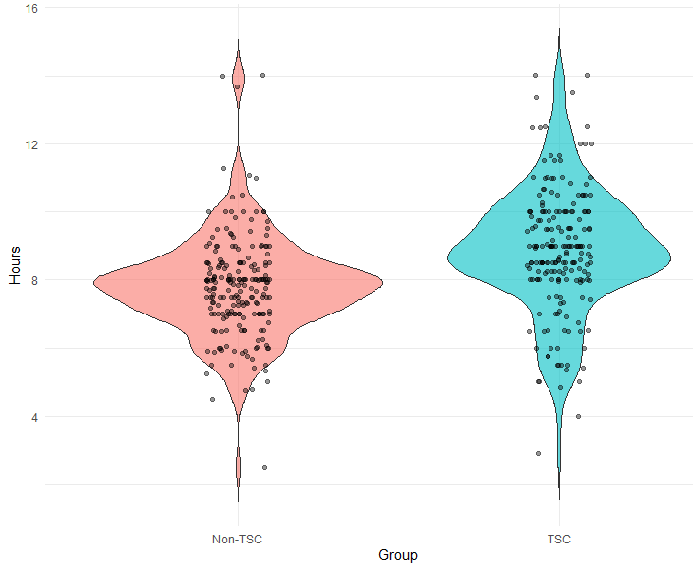

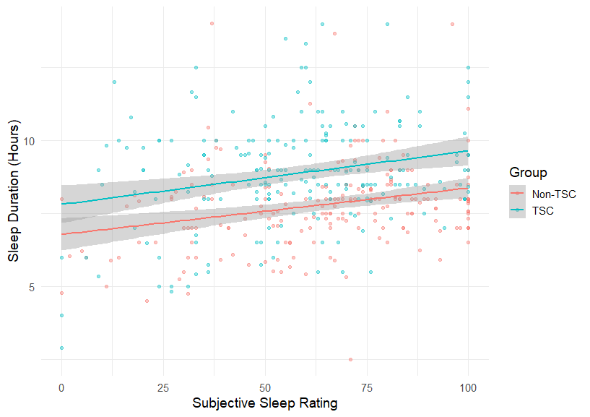

Note. Panel A: Violin plot of sleep duration by participant group. Panel B: Scatter plot with fitted regression line between subjective sleep rating and sleep duration by participant group.
References
Beck, A. T., Epstein, N., Brown, G., & Steer, R. (1993). Beck anxiety inventory. Journal of consulting and clinical psychology.
Beck, A. T., Steer, R. A., & Brown, G. K. (1996). Beck depression inventory.
Conners, C. K., Erhardt, D., & Sparrow, E. (2012). Conners' adult ADHD rating scales. PsycTESTS Dataset.
Constantino, J. N. (2013). Social responsiveness scale. In Encyclopedia of autism spectrum disorders (pp. 2919–2929). Springer.
Crawford, J. R., & Henry, J. D. (2004). The Positive and Negative Affect Schedule (PANAS): Construct validity, measurement properties and normative data in a large non‐clinical sample. British Journal of Clinical Psychology, 43(3), 245–265. https://doi.org/https://doi.org/10.1348/0144665031752934
Fifield, K., Blackford, K., Snaith, B., Singhania, A., Tye, C., & Simblett, S. (2025). Exploring the use of smartphone monitoring for young adults with Tuberous Sclerosis Complex (TSC): A qualitative analysis. https://doi.org/https://doi.org/10.21203/rs.3.rs-5185491/v1
Goodman, R. (1997). The Strengths and Difficulties Questionnaire: a research note. Journal of Child Psychology and Psychiatry, 38(5), 581–586. https://doi.org/https://doi.org/10.1111/j.1469-7610.1997.tb01545.x
Hall, M., Scherner, P. V., Kreidel, Y., & Rubel, J. A. (2021). A systematic review of momentary assessment designs for mood and anxiety symptoms. Frontiers in Psychology, 12, 642044. https://doi.org/https://doi.org/10.3389/fpsyg.2021.642044
Haney, A. M., Fleming, M. N., Wycoff, A. M., Griffin, S. A., & Trull, T. J. (2023). Measuring affect in daily life: A multilevel psychometric evaluation of the PANAS-X across four ecological momentary assessment samples. Psychological Assessment, 35(6), 469.
Heunis, T.-M., Chambers, N., Vanclooster, S., Bissell, S., Byars, A. W., Capal, J. K., Cukier, S., Davis, P. E., de Vries, M. C., & De Waele, L. (2023). Development and feasibility of the self-report quantified tuberous sclerosis complex-associated neuropsychiatric disorders checklist (TAND-SQ). Pediatric neurology, 147, 101–123. https://doi.org/https://doi.org/10.1016/j.pediatrneurol.2023.07.001
Humphrey, A., Ploubidis, G. B., Yates, J. R., Steinberg, T., & Bolton, P. F. (2008). The early childhood epilepsy severity scale (E-chess). Epilepsy research, 79(2-3), 139–145. https://doi.org/https://doi.org/10.1016/j.eplepsyres.2008.01.007
Laver, K., George, S., Ratcliffe, J., & Crotty, M. (2012). Measuring technology self efficacy: reliability and construct validity of a modified computer self efficacy scale in a clinical rehabilitation setting. Disability and rehabilitation, 34(3), 220–227. https://doi.org/10.3109/09638288.2011.593682
Lewis, J. R. (2002). Psychometric evaluation of the PSSUQ using data from five years of usability studies. International Journal of Human-Computer Interaction, 14(3-4), 463–488. https://doi.org/https://doi.org/10.1080/10447318.2002.9669130
Liao, Y., Skelton, K., Dunton, G., & Bruening, M. (2016). A systematic review of methods and procedures used in ecological momentary assessments of diet and physical activity research in youth: an adapted STROBE checklist for reporting EMA studies (CREMAS). Journal of medical Internet research, 18(6), e151. https://doi.org/https://doi.org/10.2196/jmir.4954
Mestdagh, M., Verdonck, S., Piot, M., Niemeijer, K., Kilani, G., Tuerlinckx, F., Kuppens, P., & Dejonckheere, E. (2023). m-Path: an easy-to-use and highly tailorable platform for ecological momentary assessment and intervention in behavioral research and clinical practice. Frontiers in digital health, 5, 1182175. https://doi.org/https://doi.org/10.3389/fdgth.2023.1182175
Ware Jr, J. E., & Sherbourne, C. D. (1992). The MOS 36-ltem short-form health survey (SF-36): I. Conceptual framework and item selection. Medical care, 30(6), 473–483. https://doi.org/10.1097/00005650-199206000-00002
Wechsler, D. (2009). Test of premorbid functioning: UK edition. Assessment.
Wechsler, D. (2011). Wechsler Abbreviated Scale of Intelligence Second Edition (WASI-II) San Antonio. TX: Pearson.

