Subnational simulation trajectories, design comparison boxplots, and bias/variance distribution validation curves.
This file contains the complete set of supplementary figures detailing the subnational impact of survey design on malaria prevalence estimation across the Northern, Central, and Southern regions of Malawi.
Simulated regional malaria prevalence estimates under repeated Malaria Indicator Survey (MIS) sampling, Malawi 2010–2017.
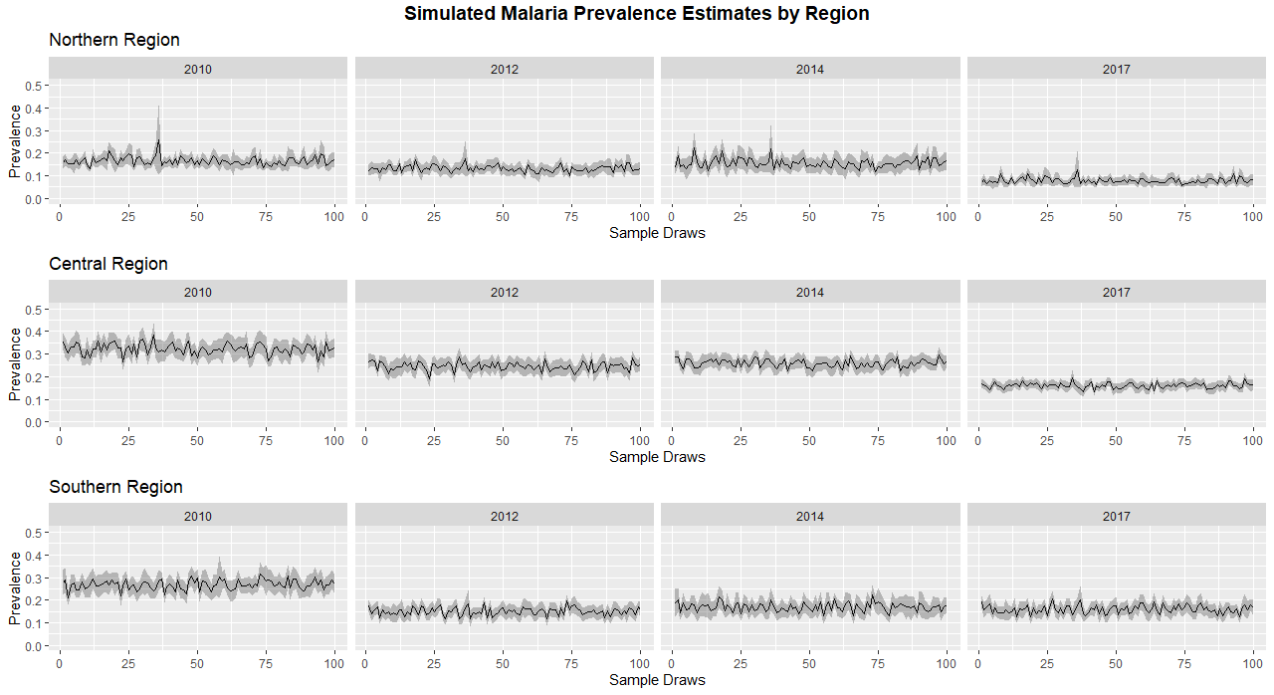
Figure S1: Simulated regional malaria prevalence estimates under repeated Malaria Indicator Survey (MIS) sampling, Malawi 2010–2017. Each panel shows simulated prevalence trajectories for Northern, Central, and Southern regions based on 100 Malaria Indicator Survey (MIS) enumeration area (EA) draws derived from modelled Plasmodium falciparum prevalence surfaces. Solid lines represent mean estimates across simulations for each survey year (2010, 2012, 2014, and 2017), with shaded regions indicating 95% uncertainty intervals arising from random spatial sampling of EAs.

Regional distributions of simulated changes in malaria prevalence under fixed and resampled sampling designs.
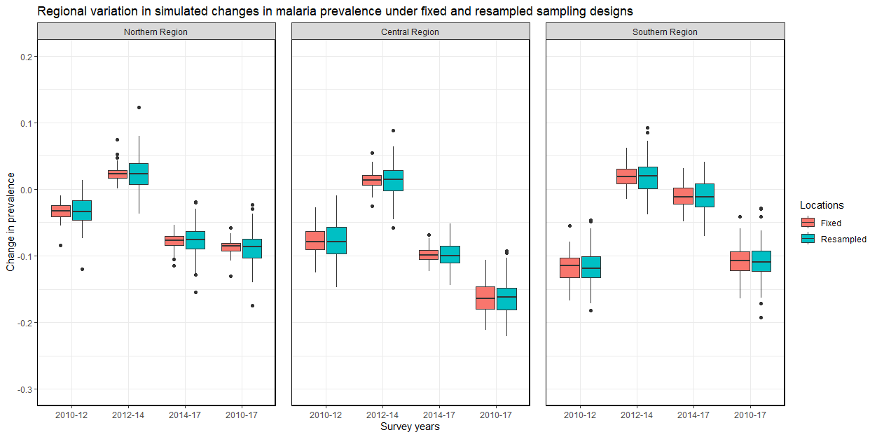
Supplementary Figure S2: Regional distributions of simulated changes in malaria prevalence under fixed and resampled sampling designs. Boxplots show the distribution of estimated changes in prevalence across four survey intervals (2010–12, 2012–14, 2014–17, and 2010–17) for Northern, Central, and Southern regions in Malawi. Each box represents one hundred simulated Malaria Indicator Survey (MIS) draws. The fixed design retains the same enumeration areas across survey rounds, while the resampled design independently selects new enumeration areas for each survey. Across all regions, the fixed design reduces variability in estimated temporal changes without altering the median estimates. The reduction in variance is most pronounced in the Northern Region, where underlying spatial heterogeneity is highest.

Distribution of median estimates of regional malaria prevalence change across four survey intervals from 100 simulations using a resampled survey design.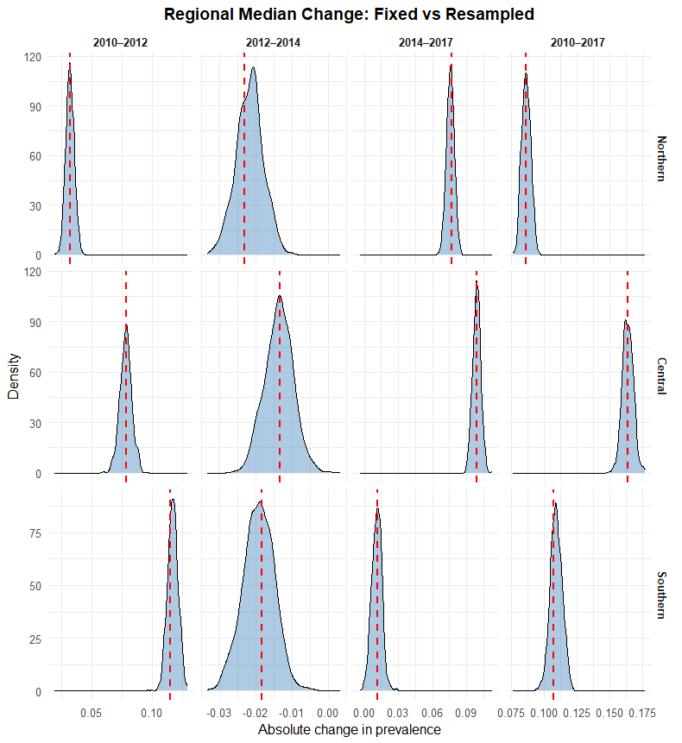 Figure S3: Distribution of median estimates of regional malaria prevalence change across four survey intervals (2010–12, 2012–14, 2014–17, and 2010–17) from 100 simulations using a resampled (independent cluster draw) survey design. The red vertical line in each panel represents the single median change estimate derived from the initial survey design simulation. The fixed median consistently falls within the distribution of resampled medians, indicating that resampling does not introduce systematic bias to the central estimate of the trend.

Distribution of variance of regional malaria prevalence change across four survey intervals from 100 simulations using a resampled survey design.
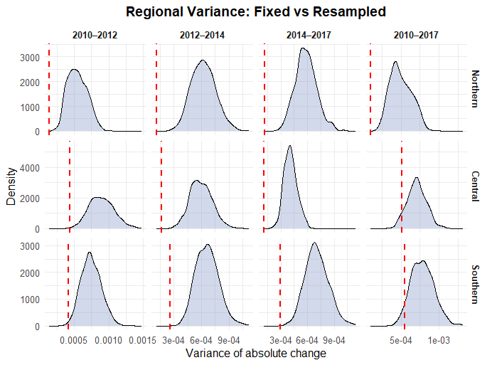
Figure S4. Distribution of variance of regional malaria prevalence change across four survey intervals (2010–12, 2012–14, 2014–17, and 2010–17) from 100 simulations using a resampled (independent cluster draw) survey design. The red vertical line in each panel represents the single variance change estimate derived from the initial survey design simulation.

