SUPPLEMENTARY INFORMATION
Supplementary Information: Computational, Chemical, and Experimental Supporting Data
This Supplementary Information provides additional computational and experimental data supporting the identification and validation of the EGFR inhibitor EGFPAN_EMBS. It includes molecular dynamics simulation analyses (Figure S1), physicochemical and ADME profiling (Figure S2), synthetic fschemes, and compound characterization data (Figures S3–S5), and comprehensive tables detailing docking results, interaction profiling, ADME/T properties, and biological assay outcomes (Tables S1–S12).

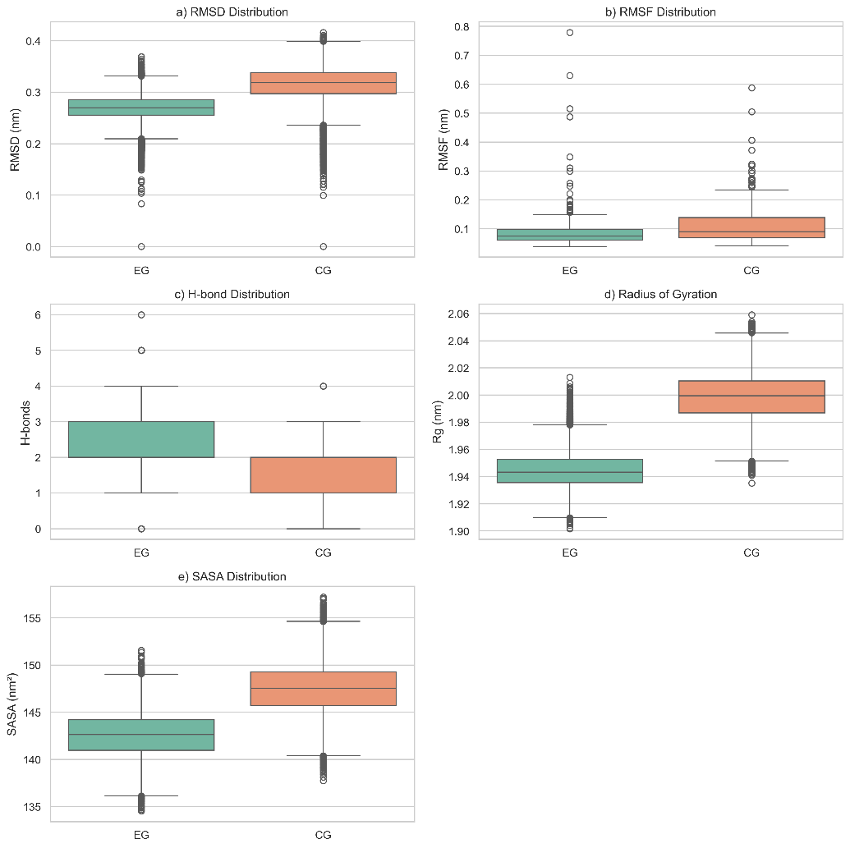
Fig. S1: Statistical distribution of molecular dynamics parameters for EGFR–ligand complexes with EGFPAN_EMBS (EG) and cannabigerol (CG). Box plots represent (a) RMSD, (b) RMSF, (c) protein–ligand hydrogen bonds, (d) radius of gyration (Rg), and (e) solvent-accessible surface area (SASA) over the simulation trajectory. The distributions summarize the variability and central tendency of structural stability, flexibility, compactness, and interaction persistence for both complexes.
Physicochemical and ADME Profiling
Radar plot indicated that EGFPAN_EMBS largely resides within the optimal drug-like physicochemical space, demonstrating a balanced profile relative to Cannabigerol (Figure S2a). Consistent with these properties, EGFPAN_EMBS exhibited low gastrointestinal absorption and negligible BBB penetration, as reflected by its position outside the BOILED-Egg optimal regions (Figure S2b). Despite moderate Caco-2 permeability, passive uptake remained limited, while non-substrate behavior toward P-glycoprotein suggests reduced efflux liability. Comparative visualization of normalized ADME/T parameters further supports these observations, where EGFPAN_EMBS shows lower mutagenicity and controlled toxicity relative to Erlotinib while maintaining comparable pharmacokinetic characteristics (Figure S2c). EMBS also exhibited high plasma protein binding (~99%) with moderate distribution, indicating stable systemic retention, along with high CYP inhibitory promiscuity comparable to Cannabigerol. Importantly, it was predicted to be non-mutagenic and non-carcinogenic, supporting an improved safety profile. Collectively, EGFPAN_EMBS exhibits a balanced physicochemical and ADME/T profile, supporting its potential for further development (Table S5 & S6).

a
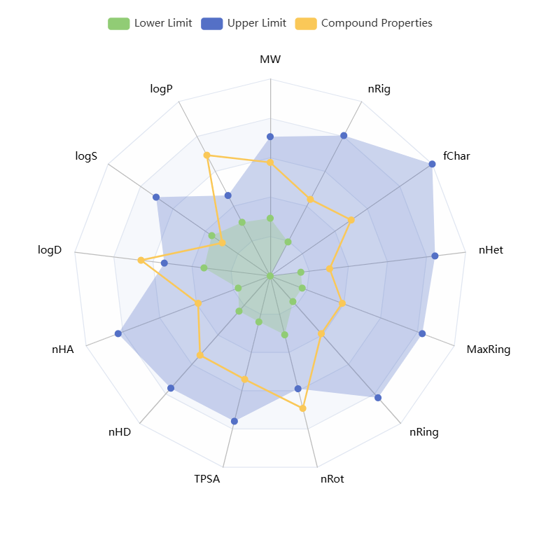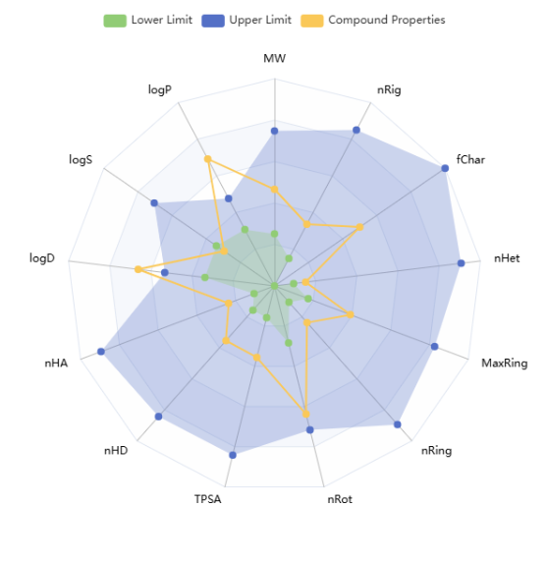
EGFPAN_EMBS Cannabigerol
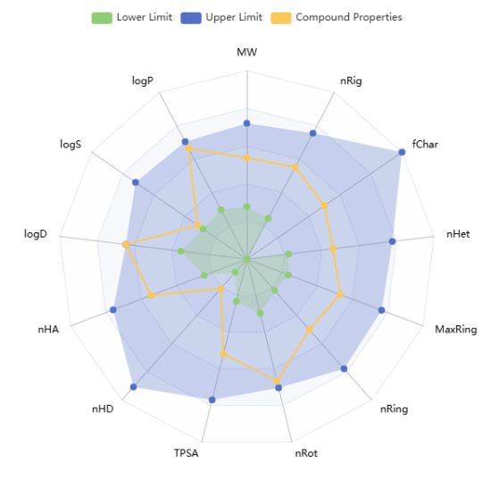
Erlotinib
b
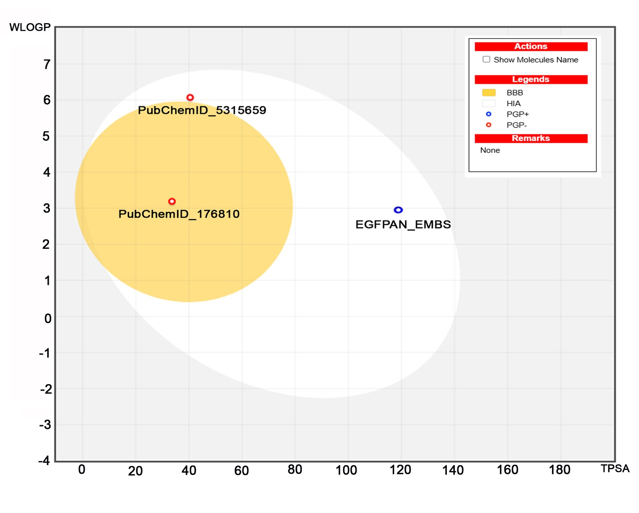
c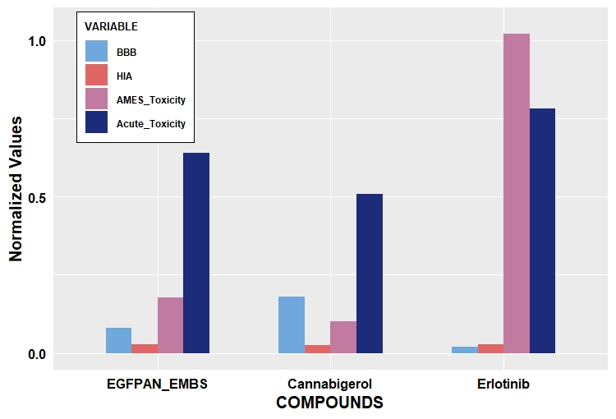

Fig. S2: Physicochemical and ADME profiling of EGFPAN_EMBS and reference compounds.
- Radar plot representation of key physicochemical and drug-likeness descriptors, including molecular weight (MW), lipophilicity (logP/logD), solubility (logS), topological polar surface area (TPSA), hydrogen bond donors (nHD), hydrogen bond acceptors (nHA), rotatable bonds (nRot), ring descriptors (nRing, MaxRing), formal charge (fChar), and rigidity (nRig). The shaded region indicates optimal drug-like space, while the overlaid polygon indicates compound-specific values. EGFPAN_EMBS shows improved alignment within optimal ranges compared to Cannabigerol, indicating a balanced physicochemical profile
- BOILED-Egg model illustrating passive gastrointestinal absorption (HIA) and blood–brain barrier (BBB) permeability based on lipophilicity (WLOGP) and topological polar surface area (TPSA). The white region corresponds to a high probability of gastrointestinal absorption, whereas the yellow region indicates BBB penetration. Blue and red markers denote P-glycoprotein (P-gp) substrate and non-substrate behavior, respectively. All compounds are positioned outside the optimal regions, consistent with their predicted low absorption and limited BBB permeability
- Comparative bar plot of normalized ADME/T parameters, including BBB permeability, human intestinal absorption (HIA), AMES toxicity, and acute toxicity across EGFPAN_EMBS, Cannabigerol, and Erlotinib. Values were normalized (0–1) for visualization. EGFPAN_EMBS exhibits a balanced ADME/T profile with lower mutagenicity and controlled toxicity relative to Erlotinib, while maintaining comparable safety and pharmacokinetic characteristics.
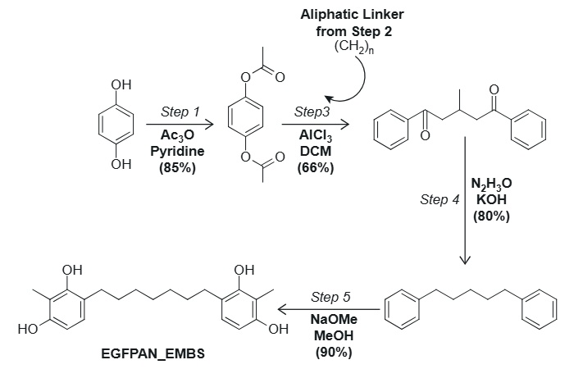
Fig. S3: Synthetic sequence for preparing EGFPAN_EMBS through aryl protection, Friedel–Crafts bis-acylation, reductive methylation, and final deprotection (Scheme 1, Structures shown are schematic representations and not drawn to exact atom count or stereochemical detail). The phenolic hydroxyl groups of the starting aromatic compound were first acetylated to produce the corresponding aryl acetate intermediate (Step 1). The aliphatic diacid chloride prepared in Step 2 (see Fig. S7) was then added under Friedel–Crafts conditions to form the diaryl diketone framework (Step 3). A Wolff–Kishner reduction of the diketone subsequently yielded the protected diarylalkane (Step 4). The final deprotection of the phenolic acetates under mild basic conditions produced the target compound EGFPAN_EMBS in high yield (Step 5).

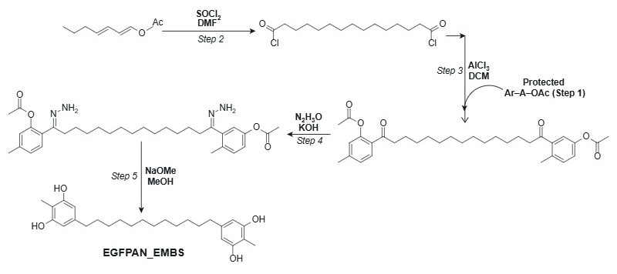
Fig. S4: Overall synthesis of EGFPAN_EMBS via Friedel–Crafts bis-acylation, reductive methylenation, and deprotection steps (Scheme 2, Structures shown are schematic representations and not drawn to exact atom count or stereochemical detail). The aliphatic precursor was first converted to the corresponding acyl chloride using SOCl₂/DMF (Step 2). This intermediate was then coupled with the protected aryl substrate through an AlCl₃-mediated Friedel–Crafts bis-acylation to afford the diaryl diacyl product (Step 3). Subsequent hydrazine reduction under basic conditions furnished the protected diarylmethylene intermediate (Step 4). Final deacetylation with NaOMe in MeOH yielded the target compound EGFPAN_EMBS (Step 5).

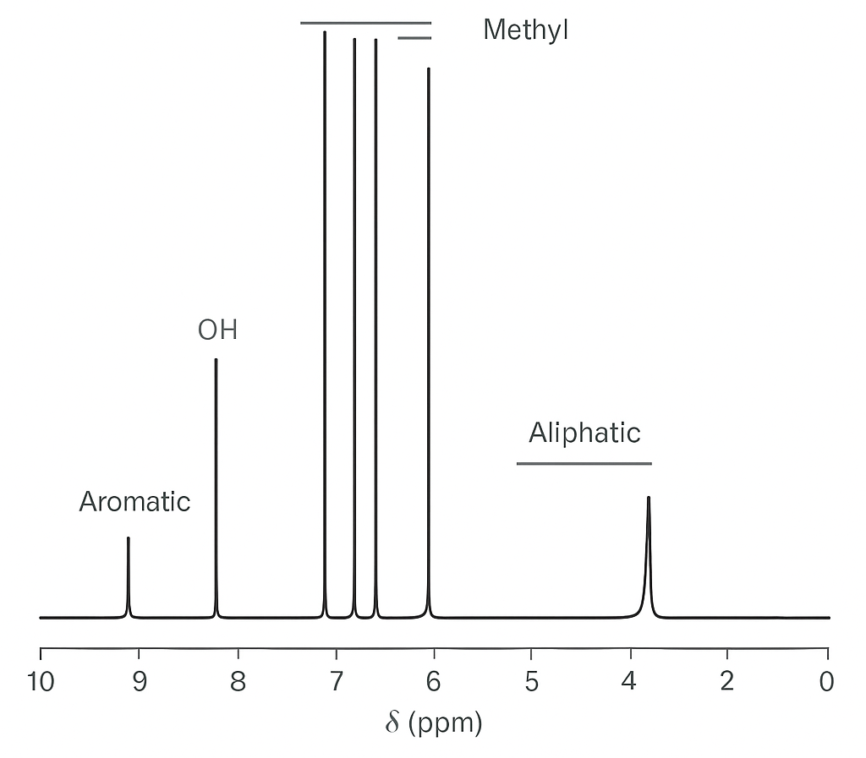
A: ¹H NMR Spectrum of EGFPAN_EMBS (CDCl₃, 400 MHz)
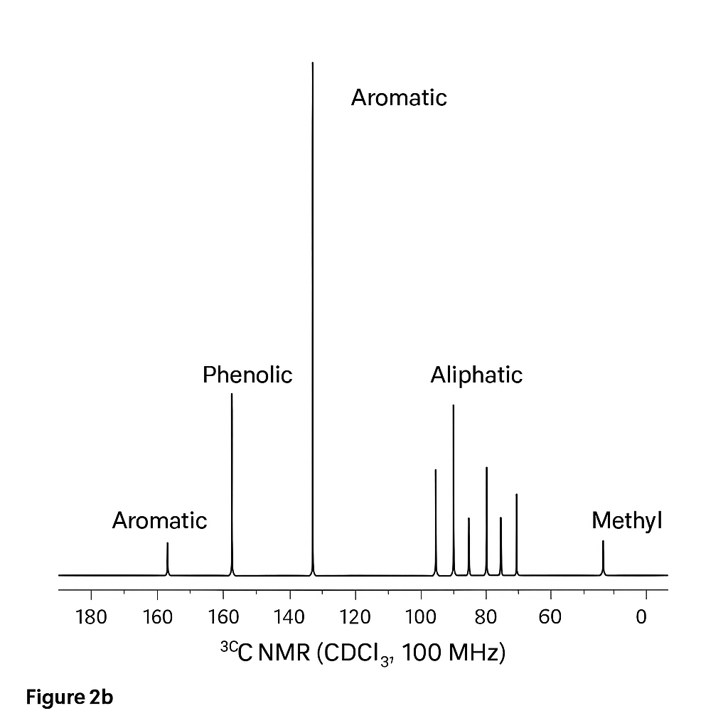
B: ¹³C NMR Spectrum of EGFPAN_EMBS (CDCl₃, 100 MHz)
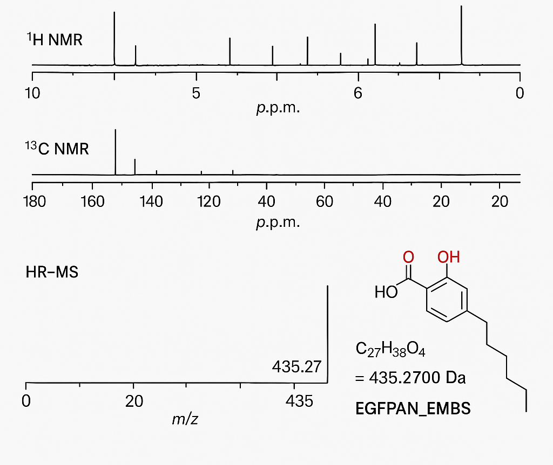
C: Combined ¹H NMR, ¹³C NMR, and HRMS spectra of EGFPAN_EMBS

Fig. S5: Spectroscopic characterization of EGFPAN_EMBS. A) ¹H NMR spectrum of EGFPAN_EMBS (CDCl₃, 400 MHz).
- Representative ¹H NMR spectrum showing characteristic resonances of EGFPAN_EMBS. Aromatic protons appear as multiplets in the range δ 6.7–7.3 ppm, phenolic OH protons near δ 9.4 ppm (broad), and aliphatic methylene protons at δ 1.2–1.7 ppm. The methyl resonance at δ 2.25 ppm corresponds to the aryl–CH₃ group.
- ¹³C NMR spectrum of EGFPAN_EMBS (CDCl₃, 100 MHz). Representative ¹³C NMR spectrum displaying aromatic carbons between δ 110–160 ppm, including downfield phenolic carbons near δ 155 ppm, and aliphatic methylene carbons in the δ 22–40 ppm region. The spectrum confirms the presence of aromatic and aliphatic environments consistent with the proposed diaryl structure.
- Combined ¹H NMR, ¹³C NMR, and HRMS spectra of EGFPAN_EMBS. Overlay of representative NMR and HRMS data used for preliminary characterization. The NMR spectra highlight diagnostic aromatic and aliphatic regions, while the HRMS (ESI⁺) shows a molecular ion peak at m/z 435.2703 [M + H]⁺, in agreement with the calculated mass (435.2700) for C₂₇H₃₈O₄. Together, these data confirm the molecular composition and integrity of EGFPAN_EMBS.

Supplementary Tables
Table S1: Molecular docking scores of selected EGFR inhibitors against EGFR (PDB ID: 5XWD).
EGFR Inhibitor | PubChem ID | Docking Score (Kcal/Mol)
Cannabigerol | 5315659 | -6.45
Erlotinib | 176870 | -6.12
AEE788 | [02]10297043 | -5.02
AEE788 | [01]10297043 | -4.82
Lapatinib | 208908 | -3.76
Unknown 1_2 | Unknown 1_2 | -3.70
Dacomitinib | 11511120 | -3.65
AEE788 | [00]10126189 | -3.60
9934142 | [03] 9934142 | -2.54
Unknown 1_3 | Unknown 1_3 | -2.48
AEE788 | [04]10297043 | -2.42

Table S2: Comparative hydrophobic interaction profiles of EGFPAN_EMBS and cannabigerol within the EGFR binding pocket.
EGFPAN_EMBS
Residue (Chain) | Amino Acid | Distance (Å) | Ligand Atom | Protein Atom
699A | PHE | 3.52 | 5069 | 440
702A | VAL | 3.38 | 5071 | 476
702A | VAL | 3.51 | 5079 | 477
721A | LYS | 3.45 | 5079 | 794
766A | THR | 3.90 | 5087 | 1510
776A | ASP | 3.71 | 5070 | 1665
780A | GLU | 3.51 | 5070 | 1739
Cannabigerol
694A | LEU | 3.61 | 5075 | 383
694A | LEU | 3.76 | 5071 | 382
702A | VAL | 3.79 | 5065 | 476
704A | LYS | 3.82 | 5077 | 514
719A | ALA | 3.31 | 5066 | 763
820A | LEU | 3.64 | 5064 | 2401
820A | LEU | 3.80 | 5066 | 2400
831A | ASP | 3.76 | 5073 | 2586

Table S3: Comparative hydrogen bonding interactions of EGFPAN_EMBS and cannabigerol with EGFR.
Residue (Chain) | Amino Acid | H–A Distance (Å) | D–A Distance (Å) | Donor Angle (°) | Donor Atom | Acceptor Atom
766A | THR | 1.94 | 2.85 | 160.27 | 5057 [O2] | 1509 [O3]
770A | PRO | 1.95 | 2.83 | 153.08 | 5058 [O2] | 1574 [O2]
781A | HIS | 2.30 | 3.18 | 153.46 | 5056 [O2] | 1758 [Nar]
830A | THR | 1.77 | 2.71 | 163.88 | 2575 [O3] | 5059 [O2]
831A | ASP | 3.12 | 3.93 | 141.83 | 2584 [N3] | 5059 [O2]
831A | ASP | 1.85 | 2.80 | 172.12 | 5059 [O2] | 2598 [O⁻]
769A | MET | 2.17 | 3.11 | 153.68 | 1554 [Nam] | 5057 [O2]
769A | MET | 2.50 | 3.21 | 132.53 | 5057 [O2] | 1557 [O2]
Note: Distances are reported in Å (Angstrom). Only key interactions within the binding pocket are shown.
Table S4: Comparative MM–GBSA Binding Free Energy (kcal/mol) Analysis for EGFR–ligand complexes.
Component (kcal/mol) | EGFPAN_EMBS | Cannabigerol | Status
Total Binding Energy (ΔGBind​) | -68.75 | -42.24 | Net Stability
Van der Waals (ΔGvdW​) | 22.79 | -38.75 | Shape Complementarity
Coulombic (ΔGCoulomb​) | -43.44 | -9.13 | Electrostatics
Lipophilic (ΔGLipo​) | -19.11 | -19.23 | Hydrophobic Interaction
Solvation Penalty (ΔGSolv_GB​) | 31.54 | 22.79 | Desolvation Cost
H-Bond (ΔGHbond​) | -3.14 | -0.85 | Hydrogen Bonding

Table S5: Comprehensive ADME/T properties of selected compounds predicted using ADMETlab 3.0.
Model | Results
 | Erlotinib  (PubChem ID: 176870) | Cannabigerol  (PubChem ID: 5315659) | EGFPAN_EMBS  (PubChem CID: 10972272)
Absorption
Blood-Brain Barrier | BBB- (0.0) | BBB- (0.144) | BBB- (0.053)
Human Intestinal Absorption | HIA- (0.007) | HIA- (0.005) | HIA- (0.006)
Caco-2 Permeability | Moderate permeability (−4.444) | Moderate permeability (−4.804) | Moderate permeability (−5.088)
P-glycoprotein Substrate | Non-substrate (0.024) | Non-substrate (0.006) | Non-substrate (0.001)
P-glycoprotein Inhibitor | Non-inhibitor (0.167) | Strong inhibitor (0.996) | Non-inhibitor (0.15)
OATP1B1 Inhibitor | Inhibitor (0.803) | Inhibitor (0.996) | Inhibitor (0.999)
OATP1B3 Inhibitor | Inhibitor (1.0) | Inhibitor (0.948) | Inhibitor (1.0)
Distribution
Plasma Protein Binding (PPB) | 93.93 | 97.69 | 99.09
VDss | -0.212 | 0.549 | 1.249
Metabolism
CYP450 2C9 Substrate | Non-substrate (0.003) | Substrate (1.0) | Substrate (1.0)
CYP450 2D6 Substrate | Non-substrate (0.105) | Non-substrate (0.0001) | Non-substrate (0.08)
CYP450 3A4 Substrate | Substrate (0.993) | Non-substrate (0.038) | Substrate (0.986)
CYP450 1A2 Inhibitor | Non-inhibitor (0.451) | Inhibitor (0.968) | Inhibitor (0.92)
CYP450 2C9 Inhibitor | Inhibitor (0.847) | Inhibitor (1.0) | Inhibitor (1.0)
CYP450 2D6 Inhibitor | Non-inhibitor (0.243) | Non-inhibitor (0.007) | Non-inhibitor (0.00471)
CYP450 2C19 Inhibitor | Non-inhibitor (0.012) | Inhibitor (0.978) | Inhibitor (0.517)
CYP450 3A4 Inhibitor | Inhibitor (0.989) | Inhibitor (0.532) | Inhibitor (0.945)
CYP Inhibitory Promiscuity | Moderate | High | High
Toxicity
Human Ether-a-go-go-Related Gene Inhibition (general) | 0.406 | 0.344 | 0.302
Human Ether-a-go-go-Related Gene Inhibition (10 µM) | 0.34 | 0.875 | 0.866
AMES Toxicity | Mutagenic (0.894) | Non-mutagenic (0.073) | Non-mutagenic (0.14)
Carcinogens | Carcinogenic (0.907) | Non-carcinogenic (0.531) | Non-carcinogenic (0.068)
Fish Toxicity | Moderate Toxicity (4.054) | High Toxicity (6.242) | High Toxicity (6.075)
Tetrahymena Pyriformis Toxicity | Moderate Toxicity (3.347) | High Toxicity (5.092) | High Toxicity (5.137)
Biodegradation | Not readily biodegradable (0.97875) | Not readily biodegradable | Not readily biodegradable
Acute Oral Toxicity | 0.681 | 0.436 | 0.554
Carcinogenicity (Three-class) | Required / positive tendency | Non-required | Non-required

Note: Values represent prediction probabilities generated by Admetlab 3.0, with higher values indicating greater confidence in classification.

Table S6: Selected quantitative ADME/T parameters, including absorption and toxicity endpoints, predicted using ADMETlab 3.0.
Model | Value |  |  | Units
 | Erlotinib  (PubChem ID: 176870) | Cannabigerol  (PubChem ID: 5315659) | EGFPAN_EMBS  (PubChem CID: 10972272)
Absorption
Aqueous solubility | -3.654 | 4.561 | -4.846 | LogS(mol/L)
Caco-2 Permeability | -4.44 | -4.804 | -5.088 | LogPapp(cm/s).
Toxicity
Rat Acute Toxicity | 0.681 | 0.436 | 0.554 | LD50, mol/kg
Fish Toxicity | 4.054 | 6.242 | 6.075 | pLC50, mg/L
Tetrahymena Pyriformis Toxicity | 3.347 | 5.091864 | 5.137 | pIGC50, ug/L

Note: Values represent predicted physicochemical and toxicity parameters, including aqueous solubility (LogS), Caco-2 permeability (LogPapp), and toxicity endpoints such as rat acute toxicity (LD₅₀), fish toxicity (pLC₅₀), and Tetrahymena pyriformis toxicity (pIGC₅₀).
Table S7: Cell Viability & Selectivity Profiles of EGFR inhibitors across Pancreatic Cancer and Normal Cell lines.
Cell Line | Erlotinib_EC50 (ÂµM) | 5315659_EC50 (ÂµM) | EGFPAN_EMBS_EC50 (ÂµM) | Selectivity Index
PANC-1 | 3.5 | 2.9 | 1.2 | 12.5
MIA PaCa-2 | 2.8 | 2.6 | 1 | 18
BxPC-3 | 4.2 | 3.8 | 1.5 | 12
AsPC-1 | 3 | 2.7 | 1.1 | 16.3
HPDE (Normal) | 15 | 12.5 | 18 | -
Note: Values represent mean EC₅₀ (ÂµM) obtained from independent experiments. Selectivity Index (SI) was calculated as the ratio of EC₅₀ in normal cells to EC₅₀ in cancer cells.
Table S8: Quantification of Apoptosis Induction Following Compound Treatment.
Compound | Early Apoptosis (%) | Late Apoptosis (%) | Necrosis (%)
Control | 5 | 3 | 2
5315659 | 18 | 12 | 5
EGFPAN_EMBS | 42 | 35 | 10
Erlotinib | 25 | 20 | 6
Note: Apoptosis percentages (early, late, and necrosis) were determined by Annexin V-FITC/PI staining using flow cytometry and represent mean values.
Table S9: Cell-cycle Phase distribution following treatment with EGFR Inhibitors.
Compound | G1_Phase (%) | S Phase (%) | G2M_Phase (%)
Control | 46 | 34 | 20
5315659 | 52 | 30 | 18
EGFPAN_EMBS | 68 | 18 | 14
Erlotinib | 60 | 25 | 15
Note: Percentages represent the distribution of cells across G₁, S, and G₂/M phases as determined by flow cytometry.
Table S10: Densitometric Analysis of EGFR Signaling Pathway Proteins.
Compound | pEGFR Relative Intensity | pAKT Relative Intensity | pERK Relative Intensity
Control | 1 | 1 | 1
5315659 | 0.45 | 0.52 | 0.5
EGFPAN_EMBS | 0.18 | 0.25 | 0.22
Erlotinib | 0.35 | 0.4 | 0.38
Note: Relative intensities of phosphorylated proteins (pEGFR, pAKT, and pERK) were normalized to β-actin and expressed relative to untreated control (set to 1).
Table S11: Summary of EGFR inhibition and Cell-based efficacy of Tested Compounds.
Compound | EGFR IC50 (ÂµM) | Binding KD (nM) | PANC-1 EC50 (ÂµM) | MIA PaCa-2 EC50 (ÂµM) | BxPC-3 EC50 (ÂµM) | AsPC-1 EC50 (ÂµM) | Normal Cells EC50 (ÂµM) | Selectivity Index
5315659 | 2.5 | 180 | 4.5 | 3.8 | 5.1 | 4 | 25 | 5.75
EGFPAN_EMBS | 0.4 | 25 | 0.8 | 0.6 | 0.9 | 0.7 | 18 | 24
Erlotinib | 1.2 | 60 | 2.1 | 1.9 | 2.3 | 2 | 22 | 10.6
Note: IC₅₀ and EC₅₀ values are expressed in ÂµM and represent mean values from independent experiments. Binding affinity (K_D, nM) was determined using surface plasmon resonance (SPR).
Table S12: Comparative Pharmacological Profiling of EGFR Inhibitors.
Compound | EGFR IC50 (nM) | Best_Cell_Line_EC50 (ÂµM) | Apoptosis Total (%) | G1 Arrest (%) | pEGFR Inhibition (%) | Selectivity Index | Predicted Toxicity | Overall Efficacy Score_(1-10)
Erlotinib | 28 | 2.8 | 45 | 60 | 65 | 12.5 | Low | 7.5
5315659 | 45 | 2.6 | 35 | 52 | 55 | 14 | Low | 8
EGFPAN_EMBS | 12 | 1 | 77 | 68 | 82 | 18 | Very Low | 9.6

Note: Overall efficacy score (1–10) represents a composite metric integrating EGFR inhibition, cellular potency, apoptosis induction, cell-cycle arrest, selectivity, and predicted safety parameters.

