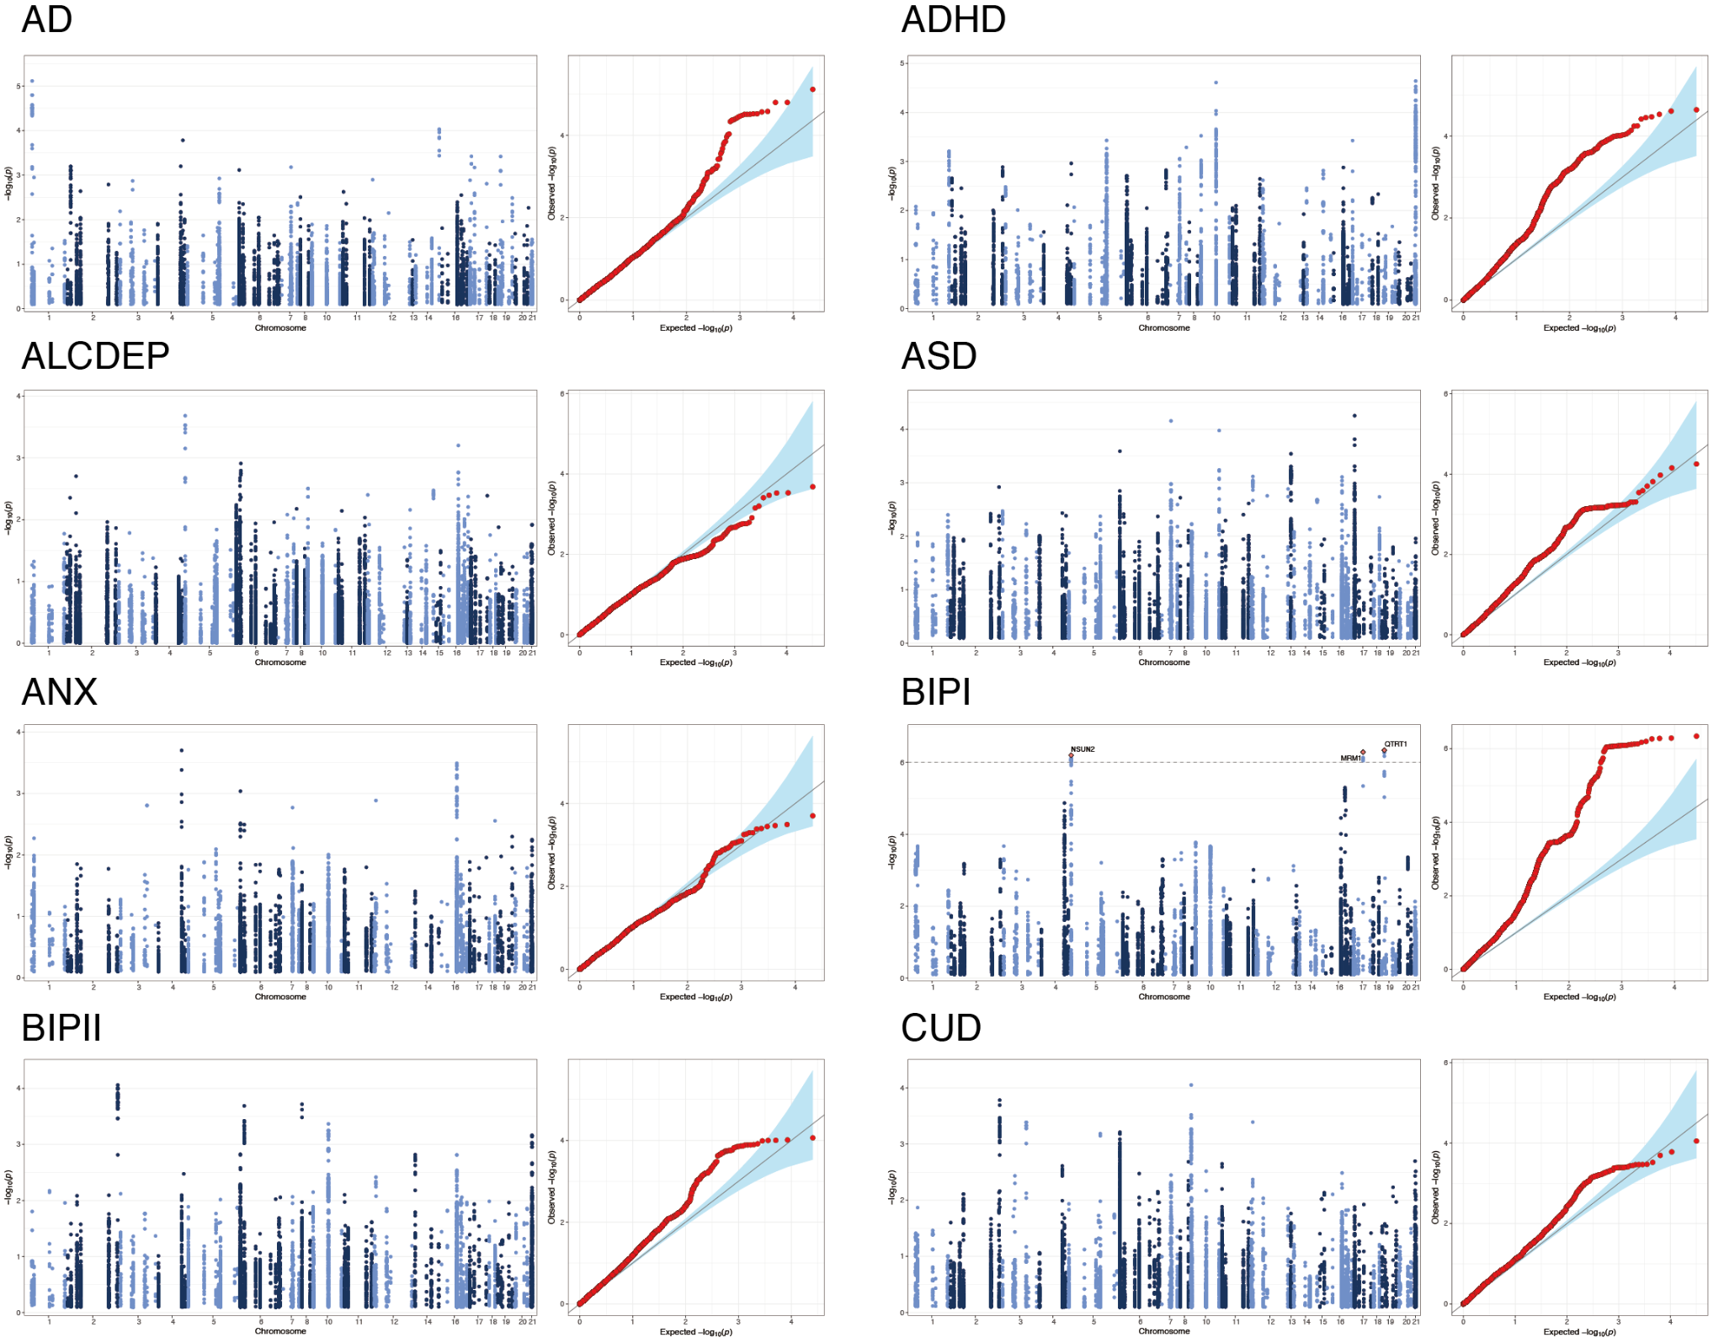
Figure S1: Supplementary figure for Figure 1
Manhattan plots (left) and quantile–quantile (QQ) plots (right) of GWAS summary statistics. (Continued on the next page)

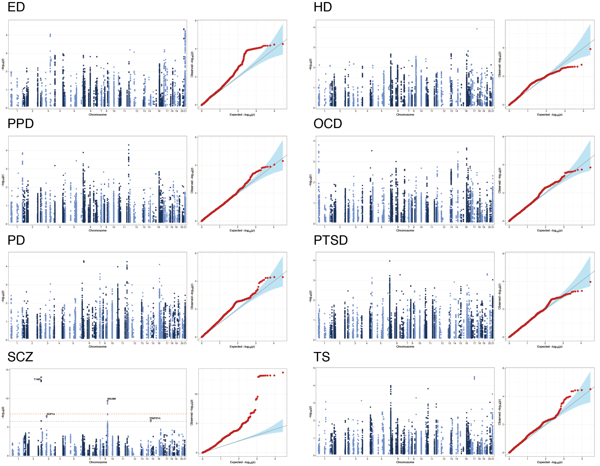
Figure S1 (continued):
Manhattan plots and quantile–quantile (QQ) plots of GWAS summary statistics.

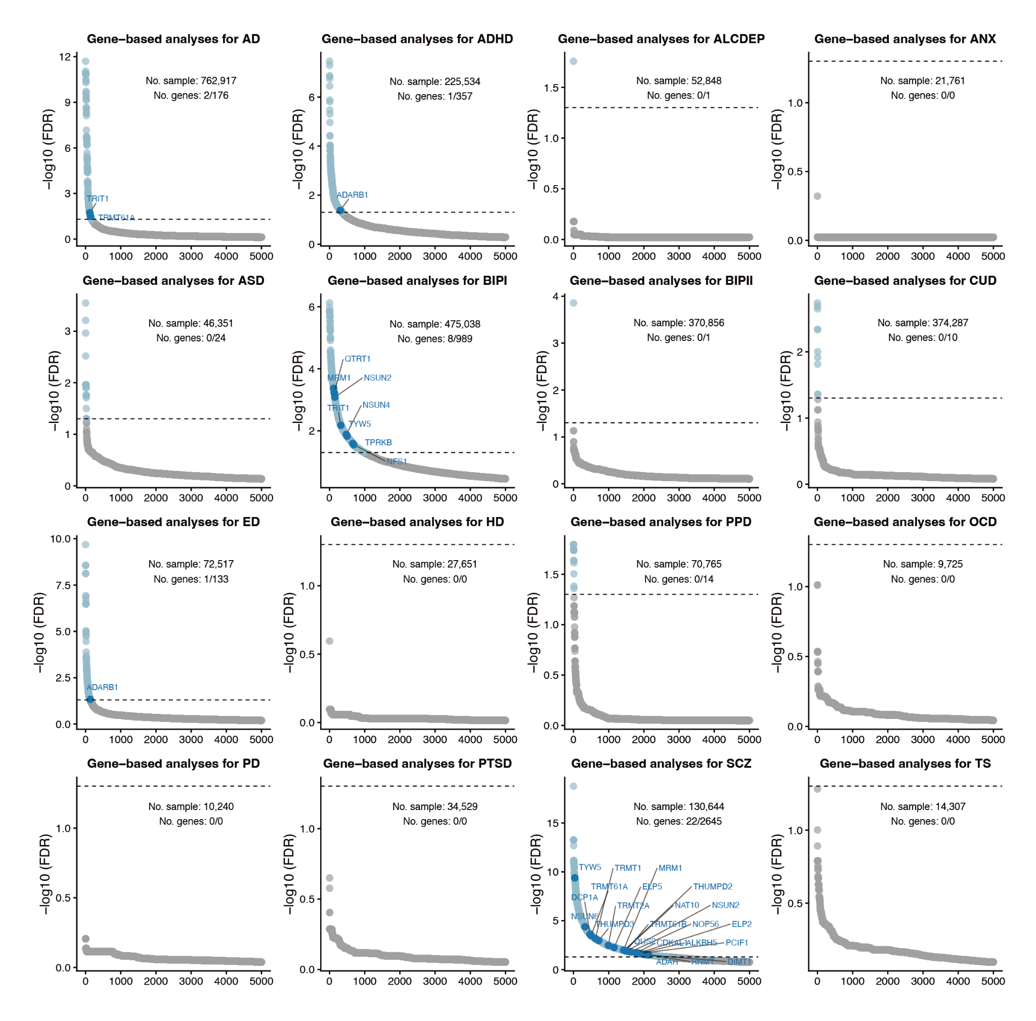
Figure S2: Supplementary figure for Figure 1
Scatter plots illustrating MAGMA gene-based association results for RMP genes. The y-axis represents −log₁₀(FDR), and the x-axis corresponds to genes ranked by −log₁₀(FDR). Annotated dark blue dots represent significantly associated RMR genes; light blue dots represent significantly associated genes (FDR<0.05); gray dots represent non-significant genes (FDR>0.05). Total sample sizes of the GWAS summary statistics (No. sample) and the counts of significantly associated RMP genes and total genes (No. gene) are indicated for each cohort.
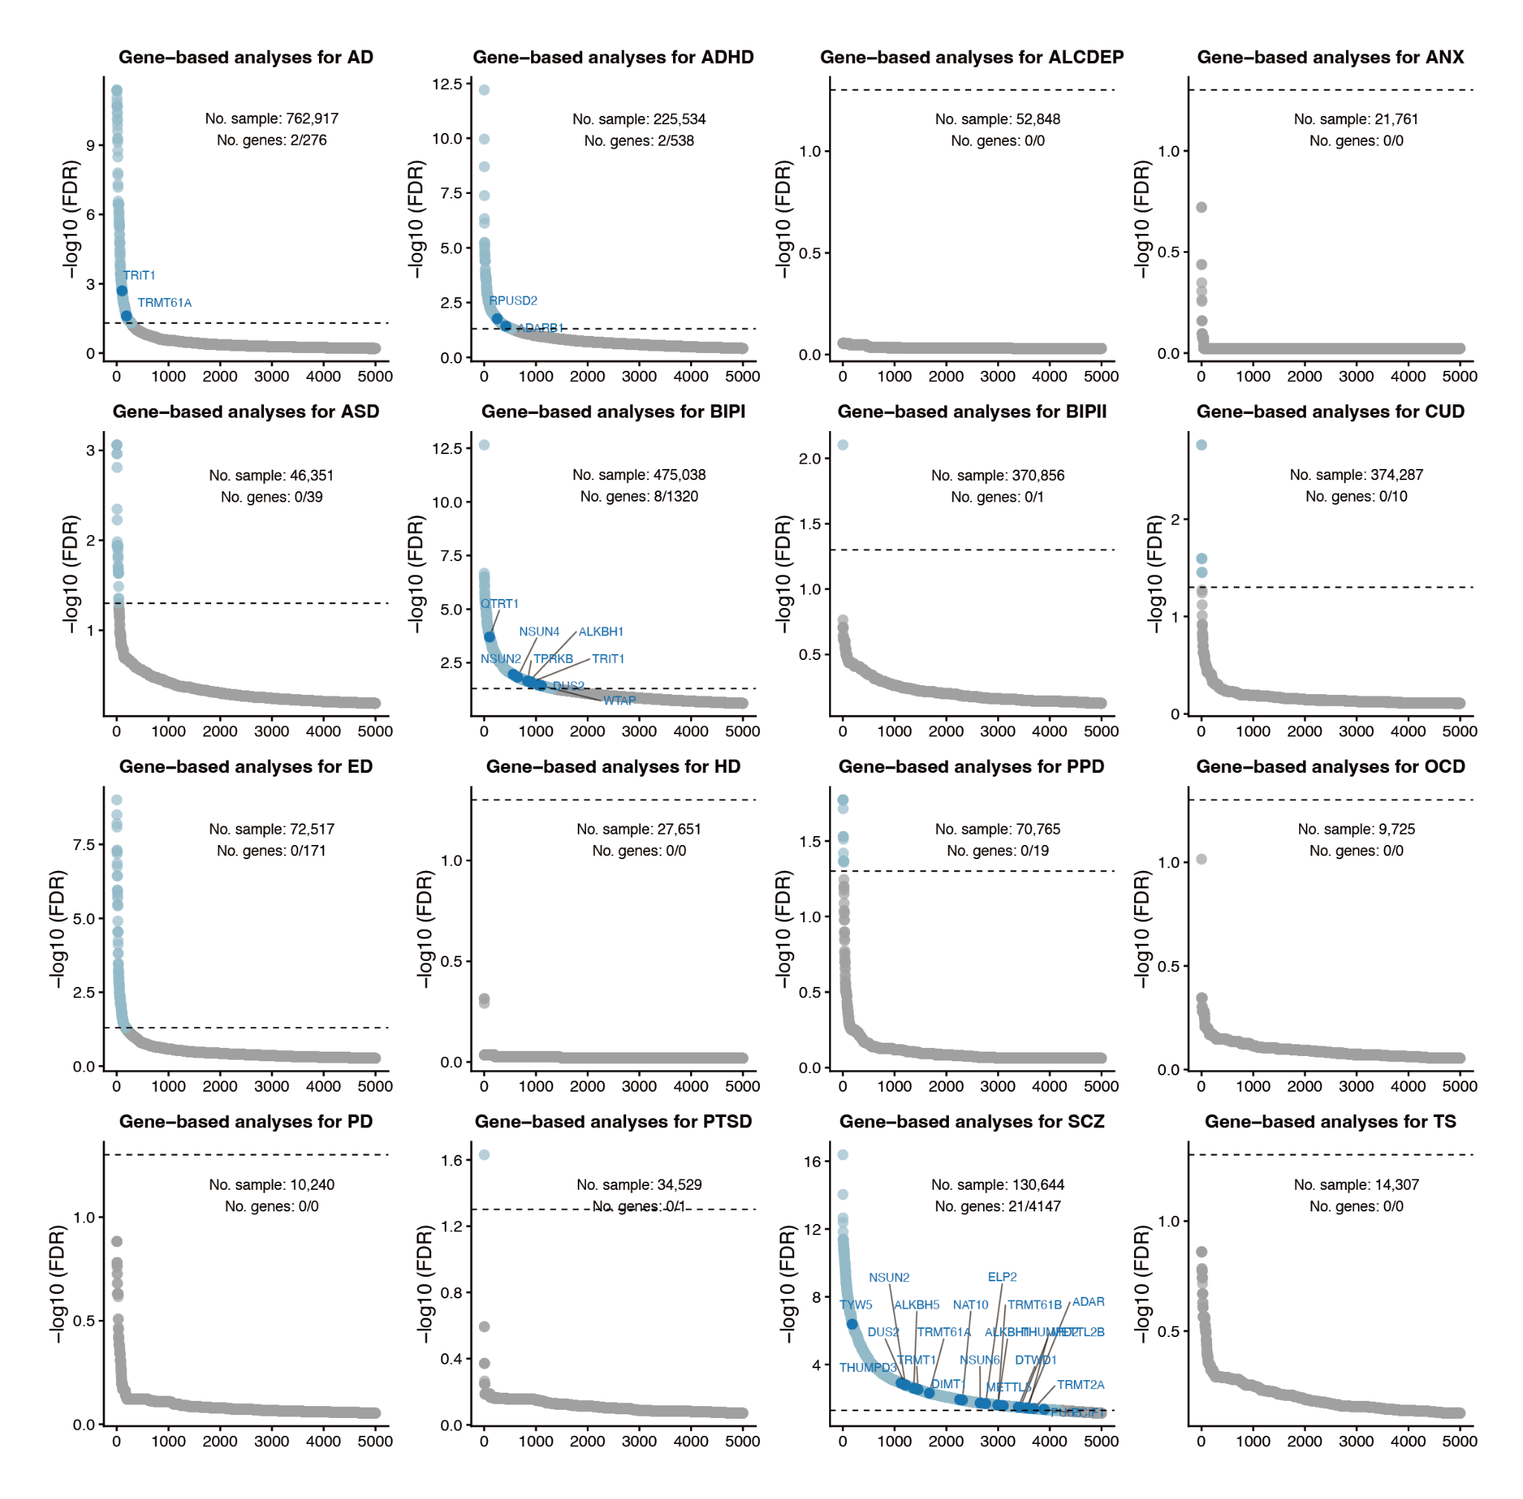
Figure S3: Supplementary figure for Figure 1
Scatter plots illustrating H-MAGMA gene-based association results for RMP genes.
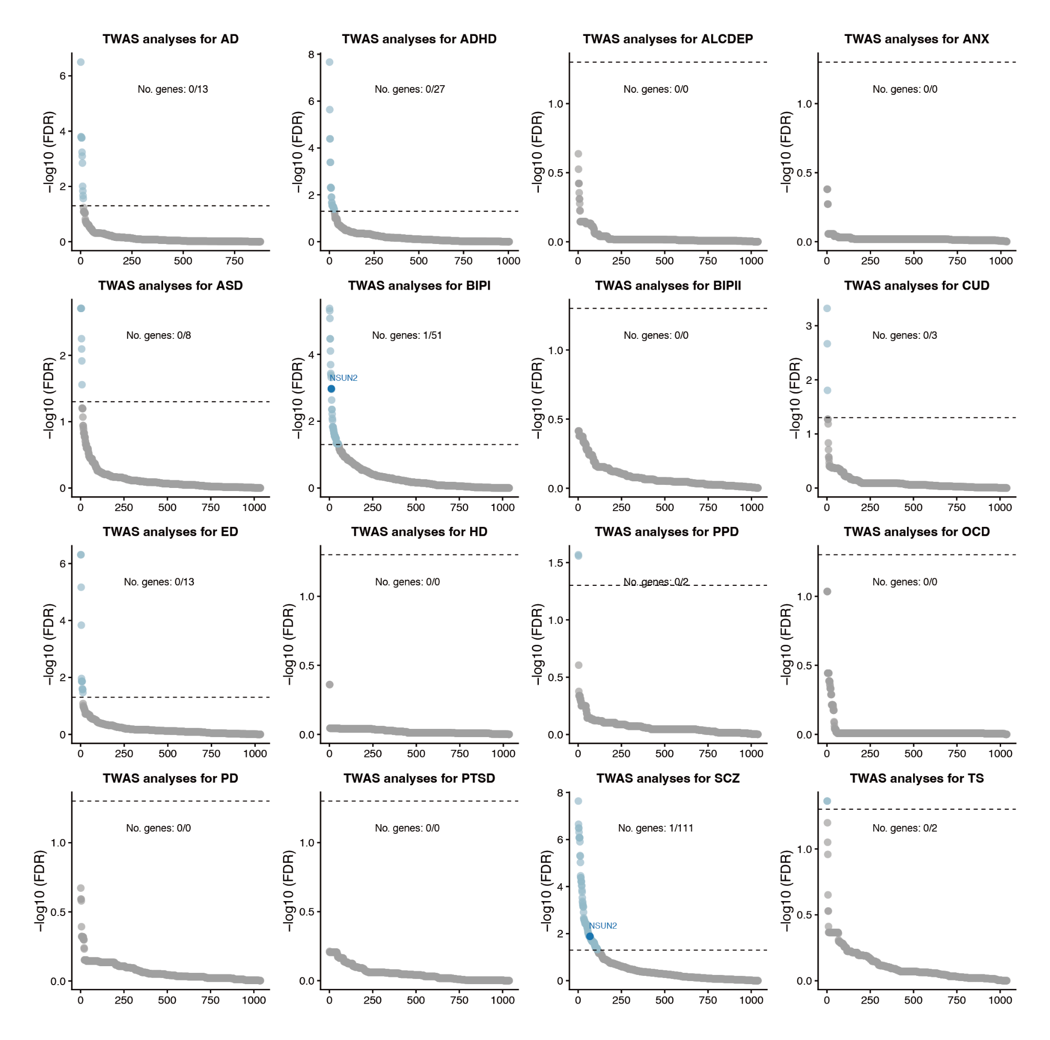
Figure S4: Supplementary figure for Figure 1
Scatter plots illustrating FUSION-based TWAS results based on DLPFC reference panels.
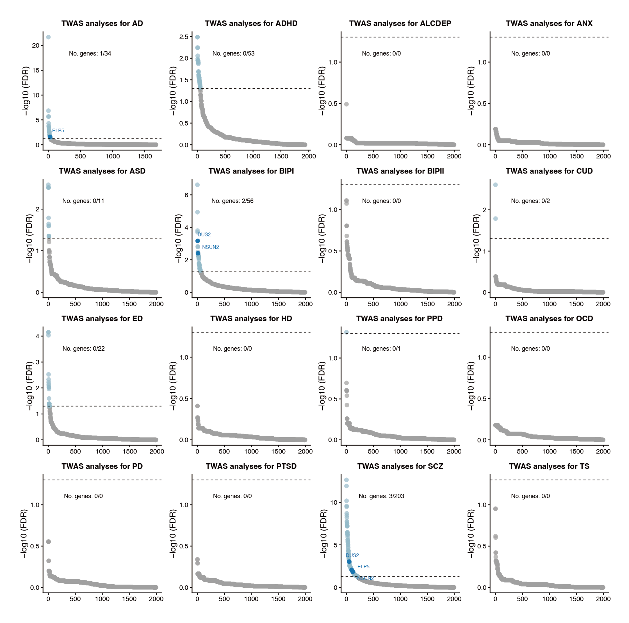
Figure S5: Supplementary figure for Figure 1
Scatter plots illustrating FUSION-based TWAS results based on Blood reference panels.
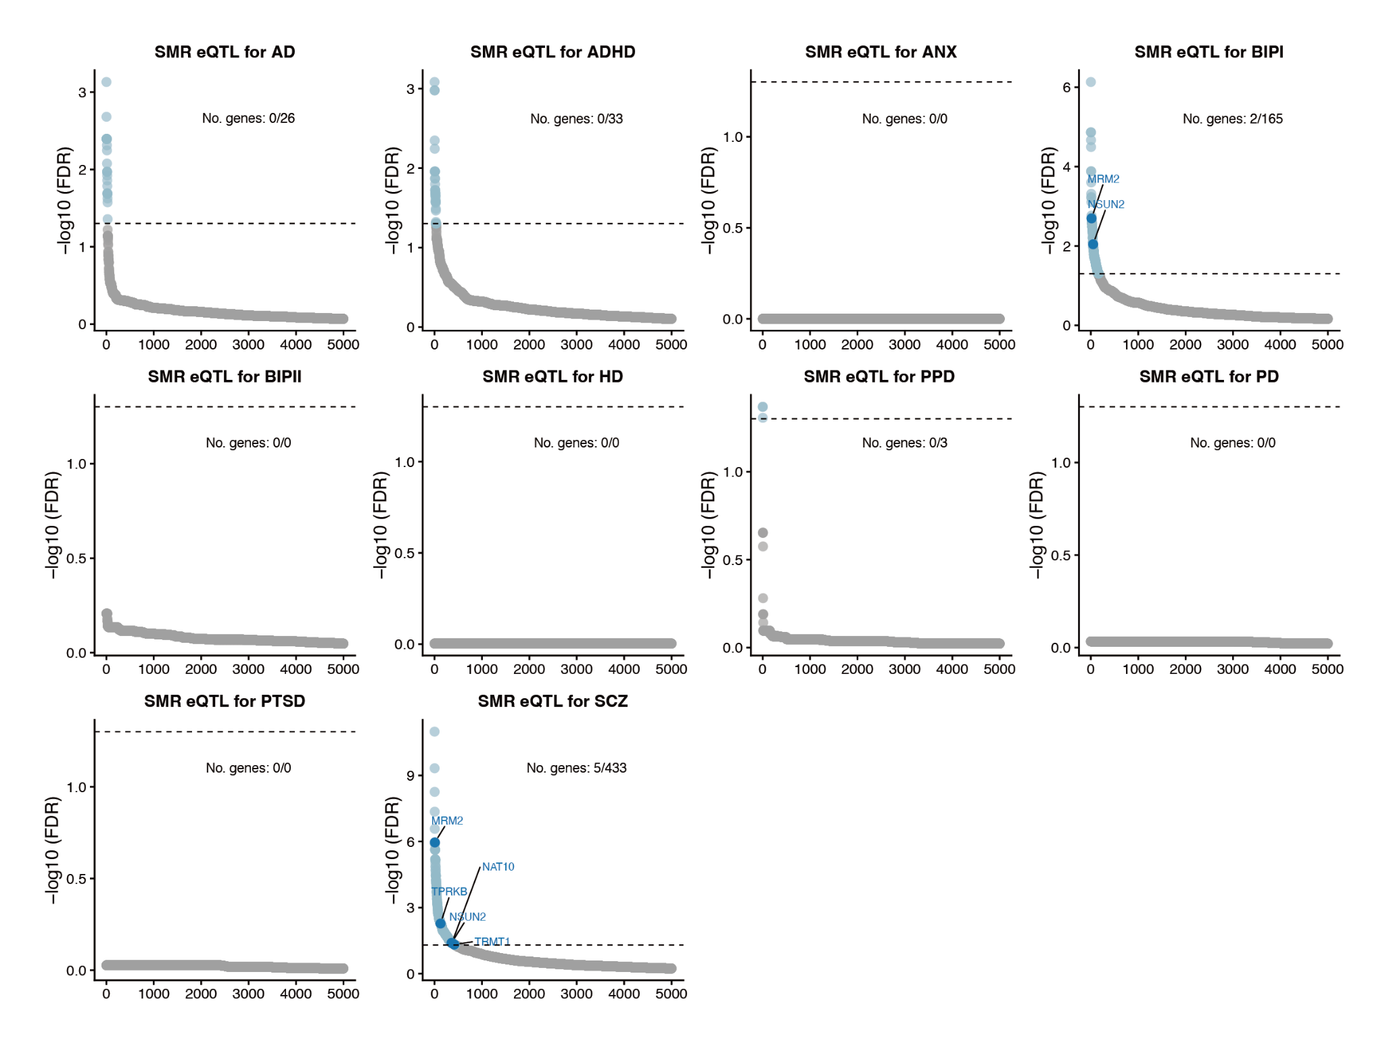
Figure S6: Supplementary figure for Figure 1
Scatter plots illustrating SMR results based on DLPFC eQTL reference panels.
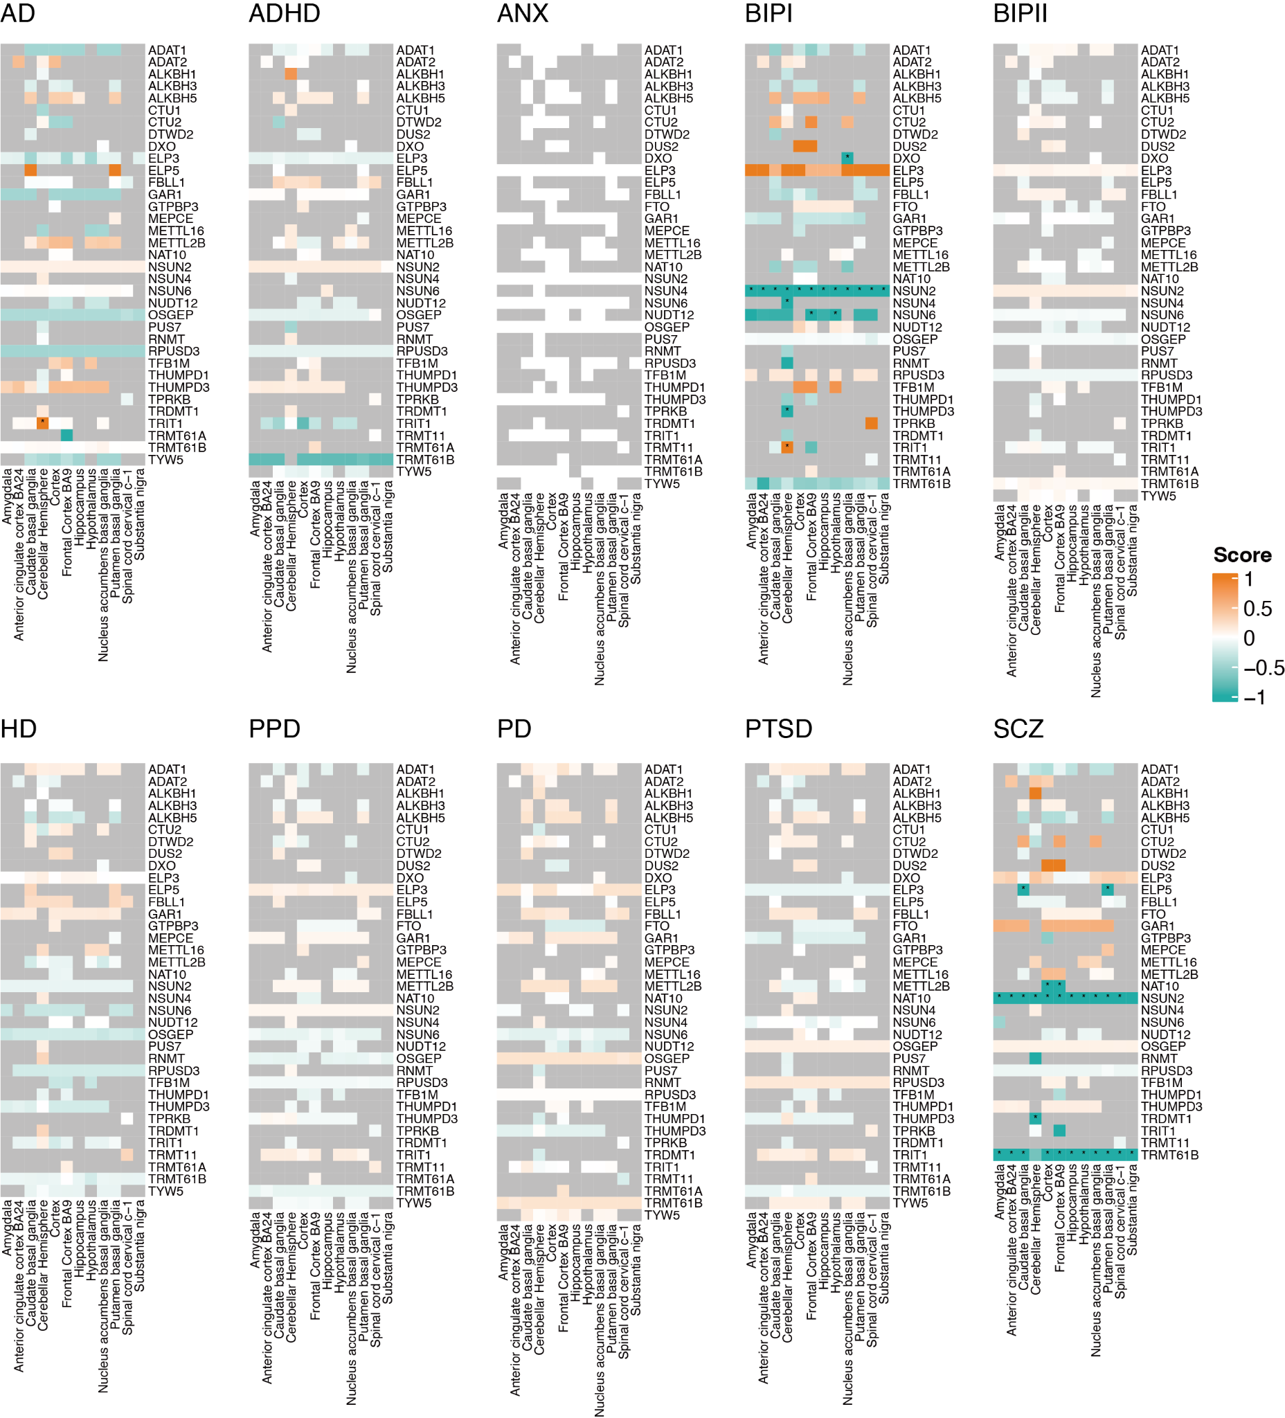
Figure S7: Supplementary figure for Figure 1
SMR analysis results based on eQTLs from different brain regions as references. The score is calculated as -sign(beta)*log10(FDR). Asterisks indicate significant associations with FDR < 0.05.
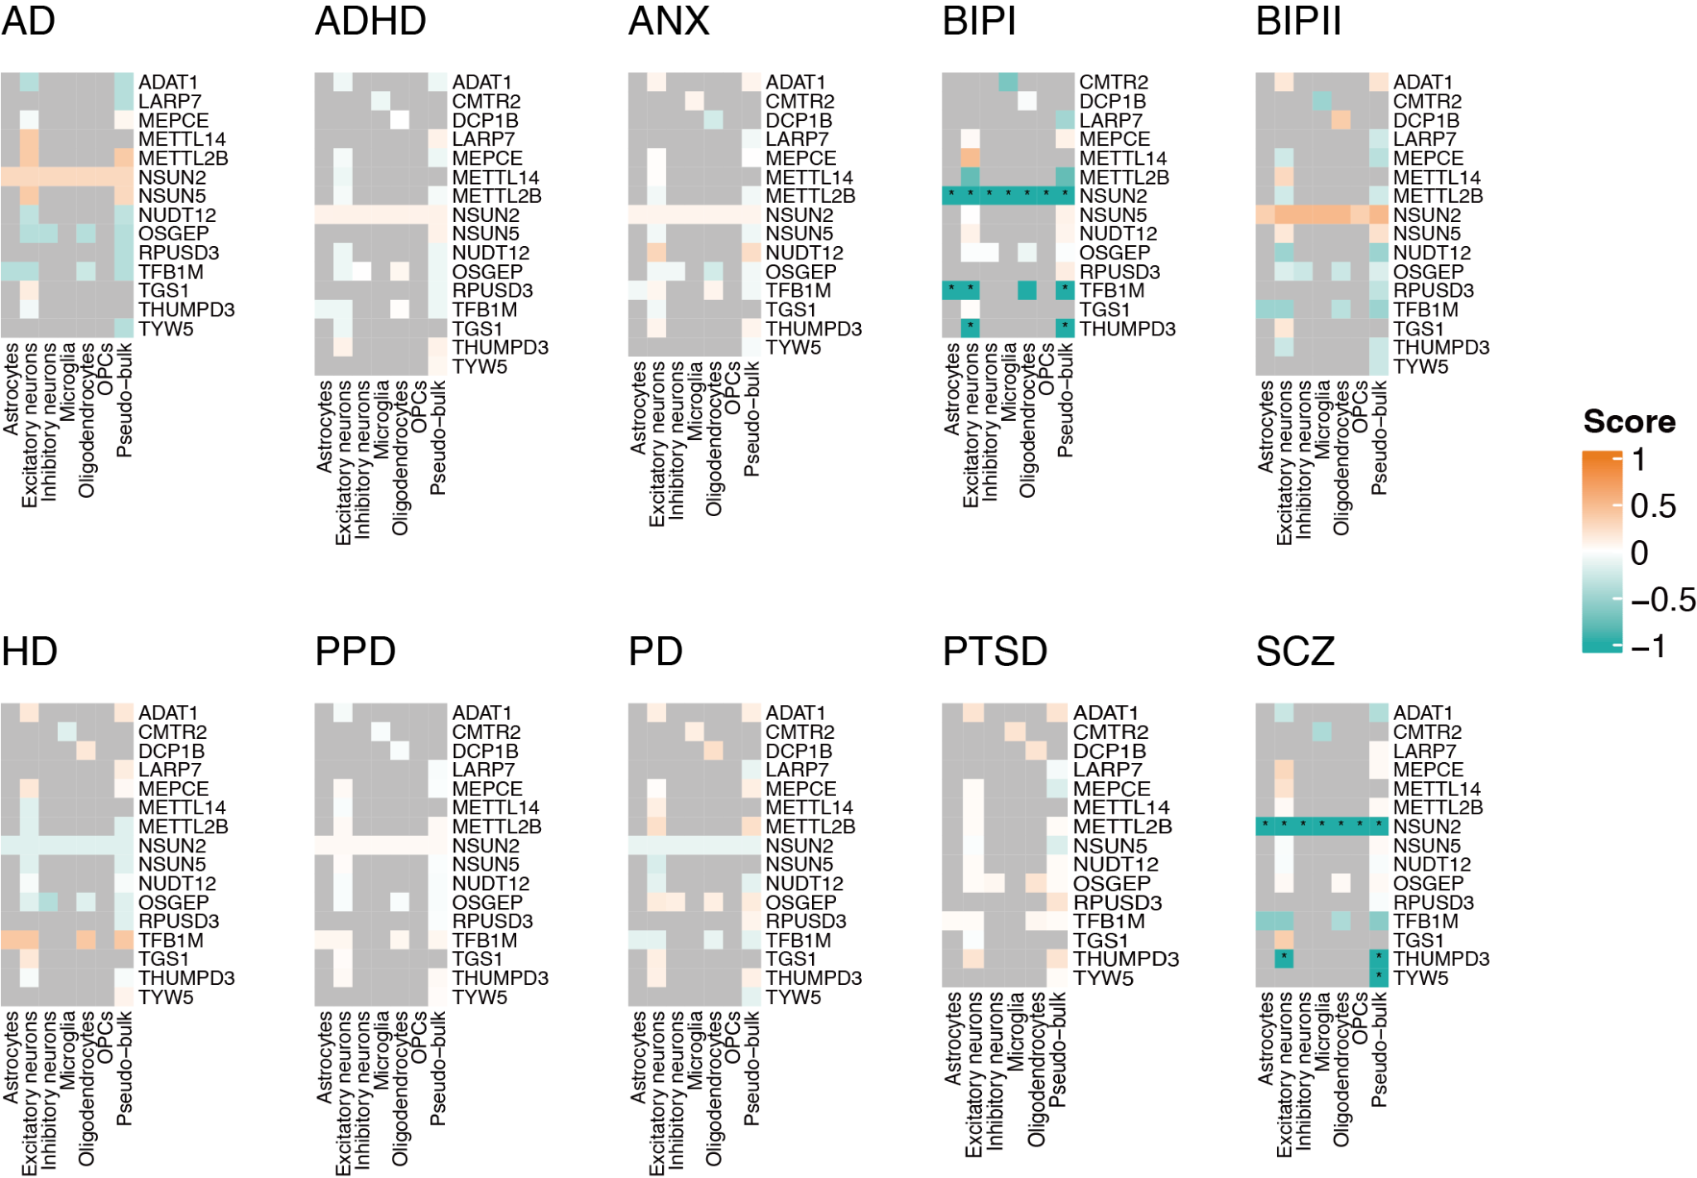
Figure S8: Supplementary figure for Figure 1
SMR analysis results based on eQTLs from different cell types as references. The score is calculated as -sign(beta)*log10(FDR). Asterisks indicate significant associations with FDR < 0.05.

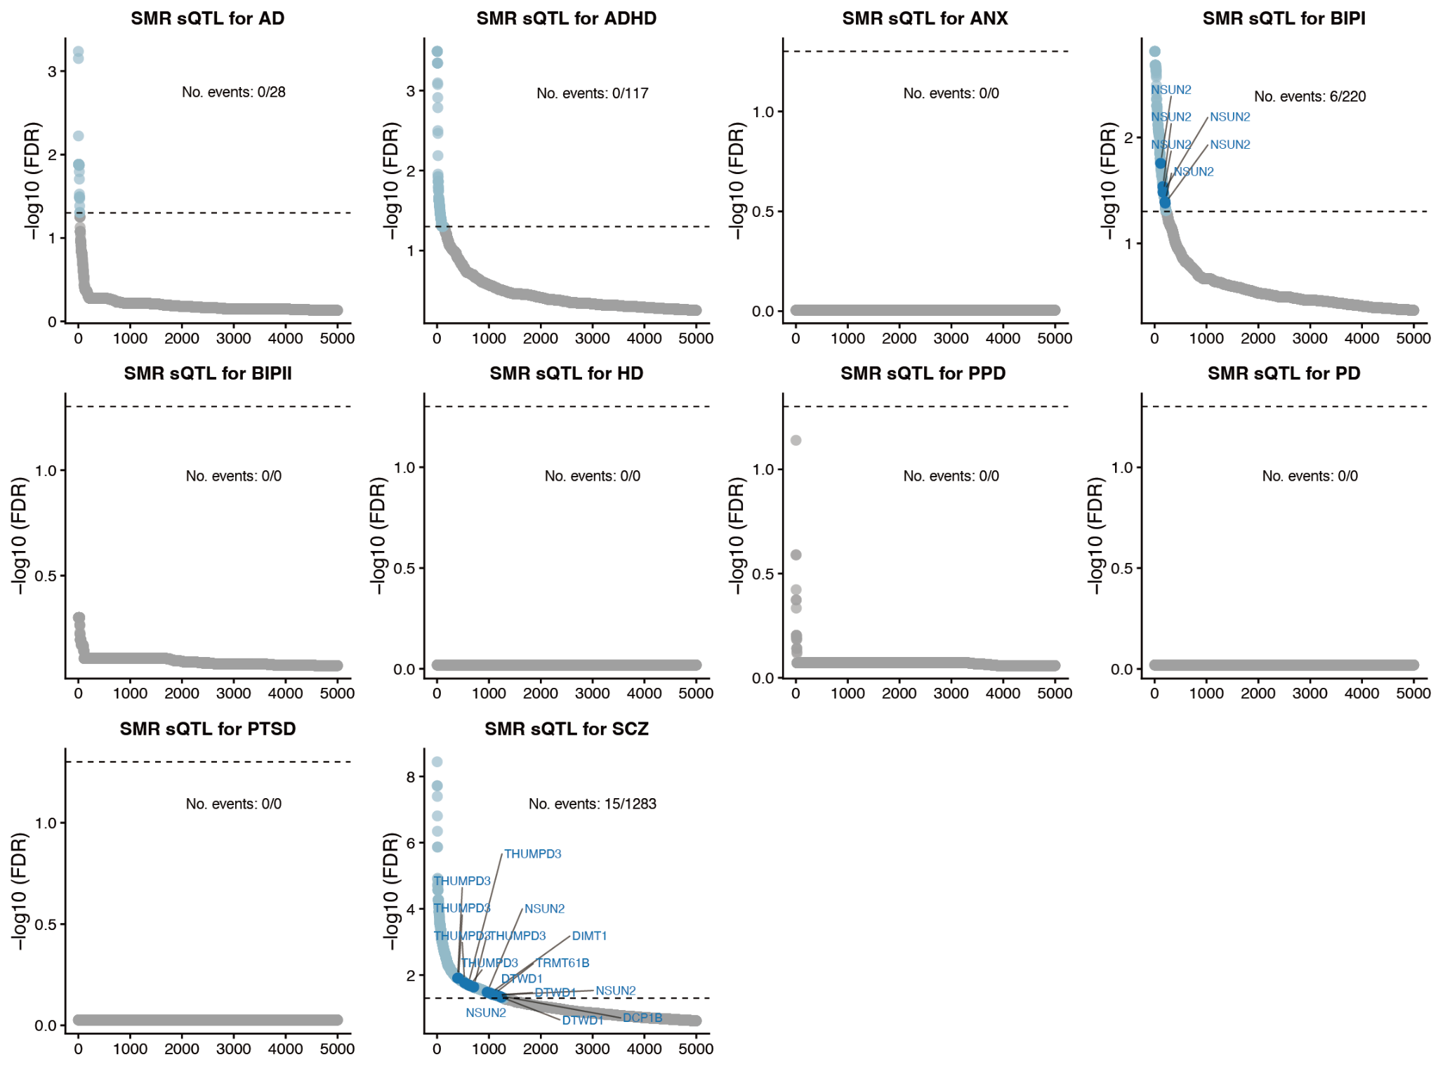
Figure S9: Supplementary figure for Figure 1
Scatter plots illustrating SMR results based on DLPFC sQTL reference panels.
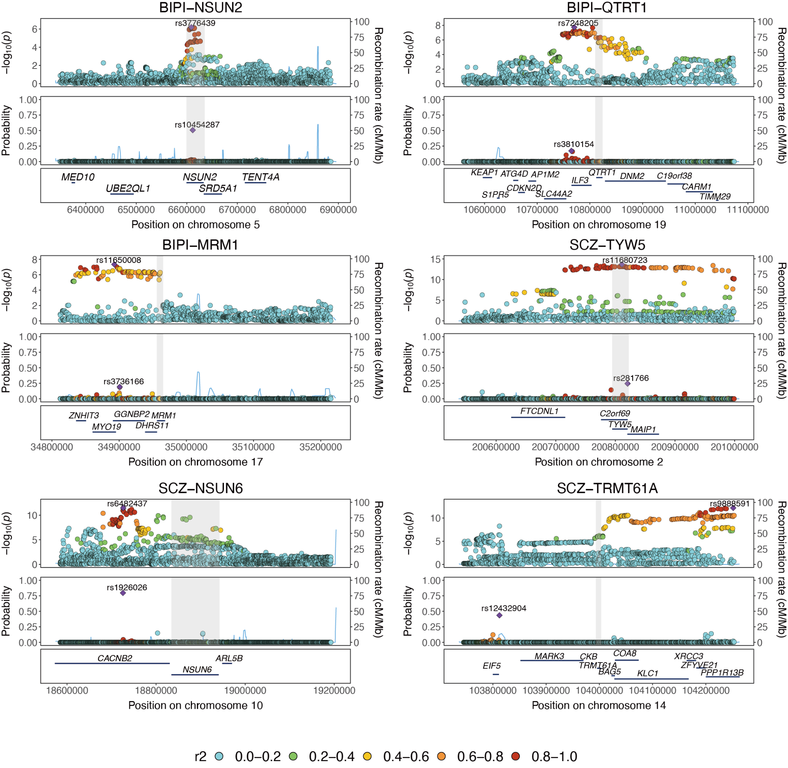
Figure S10: Supplementary figure for Figure 4
Stacked LocusZoom plots provide a regional view of GWAS signals and fine-mapping posterior inclusion probabilities (PIPs) for NSUN2 (BIPI), QTRT1 (BIPI), MRM1 (BIPI), TYW5 (SCZ), NSUN6 (SCZ), and TRMT61A (SCZ). For each region, a ±500 kb genomic region centered on the gene locus is shown in the LocusZoom plots. Gray rectangles indicate the gene body and promoter regions within the genomic locus.
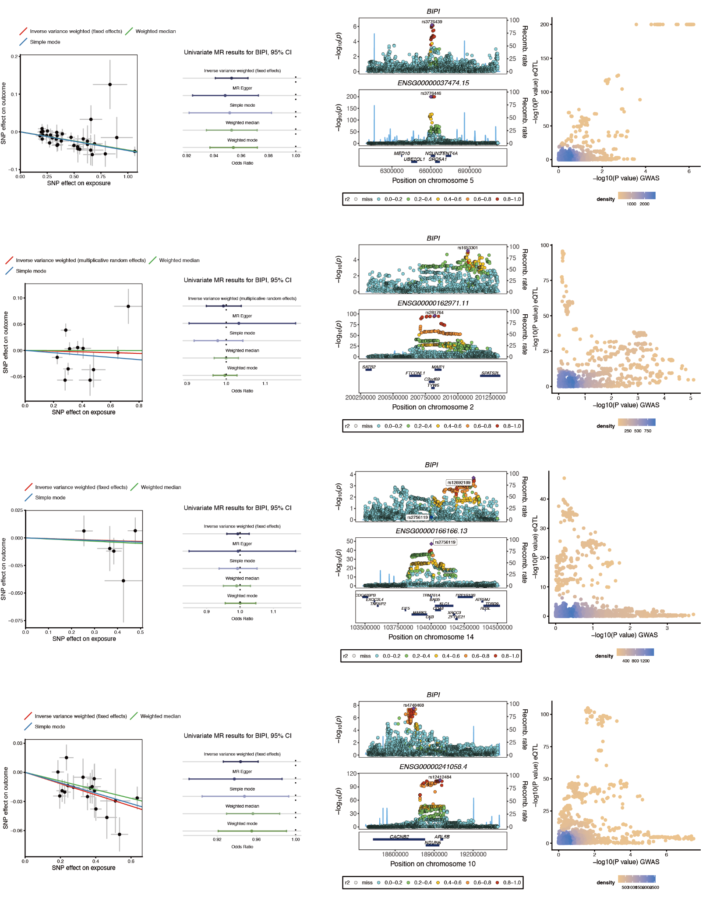
Figure S11: Supplementary figure for Figure 4
Two-sample Mendelian randomization and colocalization analyses for prioritized RMP genes in BIPI. Results are shown for NSUN2, TYW5, TRMT61A, and NSUN6. Left panels: scatter plots depicting GWAS and eQTL effect sizes for individual SNPs, with regression lines for each MR method; the slope represents the estimated causal effect. Middle panels: forest plots summarizing the estimated causal effects from different MR methods. Right panels: colocalization LocusZoom plots with corresponding scatter plots of GWAS versus eQTL association P-values.

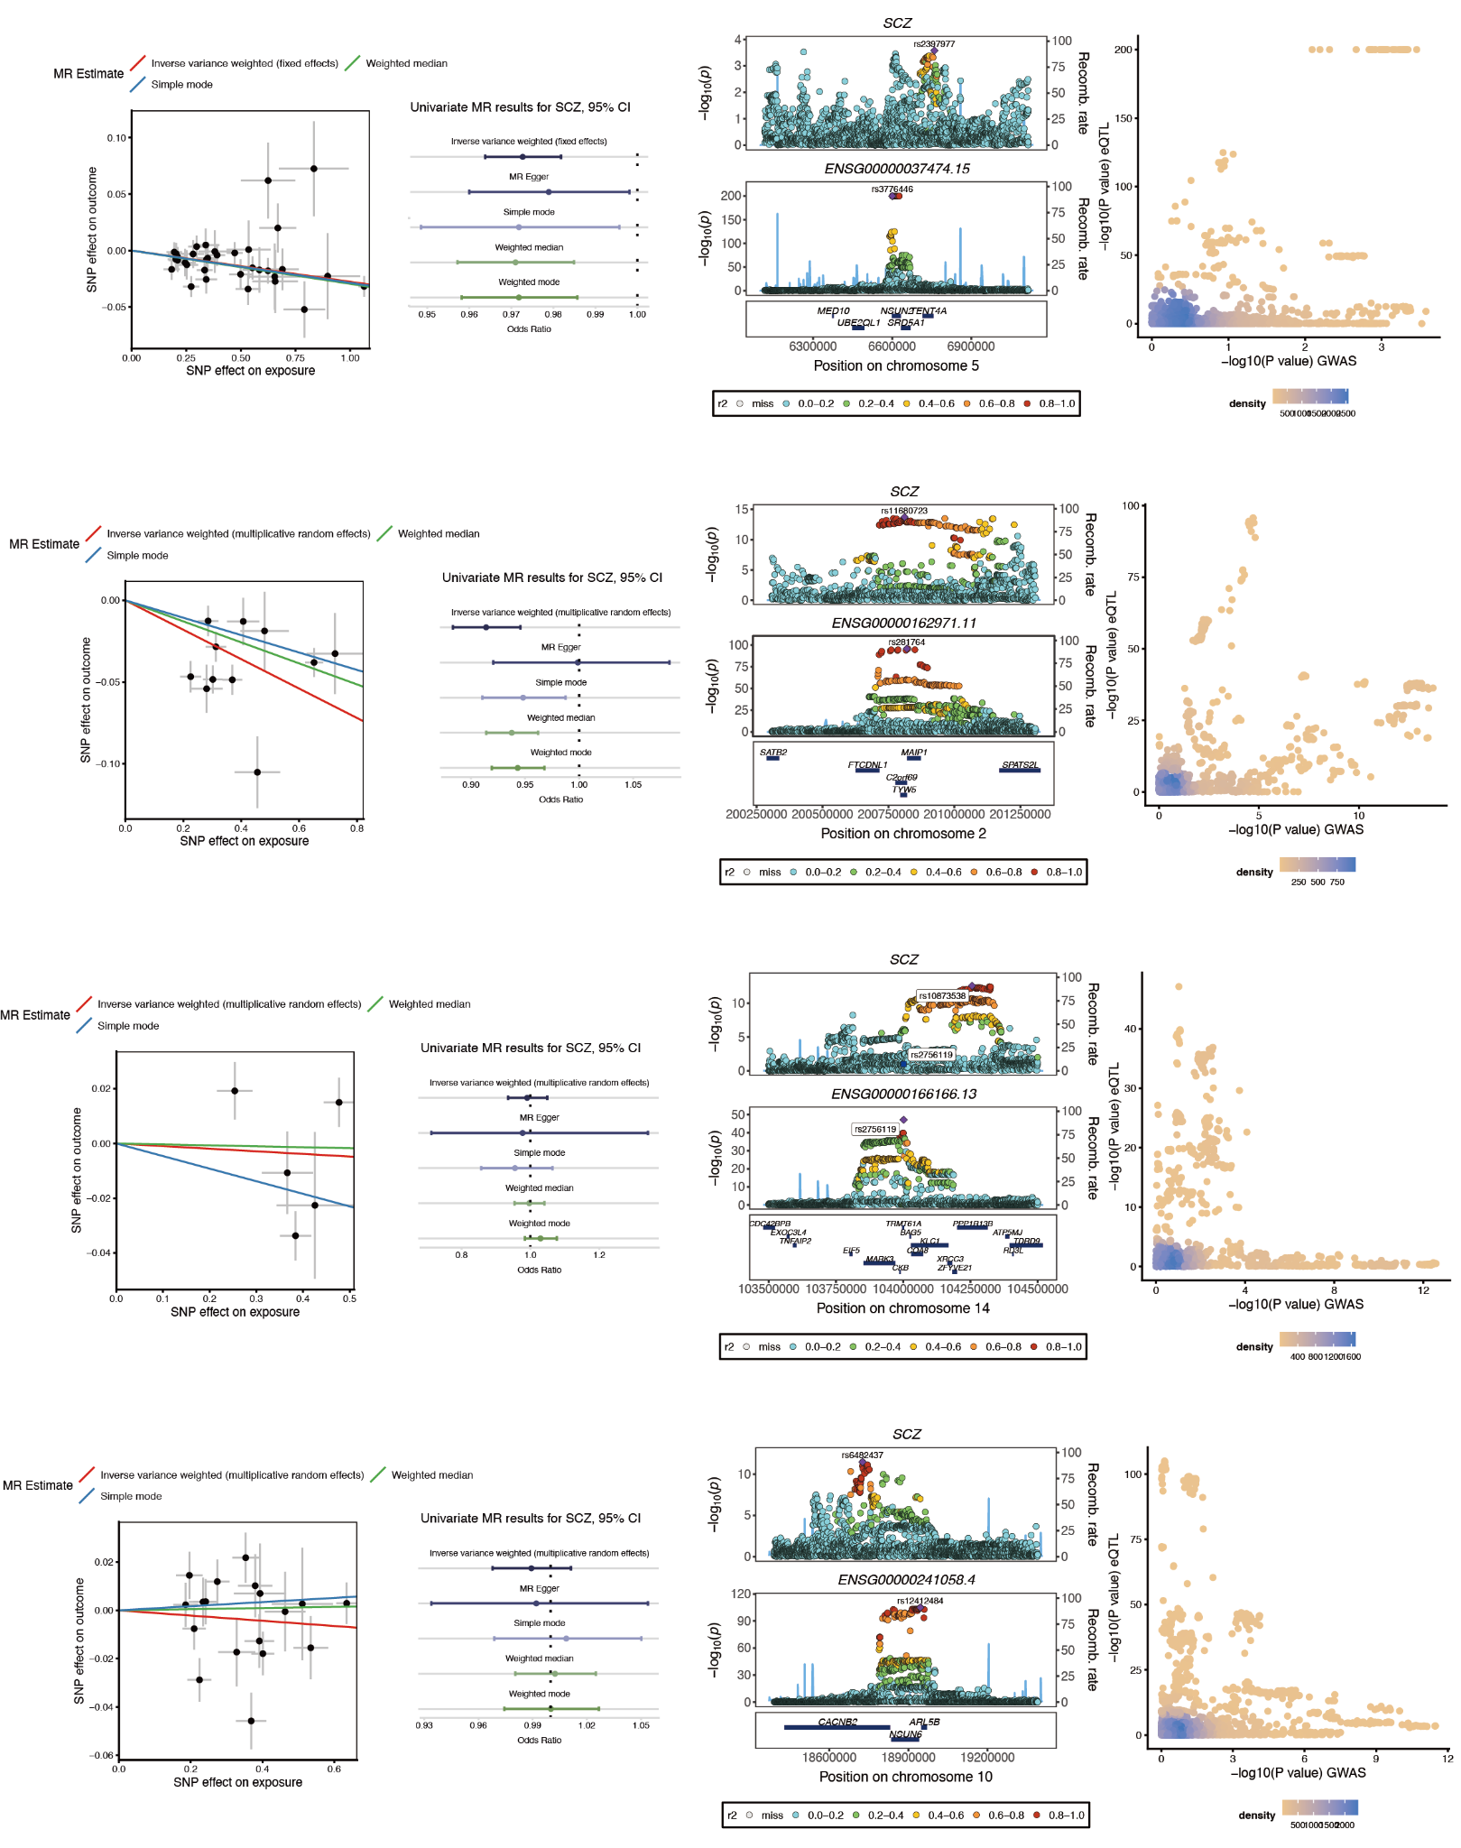
Figure S12: Supplementary figure for Figure 4
Two-sample Mendelian randomization and colocalization analyses for prioritized RMP genes in SCZ.
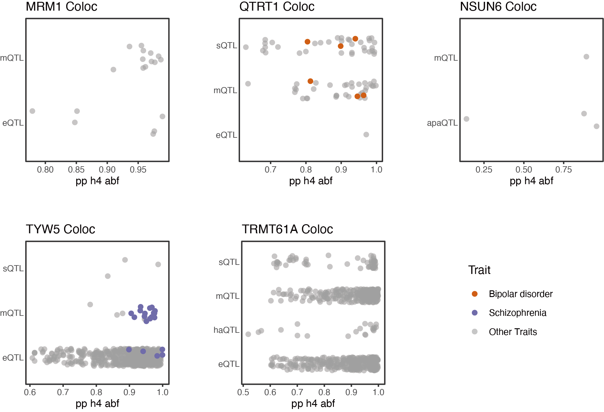
Figure S13: Supplementary figure for Figure 5
Coloc analysis results of xQTL–trait associations for the candidate genes
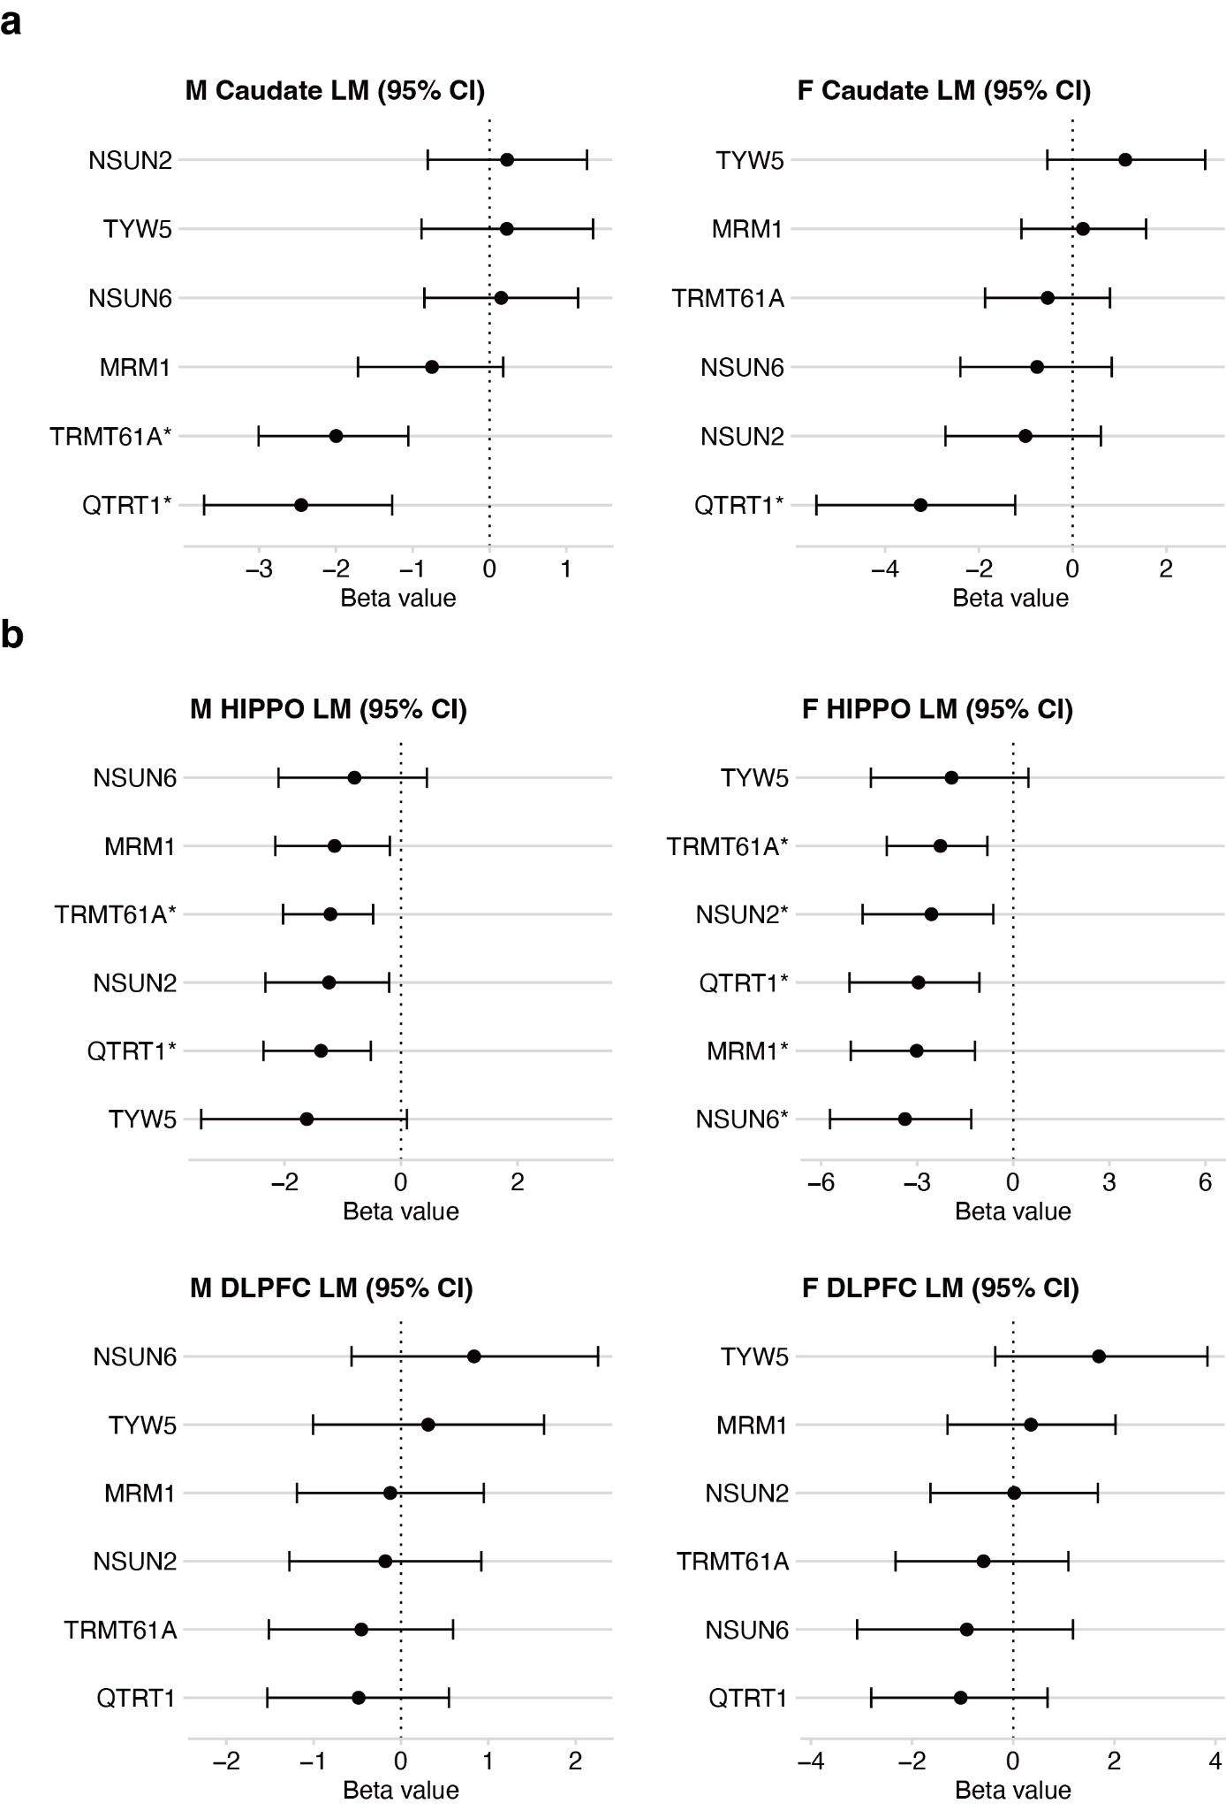
Figure S14: Supplementary figure for Figure 6
Logistic regression analysis of isoform expression-trait associations. Forest plots present the Beta values and 95% confidence intervals (CI) derived from logistic regression models evaluating the association between transcript expression and BIP or SCZ status (*, FDR < 0.05).

