Appendix

A Effects of the Agricultural and Nonagricultural Sectors
Section 4.1 uses the ratio of the agricultural sector to the nonagricultural sector as the key independent variable when estimating the effect of prefecture-level industrial structure on labor migration. The estimates in Table 1 therefore capture the relative effects of the two sectors. To estimate their separate effects, Appendix A replaces the key independent variable. Table A1 uses the agricultural share (A), measured as primary-industry value added relative to GDP, and the nonagricultural share (N-A), measured as the combined value added of the secondary and tertiary industries relative to GDP.

Table A1 Effects of the Agricultural and Nonagricultural Sectors
 | Panel A. Agricultural-Sector Share
 | (1) | (2) | (3) | (4)
 | Choice | Choice | Choice | Choice
A | -4.671*** | -5.459*** | -8.408*** | -4.826***
 | (0.157) | (0.132) | (0.100) | (0.259)
Controls | Yes | Yes | Yes | Yes
N | 5,145,182 | 17,070,615 | 42,604,520 | 7,088,235
$$Pseudo R^{2}$$ | 0.280 | 0.309 | 0.251 | 0.178
 | Panel B. Nonagricultural-Sector Share
 | (1) | (2) | (3) | (4)
 | Choice | Choice | Choice | Choice
N-A | 4.619*** | 5.455*** | 8.549*** | 4.525***
 | (0.147) | (0.132) | (0.096) | (0.252)
Controls | Yes | Yes | Yes | Yes
N | 5,145,182 | 17,070,615 | 42,604,520 | 7,088,235
$$Pseudo R^{2}$$ | 0.280 | 0.309 | 0.252 | 0.177
Note: Columns 1-4 use the 2000, 2005, 2010, and 2015 samples, respectively. Controls include the logarithms of candidate prefectures' GDP, population, and fiscal expenditure and measures of fixed-asset investment, medical services, secondary education services, primary education services, and transportation services. *** p < 0.01, ** p < 0.05, * p < 0.10.

Panel A shows that the agricultural sector has a negative effect on destination choice, whereas Panel B shows that the nonagricultural sector has a positive effect. These findings support the baseline result that the nonagricultural sector attracts migrant workers relative to the agricultural sector.

B Additional Test of the Employment-Opportunity Channel
Section 5.1 uses the number of employees in prefectural work units to examine the employment-opportunity channel. However, the China City Statistical Yearbooks exclude private-sector employees from the work-unit measure, which may weaken its validity as a proxy for local employment opportunities.

Table B1 Mechanism Analysis: Employment-Opportunity Channel
 | Panel A. Employment Opportunities as the Dependent Variable
 | (1) | (2) | (3)
 | ln(Private employees) | ln(Private employees) | ln(Private employees)
A/N-A | -1.232*** | -1.124*** | -0.812***
 | (0.001) | (0.001) | (0.002)
Controls | Yes | Yes | Yes
N | 17,070,615 | 42,604,520 | 7,088,235
$$Adjust R^{2}$$ | 0.799 | 0.814 | 0.829
 | Panel B. Destination Choice with Employment Opportunities
 | (1) | (2) | (3)
 | Choice | Choice | Choice
A/N-A | -2.815*** | -5.185*** | -2.024***
 | (0.094) | (0.082) | (0.207)
ln(Private employees) | 0.254*** | 0.151*** | 0.236***
 | (0.017) | (0.007) | (0.021)
Controls | Yes | Yes | Yes
N | 17,070,615 | 42,604,520 | 7,088,235
$$Pseudo R^{2}$$ | 0.309 | 0.251 | 0.177
Note: Columns 1-3 use the 2005, 2010, and 2015 samples, respectively. Controls include the logarithms of candidate prefectures' GDP, population, and fiscal expenditure and measures of fixed-asset investment, medical services, secondary education services, primary education services, and transportation services. *** p < 0.01, ** p < 0.05, * p < 0.10.

Appendix B uses the natural logarithm of the number of private-sector employees [ln(Private employees)] as an alternative measure of employment opportunities. Because data are unavailable before 2000, Table B1 examines migration during 2001-2015. Panel A shows a negative effect of prefecture-level industrial structure on employment opportunities, while Panel B supports the hypothesis that industrial structure attracts migrant workers by expanding employment. These findings are consistent with Table 8 and alleviate concerns about the specification used in Section 5.1.

C Trends in Housing Prices
Housing prices are commonly used as a proxy for regional living costs and to assess whether living costs affect labor migration. The paper classifies prefectures into groups with large and small nonagricultural sectors using either the mean or the median agricultural-to-nonagricultural ratio calculated from the 2005, 2010, and 2015 census samples. For example, during 2000-2004, a prefecture is assigned to the large-nonagricultural-sector group if its agricultural-to-nonagricultural ratio is below the mean or median calculated from the 2005 sample; otherwise, it is assigned to the small-nonagricultural-sector group. The paper then collects annual prefecture-level housing prices for 2000-2014 and plots the trends over time.

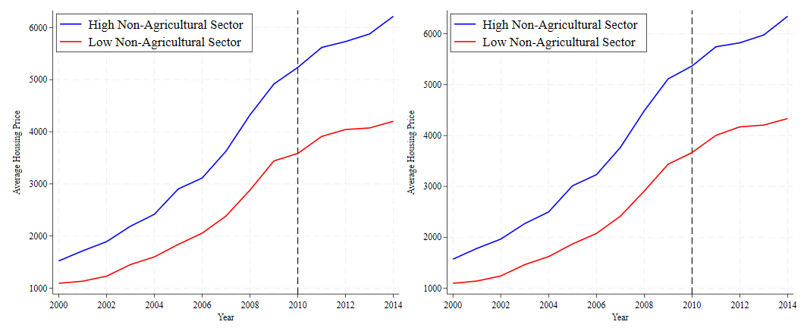
Figure C1 Trends in Housing Prices
Note: The left panel classifies prefectures using the mean agricultural-to-nonagricultural ratio, whereas the right panel uses the median. The blue line represents prefectures with large nonagricultural sectors, and the red line represents prefectures with small nonagricultural sectors.

Figure C1 shows that average housing prices are consistently higher in prefectures with large nonagricultural sectors than in those with small nonagricultural sectors. The gap widens over time and expands particularly rapidly around 2010. This pattern provides suggestive evidence for the dynamic-effect analysis in Section 4.1: rapidly rising living costs associated with nonagricultural agglomeration may weaken the sector's pull effect in the later period.

D Summary Statistics
Table D1 reports summary statistics for the four migration samples. Panel A covers 1996-2000 and includes 227 candidate prefectures and 22,666 individuals. Panel B covers 2001-2005 and includes 279 candidate prefectures and 61,185 individuals. Panel C covers 2006-2010 and includes 280 candidate prefectures and 152,159 individuals. Panel D covers 2011-2015 and includes 285 candidate prefectures and 24,871 individuals.

Table D1 Summary Statistics
 | N | Mean | SD | Min | Max
Panel A. 2000 Sample
A/N-A | 227 | 0.311 | 0.199 | 0.008 | 0.982
ln(GDP) | 227 | 14.433 | 0.857 | 11.945 | 16.617
ln(Population) | 227 | 5.683 | 0.751 | 2.599 | 6.977
ln(Fiscal expenditure) | 227 | 11.884 | 0.713 | 9.596 | 14.247
FA | 227 | 0.220 | 0.096 | 0.071 | 0.667
MS | 227 | 8.995 | 0.644 | 6.607 | 10.520
SES | 227 | 6.499 | 0.571 | 5.863 | 11.381
PES | 227 | 6.091 | 0.212 | 5.550 | 6.698
TS | 227 | 8.034 | 0.873 | 4.680 | 10.306
SI/TI | 227 | 1.460 | 0.737 | 0.366 | 7.368
ln(Wage) | 227 | 8.698 | 0.252 | 8.072 | 9.709
ln(Unit employees) | 227 | 4.710 | 0.747 | 2.065 | 6.201
Gender | 22,666 | 0.556 | 0.497 | 0 | 1
Age | 22,666 | 27.096 | 8.145 | 16 | 64
Education level | 22,666 | 2.964 | 0.718 | 1 | 7
Occupation | 22,666 | 667.756 | 212.993 | 33 | 999
Panel B. 2005 Sample
A/N-A | 279 | 0.265 | 0.176 | 0.004 | 0.891
ln(GDP) | 279 | 14.790 | 0.868 | 12.534 | 17.261
ln(Population) | 279 | 5.763 | 0.670 | 2.787 | 6.976
ln(Fiscal expenditure) | 279 | 12.411 | 0.683 | 10.234 | 15.027
FA | 279 | 0.337 | 0.131 | 0.111 | 1.083
MS | 279 | 8.937 | 0.627 | 6.973 | 10.548
SES | 279 | 6.299 | 0.140 | 5.787 | 6.805
PES | 279 | 6.211 | 0.233 | 5.624 | 7.205
TS | 279 | 8.221 | 0.855 | 5.055 | 10.863
SI/TI | 279 | 1.368 | 0.767 | 0.468 | 8.202
ln(Wage) | 279 | 9.258 | 0.254 | 8.617 | 10.241
ln(Unit employees) | 279 | 3.332 | 0.661 | 1.670 | 5.260
Gender | 61,185 | 0.550 | 0.498 | 0 | 1
Age | 61,185 | 27.930 | 8.746 | 16 | 64
Education level | 61,185 | 3.122 | 0.812 | 1 | 7
Occupation | 61,185 | 63.400 | 22.207 | 1 | 99
Panel C. 2010 Sample
A/N-A | 280 | 0.196 | 0.136 | 0.001 | 0.721
ln(GDP) | 280 | 15.561 | 0.871 | 13.377 | 18.084
ln(Population) | 280 | 5.797 | 0.676 | 2.917 | 7.057
ln(Fiscal expenditure) | 280 | 13.488 | 0.645 | 11.250 | 15.841
FA | 280 | 0.555 | 0.163 | 0.149 | 1.099
MS | 280 | 9.098 | 0.647 | 7.035 | 10.787
SES | 280 | 6.436 | 0.192 | 5.895 | 7.580
PES | 280 | 6.327 | 0.221 | 5.732 | 6.973
TS | 280 | 8.575 | 0.841 | 6.116 | 10.898
SI/TI | 280 | 1.498 | 0.852 | 0.381 | 8.691
ln(Wage) | 280 | 9.937 | 0.237 | 9.089 | 10.755
ln(Unit employees) | 280 | 3.303 | 0.714 | 1.466 | 5.386
Gender | 152,159 | 0.605 | 0.489 | 0 | 1
Age | 152,159 | 30.430 | 9.819 | 16 | 64
Education level | 152,159 | 3.257 | 0.878 | 1 | 7
Occupation | 152,159 | 622.597 | 232.005 | 10 | 999
Panel D. 2015 Sample
A/N-A | 285 | 0.160 | 0.118 | 0.000 | 0.924
ln(GDP) | 285 | 16.313 | 0.837 | 14.260 | 18.741
ln(Population) | 285 | 5.851 | 0.676 | 3.046 | 7.100
ln(Fiscal expenditure) | 285 | 14.519 | 0.607 | 12.136 | 16.622
FA | 285 | 0.751 | 0.228 | 0.180 | 1.731
MS | 285 | 9.491 | 0.663 | 7.318 | 11.349
SES | 285 | 6.631 | 0.181 | 6.175 | 7.286
PES | 285 | 6.402 | 0.205 | 5.941 | 7.217
TS | 285 | 8.883 | 0.890 | 6.108 | 11.887
SI/TI | 285 | 1.532 | 0.654 | 0.319 | 5.271
ln(Wage) | 285 | 10.577 | 0.188 | 10.005 | 11.115
ln(Unit employees) | 285 | 3.544 | 0.748 | 1.790 | 5.836
Gender | 24,871 | 0.631 | 0.483 | 0 | 1
Age | 24,871 | 32.093 | 9.921 | 16 | 64
Education level | 24,871 | 3.502 | 1.030 | 2 | 7
Occupation | 24,871 | 484.180 | 144.281 | 101 | 800

