Supplementary Material for

House mice (Mus musculus domesticus) demonstrate prosocial behaviour only in the absence of food rewards

Tamara Isabelle Sorg^{1,2*}, Anja Guenther^{3,4}, Peter M. Kappeler^{1,2,5}, Claudia Fichtel¹
¹Behavioral Ecology & Sociobiology Unit, German Primate Center, Leibniz Institute for Primate Research, Göttingen, Germany
²Department of Sociobiology /Anthropology, Johann-Friedrich-Blumenbach Institute of Zoology and Anthropology, University of Göttingen, Göttingen, Germany
³RG Behavioural Ecology of Individual Differences, Max Planck Institute for Evolutionary Biology, Ploen, Germany
⁴Zoology and Animal Ecology, University of Hildesheim, Hildesheim, Germany
⁵Université d’Antananarivo; Antananarivo, Madagascar
*Corresponding author. Email: tamara.i.sorg@gmail.com

Fig. S1 Top-view of bar-pulling PCT set-up. Compartments for actor and partner mouse are divided by a mobile barrier made of wire bars to allow limited contact between individuals and are covered by an acrylic glass lid to prevent escape. The set-up consists of a bottom and an upper tray, the upper tray is pulled backwards so both trays are visible in the picture. The left side of both trays features a handle that extends into the actor’s compartment which could be grabbed by the actor in order to pull either tray forward. Doing so pulled the other tray backward via a pulley system at the back of the trays. Blue dots indicate the food rewards, in this example a choice between (1/0 and 0/1). Schematic created from photo of set-up with use of AI.
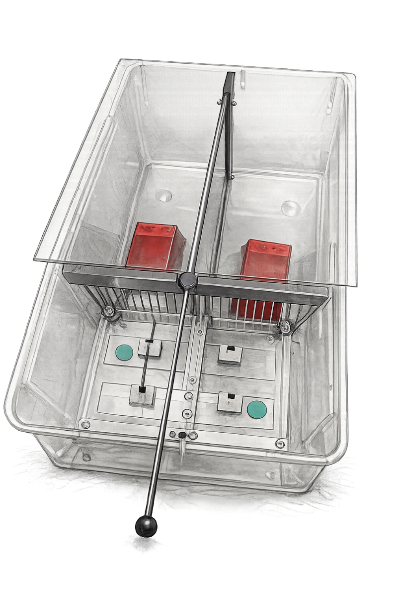

Vid.S2 Video recording of PCT Trials with female house mice. The actor (upper compartment) is offered the choice between both-benefit and an other-benefit in two consecutive trials. In the first trial, the both-benefitting outcome is presented on the upper tray with the other-benefitting outcome on the lower tray, while in the second the placement is reversed with the both-benefitting outcome on the lower tray. In both trials, the actor chooses the both-benefit by pulling the corresponding tray close and both animals take the reward offered on the tray in front of them.

Fig. S3 Trap set-up used in the release paradigm. The metal bar blocked the door from swinging open and thereby prevented mice from leaving or entering the trap while the bar was in place. By pulling or pushing the bar to one side through the hinge, the door could be unblocked. During test conditions, the bar was only hinged on one side as hinging it on both sides proved too difficult for mice to dislodge. Schematic created from photo of set-up with use of AI.
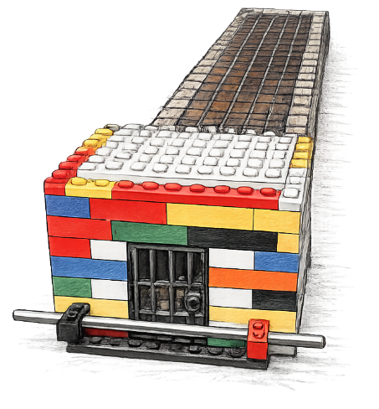

Vid. S4 Video recording of Release Paradigm Trial of the social condition with a trapped partner mouse. The actor is seen entering the test cage and immediately approaches the trap with her cage mate inside. After exploring the trap, she unblocks the trap by pulling away the bar and opens the trap door, after which her partner leaves the trap.

Tab. S5 Estimates and coefficients for the random effects of a GLMM on the effect of the social conditions on the probability of the prosocial option being chosen across all PCT conditions
Groups | Name | Variance | Std.Dev.
ID | (Intercept) | 0.000 | 0.000
ID.1 | condition.both.other | 0.000 | 0.000
ID.2 | condition.both.self | 0.154 | 0.393
ID.3 | condition.self.other | 0.744 | 0.862
ID.4 | condition.other.no | 0.000 | 0.000

Tab. S6 Estimates and coefficients for the random effects of a GLMM on the effect of the presence or absence of a partner on the probability of the prosocial option being chosen in a other- vs. no-benefit choice; LMM on the effect of condition on the latency of opening a trap in the release paradigm
Groups | Name | Variance | Std.Dev.
ID | (Intercept) | 0.000 | 0.000
ID.1 | condition.other.no | 0.000 | 0.000

