SUPPLEMENTARY MATERIAL
Supplementary Methods:
Supplementary method 1: Fecal microbial DNA extraction, amplification, and 16S rRNA gene sequencing

Supplementary Tables:
Supplementary Table S1: Baseline characteristics of participants in the external validation cohort.

Supplementary Figures:
Supplementary Figure S1: Comparison of the Firmicutes-to-Bacteroidota (F/B) ratio between athletes and sedentary individuals
Supplementary Figure S2: Performance comparison of five machine learning models for discriminating athletes from sedentary individuals.

Supplementary method 1: Fecal microbial DNA extraction, amplification, and 16S rRNA gene sequencing
1) DNA extraction and PCR amplification
Total genomic DNA was extracted from fecal samples using the cetyltrimethylammonium bromide (CTAB) method, followed by purification. DNA quality and concentration were assessed by 1% agarose gel electrophoresis, and samples were diluted to 1 ng/μL. The V3–V4 hypervariable regions of the 16S rRNA gene were amplified using primers 338（5′-ACTCCTACGGGAGGCAGCAG-3' ) and 806R (5′-GGACTACNNGGGTATCTAAT-3′). Negative controls without template DNA were included in each batch; only batches in which the negative control showed no detectable amplification (<0.1 ng/μL) were considered valid, thereby excluding potential aerosol contamination.
PCR amplification was performed as follows: barcoded primers targeting the V3–V4 regions were used at a concentration of 1 μM. Amplification was conducted using Phusion® High-Fidelity PCR Master Mix with GC Buffer (New England Biolabs, Cat# M0530S) to ensure high accuracy and efficiency. The PCR reaction mixture (30 μL) consisted of 10 μL template DNA, 15 μL Phusion® Master Mix, 1 μL each of forward and reverse primers (1 μM, containing Illumina adapters and sample-specific barcodes), and 2 μL nuclease-free water. The thermal cycling conditions were as follows: initial denaturation at 98 °C for 1 min; 30 cycles of denaturation at 98 °C for 10 s, annealing at 50 °C for 30 s, and extension at 72 °C for 30 s; followed by a final extension at 72 °C for 10 min and hold at 10 °C. Amplification was performed using a Bio-Rad T100 thermal cycler.
2) PCR product purification and pooling
PCR products were pooled at equimolar concentrations and thoroughly mixed. The pooled amplicons were purified by 2% agarose gel electrophoresis (1× TAE buffer), and the target bands were excised and recovered using a Universal DNA purification kit. Fragment quality was verified using an Agilent 5400 Fragment Analyzer.
3) Library preparation and sequencing
Sequencing libraries were constructed using the NEBNext® Ultra DNA Library Prep Kit. Library quality was assessed using the Agilent 5400 system and quantified by qPCR. Sequencing was performed on the Illumina NovaSeq 6000 platform using a paired-end 250 bp (PE250) strategy, with a minimum sequencing depth of ≥50,000 reads per sample.
4) Bioinformatics analysis
The raw high-throughput sequencing data were processed using QIIME2 (version 2024.2). The DADA2 algorithm was employed for quality control, trimming, denoising, and assembly of the raw sequences to remove phiX, chimeric, and erroneous reads, thereby generating amplicon sequence variants (ASVs). Taxonomy was assigned to ASVs using the classify-sklearn method against the Silva 138 database ( https://www.arb-silva.de/ ).
5) Microbial diversity
Alpha diversity: Alpha diversity of the microbial community was assessed through richness (observed ASVs and Chao1 index), diversity (Shannon and Simpson indices), evenness (Pielou’s evenness index), and coverage (Good’s coverage). Kruskal–Wallis rank sum tests were used to compare alpha diversity indices among groups. Rarefaction curves were generated by rarefying the ASV table to a series of sequencing depths and calculating the number of observed ASVs at each depth; curves approaching a plateau indicate that the sequencing depth was sufficient to capture the majority of microbial diversity.
Beta diversity: Beta diversity, representing between-sample differences in community composition, was evaluated by computing Bray–Curtis distance and Jaccard distance based on ASV abundances. Statistical significance of group differences was determined by permutational multivariate analysis of variance (PERMANOVA) using the adonis function. Principal coordinate analysis (PCoA) were performed based on the distance matrices and visualized using the vegan and ggplot2 packages in R.
Biomarker discovery: Between-group differences in microbial community structure were assessed using permutational multivariate analysis of variance (PERMANOVA), a non-parametric statistical test. Pairwise comparisons were performed as post-hoc tests, with p-values adjusted using the false discovery rate (FDR) method.
The metagenomic function was predicted by PICRUSt2 (Phylogenetic Investigation of Communities by Reconstruction of Unobserved States)^{[4]} based on ASV representative sequences. PICRUSt2 is a software containing a series of tools as follows: HMMER was used to aligns ASV representative sequences with reference sequences. EPA-NG and Gappa were used to put ASV representative sequences into a reference tree. The castor was used to normalize the 16S gene copies. MinPath was used to predict gene family profiles, and locate into the gene pathways. Entire analysis process was accord to protocols of PICRUSt2.
Keystoneness calculation:Structural Keystoneness (Ks) was calculated using the deep learning-based keystone species identification framework proposed by Wang et al^{[1]}.This method constructs a neural network model from species abundance data and assesses the structural importance of each taxon by sequentially removing it and quantifying the resulting reduction in community prediction accuracy, thereby assigning a keystone-ness score to each taxon. Specifically, a trained deep learning model is used to predict the original intact community; the abundance of the target species is then set to zero and the community is re-predicted. The difference in prediction error between the two conditions represents the raw keystone-ness score of that species. Based on these scores, the median keystone-ness [median(Ks)] and the median absolute deviation of keystone-ness [MAD(Ks)] across all samples were calculated for each taxon, to evaluate the community specificity and condition.
The Gut Microbiome Health Index (GMHI) and the Microbial Dysbiosis Index (MDI) were calculated to comprehensively evaluate gut microbial health status. GMHI was calculated according to the method proposed by Gupta et al., which integrates the relative abundances of health-prevalent and health-scarce microbial species into a single quantitative index reflecting host gut microbial health. Compared with conventional α-diversity metrics, GMHI has demonstrated superior ability to distinguish healthy from non-healthy individuals and has shown good reproducibility across independent cohorts.
Briefly, microbial prevalence in healthy and non-healthy reference populations was used to calculate the prevalence fold change and prevalence difference for each microbial species. Species meeting the predefined thresholds were classified as health-prevalent or health-scarce taxa. GMHI was subsequently calculated based on the relative abundances of these taxa, with higher GMHI values indicating a healthier gut microbial ecosystem. GMHI was computed using the publicly available implementation described by Gupta et al^{[2]}.
The Microbial Dysbiosis Index (MDI) was calculated to evaluate the degree of gut microbial dysbiosis according to the method described by Gunathilake et al. MDI quantifies microbial imbalance by comparing the cumulative relative abundance of taxa enriched in the disease group with that of taxa depleted in the disease group. Higher MDI values indicate greater disruption of the gut microbial ecosystem ^{[3]}.
6）Machine Learning Analysis
To identify key microbial signatures associated with long-term exercise training and evaluate their discriminatory performance, five supervised machine learning algorithms, including Random Forest (RF), Support Vector Machine (SVM), Decision Tree (DT), K-Nearest Neighbors (KNN), and Logistic Regression (LR), were constructed using genus-level relative abundance profiles. Model performance was evaluated based on the area under the receiver operating characteristic curve (AUC), accuracy, precision, recall, and F1-score, and the optimal model was selected accordingly.
The dataset was randomly divided into a training set (70%) and an independent testing set (30%). To reduce overfitting and improve model stability, five-fold cross-validation was performed during model training. Briefly, the training dataset was randomly partitioned into five equal subsets; in each iteration, one subset was used for validation and the remaining four subsets were used for model training. This procedure was repeated five times, and the average performance metrics were calculated to determine the optimal model.
Feature importance was assessed using the Mean Decrease Accuracy (MDA) algorithm implemented in the Random Forest model. The optimal number of microbial features was determined according to model performance, and receiver operating characteristic (ROC) curves were generated to evaluate classification performance. To further verify the stability of the model, an independent external validation cohort was used for validation. The baseline characteristics of participants in the external validation cohort are presented in Supplementary Table S1. All machine learning analyses were performed using R software (version 4.3.2).
Reference
[1] Wang XW, Sun Z, Jia H, Michel-Mata S, Angulo MT, Dai L, He X, Weiss ST, Liu YY. Identifying keystone species in microbial communities using deep learning. Nat Ecol Evol. 2024;8(1):22-31.
[2] Gupta VK, Kim M, Bakshi U, Cunningham KY, Davis JM 3rd, Lazaridis KN, Nelson H, Chia N, Sung J. A predictive index for health status using species-level gut microbiome profiling. Nat Commun. 2020,11(1):4635.
[3] Gunathilake M, Lee J, Choi IJ, Kim YI, Yoon J, Sul WJ, Kim JF, Kim J. Alterations in Gastric Microbial Communities Are Associated with Risk of Gastric Cancer in a Korean Population: A Case-Control Study. Cancers (Basel). 2020,12(9):2619.
[4] Douglas G M , Maffei V J , Zaneveld J R , et al. PICRUSt2 for prediction of metagenome functions[J]. Nature Biotechnology. 2020, 38: 685–688.

Supplementary Table S1. Baseline characteristics of participants in the external validation cohort.
characteristics | EXD (n = 30) | SED (n = 30) | t/χ² | P
Sex n (%) |  |  | χ²=2.58 | 0.108
Male | 14 (46.67) | 8 (26.67)
Female | 16 (53.33) | 22 (73.33)
Age(y) | 20.33 ± 2.04 | 20.80 ± 2.07 | t=-0.88 | 0.383
Height (Cm) | 173.96 ± 5.60 | 171.38 ± 4.37 | t=1.99 | 0.052
Weight (Kg) | 67.37 ± 6.66 | 65.87 ± 5.25 | t=0.97 | 0.336
BMI (kg/m2) | 22.26 ± 1.94 | 22.44 ± 1.79 | t=-0.37 | 0.709
VO₂ MAX (ml/Kg/Min) | 3.71 ± 0.93 | 2.28 ± 0.57 | t=7.17 | <.001
VO₂ MAX (L/Min) | 46.67 ± 9.75 | 32.80 ± 4.48 | t=7.08 | <.001
Carbohydrates intake (g/d) | 264.02 ± 26.60 | 253.01 ± 32.35 | t=1.44 | 0.155
Protein intake (g/d) | 73.90 ± 17.77 | 67.92 ± 15.83 | t=1.38 | 0.174
Fat intake (g/d) | 27.35 ± 4.61 | 24.41 ± 4.66 | t=2.45 | 0.017
Total energy intake (kcal/d) | 1597.79 ± 153.71 | 1503.44 ± 194.63 | t=2.08 | 0.042

Supplementary Figure S1: Comparison of the Firmicutes-to-Bacteroidota (F/B) ratio between athletes and sedentary individuals
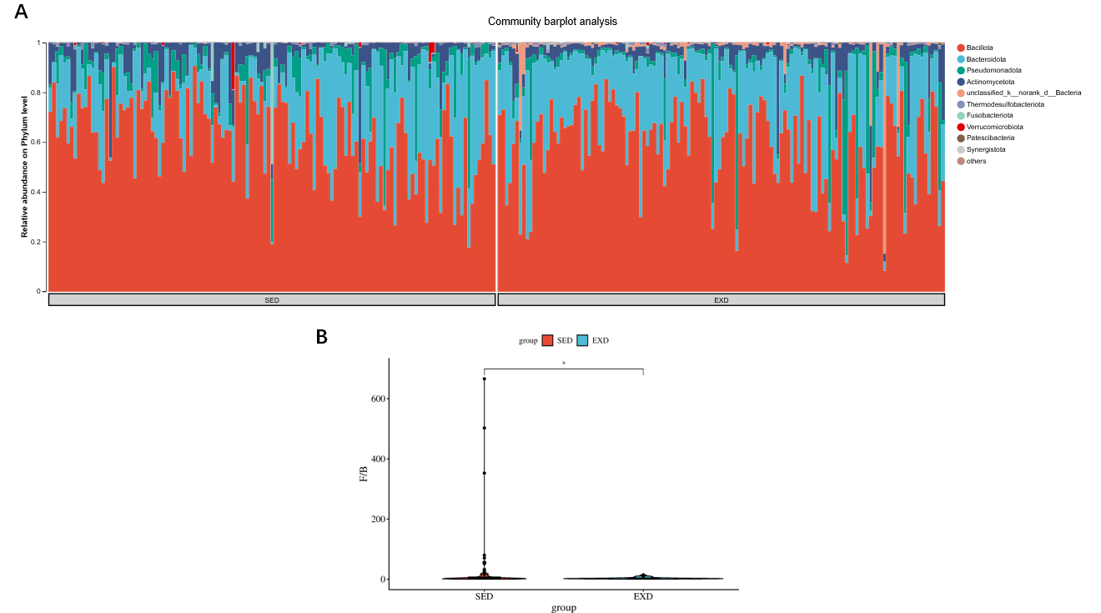
- Relative abundance of major bacterial phyla; (B) Intergroup comparison of the Firmicutes/Bacteroidetes (F/B) ratio.

Supplementary Figure S2: Performance comparison of five machine learning models for discriminating athletes from sedentary individuals.
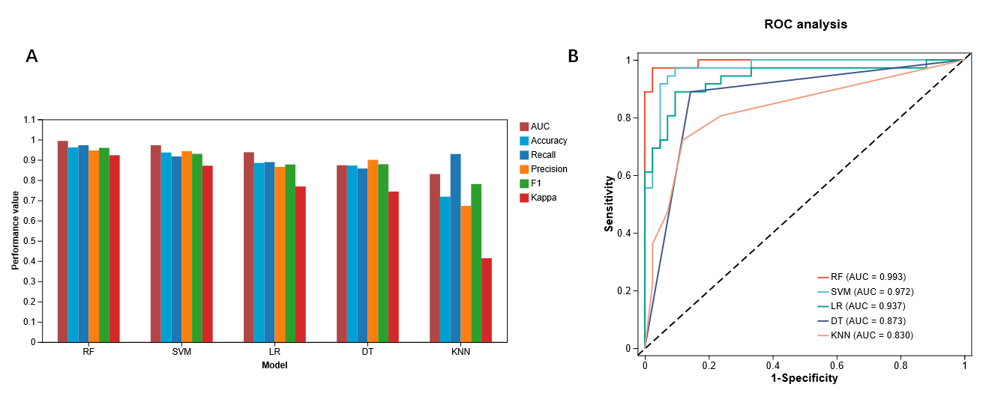
(A) Comparison of classification performance among five supervised machine learning algorithms, including Random Forest (RF), Support Vector Machine (SVM), Decision Tree (DT), K-Nearest Neighbors (KNN), and Logistic Regression (LR). Model performance was evaluated using accuracy, precision, recall, F1-score, specificity, and the area under the receiver operating characteristic curve (AUC).
(B) Receiver operating characteristic (ROC) curves of the five machine learning models. Among all classifiers, the Random Forest model achieved the highest classification performance and was therefore selected for subsequent feature selection and predictive analyses.

