Supplementary Material

Ecological relevance of oral Staphylococcus carriage in healthy adults

Maeva Fonseca^{1*}; Marta Sousa^{1*}; Carla Campos^{2,3}; Joana Campos⁴; Carolina F.F.A. Costa^{5*}; Benedita Sampaio-Maia^{1,4*}
¹Faculdade de Medicina Dentária da Universidade do Porto, Porto, Portugal;
²Serviço de Patologia Clínica, Departamento de Patologia e Medicina Laboratorial, Instituto Português de Oncologia do Porto Francisco Gentil, Porto, Portugal;
³Escola Superior de Saúde, Instituto Politécnico do Porto, Porto, Portugal;
⁴i3S - Instituto de Investigação e Inovação em Saúde, Universidade do Porto, 4200-135 Porto, Portugal;
⁵Department of Pharmacology, University of Oxford, Oxford, UK.
*Contributed equally

Corresponding Author: Benedita Sampaio Maia, bmaia@fmd.up.pt

Detailed Materials and Methods

- Population and Sample Collection

Students from the Integrated Master's Degree in Dental Medicine at FMDUP were invited to participate during the recruitment period. Participation was entirely voluntary, and the final study sample comprised 101 students. The study size was determined by the number of eligible students who agreed to participate.
The study protocol was reviewed and approved by the FMDUP Ethics Committee (Research Project No. 19/2025), and written informed consent was obtained from all participants.
Demographic and recent clinical history data were collected through a questionnaire, including age, sex, smoking habits, infections, and antibiotic or probiotic use during the previous 6 months. Participants reporting antibiotic use or infection within the previous 6 months were excluded to minimize potential disturbances of the oral microbiota.
Oral health status was assessed clinically by two calibrated examiners and included gingival status, the presence of fixed prosthodontics, and the DMFT index (Decayed, Missing, and Filled Teeth). For exploratory analyses, participants were categorized as caries-free (DMFT = 0) or having previous caries experience (DMFT > 0).
The primary outcomes included oral and nasal Staphylococcus carriage, species distribution, antimicrobial susceptibility profiles, multidrug resistance, and longitudinal strain persistence patterns. The DMFT index was explored as a potential predictor of Staphylococcus colonization.
Oral and nasal samples were collected once from all participants (n = 101) using sterile swabs. Questionnaire and clinical examination data were available for 93 participants and no imputation of missing data was performed. Additionally, oral samples were longitudinally collected at up to four time points from a subgroup of participants (n = 31) to explore colonization dynamics using strain typing by Fourier Transform Infrared Spectroscopy with Attenuated Total Reflectance (FTIR-ATR). No imputation procedures were applied for missed follow-up visits. Longitudinal analyses were based on the isolates available from each participant at the sampled time points. Reasons for missing questionnaire and clinical data were not systematically recorded.

- Microbial Isolation and Identification

The swabs were seeded on Mannitol Salt Agar (VWR Chemicals, Leuven, Belgium) and incubated at 37ºC for 48 hours. Morphologically distinct colonies were subcultivated (3-6 per sample) for purity. The isolates were identified by MALDI-TOF MS mass spectrometry (Bruker Daltonics, Bremen, Germany). Only identifications with a score ≥2.0 (representing identification to the species level) were considered.

- Evaluation of Antimicrobial Susceptibility

The antibiotic susceptibility profiles of the isolates were evaluated using the disc diffusion agar method on Mueller-Hinton Agar II (Alliance Bio Expertise, France) following the European Committee on Antimicrobial Susceptibility Testing (EUCAST, 2026)[1] or, when not applicable, Clinical and Laboratory Standards Institute (CLSI, 2026) [2] guidelines (Appendix Table 1). The following nine antibiotics were tested: Amoxicillin (AMO, 10 µg); Cefoxitin (CXI, 30 µg); Chloramphenicol (CHL, 30 µg); Ciprofloxacin (CIP, 5 µg); Clindamycin (CLI, 2 µg); Erythromycin (ERY, 15 µg); Gentamicin (GEN, 10 µg); Tetracycline (TET, 30 µg); Trimethoprim + Sulfamethoxazole (TRS, 25 µg) (Liofilchem, Italy) [1, 2]. Staphylococcus aureus ATCC® 29213 was used as a quality control strain.
Of note, recent guidelines do not define clinical breakpoints for amoxicillin; however, given its widespread prescription in dentistry, its evaluation was maintained in the present study using the reference values established by the 2020 CLSI. Similarly, because EUCAST provides chloramphenicol clinical breakpoints only for S. aureus, CLSI breakpoints were used for the remaining Staphylococcus species. Quinupristin-Dalfopristin (QUD, 15 µg) was evaluated exclusively for S. aureus isolates [1].
Isolates that showed resistance to at least one antibiotic were classified as resistant. Isolates that presented resistance to three or more antibiotic classes were classified as multidrug-resistant (MDR). Amoxicillin was excluded from MDR classification because its assessment was exploratory. Erythromycin, clindamycin, and quinupristin-dalfopristin were considered as a single antimicrobial class for MDR classification; therefore, resistance to one or more of these agents counted as resistance to one class only. For resistance and MDR classification, isolates categorized as intermediate or susceptible under increased exposure were considered susceptible.

- Strain Typing by Infrared Spectroscopy

To assess strain relatedness, evaluate potential colonization persistence, and explore patterns of colonization over time, phenotypic strain typing was performed using the IR Biotyper® system (Bruker Daltonics, Bremen, Germany). This analysis focused on a subgroup of longitudinally monitored participants (n=31), with samples collected at four distinct time points: baseline (T0), 5 months later (T1), and at two additional follow-ups, 2 and 3 weeks later (T2 and T3). Typing was specifically applied to S. aureus and S. warneri isolates from individuals in whom the same species was detected at two or more time points. This methodological approach enabled the identification of strain similarity patterns across time points, allowing inference of potential persistence (presence of highly similar strain profiles over time) or turnover (presence of distinct strain profiles).
The laboratory procedure was carried out according to the manufacturer's instructions, following standardized cultivation using up to six replicates of the same isolate. Spectra were automatically acquired and quality-controlled by the software, and similarity between isolates was calculated using Euclidean distance based on the polysaccharide spectral region, which is commonly used for bacterial discrimination in FTIR-based analysis [3]. Hierarchical clustering was performed by IR Biotyper® software using average linkage. Clustering cut-off values were determined from the dataset, based on intra-sample similarity patterns.

V. Statistical analysis

Statistical Package for the Social Science (IBM® SPSS® Statistics, SPSS Inc, Chicago, IL, USA, version 29) was used for statistical analysis. The categorical variables were described through absolute or relative frequencies (%). Differences between groups for categorical variables were analysed using Fisher’s exact test, while the exact McNemar's test was used for paired comparisons. The continuous variables were reported as mean ± standard deviation (SD), and the Shapiro-Wilk test was used to assess normality. For continuous variables without normal distribution, the Mann-Whitney test was applied for mean comparison between two groups. Statistical significance was assumed when P values were less than 0.05.

This study was conducted and reported in accordance with the STROBE guidelines.

Supplementary Tables
Supplementary Table S1: Clinical and demographic characterization of the studied population.
Clinical and Demographic Factors
Sex, % (female; male) | 81.52%; 18.68%
Age, years | 21.54 ± 2.63
Smoking habits, % | 4.35%
Prosthesis, % | 3.26%
Gingivitis, % | 4.35%
DMFT | 2.60 ± 2.62
Results are shown in prevalence (%) or as mean ± standard deviation (SD). DMFT: decayed, missing, and filled teeth index.

Supplementary Table S2: Distribution of Staphylococcus species among isolates obtained from oral and nasal cavity samples.
Staphylococcus species | Total |  |  | Oral |  |  | Nasal
Staphylococcus species | n | % |  | n | % |  | n | %
Total isolates | 364 | 100% |  | 161 | 100% |  | 203 | 100%
Staphylococcus aureus | 51 | 14.0% |  | 24 | 14.9 |  | 27 | 13.3%
Staphylococcus capitis | 29 | 8.0% |  | 7 | 4.4% |  | 22 | 10.8%
Staphylococcus cohnii | 2 | 0.6% |  | 1 | 0.6% |  | 1 | 0.5%
Staphylococcus carnosus group | 1 | 0.3% |  | 1 | 0.6% |  | 0 | 0.0%
Staphylococcus epidermidis | 171 | 47.0% |  | 80 | 49.7% |  | 91 | 44.8%
Staphylococcus haemolyticus | 6 | 1.7% |  | 3 | 1.7% |  | 3 | 1.5%
Staphylococcus hominis | 6 | 1.7% |  | 2 | 1.2% |  | 4 | 2.0%
Staphylococcus lugdunensis | 6 | 1.7% |  | 2 | 1.2% |  | 4 | 2.0%
Staphylococcus pasteuri | 15 | 4.1% |  | 11 | 6.8% |  | 4 | 2.0%
Staphylococcus pettenkoferi | 2 | 0.6% |  | 2 | 1.2% |  | 0 | 0.0%
Staphylococcus saprophyticus | 23 | 6.3% |  | 6 | 3.7% |  | 17 | 8.4%
Staphylococcus warneri | 52 | 14.3% |  | 22 | 13.7% |  | 30 | 14.8%

Supplementary Table S3: Oral colonization by Staphylococcus species according to DMFT status.
Staphylococcus species | DMFT = 0 |  | DMFT ≠ 0 |  | p
Staphylococcus species | n | % | n | % | p
Staphylococcus aureus | 4 | 16.0% | 14 | 12.0% | 0.770
Staphylococcus capitis | 1 | 4.0% | 5 | 7.5% | >0.999
Staphylococcus cohnii | 0 | 0.0% | 1 | 4.0% | 0.272
Staphylococcus carnosus group | 1 | 4.0% | 0 | 0.0% | 0.272
Staphylococcus epidermidis | 13 | 52.0% | 44 | 65.7% | 0.239
Staphylococcus haemolyticus | 0 | 0.0% | 2 | 3.0% | >0.999
Staphylococcus hominis | 0 | 0.0% | 2 | 3.0% | >0.999
Staphylococcus lugdunensis | 1 | 4.0% | 1 | 1.5% | 0.472
Staphylococcus pasteuri | 1 | 4.0% | 7 | 10.4% | 0.440
Staphylococcus pettenkoferi | 0 | 0.0% | 2 | 3.0% | >0.999
Staphylococcus saprophyticus | 3 | 12.0% | 3 | 4.5% | 0.339
Staphylococcus warneri | 4 | 16.0% | 12 | 17.9% | >0.999
P-values were calculated using Fisher's exact test.

Supplementary Figures
Supplementary Figure S1: Dendrogram representing the hierarchical clustering of Staphylococcus warneri isolates based on FTIR-ATR spectra. The dashed line indicates the clustering cut-off value of 0.160.
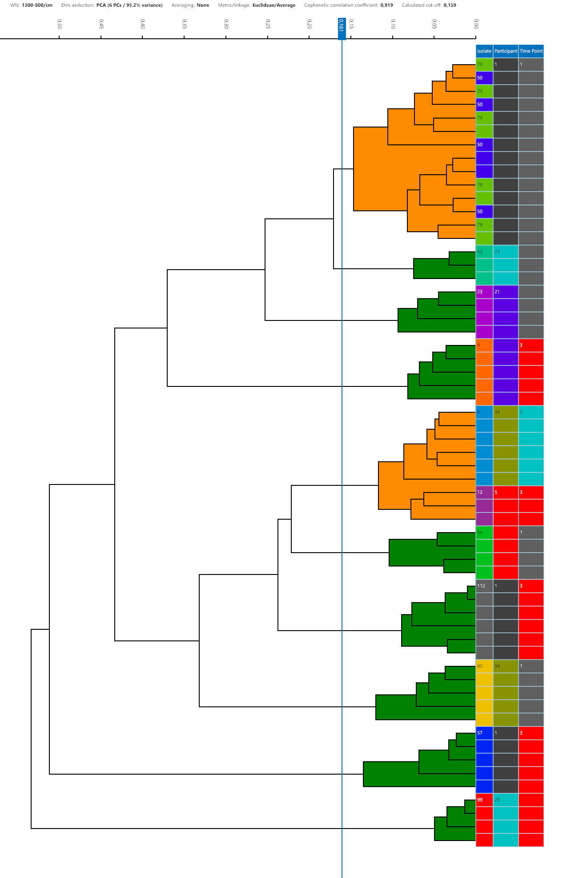

Supplementary Figure S2: Temporal distribution of Staphylococcus warneri isolates showing marked heterogeneity across sampling time points (T0 to T3).
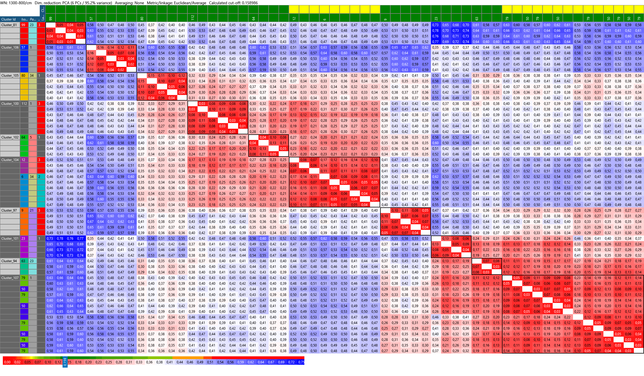

Supplementary Figure S3: Dendrogram representing the hierarchical clustering of Staphylococcus aureus isolates based on FTIR-ATR spectra.
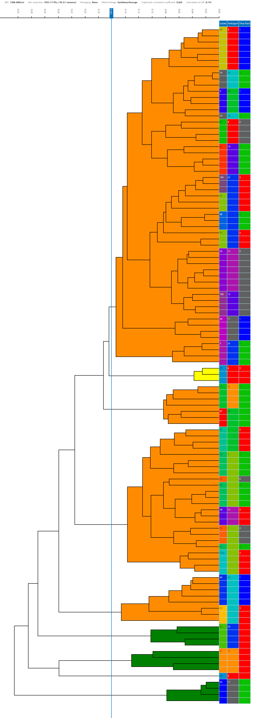
Supplementary Figure S4: Temporal distribution and clustering patterns of Staphylococcus aureus isolates across up to four sampling time points (T0 to T3).
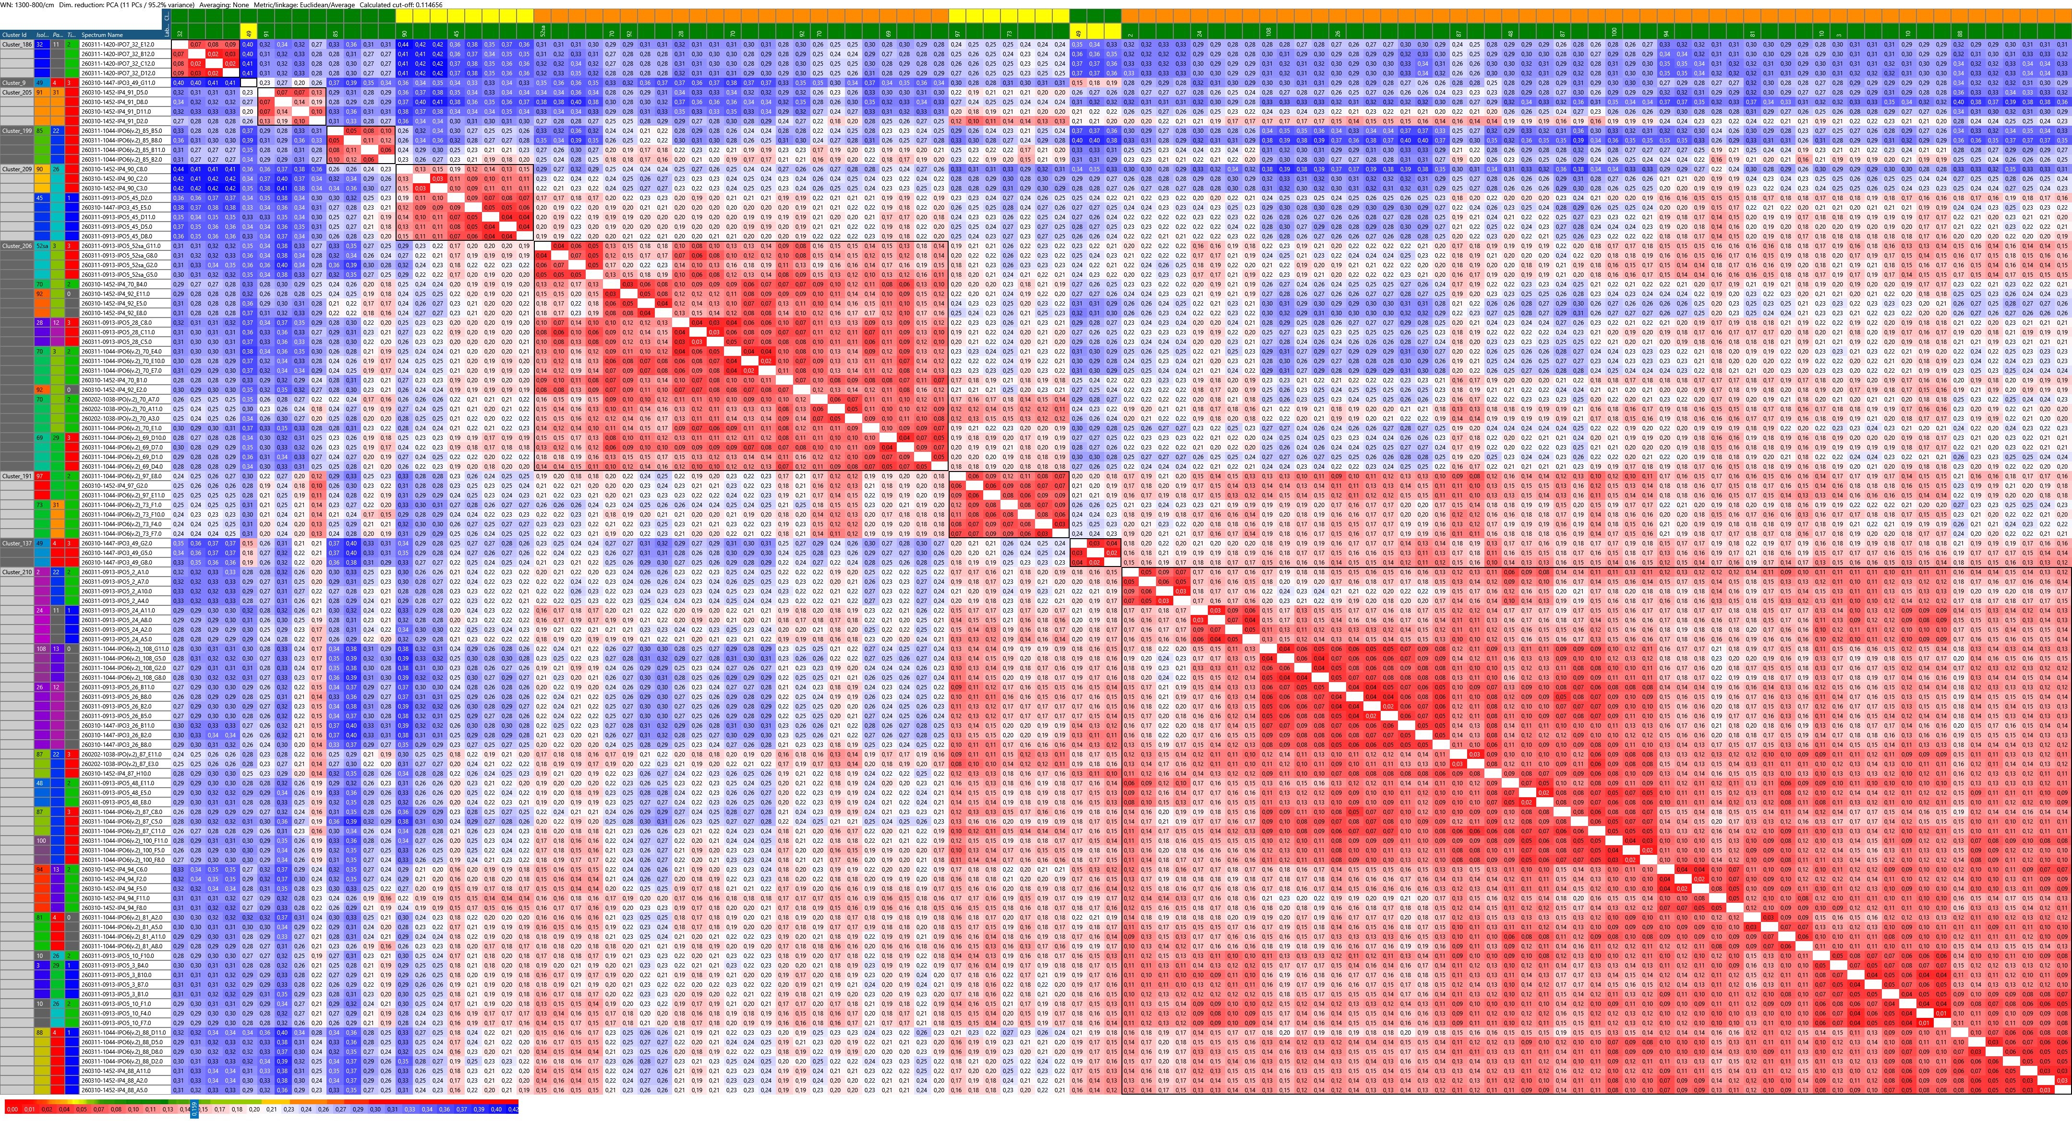

Supplementary References

1. European Committee on Antimicrobial Susceptibility Testing: Breakpoint tables for interpretation of MICs and zone diameters. Version 16.0. http://www.eucast.org. (2026). Accessed 2026.
2. Clinical and Laboratory Standards Institute. Performance Standards for Antimicrobial Susceptibility Testing. 36th ed. CLSI supplement M100. 2026.
3. Grunert T, Wenning M, Barbagelata MS, Fricker M, Sordelli DO, Buzzola FR, et al. Rapid and reliable identification of Staphylococcus aureus capsular serotypes by means of artificial neural network-assisted Fourier transform infrared spectroscopy. J Clin Microbiol. 2013;51(7):2261-6. doi: 10.1128/jcm.00581-13.

