Trees: Structure and Function

Branches of invasive maple Acer negundo are characterized by abundant photosynthetically active surface chlorenchyma
Konstantin G. Tikhonov (http://orcid.org/0000-0002-1319-0929), Alexey V. Pigolev (http://orcid.org/0000-0002-4488-240X), Evgeny A. Degtyaryov (http://orcid.org/0000-0002-9266-7317), and Tatyana V. Savchenko (https://orcid.org/0000-0003-0126-4932)

Institute of Basic Biological Problems, Pushchino Scientific Center for Biological Research, Russian Academy of Sciences, Pushchino, Russia

*e-mail: savchenko_t@rambler.ru

Supplementary Table 1. Measured parameters of variable chlorophyll fluorescence.

Parameter | Formula | Definition
F₀ |  | Minimum chlorophyll a fluorescence (or initial fluorescence) detected in the dark-adapted state
F_{m} |  | Maximum chlorophyll a fluorescence yield induced by a saturating light pulse in dark-adapted samples
F_{v} | F_{m}-F₀ | Variable chlorophyll a fluorescence associated with the photosynthetic activity of PSII
F_{v}/F_{m} | (F_{m}-F₀)/F_{m} | Maximum quantum yield of PSII photochemistry
F_{s} |  | Steady-state (stationary) level of chlorophyll a fluorescence
F_{m}' |  | Light-induced maximum chlorophyll a fluorescence level registered in the actinic light exposed samples
Y(II) | (F_{m}'-F_{s})/F_{m}' | Effective quantum yield of PSII photochemistry
qN | (F_{m}-F_{m}′)/(F_{m} − F₀) | Coefficient of non-photochemical quenching
qE | F_{m} _{(at 200 s of dark relaxa-tion)} - F_{m}' (at last satura-ting flash under acting light) | qN component recovered within 200 s
non-qE | qN - qE | Moderate and slow relaxing components of non-photochemical quenching
rETR | 0.42 × PPFD × Y(II), PPFD – Photosynthetic Photon Flux Density | Relative electron transport rate at PSII
α |  | Initial slope of rETR increase with the increase of PPFD
Lk | rETR_{max}/α | Calculated PPFD required to achieve maximal rETR while maintaining the slope of rETR increase equal to α
OJIP-derived parameters
F₀ |  | Initial fluorescence value
F_{P} |  | Maximum fluorescence value
F_{t} |  | Fluorescence value at a given time point.
V_{t} | (F_{t}−F₀)/(F_{P}−F₀) | Relative variable fluorescence at any given time
M₀ | ΔV_{t}/Δt | Initial relative rate of increase in variable fluorescence
S_{m} |  | Normalized area above OJIP curve, i.e., area between OJIP curve and the line V = 1 at linear time scale
ABS/RC | M₀/(V_{J}×φ_{Po}) | Absorption flux (exciting PSII antenna Chl a molecules) per reaction center
φ_{Po} | 1-(F₀/F_{P}) | Maximum quantum yield for primary photochemistry
ψ_{Eo} | 1-V_{J} | Efficiency/probability that an electron moves beyond Q_{A}
δ_{Ro} | (1-V_{I})/(1-V_{J}) | Efficiency/probability with which an electron from the intersystem electron carriers is transferred to the end electron acceptors at the PSI acceptor side
PI_{ABS} | ABS/RC⁻¹ × φ_{Po} × ψ_{Eo} / ((1-φ_{Po}) × (1-ψ_{Eo})) | Performance index for energy conservation from photons absorbed by PSII until the reduction of intersystem electron acceptors
PI_{total} | PI_{ABS} × δ_{Ro} / (1-δ_{Ro}) | Performance index for energy conservation from photons absorbed by PSII until the reduction of PSI end electron acceptors

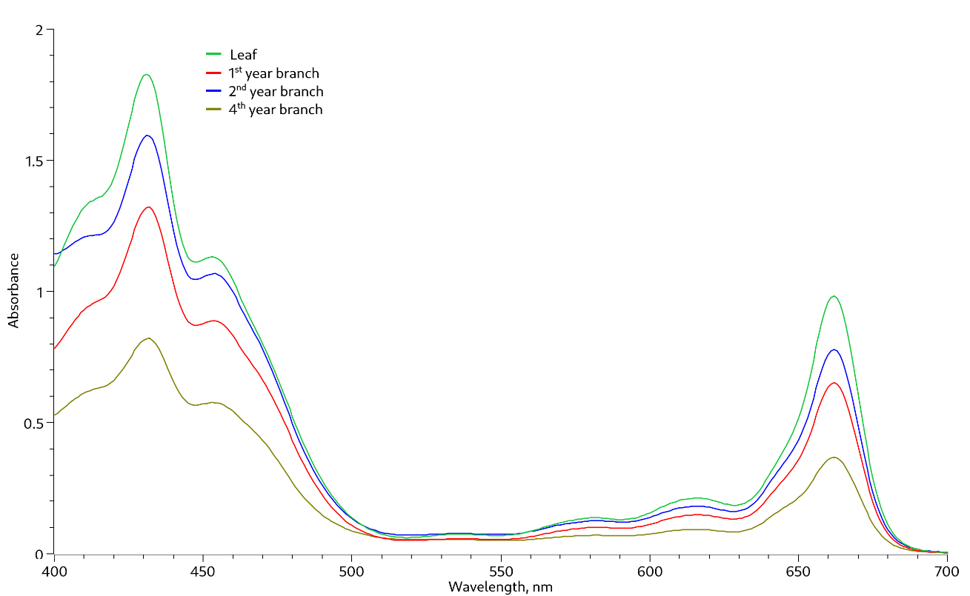

Supplementary Fig. 1 Absorption spectra of pigment extracts from A. negudo leaves and branch chlorenchyma.

Supplementary Table 2. Comparison of surface area of leaves and branches in ​​A. negundo.

No. of internode starting from the apex of the branch | Internode length, cm | Branch diameter at the middle of the internode, cm | Branch cortex surface area, cm² | Leaf area, cm² | Cortex area to leaf area, %
1 | 1.6 | 0.27 | 1.4 | 54 | 2.5
2 | 4.8 | 0.33 | 5.0 | 192 | 2.6
3 | 5.6 | 0.38 | 6.7 | 238 | 2.8
4 | 7.6 | 0.46 | 11.0 | 275 | 4.0
5 | 7.7 | 0.52 | 12.6 | 341 | 3.7
6 | 6.2 | 0.55 | 10.7 | 213 | 5.0
7 | 4.4 | 0.58 | 8.0 | 126 | 6.4
8 | 4.4 | 0.61 | 8.4 | 94 | 8.9
9 | 5.8 | 0.64 | 11.7 | 127 | 9.2
10 | 7.4 | 0.68 | 15.8 | 81 | 19.4
11 | 8.7 | 0.70 | 19.1 | 178 | 10.7
12 | 9.5 | 0.77 | 23.0 | 213 | 10.8
13 | 11.8 | 0.81 | 30.0 | 264 | 11.4
14 | 10.5 | 0.87 | 28.7 | 335 | 8.6
15 | 11.1 | 0.94 | 32.8 | 475 | 6.9
16 | 11.3 | 1.02 | 36.2 | 380 | 9.5
Total | 118.4 | - | 261.1 | 3586 | 7.3

The total fresh weight of leaf blades was 58.3 g, petioles - 15.5 g, and stems - 39.7 g.

Supplemental Table 3. Two-way ANOVA of the effective quantum yield of PSII.

Factors | p
Organ (leaf or branch) | 0.78
Orientation (upper or lower) | <0.001
Organ × Orientation | 0.754

