APPENDIX I
QUESTIONNAIRE
SECTION: A
SOCIO-ECONOMIC CHARACTERISTICS/BIO-DATA
Please tick “√”the correct answer(s)
1. How old are you? -------
2. What is your marital status?
(a). Married (b) Single ( c) Widowed (d) Separated (e) Divorced
3. What is your level of formal education? (a) None (b) Primary (c) Secondary (d) Tertiary (e) Post-Graduate
4. What is your household income?
(A ) Less than #30,000 (B) #30,000-#79,999 (C) #80,000-#149,999 (D) #150,000-#349,999 (e) Above #350,000
5. What is your occupation? (A) Public Civil Servant (B) Private Civil Servant (C) Business woman/Trader (D) Craftswoman/artisan (E) Others (specify) _________
6. How many children do you have? ……………………………………….
7. What are the age differences between your wards (kids)? (A) 1 (B) 2 (C)3 (D) 4 and above

SECTION B
COMMON CHILDBIRTH PRACTICES
1. Where did you have your last delivery?
(a) church (b) home (c) hospital (d) maternity home (e) health centre (f) on the bus/car
(g) no previous delivery (h) Farmland or roadside
2. Which would you like to choose among these as your favorite place of child delivery?
(a) Home (b) Hospital (c) Church (d) Health centre (e) Others (specify)_______
3. How many times have you used for delivery, the place you chose in number 2 above?
(a)1 (b) 2 (c) 3 (d) 4 (e) 5 and above

Which of the following are the common birth practices in your community? Tick the appropriate answer(s)/boxes
S/N | BIRTH PRACTICES | YES | NO
1. | Hospital/Health facility delivery
2. | Traditional birth attendants home
3. | Home delivery
4. | Others

Which of the common birth practices would you have preferred or chosen when giving birth next time? Tick the appropriate answer(s)/boxes
S/N | BIRTH PLACES | YES | NO
1. | Hospital/Health facility delivery
2. | Traditional birth attendants home
3. | Home delivery
4. | Others

SECTION C
Social factors influencing choice of childbirth places
Which of the social factors are the reasons behind your choice of birth practice? Tick the appropriate answer(s)/boxes
S/N | Social factors | YES
1. | Road access to health facility
2. | Distance from health facility
3. | Financial/Economic status
4. | Unavailability of skilled birth personnel

Other informations that women of bearing age undergo during pregnancy, labour and delivery in Oyigbo Local Government? __________________________________

DATASET
NEW FILE.
DATASET NAME DataSet1 WINDOW=FRONT.
FREQUENCIES VARIABLES=AGE MARITALSTATUS EDUCATION INCOME OCCUPATION NOCHILDREN AGEDIFFERENCE
/PIECHART FREQ
/ORDER=ANALYSIS.

Frequencies

Frequency Table

AGES
 |  | Frequency | Percent | Valid Percent | Cumulative Percent
Valid | 20-25YRS | 66 | 17.2 | 17.2 | 17.2
Valid | 26-31YRS | 197 | 51.3 | 51.3 | 68.5
Valid | 32-37YRS | 99 | 25.8 | 25.8 | 94.3
Valid | 45&ABOVE | 22 | 5.7 | 5.7 | 100.0
Valid | Total | 384 | 100.0 | 100.0
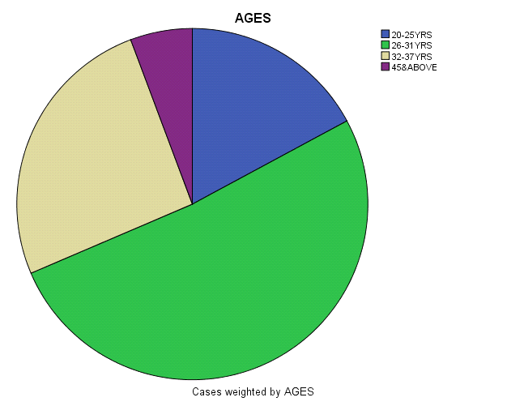

MARITALSTATUS
 |  | Frequency | Percent | Valid Percent | Cumulative Percent
Valid | MARRIED | 351 | 91.4 | 91.4 | 91.4
Valid | SINGLE | 22 | 5.7 | 5.7 | 97.1
Valid | SEPARATED | 11 | 2.9 | 2.9 | 100.0
Valid | Total | 384 | 100.0 | 100.0

EDUCATION
 |  | Frequency | Percent | Valid Percent | Cumulative Percent
Valid | NONE | 22 | 5.7 | 5.7 | 5.7
Valid | PRIMARY | 11 | 2.9 | 2.9 | 8.6
Valid | SECONDARY | 219 | 57.1 | 57.1 | 65.7
Valid | TERTIARY | 110 | 28.6 | 28.6 | 94.3
Valid | POSTGRADUATE | 22 | 5.7 | 5.7 | 100.0
Valid | Total | 384 | 100.0 | 100.0

INCOME
 |  | Frequency | Percent | Valid Percent | Cumulative Percent
Valid | LESS THAN #30,000 | 263 | 68.5 | 68.5 | 68.5
Valid | #30,000-#79,999 | 66 | 17.2 | 17.2 | 85.7
Valid | #80,000-#149,999 | 22 | 5.7 | 5.7 | 91.4
Valid | #150,000-#349,999 | 22 | 5.7 | 5.7 | 97.1
Valid | >#350,000 | 11 | 2.9 | 2.9 | 100.0
Valid | Total | 384 | 100.0 | 100.0

OCCUPATION
 |  |  |  | Frequency |  | Percent |  | Valid Percent |  | Cumulative Percent
Valid | PUBLIC CIVIL SERVANT |  |  | 33 |  | 8.6 |  | 8.6 |  | 8.6
Valid | PRIVATE CIVIL SERVANT |  |  | 77 |  | 20.0 |  | 20.0 |  | 28.6
Valid | BUSINESS/TRADER |  |  | 230 |  | 60.0 |  | 60.0 |  | 88.6
Valid | OTHERS |  |  | 44 |  | 11.4 |  | 11.4 |  | 100.0
Valid | Total |  |  | 384 |  | 100.0 |  | 100.0
NOCHILDREN
 |  | Frequency | Percent |  | Valid Percent |  | Cumulative Percent
Valid | .00 | 11 | 2.9 |  | 2.9 |  | 2.9
Valid | 1.00 | 99 | 25.8 |  | 25.8 |  | 28.7
Valid | 2.00 | 44 | 11.5 |  | 11.5 |  | 40.2
Valid | 3.00 | 132 | 34.3 |  | 34.3 |  | 74.5
Valid | 4.00 | 55 | 14.3 |  | 14.3 |  | 88.8
Valid | 5.00 | 33 | 8.6 |  | 8.6 |  | 97.4
Valid | 6.00 | 10 | 2.6 |  | 2.6 |  | 100.0
Valid | Total | 384 | 100.0 |  | 100.0

AGEDIFFERENCE
 |  | Frequency | Percent | Valid Percent | Cumulative Percent
Valid | 1 | 77 | 20.05 | 20.05 | 20.0
Valid | 2 | 176 | 45.8 | 45.8 | 65.7
Valid | 3 | 77 | 20.05 | 20.05 | 85.7
Valid | 4+ | 54 | 14.1 | 14.1 | 100.0
Valid | Total | 384 | 100.0 | 100.0

Pie Chart
