Supplementary Material
Time-Specific Recovery of Shared Decision-Making Willingness: A Dual-Role Simulation Evaluating Video-Assisted Patient Decision Aids in Postgraduate Medical Education
This file contains Supplementary Tables 1–5 and Supplementary Figures 1–4. All analyses are based on the full sample of 100 postgraduate-year physicians (n = 100).
Supplementary Table 1. Individual-level transition matrix of implementation willingness (traditional → video-assisted SDM)
Supplementary Table 2. High-willingness proportions (≥70%) and McNemar comparisons across contexts
Supplementary Table 3. Robustness analyses: Holm correction, scale dimensionality, and gender sensitivity
Supplementary Table 4. Video-assisted SDM: benefits and limitations identified through dual-role simulation
Supplementary Table 5. SDM benefits selected as most important
Supplementary Figure 1. Barriers to SDM implementation reported by PGY physicians, grouped by level (n = 100). Corresponds to Table 1.
Supplementary Figure 2. Perceived information clarity across five psoriasis content domains: video-assisted vs traditional PDA (n = 100). Corresponds to Table 2.
Supplementary Figure 3. Item-level effectiveness evaluation of traditional versus video-assisted PDAs (mean ± SD; n = 100). ***, p < .001; ns, not significant. Corresponds to Table 3.
Supplementary Figure 4. SDM benefits selected as most important by PGY physicians (n = 97 valid responses). Corresponds to Supplementary Table 5.

Supplementary Table 1. Individual-level transition matrix of implementation willingness (traditional → video-assisted SDM)
Traditional ↓ / Video → | <10% | 10–30% | 30–50% | 50–70% | 70–90% | >90% | Total
<10% | 1 | – | – | 1 | 1 | 1 | 4
10–30% | – | – | 1 | 2 | 1 | – | 4
30–50% | – | – | 2 | 3 | 4 | 1 | 10
50–70% | – | – | – | 8 | 23 | 4 | 35
70–90% | – | – | – | 3 | 25 | 10 | 38
>90% | – | – | – | 2 | – | 7 | 9
Green cells (upper triangle) indicate increased willingness (52%); red cells (lower triangle) indicate decreased willingness (5%); the diagonal indicates no change (43%). This matrix provides the numerical basis for Fig. 2b. n = 100.

Supplementary Table 2. High-willingness proportions (≥70%) and McNemar comparisons across contexts
Context | High willingness, n (%) | McNemar comparison | p value
Ideal conditions | 76 (76%) | Ideal vs Traditional | < .0001
Traditional SDM | 47 (47%) | Traditional vs Video-assisted | < .0001
Video-assisted SDM | 77 (77%) | Ideal vs Video-assisted | 1.000
High willingness defined as a score ≥4 (≥70% of patients). SDM, shared decision-making. n = 100.

Supplementary Table 3. Robustness analyses: Holm correction, scale dimensionality, and gender sensitivity
(a) Holm-adjusted p values for the 11 effectiveness-item comparisons
Item | Raw p | Holm-adjusted p
Item 1 | 0.2808 | 1.0000
Item 2 | 0.2176 | 1.0000
Item 3 | 0.4395 | 1.0000
Item 4 | 0.5901 | 1.0000
Item 5 | 0.2234 | 1.0000
Item 6 | 0.3197 | 1.0000
Item 7 | 0.4217 | 1.0000
Item 8 | 0.2657 | 1.0000
Item 9 | 1.0000 | 1.0000
Item 10 | 0.0007 | 0.0076
Item 11 | 0.7343 | 1.0000
(b) Principal component analysis (variance explained)
Scale | 1st component | 2nd component
Traditional PDA | 86.1% | 3.1%
Video-assisted PDA | 80.8% | 3.5%
(c) Gender sensitivity (Mann–Whitney U tests)
Outcome | Male / Female mean | p value
Ideal willingness | 3.92 / 4.00 | 0.713
Traditional-SDM willingness | 3.26 / 3.27 | 0.795
Video-SDM willingness | 3.89 / 4.20 | 0.206
Willingness increase (video − traditional) | 0.64 / 0.93 | 0.266
Traditional PDA total score | 47.26 / 46.47 | 0.949
Video-assisted PDA total score | 47.65 / 51.00 | 0.202
Item 10 (bold in panel a) is the only comparison surviving Holm correction. PDA, patient decision aid. n = 100.

Supplementary Table 4. Video-assisted SDM: benefits and limitations identified through dual-role simulation
 | Item | Description | n (%)
Pros | Saving time | Saving time in the SDM process | 91 (91%)
 | Enhancing understanding | Efficiently enhancing patient disease understanding | 83 (83%)
 | Standardizing the process | Minimizing inter-physician variability | 75 (75%)
 | Feasible without full team | Enabling SDM even without full team support | 63 (63%)
Cons | Relationship time | Reduced time for building the patient–physician relationship | 57 (57%)
 | Accessibility for elderly | Some elderly patients may struggle with digital devices | 8 (8%)
 | Completion uncertainty | Uncertainty about whether patients complete the video | 5 (5%)
SDM, shared decision-making. The first limitation was a fixed option; the remaining two were coded from open-ended responses. n = 100.

Supplementary Table 5. SDM benefits selected as most important
SDM benefit | Times selected as most important
Reducing medical disputes | 59
Enhancing patient disease understanding | 35
Improving treatment adherence | 25
Building patient–physician relationship | 23
Enhancing treatment effect (placebo) | 11
Based on 97 valid responses; participants selecting multiple benefits as most important were each counted once. n = 100.

Supplementary Figures
Supplementary Figure 1. Barriers to SDM implementation reported by PGY physicians, grouped by level (n = 100). Corresponds to Table 1.
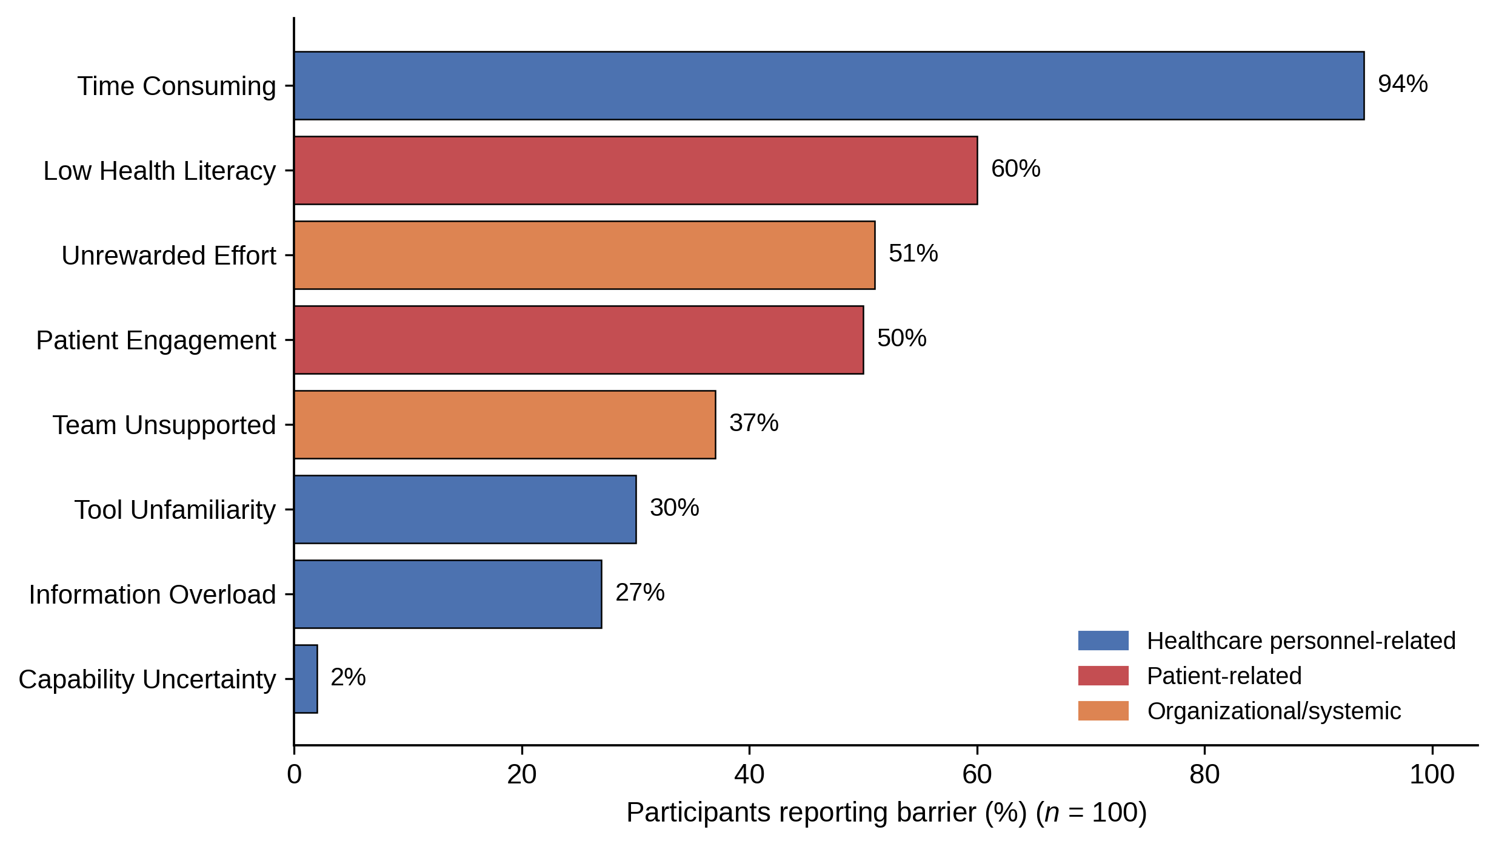

Supplementary Figure 2. Perceived information clarity across five psoriasis content domains: video-assisted vs traditional PDA (n = 100). Corresponds to Table 2.
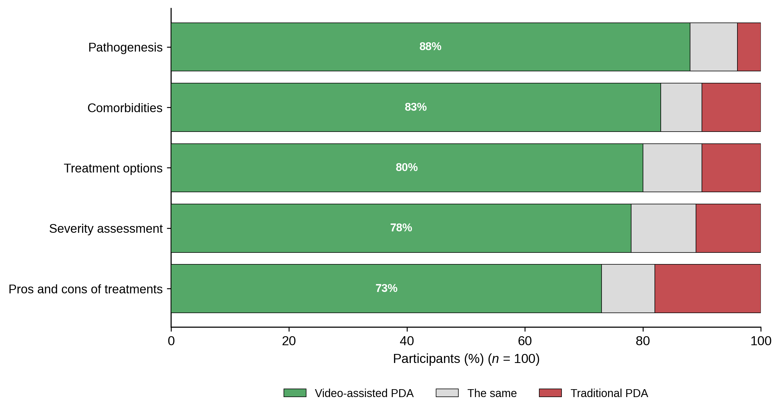

Supplementary Figure 3. Item-level effectiveness evaluation of traditional versus video-assisted PDAs (mean ± SD; n = 100). ***, p < .001; ns, not significant. Corresponds to Table 3.
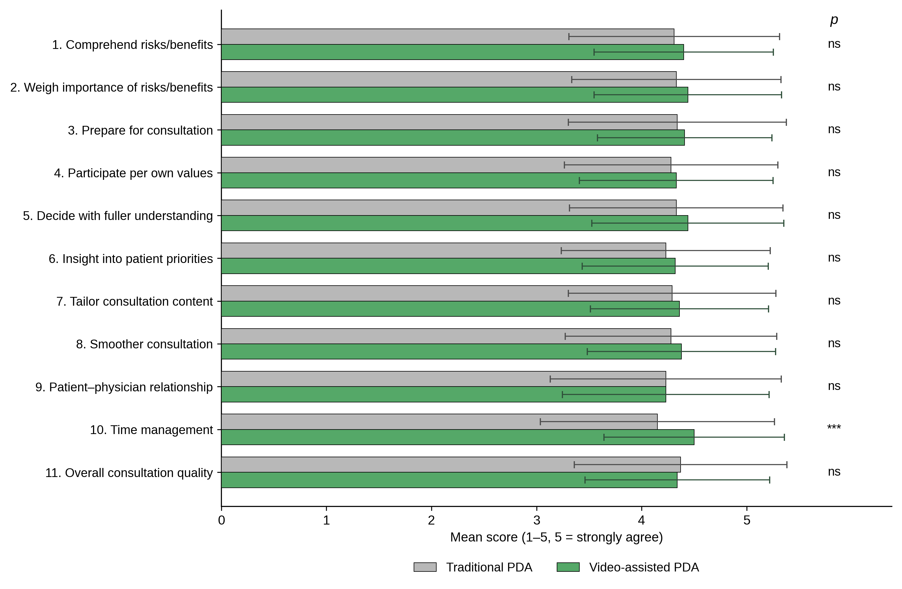

Supplementary Figure 4. SDM benefits selected as most important by PGY physicians (n = 97 valid responses). Corresponds to Supplementary Table 5.
