Table 2. Definitions of various measurements

Neutral pelvic rotation

Vertical alignment of the centre of the sacrococcygeal joint with the middle of the pubic symphysis
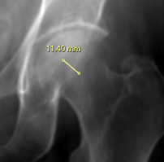
Acetabular anteversion distance (AAD)

A sphere was drawn over the femoral head. Two perpendicular lines were drawn, intersecting at the centre of the femoral head and angled at +45 and -45 degrees to the vertical axis. The acetabular anteversion distance was defined as the anterior and posterior acetabulum rims distance, measured in the same plane as the middle point, parallel to the +45 degree line drawn
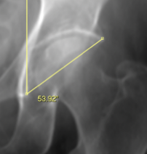
Acetabular inclination angle (AIA)

The acute angle intersecting a vertical line drawn through the medial wall of the acetabulum and a diagonal line connecting the medial and lateral surface of the acetabulum.
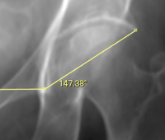
Lateral opening angle (LOA)
Also known as Sharp’s angle [19] [20]
The acute angle formed by the horizontal line connecting the “teardrop” of the acetabulum on both sides and the diagonal line connecting the medial and lateral surfaces of the acetabulum.
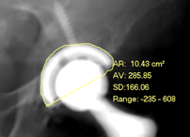
Area of prosthesis (AOP)
The prosthesis was outlined, and two-dimensional area calculated

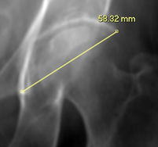
Acetabular diameter (AD)
The distance between the medial and lateral acetabulum cup margins
The length of the diagonal line connecting the medial and lateral surface of the acetabulum
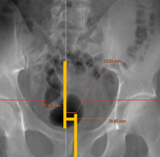
PSSC
Horizontal distance between pubic symphysis (PS, noted by bottom vertical yellow line) and middle of sacrococcygeal (SC) joint (noted by top vertical yellow line, measured in mm) [21]

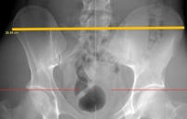
HASIS
Horizontal distance between the left and right anterior superior iliac spines (ASIS, noted by long horizontal yellow line, measured in cm)
Simplified pelvic rotation ratio (SPRR)
Horizontal distance between pubic symphysis and middle of
sacrococcygeal joint (PSSC, measured in mm) divided by the horizontal distance between
the left and right ASIS (HASIS, measured in cm)

